Lab 1

CSC 412

Professor Hamed Fazli

Jawad Kabir

1. **What is the university you are trying to research?**

In this lab, I will be using Trace Route (tracert) to reach the Columbia University server. I will be running the command tracert columbia.edu to measure the delays along the path to the Columbia server. 

1. **Explain why the reported times are different in any trace back.**

3 ms 2 ms 2 ms G3100.myfiosgateway.com [192.168.1.1]

5 ms 5 ms 6 ms lo0-100.NYCMNY-VFTTP-333.verizon-gni.net [108.30.12.1]

7 ms 6 ms 8 ms 100.41.24.186

15 ms 5 ms 6 ms 0.ae3.BR2.NYC4.ALTER.NET [140.222.1.59]

9 ms 8 ms 6 ms Verizon.com.customer.alter.net [152.179.110.202]

10 ms 9 ms 10 ms be3496.ccr42.jfk02.atlas.cogentco.com [154.54.0.141]

11 ms 9 ms 9 ms be2897.rcr24.jfk01.atlas.cogentco.com [154.54.84.214]

10 ms 8 ms 10 ms 38.122.8.210

9 ms 7 ms 8 ms cc-core-1-x-nyser32-gw-1.net.columbia.edu [128.59.255.5]

65 ms 7 ms 12 ms cc-dc-gw-1-x-cc-core-1.net.columbia.edu [128.59.255.21]

10 ms 8 ms 12 ms childpolicy.org [128.59.105.24]

1. Why the three numbers are different in any row?

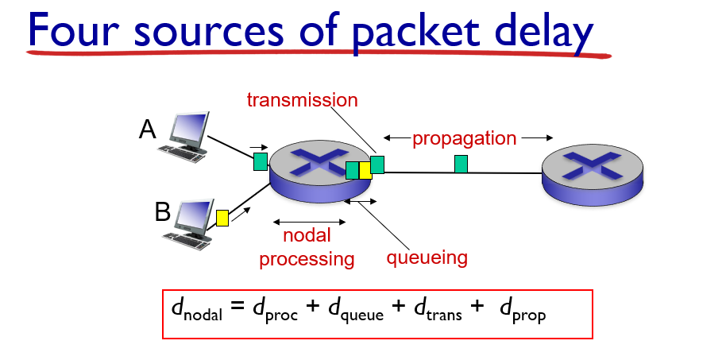

Based on the above equation, we can assume d queue is directly proportional to d nodal. As we send each packet into the queue, the queue becomes congested and may have an increase in delay. This increase in delay causes the entire node delay to increase, and thus the time it takes to go through the entire path increases.

1. Why do two rows have different reported times?

Based on the equa, we can assume d queue is directly proportional to d nodal.