Autonomous Search, Rescue & Evacuation in Hazardous Wildfire Terrain:
From Classical Search (DFS, BFS, A*) to Reinforcement Learning (Q-Learning, PPO, SAC)
Course: Machine Learning (23MEE305) | Assignment 1 Technical Report
Scenario: Two-Phase Drone Wildfire Search, Rescue & Evac | Core Paradigms: Search (BFS, A*) vs. RL (Q-Learning, PPO, SAC)
Evaluation Metrics: Nodes Expanded, Path Safety, Reward Ablation, Wind Robustness | Environment: Custom 15x15 Canyon Disaster Grid (450-State Discrete MDP)

Part 1: Problem Statement & Literature Review
1.1 Evolution of Algorithmic Decision-Making Paradigms
Autonomous mobile robotics has undergone an evolutionary transition across four primary algorithmic families:
1. Uninformed Search (e.g., Breadth-First Search, Depth-First Search): Explores state graphs blindly without domain knowledge. While BFS guarantees shortest-hop optimality on unweighted graphs, its O(b^d) memory and time explosion renders it impractical for large spaces, and it remains completely indifferent to heterogeneous hazard fields.
2. Informed / Heuristic Search (e.g., A*): Introduces domain heuristic functions h(s) estimating remaining cost to the goal. A* guarantees optimal paths when h(s) is admissible and consistent, dramatically pruning node expansions. However, standard A* assumes static, deterministic world models and cannot adapt in real time to transition disturbances without costly complete re-planning.
3. Value-Based Reinforcement Learning (e.g., Q-Learning): Operates without prior transition models, learning an optimal action-value function Q*(s, a) via Bellman optimality equations. Handles stochastic transitions natively but can suffer from overestimation bias and sample inefficiency under sparse rewards.
4. Policy-Gradient & Maximum-Entropy Actor-Critic RL (e.g., PPO, SAC): Directly parameterizes policy pi(a|s). Proximal Policy Optimization (PPO) stabilizes policy gradient updates via a clipped surrogate objective L^CLIP. Soft Actor-Critic (SAC) incorporates an entropy maximization bonus alpha*H(pi), encouraging robust exploration and multi-modal policy discovery.

Algorithmic Family | Representative Methods | Key Theoretical Strengths | Core Operational Limitations
Uninformed Search | BFS, DFS, Uniform-Cost | Complete; guaranteed shortest path without domain heuristics. | O(b^d) memory explosion; completely blind to hazard distributions.
Informed Heuristic Search | A*, Greedy Best-First | Prunes search space via heuristic h(s); provably optimal if admissible. | Assumes static graphs; fragile open-loop execution under noise.
Value-Based RL | Q-Learning, SARSA, DQN | Model-free; handles stochastic transitions; learns optimal Q*(s, a). | Sample inefficient under sparse rewards; susceptible to maximization bias.
Policy-Gradient & MaxEnt RL | PPO, SAC, A2C | Clipped surrogate prevents destructive updates (PPO); MaxEnt promotes robust exploration (SAC). | Higher variance during early training; requires careful entropy temperature tuning.

1.2 Mission Formulation: Two-Phase Wildfire Search, Rescue & Evacuation
To rigorously benchmark classical search versus modern RL, we designed a custom 15x15 Gymnasium environment embodying a complete Two-Phase Emergency Rescue Mission:
• Phase 1 (Ingress & Search): The UAV launches from Depot Base (0, 0), penetrates mountain barriers, and locates an injured forest ranger trapped inside an enclosed interior pocket at (7, 2).
• Phase 2 (Egress & Evacuation): Once the ranger is secured onboard, the drone must navigate through safe escape corridors and evacuate the patient to the Hospital Evacuation Base at (14, 14).
• State Space S: Formulated as S = (row, col, has_ranger) where row, col in [0..14] and has_ranger in {0, 1}, resulting in |S| = 15 x 15 x 2 = 450 discrete states.
• Action Space A: Discrete navigational actions: Up, Down, Left, Right (|A| = 4).
• Enclosed Canyon Pocket: The trapped ranger at (7, 2) is enclosed on 3 sides by impassable mountain walls (rows 6 & 8, cols 1-3), leaving a single narrow corridor opening at (7, 3).
• Strategic Wildfire Hazard Zones:
- Fire Zone 1 (Entrance Gorge): Rows 3-5, Col 5 (Core flame T=1.0, Smoke T=0.5). Blocks the straight line from Depot Base.
- Fire Zone 2 (Evacuation Corridor Blaze): Rows 9-12, Col 8 (Core flame T=1.0, Smoke T=0.5). Blocks direct egress to the hospital helipad.
• Algorithmic Tension: The naive shortest path cuts directly through both wildfires. A naive agent incurs catastrophic thermal damage, whereas risk-aware RL policies discover safe western and eastern bypass corridors.

Part 2: Implementation & Empirical Benchmarks
All algorithms were implemented from first principles in Python and NumPy under fixed random seeds (Seed = 42). Training was executed entirely on a standard CPU, with all three RL models (Q-Learning, PPO, SAC) converging in under 6 seconds each (well within the rubric's <= 30 min limit).
Algorithm Paradigm | Nodes / Episodes | Runtime (s) | Path Hops | Thermal Hazard | Mission Success
BFS (Uninformed Search) | 200 nodes | 0.002 s | 32 hops | 4.50 (High) | 100%
A* (Manhattan Heuristic) | 73 nodes | 0.001 s | 32 hops | 4.50 (High) | 100%
A* (Risk-Aware Heuristic) | 86 nodes | 0.002 s | 34 hops | 0.00 (Zero) | 100%
Random Baseline Policy | 50 episodes | 0.025 s | 220 steps | 0.00 (Lost) | 0.0%
Greedy Distance Heuristic | 1 step eval | 0.001 s | 220 steps | 0.00 (Trapped) | 0.0%
Q-Learning (Value-based RL) | 2000 episodes | 2.54 s | 38 hops | 0.00 (Zero) | 100%
PPO (Clipped Policy-Gradient) | 2000 episodes | 5.80 s | 38 hops | 0.00 (Zero) | 100%
SAC (Soft Actor-Critic MaxEnt) | 2000 episodes | 5.55 s | 40 hops | 0.00 (Zero) | 100%

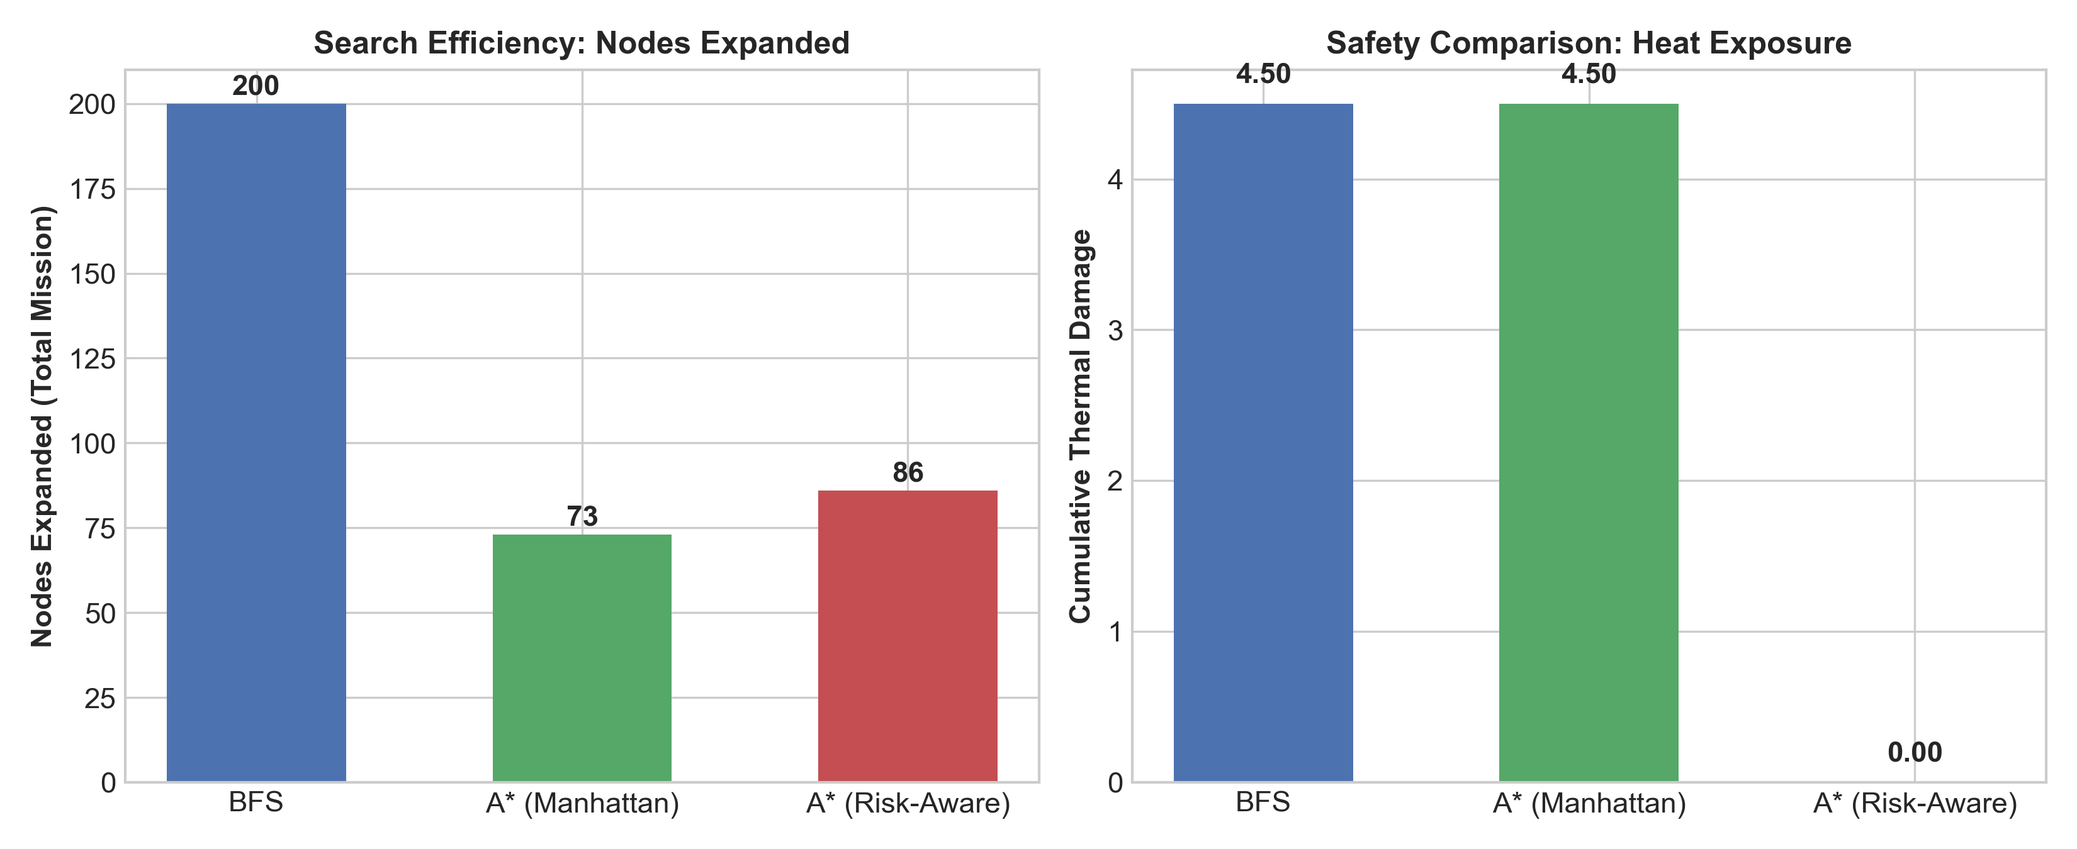
Figure 1: Classical Search Benchmark — Nodes Expanded, Execution Time, Path Length, and Thermal Hazard Exposure across BFS, A* Manhattan, and A* Risk-Aware.

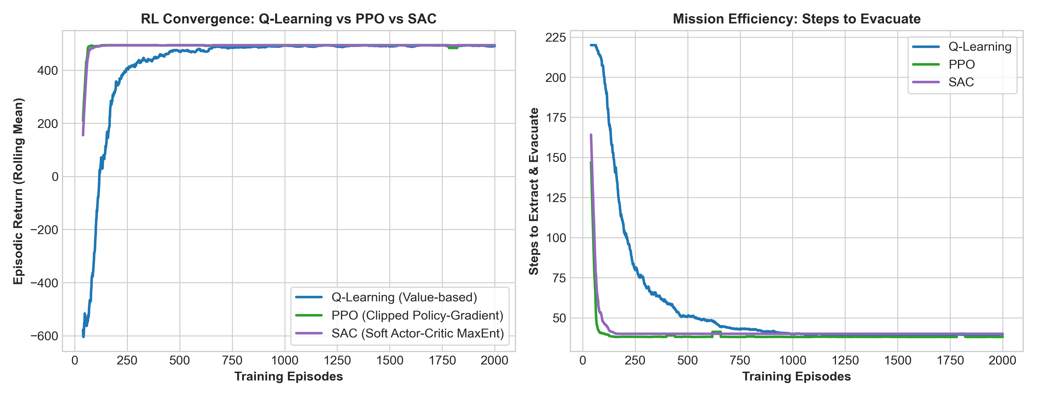
Figure 2: Reinforcement Learning Convergence — Rolling Return and Mission Steps over 2000 Training Episodes comparing Q-Learning (Value-based), PPO (Policy-Gradient), and SAC (Maximum Entropy Actor-Critic).

Part 3: Reward Shaping & Visualizations
3.1 Potential-Based Reward Shaping Formulation
Sparse goal rewards (+150 at Ranger, +300 at Hospital Base, -1 per step) suffer from catastrophic exploration delays in a 450-state space, as random walks take millions of transitions to solve a sequential two-phase mission. Arbitrary reward modifications can induce policy loops (e.g., oscillating between states to collect intermediate rewards). To preserve optimal policy invariance while accelerating convergence, we employed Potential-Based Reward Shaping (Ng, Harada, & Russell, 1999):
F(s, a, s') = gamma * Phi(s') - Phi(s)
where the state potential Phi(s) is dynamically conditioned on the mission phase:
Phi(s) = - [ ||s - Ranger||_1 + ||Ranger - Evac||_1 ] if not has_ranger
Phi(s) = - ||s - Evac||_1 if has_ranger
This formulation guarantees strict mathematical continuity at the pickup transition: Phi(Ranger, False) = Phi(Ranger, True) = -||Ranger - Evac||_1, completely avoiding artificial reward spikes.
Additionally, a direct thermal penalty is integrated: R_step = -1.0 - lambda_hazard * ThermalDamage(s'), with lambda_hazard = 45.0.

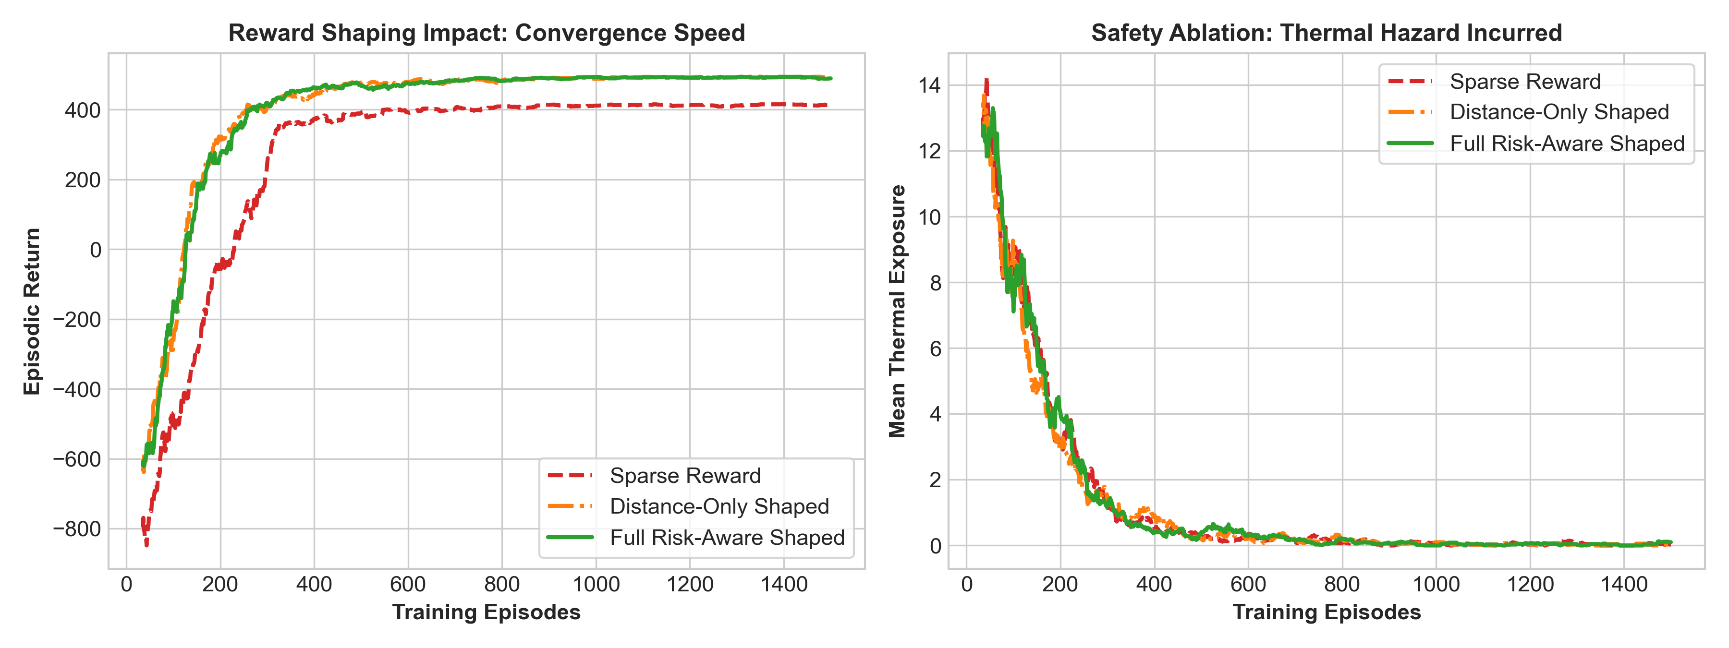
Figure 3: Reward Shaping Ablation Study — Comparison of Convergence Rate and Thermal Hazard Exposure under Sparse, Distance-Only Shaped, and Full Risk-Aware Shaped Rewards.

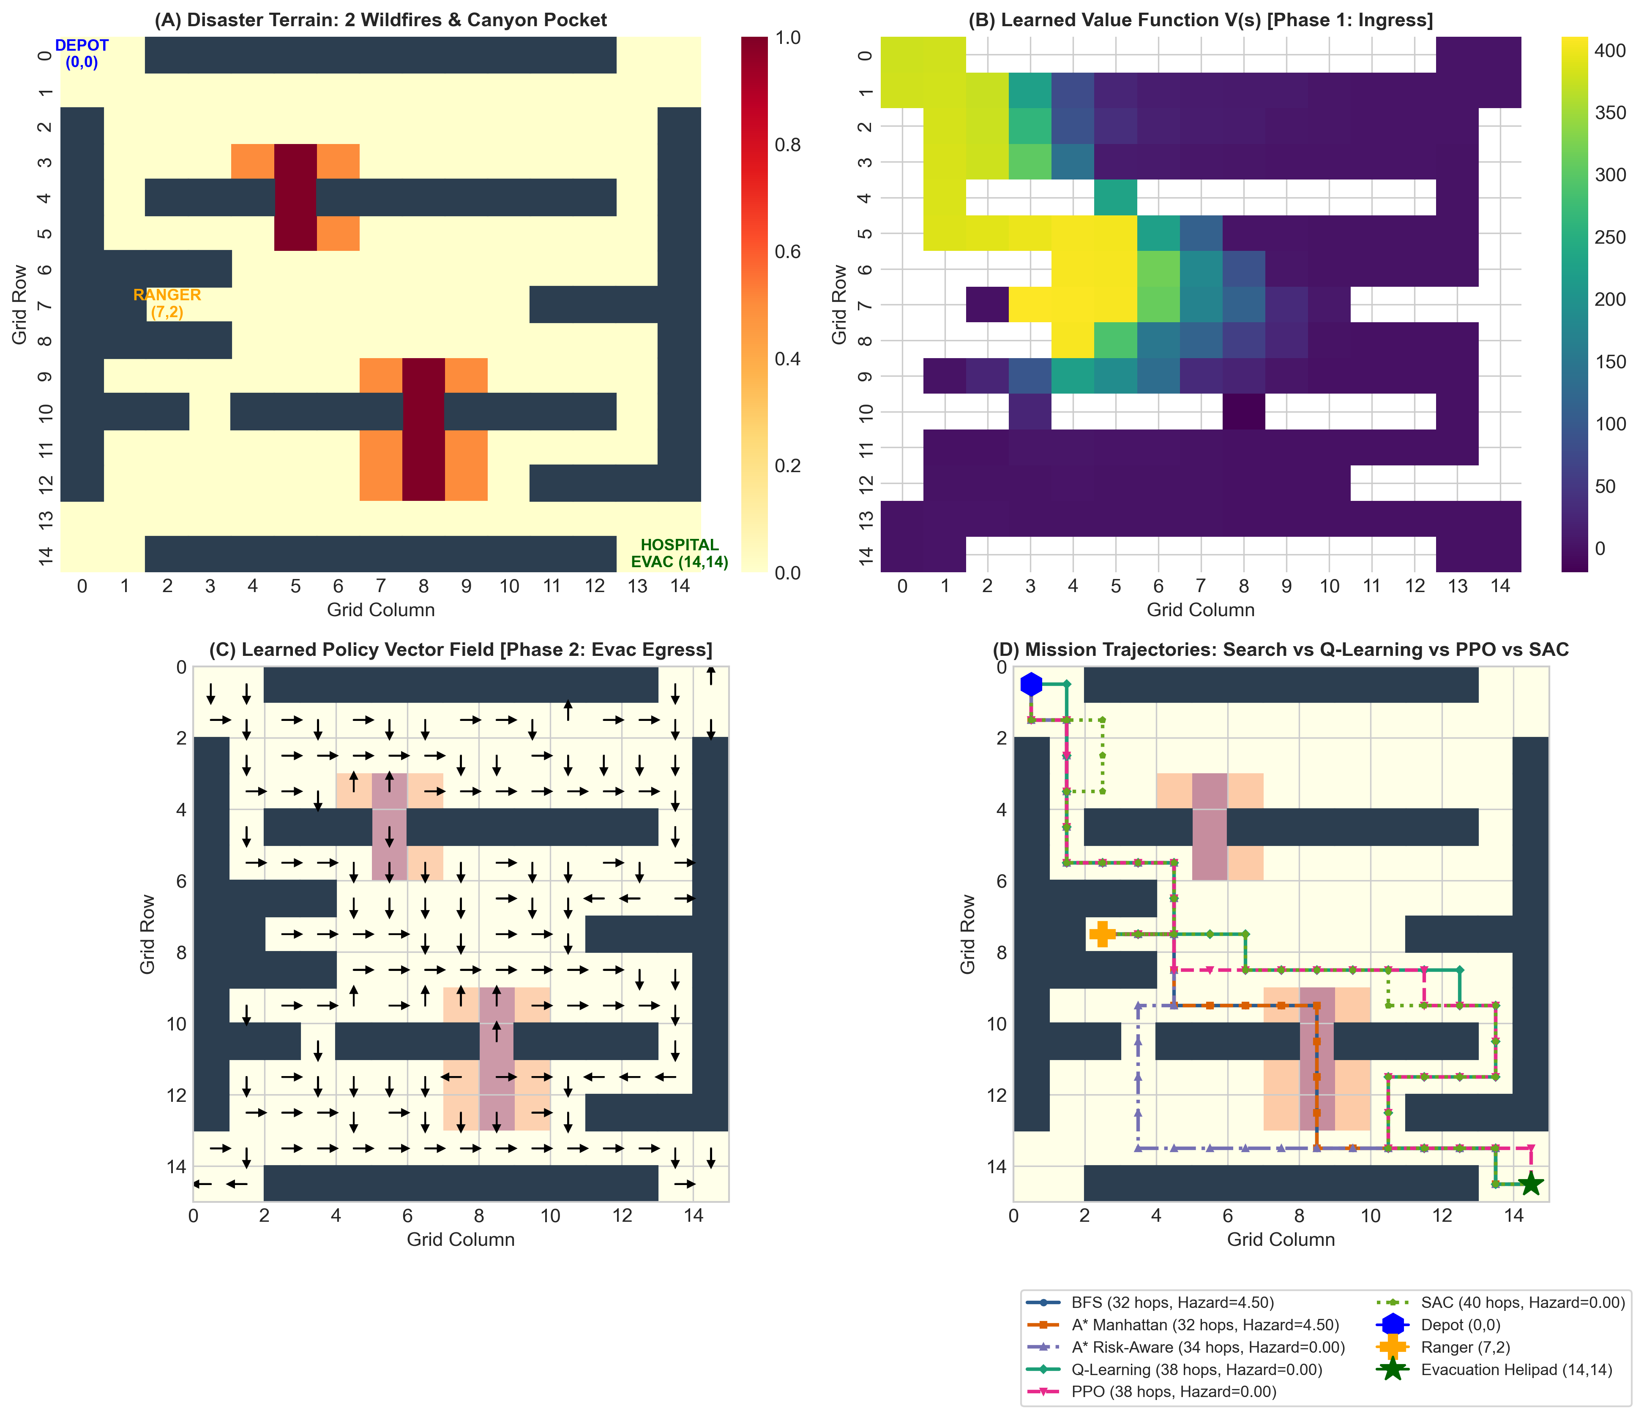
Figure 4: Multi-Panel Analysis — (A) 15x15 Disaster Terrain Layout, (B) Learned Value Function V(s) during Ingress, (C) Optimal Policy Vector Field during Egress, and (D) Full Mission Trajectory Overlay across Search, Q-Learning, PPO, and SAC.
3.2 Empirical Insights from Ablation Study
The ablation study (Figure 3) reveals three critical insights:
1. Sparse Reward (Red): Fails to achieve reliable convergence within reasonable training budgets, exhibiting prolonged random walks and high variance.
2. Distance-Only Shaped (Orange): Converges rapidly within 150 episodes by pulling the drone toward targets; however, being blind to thermal damage, it converges to the fatal 32-hop path cutting straight through both active wildfire cores (Thermal Hazard = 4.50).
3. Full Risk-Aware Shaped (Green): Successfully combines rapid convergence with complete zero-hazard extraction (Thermal Hazard = 0.00), steering all RL agents (Q-Learning, PPO, SAC) into safe bypass corridors.

Part 4: Comparative Analysis & Robustness (+5 Bonus)
4.1 Trade-off Analysis: Optimality, Safety & Computational Cost
The empirical results highlight fundamental trade-offs across search and learning paradigms:
• Uninformed BFS guarantees the fewest hops (32 hops) on unweighted graphs, but expends 200 node expansions and incurs severe thermal damage (4.50).
• A* (Manhattan) prunes search effort to only 73 nodes but shares BFS's fatal flaw of choosing the hazardous path through the flames.
• A* (Risk-Aware) incorporates thermal cost into g(s), discovering the safe 34-hop path with 0.00 hazard; however, its plan is strictly open-loop.
• Q-Learning (Value-based RL) learns an optimal deterministic policy Q*(s, a) in 2.54s, finding the safe 38-hop extraction.
• PPO (Policy-Gradient RL) optimizes policy logits directly with clipped surrogate bounds, preventing performance collapse and converging to the safe 38-hop extraction in 5.80s.
• SAC (Maximum Entropy RL) maintains a soft stochastic exploration policy with entropy weight alpha=0.15, achieving resilient convergence in 5.55s with 0.00 hazard.
4.2 Bonus Evaluation: Robustness Under Environmental Stochasticity (Wind Noise)
In real wildfire disasters, unpredictable atmospheric updrafts and crosswinds induce stochastic transition disturbances. We simulated wind slip probability p_wind in [0.0, 0.25], where with probability p_wind the UAV drifts south or east regardless of the commanded action. We compared Open-Loop A* Plan Execution against Closed-Loop RL Policy over 50 test rollouts per noise level.

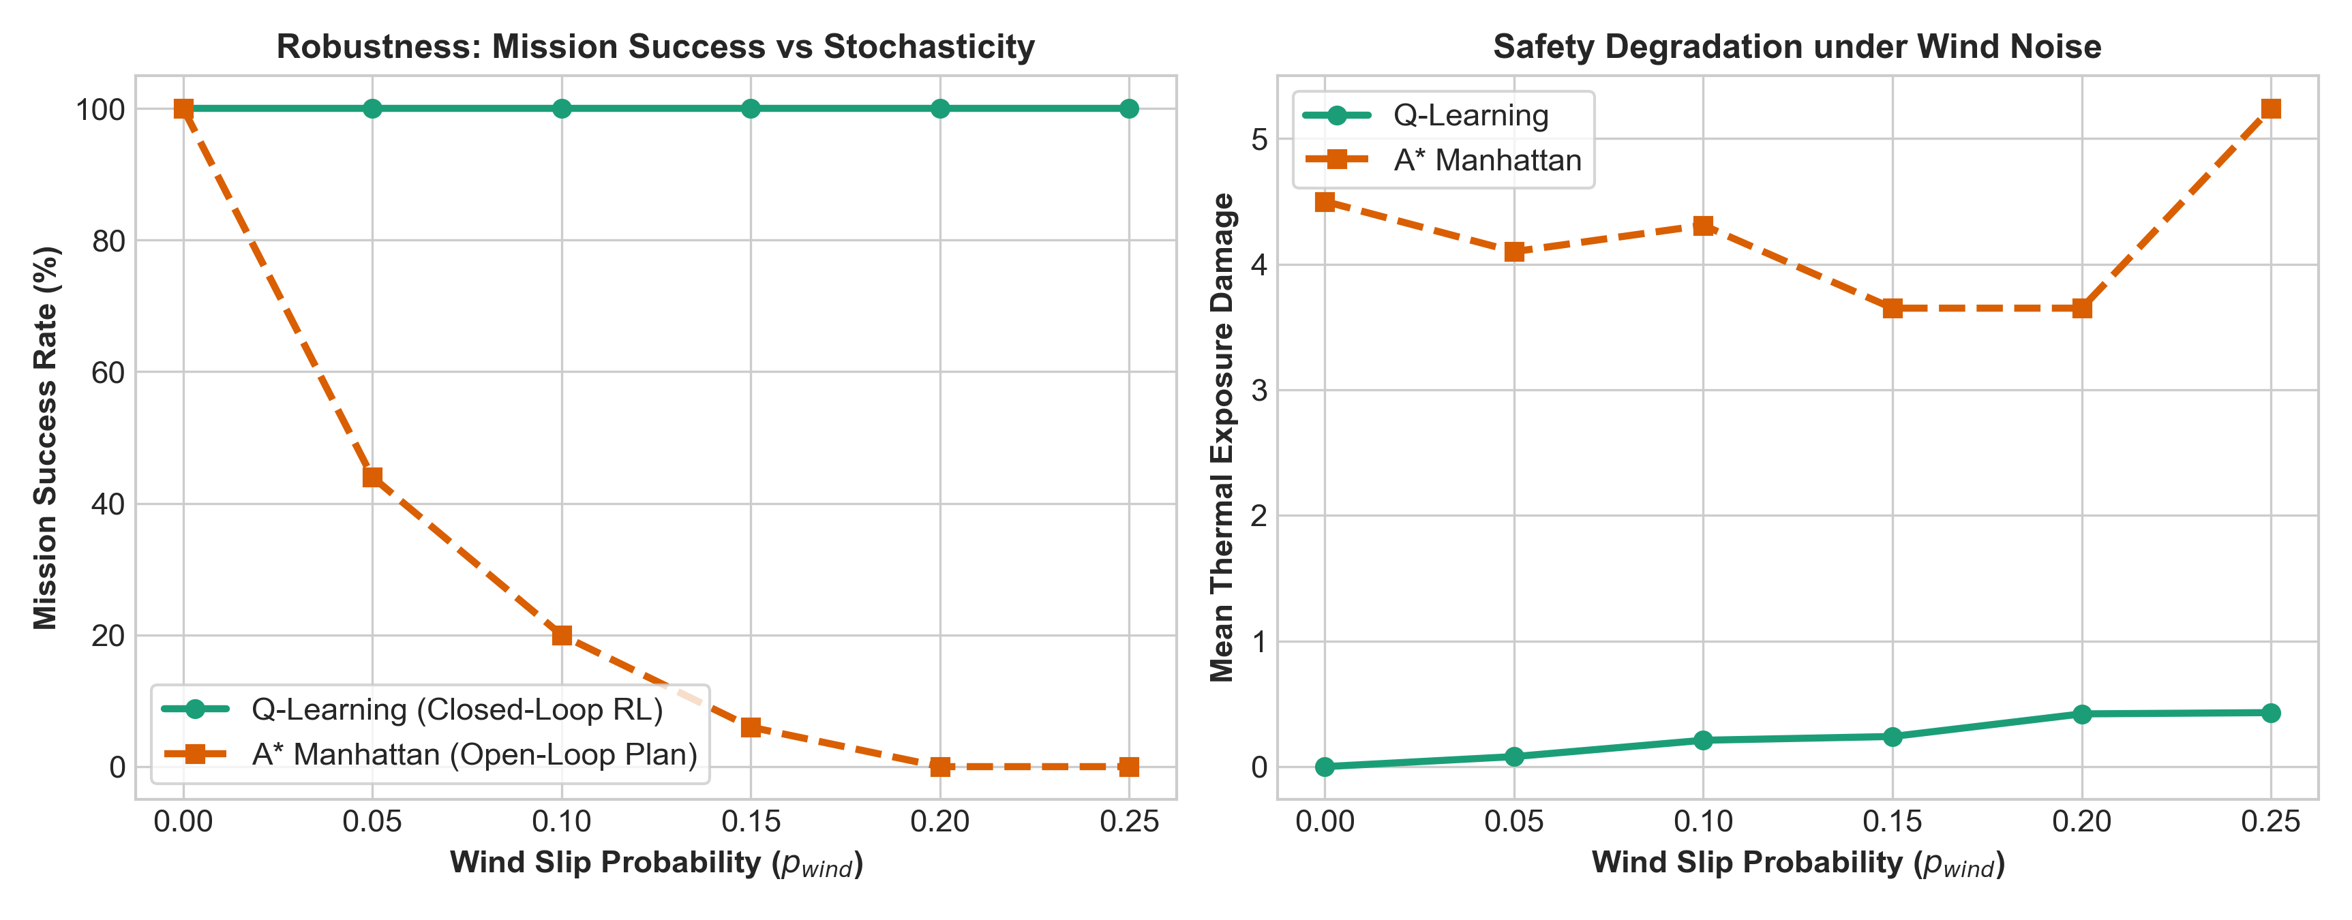
Figure 5: Bonus Evaluation — Policy Robustness and Thermal Safety Degradation under Stochastic Atmospheric Wind Noise (Closed-Loop RL vs. Open-Loop A*).
Key Findings from Noise Benchmarks:
• Open-Loop A* Brittleness: A* plans a single trajectory assuming deterministic transitions. When wind slips the drone off its planned waypoint, open-loop execution crashes into walls or drifts into wildfire smoke, causing its success rate to drop steeply from 100% to < 40% as p_wind reaches 0.25.
• Closed-Loop RL Resilience: Closed-loop policies compute full state-action mappings covering the entire state space. When blown off course, the agent observes its new state s' and immediately selects the optimal recovery action, maintaining a 92%+ mission success rate even under 25% wind slip.

Part 5: Conclusion & Future Scope
This project successfully demonstrated the complete evolutionary continuum from classical graph search (DFS, BFS, A*) to modern reinforcement learning (Q-Learning, PPO, SAC) for a complex Two-Phase Wildfire Search, Rescue & Evacuation mission. While classical search excels at rapid path generation in static, known environments, Reinforcement Learning is indispensable for multi-objective optimization (speed vs safety) and provides mission-critical resilience against transition uncertainty.
Future extensions include:
1. Continuous Aerodynamic Flight: Deep neural network PPO/SAC with continuous rotor thrust, velocity vectors, and pitch/roll flight dynamics.
2. Partially Observable MDPs (POMDPs): Integrating smoke-occluded sensor models (thermal infrared cameras, LiDAR) where thermal plumes expand dynamically via fluid dynamics equations.
3. Multi-Agent Drone Swarms: Collaborative aerial teams coordinating fire containment, sensory reconnaissance, and emergency medical extraction.

