*Classroom Activity: Protecting groundwater by designing landfill liner*

**Introduction**

A properly designed landfill liner is an important part of preventing leachate from contaminating groundwater. After explaining the importance of leachate management, the ability of water to infiltrate various materials used in leachate liners (clay, sand, gravel, plastic sheets) will be demonstrated. Students will then be given the goal to design (in groups of 3-4) a landfill liner system for a 2L soda bottle which adequately drains ‘leachate’ (colored water) through the appropriate pipe without allowing leachate to infiltrate through the bottom. Students will work in groups to first design a landfill liner system which is reviewed by an expert (the teacher). After a brief second design period where students may address issues brought to light during the review, the liner system will be built in a soda bottle, tested, and compared to other group’s designs. Finally, the systems are re-evaluated in a ‘worst case’ scenario where the plastic liner, if used, is punctured prior to adding more ‘leachate’.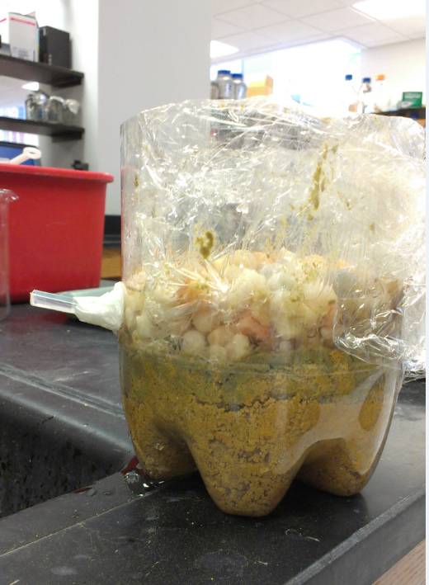

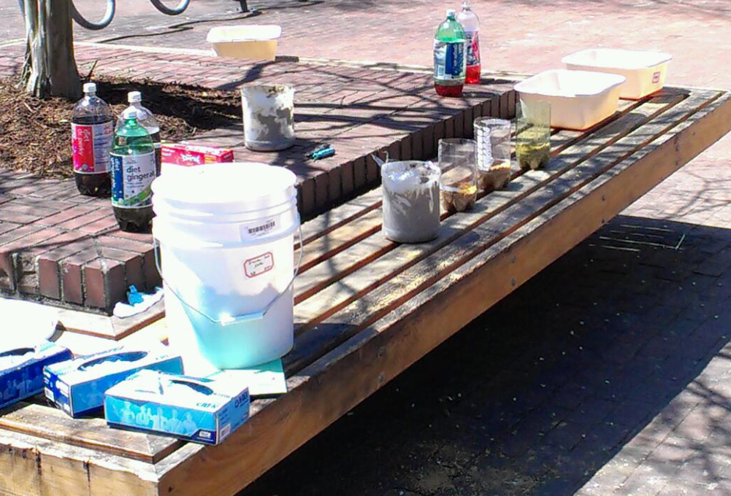

Figure 1 Example Workstation

**Learning Outcomes**

* R*ecall* that landfills generate leachate which must be prevented from entering groundwater
* R*ecall* the different materials used in a liner system and their associated hydraulic properties
* *Comprehend* why protecting groundwater is important and that waste must be managed
* *Comprehend* the complementary nature of the materials allows the construction of system which is not possible using just one material
* *Collaboratively* *synthesize* a solution, based on *analysis* of material properties and a clear design goal
* *Evaluate* designs in preparation for outside review and *re-evaluate* designs after review
* *Analyze* why different designs failed or worked and the tradeoffs between different designs
* *Synthesize* the results of the analysis to reflect upon how their design could be improved, based on all the results

**Curriculum Alignment**

* **Bio.2.2** *Understand the impact of human activities on the environment*
  + **EX.Bio.2.2.1** *Identify natural resources (e.g. water, air, land) impacted by human activity*
    - Here, this is the groundwater which may be impacted by improperly designed leachate systems
  + **Ex.Bio.2.2.3***Understand ways humans can work to preserve natural resources*
    - Here, ‘preserve’ is taken to include ‘protect’ and refers to the design of a landfill system which accomplishes a necessary task (waste management) while preventing the spoiling of an important natural resource (wastewater)
* **EEn.2.4** *Evaluate how humans use water*
  + **EEn.2.4.2** *Evaluate human influences on water qualityin North Carolina’s river basins, wetlands, and tidal environments*
    - Students should recognize groundwater as a major North Carolina freshwater resource and understand the link between waste generation, waste management, and groundwater protection
* **OA6.1***Understand how humans can have positive and negative effects on the environment*
  + **OA6.1.1** *Explain how humans can have a positive impact on natural resources*
    - Through proper design, fundamental needs of civilization (waste management) can be met while protecting natural resources (groundwater)

**Classroom time required**

This activity can be successfully performed within 1 hour. Alternatively, the demonstration, design, and construction/testing portions may be split into manageable subunits.

**Materials Needed**

Instructor use:

* Exacto knife or box cutters
* Malleable, watertight compound for attaching straw (putty, parafilm, and silicone caulk all work)
* 4 tops from 2L plastic bottles
* Paper towels
* 4 Rubber bands
* Long handled screwdriver
* Color water
* Catch basin for ‘leachate’

(Per group)

* 1 bottom portion of 2L plastic bottle (clear works best)
* Approximately 8 oz each of sand (white works best), modeling or pottery clay, loose gravel
* 1 sheet (about letter size) of plastic wrap
* 1 plastic drinking straw
* 1L of colored water
* 1 high-walled basin or sink for catching water

**Pre-activities**

The instructor should prepare 1 bottle per group:

* Cut the top off the bottle just below the ‘shoulder’, retain at least 4 tops
* Perforate the bottom of the bottle
* Line the bottom with 1 sheet of paper towels and fill ~2 to 3 inches with sand
* Cut a hole for the straw about 3 inches above the sand layer
* Insert the straw so that it extends to the center of the bottle and seal the insertion point using putty, parafilm, caulk, or some similar moldable, adhesive, watertight material

The instructor should also prepare demonstrations of the materials

* Prepare a large amount of colored water (~1 L per group + 2 L)
* For sand, clay, and gravel, attach a paper towel to the neck of a retained bottle top with a rubber band and fill the bottle top with 3 to 4 inches of material. The clay should be well-packed. (Note: bottle top refers to the retained top ¼ of the soda bottles, not the bottle cap).
* The plastic liner can be simply attached to the neck of a fourth bottle top using a rubberband

**Activities**

*Problem statement and material demonstration*

The instructor can begin by asking students where their trash goes to lead into a general discussion which should relate that:

* Waste ends of up in landfills
* Landfills are, essentially, large holes in the ground
* Leachate is generated as waste degrades and as rainfall infiltrates into the landfill
* Groundwater is underneath the landfill and is an important source of fresh water
* Leachate must not be allowed to move from the landfill to the groundwater, but also must not be allowed to collect in the landfill itself
* Accomplishing these two goals requires that the bottom of a landfill be designed and constructed using different materials.

The instructor can then state that the students will be split into groups and will have to design and build a landfill which allows leachate to drain without contaminating an aquifer. That is, after they build a system, leachate will be poured into it and should flow smoothly out of the straw without penetrating to the sand ‘aquifer and eventually out through the bottom perforations.

Material properties can be demonstrated by working from sand through clay and then the plastic sheet. For each material the instructor should encourage students to predict what will happen when ‘leachate’ is poured over the material. For clay it should be pointed out that while no leachate should permeate immediately, it might penetrate over the course of years. For plastic liner, the instructor should ask (and may even demonstrate) what would happen if the plastic were punctured. Optionally, this is a good point to discuss the possible roles each material might play in a liner system.

*Group design*

It is important the instructor tells the students that they have a limited amount of each material and that the landfill will be tested under ‘normal’ conditions first and then by puncturing any plastic sheeting used.

Students should work in groups, with 3 having been found to be optimal, wherein they will discuss potential designs for a landfill system, sketch it on paper, and after about 8 minutes, present their design to the instructor for review.

During review, the instructor should attempt to elicit the reasoning behind the design decisions and provoke reflection (without explicitly stating the ‘correct’ design’) about possible design flaws.

After review, the students should work for 5 minutes to incorporate any new insights into their design.

*Construction and testing*

Students will be given 10 to 15 minutes to build a system based on their design using the provided materials. Experience shows that more than 15 minutes generally does not lead to better designs or greater insight.

Designs will be tested one at a time with all students observing each test. Tests are performed by steadily pouring ‘leachate’ into the top of the system and observing its flow. A second test determines how robust the design is with respect to puncturing by stabbing a long implement (such as a screwdriver) though the liner system 2 to 3 times and then adding more leachate.

**Assessment**

Although a written lab report is possible, the intention is for the oral assessment.

The instructor should look for the following cues

* Students should understand that leachate can cause *contamination* of *groundwater* which is an important *natural resource*
* Students should be able to articulate the purpose of a landfill liner system and recall the properties of the materials used
* The necessity of using complementary materials should be expressed
* Students should be able to compare and contrast the major differences between the designs they saw and exceptional mastery will be evidenced by recognizing the concept of ‘design tradeoffs’ or the fact that there is no single objectively best design
* Students should be able to reflect on their own designs and describe what worked well and what they would improve upon

**Modifications**

Different costs may be assigned to materials. This enhances student understanding of tradeoffs, but has made the problem too complex for lower grade levels