
PulseBlaster™
Models PB24-512 and PB24-32k
(PCI Board SP2)

Owner’s Manual
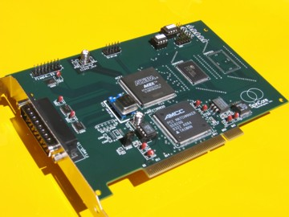

SpinCore Technologies, Inc.
http://www.spincore.com

Congratulations and thank you for choosing a design from SpinCore Technologies, Inc.
We appreciate your business!
At SpinCore we try to fully support the needs of our customers. If you are in need of assistance, please contact us and we will strive to provide the necessary support.

© 2000-2004 SpinCore Technologies, Inc. All rights reserved.
SpinCore Technologies, Inc. reserves the right to make changes to the product(s) or information herein without notice. PulseBlasterDDS™, PulseBlaster™, SpinCore, and the SpinCore Technologies, Inc. logos are trademarks of SpinCore Technologies, Inc. All other trademarks are the property of their respective owners.

SpinCore Technologies, Inc. makes every effort to verify the correct operation of the equipment. This equipment version is not intended for use in a system in which the failure of a SpinCore device will threaten the safety of equipment or person(s).
Table of Contents
I. Introduction 4
Product Overview 4
Board Architecture 5
Block Diagram 5
Output signals 5
Timing characteristics 5
Instruction set 6
External triggering 6
Status Readback 6
Summary 6
Specifications 6
Pulse Parameters 6
Pulse Program Control Flow 6
II. Installation 7
Installing the PulseBlaster Driver for Windows Operating Systems 7
For Windows XP 9
Testing Control of the PulseBlaster 10
III. Programming the PulseBlaster 11
Instruction Set Architecture 11
Machine-Word Definition 11
Breakdown of 80-bit Instruction Word 11
Using C Functions to Program the PulseBlaster 13
Example Use of C Functions 14
IV. Connecting to the PulseBlaster Board 16
Connector Information 16
DB25 Bracket Connector Flag 0..15 - Pin Assignments 16
IDC Connector Flag16..23 - Pin Assignments 16
IDC Connector Status - Pin Assignments 17
Header JP100 17
SMA Connector Clock_Out 17
SMA Connector Ext_Clk 18
Appendix I: Sample C program 19
Example Program 19
Appendix II: Programming the PulseBlaster Using Direct Outputs 20
Using DLL Functions to Send Instructions 20
Building Instructions Using the DLL Functions 21
Programming Information 21
Example Program 22
Contact Information 24

I. Introduction

Product Overview

The PulseBlaster™ device (PCI board) is an intelligent pulse/word/pattern generation unit producing precisely timed, individually controlled, 24 digital output signals.

The intelligence of the PulseBlaster timing processor comes from an imbedded microprogrammed control core (uPC). The PulseBlaster processor is able to execute instructions that allow it to control program flow. This means that the PulseBlaster processor understands Operational Control Codes, OpCodes, and will execute them much the same way as a general-purpose microprocessor does. The PulseBlaster’s microcontroller is different from the general-purpose microprocessor in that it does not contain an arithmetic logic unit (ALU) and is, therefore, incapable of doing mathematical or logical calculations. However, a unique and distinguishing feature of the PulseBlaster processor is that the execution time of instructions is user programmable. This feature makes the PulseBlaster capable of executing complex output timing patterns at greatly varying update rates, ranging from nanoseconds to years, with a constant setting accuracy of just one clock period (e.g., a 10 ns setting accuracy at a 100 MHz clock frequency).

Board Architecture

Block Diagram

Figure 1 presents the general architecture of the PulseBlaster system. The major building blocks are the SRAM memory (both internal and external to the processor), the microcontroller (uPC), the integrated bus controller (IBC), the counter, and the output buffers. The entire logic design, excluding output buffers, is contained on a single silicon chip, making it a System-on-a-Chip design. User control to the system is provided through the integrated bus controlled over the PCI bus.
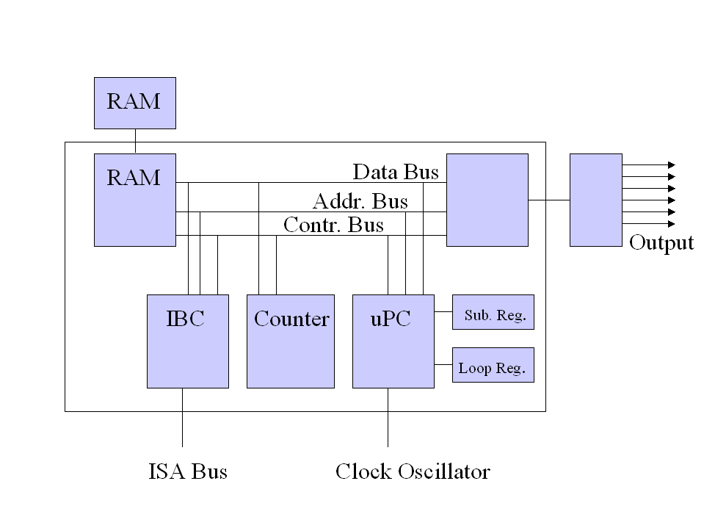
PCI Bus

Figure 1: PulseBlaster board architecture

Output signals

The PulseBlaster PB24 PCI board allows for 24 digital output signal lines. Sixteen output lines are routed to a DB25 bracket-mounted connector. The remaining 8 output lines are routed to an IDC connector. The 24 individually controlled digital output bits comply with the TTL-levels’ standard, and are capable of delivering ±25 mA per bit/channel. If more output current is necessary, the individual bits/channels can be driven in parallel.

Timing characteristics

PulseBlaster’s timing controller accepts an internal (on-board) crystal oscillator up to 100 MHz. The innovative architecture of the timing controller allows the processing of either simple timing instructions (delays of up to 2³² = 4,294,967,296 clock cycles), or double-length timing instructions (up to 2⁵² clock cycles long – nearly 2 years with a 100 MHz clock!). Regardless of the type of timing instruction, the timing resolution remains constant for any delay – just one clock period (e.g., 10 ns at 100 MHz).
The core-timing controller has a minimum delay cycle of five clock periods for PB24-512 and a minimum delay cycle of nine clock periods for PB24-32k. For a 100 MHz clock, this translates to a 50 ns pulse/delay/update for PB24-512 and 90.0 ns pulse/delay/update for PB24-32k.

Instruction set

PulseBlaster’s design features a set of commands for highly flexible program flow control. The micro-programmed controller allows for programs to include branches, subroutines, and loops at up to 8 nested levels – all this to assist the user in creating dense pulse programs that cycle through repetitious events, especially useful in numerous multidimensional spectroscopy and imaging applications.

External triggering

PulseBlaster can be triggered and/or reset externally via dedicated hardware lines. The two separate lines combine the convenience of triggering (e.g., in cardiac gating) with the safety of the "stop/reset" line. The required control signals are “active low” (or short to ground).

Status Readback

The status of the pulse program can be read in hardware or software. The hardware status output signals consist of five IDC connector pins labeled “Status”. The same output can be read through software using C. See section IV (Connecting to the PulseBlaster Board, page 16) for more detail about the hardware lines and section III (Programming the PulseBlaster, page 11) for more detail about the C function status_readback().

Summary

PB24 is a versatile, high-performance pulse/pattern TTL signal generator operating at speeds of up to 100 MHz and capable of generating pulses/delays/intervals ranging from 50 ns to two years per instruction. It can accommodate pulse programs with highly flexible control commands of up to 512 program words (Model PB24-512) or 32k program words (Model PB24-32k). Its high-current output logic bits are independently controlled with a voltage of 3.3 V.

Specifications

Pulse Parameters

- 24 individually controlled digital output lines (TTL levels, 3.3 V logical “one”)
- variable pulses/delays for every TTL line
- 25 mA output current per TTL line
- 50 ns shortest pulse/interval (at 100 MHz, Internal Memory Model, PB24-512)
- 2 years longest pulse interval (at 100 MHz, with the use of the “Long Delay” instruction)
- 10 ns pulse/interval resolution (at 100 MHz)
- up to 32k pulse program memory words/instructions (Model PB24-32k)
- external triggering and reset – TTL levels

Pulse Program Control Flow

- loops, nested 8 levels deep
- 20 bit loop counters (max. 1,048,576 repetitions)
- subroutines, nested 8 levels deep
- wait for trigger – 8 clock cycle latency (80 ns at 100 MHz), adjustable to 40 seconds in duration
- 5 MHz max. re-triggering frequency (at 100 MHz clock frequency)

II. Installation

Installing the PulseBlaster Driver for Windows Operating Systems

- Go to http://www.pulseblaster.com/CD/PulseBlaster/PCI/SP2/ and download the zip file.
- Unzip the files to their own directory.
- Turn off your computer.
- Insert the PulseBlaster board into an empty PCI slot.
- Turn on your computer.

For Windows 98
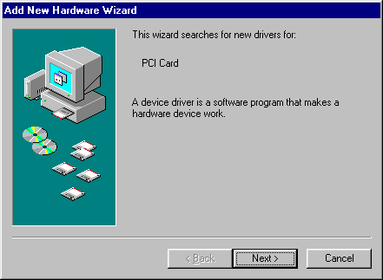
- After booting, an “Add New Hardware Wizard” dialog box will appear. Click the Next Button.

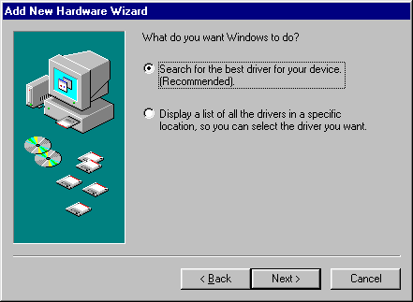
- Select Search for the best driver for your device (Recommended) and click the Next button.

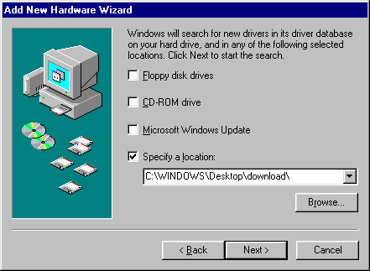
- Select Specify a location and click the Browse… button.

- Browse to the folder you created when downloading the drivers and click the OK button.

- You will return to the previous screen. Now, click the Next button.

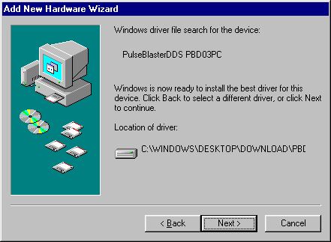
- Windows is now ready to install the PulseBlaster driver. When you see the following screen, click the Next button.

12. Windows will now copy the necessary files to your PC. When the process completes, click Finish.
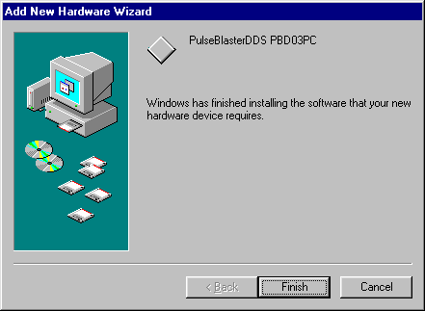

You are now ready to control the PB24 board

For Windows XP

6. After booting, the “Found New Hardware Wizard” should appear. Choose “Install from a list or specific location” and click Next
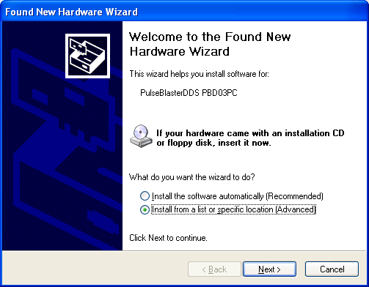

7. Choose “Include this location in the search” and browse to the directory you unzipped the drivers to. Click next.
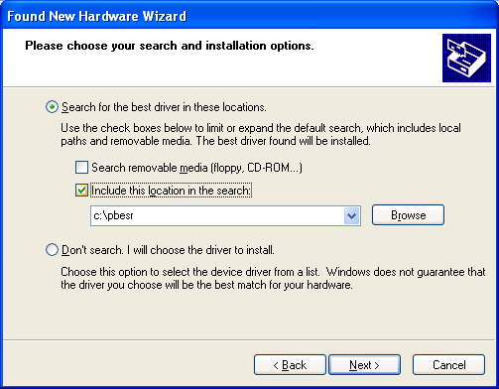
8. While windows installs the driver, a “Files Needed” dialog may pop up. Choose the directory you unzipped the drivers to, and click ok.
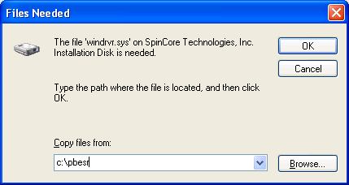

9. When finished, you should see this window.
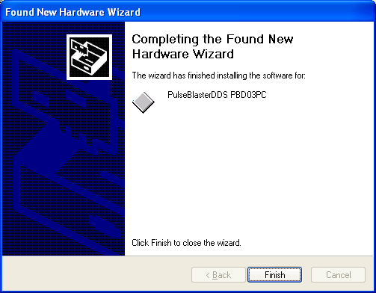

You are now ready to control the PB24 board

Testing Control of the PulseBlaster

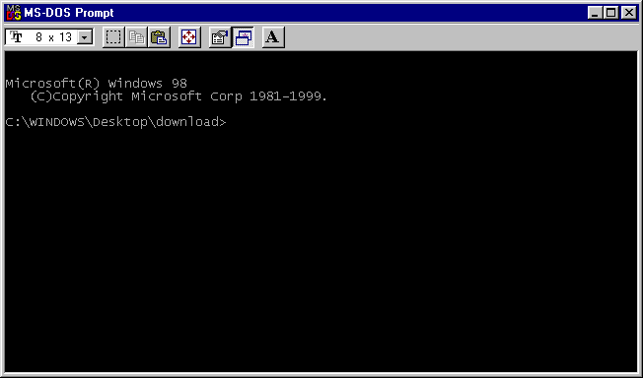
- Open an MS-DOS window in the directory of the unzipped files.

- Run example1.exe. Assuming a 100 MHz clock, all outputs should toggle high for 0.1 s, followed by low for 0.2 s and repeat.
The PulseBlaster board is now ready for use!

III. Programming the PulseBlaster

Instruction Set Architecture

Machine-Word Definition

The PulseBlaster pulse timing and control processor implements an 80-bit wide Very Long Instruction Word (VLIW) architecture. The VLIW memory words have specific bits/fields dedicated to specific purposes, and every word should be viewed as a single instruction of the micro-controller. The maximum number of instructions that can be loaded to on-chip memory is 512 (Model PB24-512, also called the “Internal Memory Model”); the maximum number of instructions that can be loaded to the on-board memory is 32k (Model PB24-32k, also called the “External Memory Model). The execution time of instructions can be varied and is under (self) control by one of the fields of the instruction word – the shortest being five clock cycles for the “Internal Memory Model” and nine clock cycles for the “External Memory Model.” All instructions have the same format and bit length, and all bit fields have to be filled. Figure 2 shows the fields and bit definitions of the 80-bit instruction word.

Bit Definitions for the 80-bit Instruction Word (VLIW)

Output/Control Word | Data Field | OP Code | Delay Count
(24 bits) (20 bits) (4 bits) (32 bits)

Figure 2: Bit definitions of the 80-bit instruction/memory word

Breakdown of 80-bit Instruction Word

The 80-bit VLIW is broken up into 4 sections

1. Output Pattern and Control Word - 24 bits
2. Data Field - 20 bits
3. OP Code - 4 bits
4. Delay Count - 32 bits.

Output Pattern and Control Word

Please refer to Table 1 for output pattern and control bit assignments of the 24-bit output/control word.

Bit # | Output Connector Label | Bit # | Output Connector Label
23 | Flag16..23 Out pin 15 | 11 | Flag0..15 Out pin 5
22 | Flag16..23 Out pin 13 | 10 | Flag0..15 Out pin 18
21 | Flag16..23 Out pin 11 | 9 | Flag0..15 Out pin 19
20 | Flag16..23 Out pin 9 | 8 | Flag0..15 Out pin 7
19 | Flag16..23 Out pin 7 | 7 | Flag0..15 Out pin 8
18 | Flag16..23 Out pin 5 | 6 | Flag0..15 Out pin 21
17 | Flag16..23 Out pin 3 | 5 | Flag0..15 Out pin 22
16 | Flag16..23 Out pin 1 | 4 | Flag0..15 Out pin10
15 | Flag0..15 Out pin 2 | 3 | Flag0..15 Out pin 11
14 | Flag0..15 Out pin 15 | 2 | Flag0..15 Out pin 24
13 | Flag0..15 Out pin 16 | 1 | Flag0..15 Out pin 25
12 | Flag0..15 Out pin 4 | 0 | Flag0..15 Out pin 13
Table 1: Output Pattern and Control Word Bits

Data Field and Op Code

Please refer to Table 2 for information on the available operational codes (OpCode) and the associated data field functions (the data field's function is dependent on the Op Code)

Op Code # | Inst | Inst_data | Function
0 | CONTINUE | Ignored | Program execution continues to next instruction
1 | STOP | Ignored | Stop execution of program (*Note all TTL values remain from previous instruction, and analog outputs turn off)
2 | LOOP | Number of desired loops. This value must be greater than or equal to 1. | Specify beginning of a loop. Execution continues to next instruction. Data used to specify number of loops
3 | END_LOOP | Address of beginning of loop | Specify end of a loop. Execution returns to begging of loop and decrements loop counter.
4 | JSR | Address of first subroutine instruction | Program execution jumps to beginning of a subroutine
5 | RTS | Ignored | Program execution returns to instruction after JSR was called
6 | BRANCH | Address of next instruction | Program execution continues at specified instruction
7 | LONG_DELAY | Number of desired loops. This value must be greater than or equal to 2. | For long interval instructions. Data field specifies a multiplier of the delay field. Execution continues to next instruction
8 | WAIT | Ignored | Program execution stops and waits for software or hardware trigger. Execution continues to next instruction after receipt of trigger. The latency is equal to the delay value entered in the WAIT instruction line plus a fixed delay of 6 clock cycles.
Table 2: Op Code and Data Field Description

Delay Count

The value of the Delay Count field (a 32-bit value) determines how long the current instruction should be executed. The allowed minimum value of this field is 0x00000002 for PB24-512 and 0x00000006 for
PB24-32K and the allowed maximum is 0xFFFFFFFF. The timing controller has a fixed delay of three clock cycles and the value that one enters into the Delay Count field should account for this inherent delay.

Using C Functions to Program the PulseBlaster

A series of functions have been written to control the board and facilitate the construction of pulse program instructions.

In order to use these functions, the DLL (pbd03pc.dll), the library file (pbd03pc.lib), the header files (pbd03pc.h and pbdfuncs.h), and source file (pbdfuncs.cpp) must be in the working directory of your C compiler.

int pb_init();
Initializes PulseBlaster board. Needs to be called before calling any functions using the PulseBlaster. Returns a negative number on an error or 0 on success.

int pb_close();
Releases PulseBlaster board. Needs to be called as last command in pulse program. Returns a negative number on an error or 0 on success.

void set_clock(double clock_freq);

Used to set the clock frequency of the board. The variable clock_frequency is specified in MHz when no units are entered. Valid units are MHz, kHz, and Hz. The default clock value is 50MHz. You only need to call this function if you are not using a –50 board.

int start_programming(int device);

Used to initialize the system to receive programming information. It accepts a parameter referencing the target for the instructions. The only valid value for device is PULSE_PROGRAM, It returns a 0 on success or a negative number on an error.

int pb_inst(int flags, int inst, int inst_data, double length);

Used to send one instruction of the pulse program. Should only be called after start_programming(PULSE_PROGRAM) has been called. It returns a negative number on an error, or the instruction number upon success. If the function returns –99, an invalid parameter was passed to the function. Instructions are numbered starting at 0.

int flags – determines state of each TTL output bit. Valid values are 0x000000 to 0xFFFFFF. For example, 0x000010 would correspond to bit 5 being on, and all other bits being off.

int inst – determines which h type of instruction is to be executed. Please see Table 2 for details.

int inst_data – data to be used with the previous inst field. Please see Table 2 for details.

int length – duration of this pulse program instruction, specified in nanoseconds. The duration of the
instruction can be specified in seconds, milliseconds, or microseconds by multiplying the value by the predefined constants s, ms, or us, respectively.

int stop_programming();

Used to tell that programming the board is complete. Board execution cannot start until this command is received. It returns a 0 on success or a negative number on an error.

int start_pb();

Once board has been programmed, this instruction will start execution of pulse program. It returns a 0 on success or a negative number on an error.

int stop_pb();

Stops output of board. Analog output will return to ground, and TTL outputs will remain in the state they were in when stop command was received. It returns a 0 on success or a negative number on an error.

int status_readback();

Reads the status of the board and returns a number whose bit representation corresponds to the status signals described in section IV. Bit zero is stopped; bit one is reset; bit two is running; bit three is waiting.

Example Use of C Functions

// Filname: Example1.cpp
//
// SpinCore Technologies, Inc.
// February 2004
// http://www.spincore.com
//

// The following program code uses C Functions from 'pbdfuncs' to
// generate and execute a pulse sequence on the PB24 board.

// Be sure to include the DLL (pbd03pc.dll), the library file
// (pbd03pc.lib), the header files (pbd03pc.h and pbdfuncs.h), and source
// file (pbdfuncs.cpp) in the working directory of your C compiler .

#include <stdio.h>
#include "pbdfuncs.h"
#include "pbdfuncs.cpp"

void main(void)
{

set_clock(100); // Set to 100 if the Board Operates at 100 MHz

//locate and initialize the board
pb_init();

int start;

start_programming(PULSE_PROGRAM); // Prepare the Board to Receive

// Instruction 0 - Continue to instruction 1 in .1s
// Flags = 0xFFFFFF, OPCODE = CONTINUE
start = pb_inst(0xFFFFFF, CONTINUE, 0, .1*s);

// Instruction 1 - Continue to instruction 2 in .1s
// Flags = 0x0, OPCODE = CONTINUE
pb_inst(0x0, CONTINUE, 0, .1*s);

// Instruction 2 - Branch to "start" (Instruction 0) in .1s
// 0x0, OPCODE = BRANCH, Target = start
pb_inst(0x0, BRANCH, start, .1*s);

stop_programming();

start_pb();

//read the status register
int status = read_status();
printf("status: %d", status);

pb_close();
}

A more complex program using C Functions is provided in Appendix I.

IV. Connecting to the PulseBlaster Board

Connector Information

DB25 Bracket Connector Flag 0..15 - Pin Assignments

Outputs TTL signals generated by the user’s Program. Please consult the table below for bit assignments.

Pin Assignments
Pin# | Bit# | Pin# | Bit#
1 | GND | 14 | GND
2 | Bit 14 | 15 | Bit 15
3 | GND | 16 | Bit 13
4 | Bit 12 | 17 | GND
5 | Bit 11 | 18 | Bit 10
6 | GND | 19 | Bit 9
7 | Bit 8 | 20 | GND
8 | Bit 7 | 21 | Bit 6
9 | GND | 22 | Bit 5
10 | Bit 4 | 23 | GND
11 | Bit 3 | 24 | Bit 2
12 | GND | 25 | Bit 1
13 | Bit 0

Table 3: Output bits and signals of the PulseBlaster

IDC Connector Flag16..23 - Pin Assignments

The IDC connector labeled Flag 23..23 outputs TTL signals generated by the user’s program. Please consult the table below for pin assignments.

Pin Assignments
Pin# |  | Pin#
1 | Bit 16 | 9 | Bit 20
2 | GND | 10 | GND
3 | Bit 17 | 11 | Bit 21
4 | GND | 12 | GND
5 | Bit 18 | 13 | Bit 22
6 | GND | 14 | GND
7 | Bit 19 | 15 | Bit 23
8 | GND | 16 | GND
Table 4: Output bits and signals of the PulseBlaster

IDC Connector Status - Pin Assignments

The IDC connector labeled Status outputs TTL signals based on status of the user’s program. Please consult the table below for pin assignments.

Pin Assignments
Pin# |  | Pin#
1 | Stopped | 6 | GND
2 | GND | 7 | Waiting
3 | Reset | 8 | GND
4 | GND | 9 | Reserved
5 | Running | 10 | GND

Table 5: Status signals of the PB24

The status pins correspond to the current state of the pulse program and are defined as follows:

Stopped – Driven high when the PulseBlaster device has encountered a STOP Op Code during program execution and has entered a stopped state.

Reset – Driven high when the PulseBlaster device is in a RESET state and must be reprogrammed before code execution can begin again.

Running – Driven high when the PulseBlaster device is executing a program. It is low when the PulseBlaster enters either a reset or idle state.

Waiting – the PulseBlaster device has encountered a WAIT Op Code and is waiting for the next trigger (either hardware or software) to resume operation.

Header JP100

This is an input connector, for hardware triggering (HW_Trigger) and resetting (HW_Reset).

HW_Trigger is pulled high by default, and pin 1 is active (pin 2 = GND). When a falling edge is detected (e.g., when shorting pins 1-2), it initiates code execution. This trigger will also restart execution of a program from the beginning of the code if it is detected after the design has reached an idle state. The idle state could have been created either by reaching the STOP Op Code of a program, or by the detection of the HW_Reset signal. When the WAIT Op Code is used in the pulse program, the HW_Trigger will cause the program to continue to the next instruction.

HW_Reset is pulled high by default, and pin 3 is active (pin 4 = GND). It can be used to halt the fexecution of a program by pulling it low (e.g., by shorting pins 3-4). When the signal is pulled low during the execution of a program, the controller resets itself back to the beginning of the program. Program execution can be resumed by either a software start command or by a hardware trigger.

SMA Connector Clock_Out

This SMA connector outputs the reference clock as a 3.3 V TTL signal, i.e., it generates positive- only voltage. The output resembles a square wave if properly terminated. This signal can be measured with an oscilloscope using either a high impedance probe at the SMA connector or a 50 ohm coaxial line that is terminated.

SMA Connector Ext_Clk

This SMA connector can be used to input an external clock signal. Extreme care should be excercised, and certain conditions have to be met prior to using this connector. First, before attaching any external clock source, the internal clock oscillator must be removed from its socket. The internal clock oscillator’s orientation should be noted - if the internal clock is reconnected, it must be inserted in the same orientation or board damage may occur. Second, the external clock signal must be 3.3 V TTL, i.e., a positive-only voltage - any negative voltage at the Ext_Clk connector will damage the programmable-logic processor chip. Third, as the Ext-Clk connector is not terminated on the printed circuit board, a 50 ohm terminating resistor should be used externally via a T connector placed directly at the SMA Ext_Clk connector. Alternatively, a 50 ohm resistor could be soldered on the board on R401 pads.

Appendix I: Sample C program

Example Program

// Filname: Example2.cpp
//
// SpinCore Technologies, Inc.
// February 2004
// http://www.spincore.com
//

// The following program code uses C Functions from 'pbdfuncs' to
// generate and execute a pulse sequence on the PB24 board.

// Be sure to include the DLL (pbd03pc.dll), the library file
// (pbd03pc.lib), the header files (pbd03pc.h and pbdfuncs.h), and source
// file (pbdfuncs.cpp) in the working directory of your C compiler .

#include <stdio.h>
#include "pbdfuncs.h"
#include "pbdfuncs.cpp"

void main(void)
{

if (pb_init() != 0)
printf("--- Error Initializing PulseBlaster ---\n");

// Check for proper initialization of PulseBlaster

// Set clock frequency
set_clock(100);

//Begin pulse program
start_programming(PULSE_PROGRAM);

int start, loop, sub; // define instruction labels

sub = 5; // Since we are going to jump forward in our program, we need to
// define this variable by hand. Instructions start at 0 and count up

//Instruction format
//int pb_inst(int flags, int inst, int inst_data, int length)

// Instruction 0 - Jump to Subroutine at Instruction 4 in 1s
start = pb_inst(0xFFFFFF,JSR, sub, 1 * s);

// Instruction 1 - Beginning of Loop (Loop 3 times). Continue to next
instruction in 1s
loop = pb_inst(0x0,LOOP,3,1 * s);

// Instruction 2 - End of Loop. Return to beginning of loop or continue to
next instruction in .5 s

pb_inst(0x0,END_LOOP,loop,50 * ms);

// Instruction 3 - Stay here for (5*100ms) then continue to Instruction 4
pb_inst(0x0,LONG_DELAY,5, 100 * ms);

// Instruction 4 - Branch to "start" (Instruction 0) in 1 s
pb_inst(0x0,BRANCH,start,1*s);

// Instruction 5 - Continue to next instruction in 1 * s
pb_inst(0x0,CONTINUE,0,1*s);

// Instruction 6 - Return from Subroutine to Instruction 1 in .5*s
pb_inst(0xFFFFFF,RTS,0,.5*s);

// End of programming registers and pulse program
stop_programming();

// Start execution of the pulse program
start_pb();

//read the status register
int status = read_status();
printf("status = %d", status);

pb_close();

}

Appendix II: Programming the PulseBlaster Using Direct Outputs

If you do not wish to use the provided C functions, you can take advantage of the PBD03PC_outp() function in your own applications. An explanation of using this function to program the board is included below.

Using DLL Functions to Send Instructions

The provided driver DLL, pbd03pc.dll, provides three functions necessary for programming the PulseBlaster:

int PBD03PC_Init();

This function locates and initializes the PulseBlaster PCI board. It returns a 0 upon successful completion, or a negative number for an error.

int PBD03PC_outp(unsigned short address, int data);

This function sends 8 bits of data to the PCI board, at a specified address offset. (Only the lowest 8 bits of the integer value are sent)

int PBD03PC_Close();

This function releases control of the PulseBlaster PCI board. It returns a 0 upon successful completion, or a negative number for an error.

Building Instructions Using the DLL Functions

- To send instructions to the PulseBlaster, the programmer must first call the PBD03PC_Init() function to locate and initialize the PulseBlaster for sending instructions
- Instructions are then build using the PBD03PC_outp(unsigned short address, int data) function, 8 bits at a time. For example, 10 PBD03PC_outp function calls are made to construct one 80-bit instruction in accordance with the Instruction Set Architecture
- Finally, the PBD03PC_Close() instruction is called to signal an end to programming, and to release control of the PulseBlaster.

Programming Information

Initialization of the PulseBlaster for operation involves a minimum of four steps. The steps are as follows:

- Send LOAD NUMBER OF BYTES PER WORD instruction.
- Send SELECT PERIPHERAL DEVICE instruction.
- Send CLEAR ADDRESS COUNTER instruction.
- Loading data to memory.*
- Send PROGRAMMING FINISHED instruction.

* Once the board has been programmed, this step is optional. If you are just restarting the pulse program after a STOP command or an HARDWARE_RESET has stopped the program, you can skip this step during re-initialization.

If these five commands are not sent from a PC, the PulseBlaster will not run as desired. All five instructions are required as an attempt to ensure that the device has been programmed before it can be armed. The first time the system is used, the loading of the memory with data has to be performed. Upon reset, four instructions must be executed to restart the device again.

WE for Peripherals: This register is used to select the peripheral that is to be programmed. The value of this register that is used to select program memory is always zero and this is the default value for the register. A complete listing of the values and the associated hardware that can be programmed when appropriately set is listed below in Table A1.1. By selecting 0xFF for this value, no device is selected and the initial value of the output flags may be set. (*Note that the clock signal to the FF must still be transitioned, which may be accomplished by writing to the base output port + 5 twice in succession.)
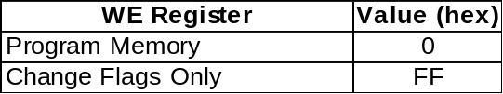
Table A1.1: Peripheral List

CLEAR ADDRESS COUNTER: The Address Counter is used to manufacture the memory address. The Address Counter is not loadable; it can only be cleared and started at zero. It is not possible to load a particular section of memory. All loads must start from either the beginning of memory, or wherever the Address Counter left off.

Flag Initialization Strobe: The output flags of the PulseBlaster can be programmed while the device is in a reset state. This is useful to initialize flags after powering-up and to reset flags to a known state if a program must be aborted. Writing to the Flag Initialization Strobe register will toggle the line used to clock data into the output latches.

LOAD_MEMORY: This instruction is used to specify data that should be used to program the memory used by the device. Since the incoming data is taken only one byte at a time, the IBC must reconstruct the data word to be programmed. The data word is reconstructed in the IBC most significant byte first.

PROGRAMMING FINISHED: This instruction enables the pattern generator of the PulseBlaster. This instruction prevents the pattern generator from accepting a hardware trigger or software start command before the device has been programmed. Once the design has been programmed, the PROGRAMMING FINISIHED command must be sent to arm the device for operation. After the pattern generator has been armed, any hardware trigger or software start command will cause the system to start operation. The PulseBlaster can be reset by issuing the DEVICE_RESET command. This will internally clear the PROGRAMMING FINISHED instruction and prevent the pattern generator from operating again until the IBC has been re-initialized.

In order to select each of the commands mentioned about, you write to the port base + offset. A table of each offset’s meaning is included below.

Offset | Command | Function
0 | DEVICE_RESET | Stops Pulse Program
1 | DEVICE_START | Starts Pulse Program (only when in initialized state)
2 | SELECT_BPW | Selects number of BPW (10 for instructions)
3 | SELECT_DEVICE | Using Table 2, selects internal device to be programmed
4 | CLEAR_ADDRESS_COUNTER | Resets internal memory address counter
5 | FLAG_STROBE | Strobes output clock signal to preset digital outputs
6 | DATA_TRANSFER | Data to be written to internal device
7 | PROGRAMMING_FINISHED | Sets device in initialized state
Table A1.2: Port Offset Command Functions

Example Program

The following is an example of the output sequence to program the PulseBlaster. You must use the PBD03PC_outp(addr, data) function from the provided DLL in order to use this method.

// Initialization:

PBD03PC_outp(0,0); //(Issue device reset)
PBD03PC_outp(2,4); //(Select number of bytes per word)
PBD03PC_outp(3,0xFF); //(Select device to program (Flag initial values))
PBD03PC_outp(4,0); //(Reset address counter)

// Set initial flag values
// Values for this example are "0x000000f0"

PBD03PC_outp(6,0); //(Data transfer)
PBD03PC_outp(6,0); //(Data transfer)
PBD03PC_outp(6,0); //(Data transfer)
PBD03PC_outp(6,0xF0); //(Data transfer)

PBD03PC_outp(5,0); //(Clock data into external buffer)
PBD03PC_outp(5,0); //(Return clock signal to low)

// Pulse Program Setup

PBD03PC_outp(0,0); //(Issue Device Reset)
PBD03PC_outp(2,10); //(Select number of bytes per word)
PBD03PC_outp(3,0); //(Select device to program (RAM))
PBD03PC_outp(4,0); //(Reset address counter)

//Send pulse program
PBD03PC_outp(6,0x18); //(Byte 9 of first instruction)
PBD03PC_outp(6,0xFF); //(Byte 8 of first instruction)
PBD03PC_outp(6,0xFF); //(Byte 7 of first instruction)
PBD03PC_outp(6,0x00); //(Byte 6 of first instruction)
PBD03PC_outp(6,0x00); //(Byte 5 of first instruction)
PBD03PC_outp(6,0x00); //(Byte 4 of first instruction)
PBD03PC_outp(6,0x00); //(Byte 3 of first instruction)
PBD03PC_outp(6,0x00); //(Byte 2 of first instruction)
PBD03PC_outp(6,0x00); //(Byte 1 of first instruction)
PBD03PC_outp(6,0x07); //(Byte 0 of first instruction)

PBD03PC_outp(6,0xXX); //(Byte 9 of second instruction)

/*
Continue this process for all instructions. The
explanation of how to create the 80 bit instruction
words is explained in the “Programming the PulseBlaster
secion of this manual. When finished with all
instructions, continue with the sequence below.
*/

PBD03PC_outp(7,0); //(Programming Finished)

/*
Only execute the following command when you are ready
for the program to start running.
*/

PBD03PC_outp(1,0); //(Start pulse program)

Contact Information

Email sales@spincore.com
Web http://www.spincore.com/

Product URL:

http://www.pulseblaster.com/CD/PulseBlaster/PCI/SP2/

These functions and library files have been generated and tested with the MS Visual Studio 6 environment. Support and updated functions/DLLs for other environments may be provided upon request if available.

