Guidelines



**Team: Y2017C-Y1-PR-Team06  
Members: Arthur Kuylaars, Erico Wiggers, Joey Jacobs**

# Programming conventions

|  |  |
| --- | --- |
| Entity kinds | Preview |
| Classes and structs | UpperCamelCase |
| Enums | UpperCamelCase |
| Unions | UpperCamelCase |
| Parameters | a_typeUpperCamelCase |
| Template parameters | a_typeUpperCamelCase |
| Local variables | typeUpperCamelCase |
| Global variables | UpperCamelCase |
| Global functions | UpperCamelCase |
| Class and structs methods | UpperCamelCase |
| Class and struct fields | m_typeUpperCamelCase |
| Class and struct public fields | UpperCamelCase |
| Union members | UpperCamelCase |
| Enum members | E_ALLUPPER |
| Other constants | ALL_UPPER |
| Global constants | ALL_UPPER |
| Namespaces | UpperCamelCase |
| Typedefs | UpperCamelCase |
| Macros | ALL_UPPER |

# Comments

**XML Comments on classes / structs and functions**  
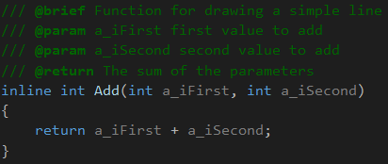

Normal comments on code that requires explanation

# Perforce

After adding a feature try and upload the files that have changed as quickly as possible. This prevents conflicts a lot more. Also don’t upload debug or VisualGDB files unless necessary.