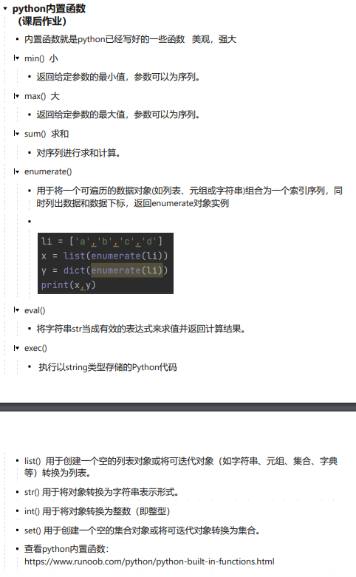

查看python内置函数： **<https://www.runoob.com/python/python-built-in-functions.html>**