Visual Studio package downloads:

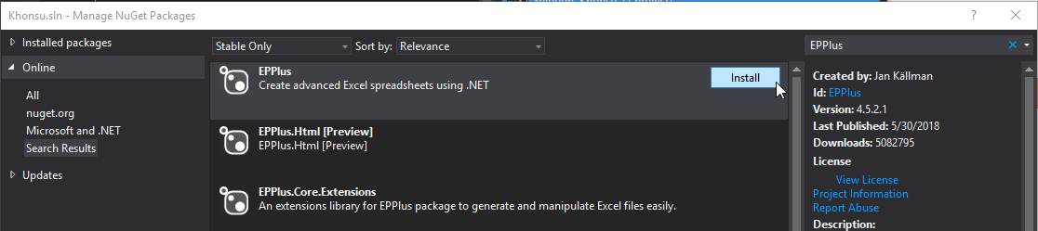

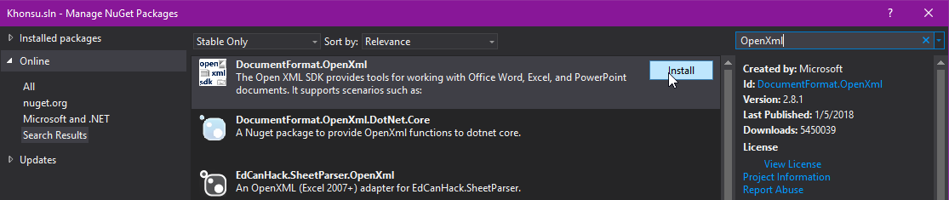

Windows downloads:

