Joseph Fortebuono

Vincent Tobia

William Grant Graney

Aleks Azen

Ken Goydan

Shi Johnson-Bey

**Vision Document**

**Revision History:**

03/13 - Revision 1.0

**Introduction:**

Our client has need for an educational game to inform incoming freshmen about the advisement resources available to them both on campus and online.

**Positioning:**

We are addressing the problem of educating incoming students about the academic resources available to them at the University of Delaware. The office of Student Advisement is the primary entity invested in this product. We intend to educate users of this product about the academic calendar, the professionals available, and how to navigate the tools necessary for their academic success.

**Problem Statement or Opportunity:**

Incoming students at the University of Delaware may need to change a class, a major, or acquire necessary documents for their academic progression. Additionally the aforementioned activities often have strict deadlines that are subject to change each semester. It has become a challenge to educate incoming students, where the solution has traditionally been hands-off and ineffective.

**Key stakeholders:**

Client/Office of Advisement

**Key goals for the users of the product:**

* To ensure the success of incoming students
* To help students learn about available resources
* Ensure students know the critical dates
* Ensure students know how to change their major

**Product Overview:**

Our product will be an interactive and educational game in which new students will learn how to use and access the proper tools in order to be a successful student at the University of Delaware. We plan on making a fun yet informative game that will keep students engaged while teaching them about the dates and resources.

**Solution envisioned:**

The game will be coded in Java, using the libGDX framework. It will feature 2D vector graphics, screenshots, and photos of the University of Delaware campus. Puzzles within the game will be implemented using various data-structures. The game will be structured as an adventure game where each user will navigate the University of Delaware, solving puzzles and answering questions pertaining to advisory tools and critical dates.

**Storyboard/Userstory:**

*As a student, I want to learn about the tools and resources available to me at UD, so that I can successfully complete my degree.*

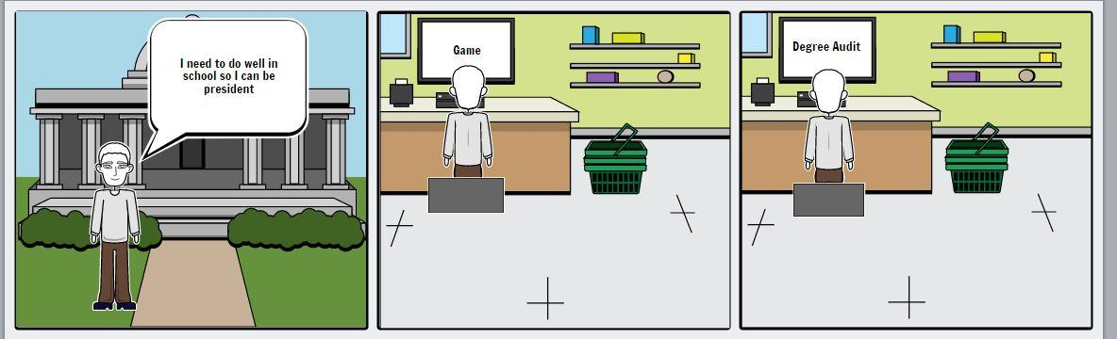

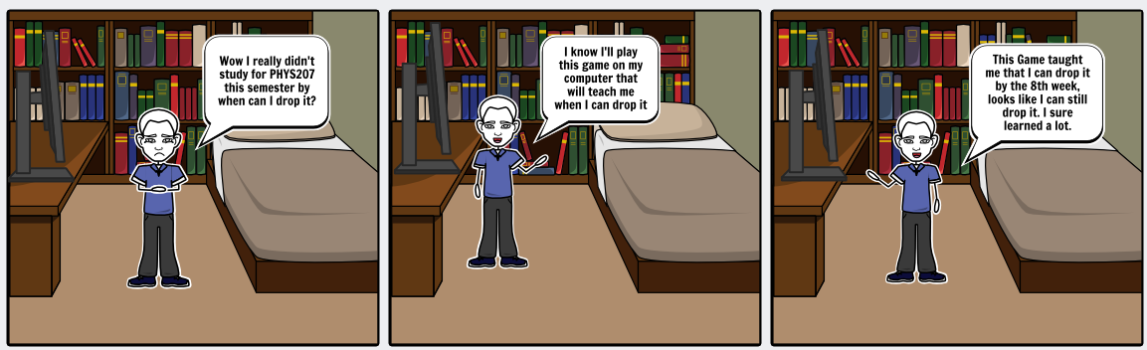

**User Story 1:** As a failing student I want to know when I can drop my class so I don’t lower my GPA.

**User Story 2:** As an indecisive student, I need to know how long I have to decide if I want to be full time or part time.

**User Story 3:** As an ambitious student I want to know about the degree audit so I can add a minor to my degree.

**User Story 4:** As a full time student I want to know where I can get information on degree programs and other stuff so that I can learn about all the University has to offer.

**User Story 5:** As a student I want to know how to register for classes so I can take classes my next semester.

**Summary of key features:**

We plan on implementing several key features to meet our desired requirements. We would like to provide users with an interactive map of the University of Delaware green in which they can enter the different halls. We will provide puzzles and tests to challenge the students knowledge within each hall. These puzzles will be fun yet very educational. In order to give precise data for the advisement office we will build a database to keep track of what question the students get wrong along with other important feedback.

**List key features:**

* Interactive map of the University of Delaware
* Puzzles that provide an interactive experience
* Tests pertaining to student resources and dates
* Quality diagnostic feedback
* Database of user results and records
* Ability to identify individual users