**DEVELOPMENT PLANNING**

**DOCUMENT**

**for**

**Encost Smart Graph Project**

**Version 1.0**

|  |  |  |
| --- | --- | --- |
| **Stu** | **dent** | **Name** |

**Prepared by:**

**SoftFlux Engineer**

**SoftFlux**

**May 4, 2023**

Contents

1 Introduction/Purpose 3

1.1 Purpose 3

1.2 Document Conventions 3

1.3 Intended Audience and Reading Suggestions 3

1.4 Project Scope 3

2 Specialized Requirements Specification 3

3 Product Backlog 4

4 Sprint Details 4

4.1 Sprint #1 *<*Date to Date*>* 4

4.1.1 Product Backlog Items 4

4.1.2 Sprint Tasks 4

4.1.3 Software Design 4

4.1.4 Software Testing 4

4.1.5 Sprint Task Completion 5

4.2 Sprint #2 *<*Date to Date*>* 5

4.2.1 Product Backlog Items 5

4.2.2 Sprint Tasks 5

4.2.3 Software Design 5

4.2.4 Software Testing 5

4.2.5 Sprint Task Completion 5

4.3 Sprint #3 *<*Date to Date*>* 5

4.3.1 Product Backlog Items 5

4.3.2 Sprint Tasks 5

4.3.3 Software Design 5

4.3.4 Software Testing 6

4.3.5 Sprint Task Completion 6

4.4 Sprint #n *<*Date to Date*>* 6

4.4.1 Product Backlog Items 6

4.4.2 Sprint Tasks 6

4.4.3 Software Design 6

4.4.4 Software Testing 6

4.4.5 Sprint Task Completion 6

5 Conclusion 6

Revision History

|  |  |  |  |
| --- | --- | --- | --- |
| Name | Date | Reason for Changes | Version |
|  |  |  |  |
|  |  |  |  |
|  |  |  |  |
|  |  |  |  |
|  |  |  |  |

# Introduction/Purpose

## Purpose

This document is Development Planning Document for the software Encost Smart Graph Project (ESGP) for the company Encost. The purpose of this document is to provide a way to compile all the tasks needed to do and track their progress over the entire software development process.

## Document Conventions

This document uses the following conventions:

* ESGP: Encost Smart Graph Project
* ESHD: Encost Smart Home Dataset
* CSV: Comma-Separated Values
* GSL: Graph Stream Library
* WIP: Work in progress

## Intended Audience and Reading Suggestions

* Project Manager and Product Owner: Uses this document to track the progress of the software development.
* Developer: Uses this document to help implement software and track their progress.

## Project Scope

The ESGP is a software system with aims to enable the Encost smart devices to be visualised in a graph data structure from the command line. With both accessibility to Encost verified users and community users but with restricted access to the software capability. There will be no hardware integration required for the ESGP nor for the testing purposed of the software. SoftFlux is responsible to the software development of the ESGP and the insurance that the software meets the requirements listed in the functional software test plan 5 and the SDS 1.

# Specialized Requirements Specification

Have you found any ambiguities, missing detail, missing features, etc. in the existing documents? Have you discussed them with your client (your lecturers) and received confirmation/clarification? If so, this information should go here.

* Only high priorities features are made in the application. All low or medium priorities could be in the application, but they will not be available to use and will tell the user that it is not available or will only show the high priority part of the feature.
* Updated the software test plan 5 test codes due to various bugs. The updated code should have the same intention as the old codes. Updated the csv files so that the valid ones have the right type. E.g validTest,csv file had device type Washing Machine when it was supposed to be Washing Machine/Dryer.
* Added a parameter to the LoadFeaturesTest java file method as it is impossible to test for inputs without the parameter input and usertype as they have similar inputs, but they do different things.
* Added more methods to device class so that it can have all the device information filled up using the loading dataset csv file and helps assist the building a graph type more.
* For the building a graph data type, I will only made two attributes devices which is the linkedlist and the graph which is graph stream library in SDS 1. I also only made getDevices, addDevice, display, addEdge, getDevicesByCategory, getDevicesByType and getDevicesbyProduct because the device distribution is the only high priority for summary statistics and the other methods are not needed.
* Changed DeviceDistributionTest and added more tests so that it tests categories, type and product name instead of just the type only.

# Product Backlog

Features:

## Categorizing Users:

User stories:

1. Sally Sallyson is one of the Encost Smart Device customers who opted to have their device information recorded *(*see 2.2 in SRS*).*As such, Encost would like for her to be able to view the Encost data. To view the data, Sally needs to be able to indicate that she is an Encost Community User and needs to be prompted by the ESGP feature options.
2. James Wally is one of the Encost employees. He needs to be able to indicate that he is an encost-unverified user and needs to be prompted to ESGP account login.

## ESGP Account Login:

User stories:

1. James Wally is one of the Encost employees. He wants to be able to login with his username and password to to get access to his encost-verified user features.

## ESGP Feature Options:

User stories:

1. Sally Sallyson is one of the Encost Smart Device customers who opted to have their device information recorded *(*see 2.2 in SRS*).*As such, Sally needs to be able to access the displaying graph data and exit options.
2. James Wally is one of the Encost employees. He needs to be able to access the loading custom dataset, displaying graph data, displaying summary statistics and exit options.

## Loading the Encost Smart Homes Dataset:

User stories:

1. As a product owner, I want my encost smart homes dataset to be in the system. I want my system to be able to find the dataset file, extract the relevant data and load it when the software application is opened. I want the dataset file to be a CSV formatted file.

Dataset file example with relevant data:

## Categorising Smart Homes Devices:

User stories:

1. As a product owner, I want my system to be able to categorise each encost smart device into one of the five device categories in the device table after it reads and processes the ESHD. I also want my system to create an object which it can be stored in, and the object should have all the information of the device.

Device table:

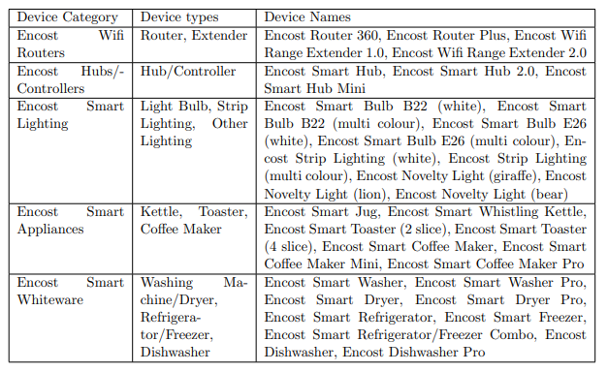

## Building a Graph Data Type

User stories:

1. As a product owner, I want my system to be able store each object in a graph data structure. I want my graph data structure to be able to use for summary statistics and graph visualisation.

## Graph Visualisation

User stories:

1. Sally Sallyson is one of the Encost Smart Device customers who opted to have their device information recorded *(*see 2.2 in SRS*).* Sally needs to be able to view the visualisation of the graph which shows her devices, different colour device categories, the ability to send and receive commands from other devices and the connection of all her devices.

Example of graph visualisation:

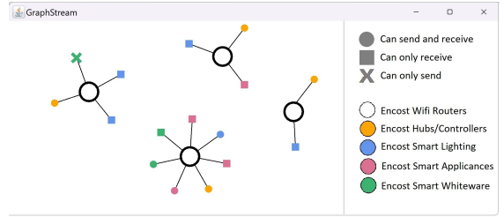

## Calculating Device Distribution

User stories:

1. James Wally is one of the Encost employees. He needs to be able to view distribution of devices across category, type, and name, based on the information stored in the graph data structure using the summary statistics option in the ESGP feature options.

# Sprint Details

## Sprint #1 *<*10/05/2023 7am – 12/05/2023 7am*>*

### Product Backlog Items

1. Sally Sallyson is one of the Encost Smart Device customers who opted to have their device information recorded *(*see 2.2 in SRS*).*As such, Encost would like for her to be able to view the Encost data. To view the data, Sally needs to be able to indicate that she is an Encost Community User and needs to be prompted by the ESGP feature options.
2. James Wally is one of the Encost employees. He needs to be able to indicate that he is an encost-unverified user and needs to be prompted to ESGP account login.
3. James Wally is one of the Encost employees. He wants to be able to login with his username and password to to get access to his encost-verified user features.
4. Sally Sallyson is one of the Encost Smart Device customers who opted to have their device information recorded *(*see 2.2 in SRS*).*As such, Sally needs to be able to access the displaying graph data and exit options.
5. James Wally is one of the Encost employees. He needs to be able to access the loading custom dataset, displaying graph data, displaying summary statistics and exit options.
6. (Added) As a product owner, I want my encost smart homes dataset to be in the system. I want my system to be able to find the dataset file, extract the relevant data and load it when the software application is opened. I want the dataset file to be a CSV formatted file.
7. (Added)As a product owner, I want my system to be able to categorise each encost smart device into one of the five device categories in the device table after it reads and processes the ESHD. I also want my system to create an object which it can be stored in, and the object should have all the information of the device.

### Sprint Tasks

Categorising users:

1. User able to indicate community or encost-unverified user.
2. Prompting user depending on their types.
3. Input validation on back-end.

ESGP account login:

1. Encost user login to be verified.
2. Encost user login validation on back-end.
3. Prompting user for what feature they want to use.

ESGP feature options:

1. Input validation on back-end.
2. Community user able to access their features.
3. Encost user able to access their features.

Loading the ESHD:

1. Error handling and checking.
2. CSV formatted file.
3. Dataset to be extracted and loaded when software application is opened.
4. Adding device object to graph.

Categorising smart homes devices:

1. Sorting each encost smart device object into its own categories.
2. Creating devices class.

### Software Design

Include any design decisions/diagrams/tables etc. that were included as part of this sprint (if any).

SDS for categorising users:

* Changing the Encost User output after the user inputs 2 to be Encost-unverified User.

SDS for ESGP account login:

* Adding a space and brackets besides user_1 which says (Encost-verified User).

SDS for ESGP feature options:

Community User:

Encost User:

### Software Testing

Include proof of tests being passed and/or failed in this sprint (if any).

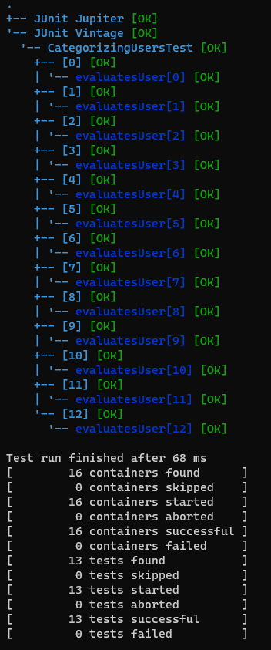

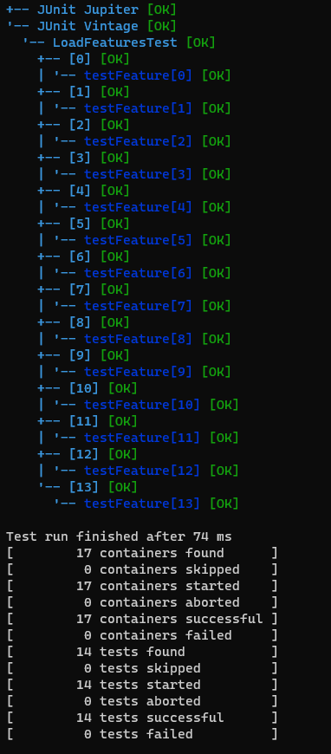

### Sprint Task Completion

* Categorising users: Done
* ESGP account login: Done
* ESGP feature options: Done
* Categorising smart home devices: WIP
* Loading the ESHD: WIP
* Loading the ESHD and Categorising smart home devices is rolled over to next sprint as it needs the building a graph data type to work before it is fully done.

## Sprint #2 *<*12/05/2023 7am – 14/05/2023 7am *>*

### Product Backlog Items

1. As a product owner, I want my encost smart homes dataset to be in the system. I want my system to be able to find the dataset file, extract the relevant data and load it when the software application is opened. I want the dataset file to be a CSV formatted file.
2. As a product owner, I want my system to be able to categorise each encost smart device into one of the five device categories in the device table after it reads and processes the ESHD. I also want my system to create an object which it can be stored in, and the object should have all the information of the device.
3. As a product owner, I want my system to be able store each object in a graph data structure. I want my graph data structure to be able to use for summary statistics and graph visualisation.
4. Sally Sallyson is one of the Encost Smart Device customers who opted to have their device information recorded *(*see 2.2 in SRS*).* Sally needs to be able to view the visualisation of the graph which shows her devices, different colour device categories, the ability to send and receive commands from other devices and the connection of all her devices.
5. James Wally is one of the Encost employees. He needs to be able to view distribution of devices across category, type, and name, based on the information stored in the graph data structure using the summary statistics option in the ESGP feature options.

### Sprint Tasks

Loading the ESHD:

1. Adding device object to graph.

Categorising smart homes devices:

1. Sorting each encost smart device object into its own categories.

Building a graph data type:

1. Adding device object to graph.
2. Making methods to aid in the graph visualisation and summary statistics.

Graph visualisation:

1. Show the graph to the user in the format of the graph visualisation example.

Calculating device distribution:

1. Calculating the device distribution by product category, product type, product name.
2. Displaying it on the console to the user in the format of the device distribution output example.

### Software Design

Graph visualisation example:

Device distribution output example:

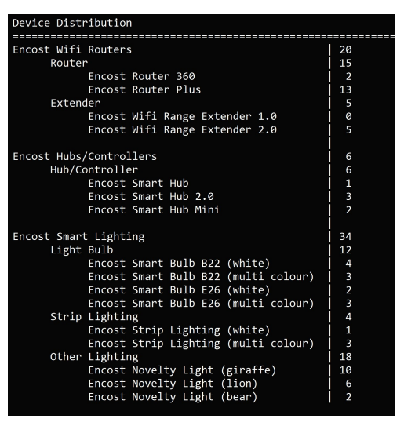

### Software Testing

### Sprint Task Completion

Loading the ESHD: WIP

Building a graph data type: WIP

Graph visualisation: WIP

Calculating device distribution: WIP

All WIP because the testing for all of them weren’t passing the tests.

## Sprint #3 *<*14/05/2023 7am – 16/05/2023 7am *>*

### Product Backlog Items

1. As a product owner, I want my encost smart homes dataset to be in the system. I want my system to be able to find the dataset file, extract the relevant data and load it when the software application is opened. I want the dataset file to be a CSV formatted file.
2. As a product owner, I want my system to be able store each object in a graph data structure. I want my graph data structure to be able to use for summary statistics and graph visualisation.
3. Sally Sallyson is one of the Encost Smart Device customers who opted to have their device information recorded *(*see 2.2 in SRS*).* Sally needs to be able to view the visualisation of the graph which shows her devices, different colour device categories, the ability to send and receive commands from other devices and the connection of all her devices.
4. James Wally is one of the Encost employees. He needs to be able to view distribution of devices across category, type, and name, based on the information stored in the graph data structure using the summary statistics option in the ESGP feature options.

### Sprint Tasks

Loading the ESHD:

1. Adding device object to graph.

Building a graph data type:

1. Adding device object to graph.
2. Making methods to aid in the graph visualisation and summary statistics.

Graph visualisation:

1. Show the graph to the user in the format of the graph visualisation example.

Calculating device distribution:

1. Calculating the device distribution by product category, product type, product name.
2. Displaying it on the console to the user in the format of the device distribution output example.

### Software Design

The software design is in sprint #2.

### Software Testing

MD5 testing for loading the ESHD:

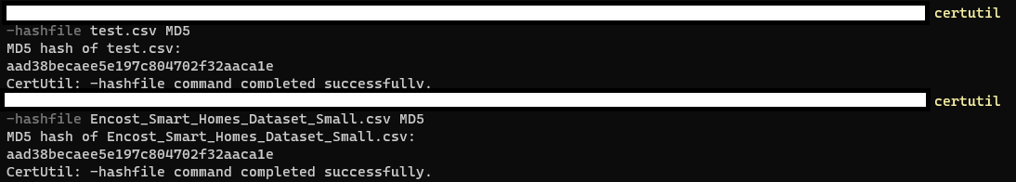

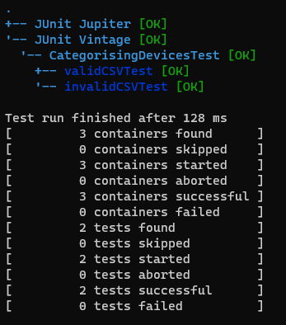

### Sprint Task Completion

Loading the ESHD: Done

Building a graph data type: Done

Graph visualisation: Done

Calculating device distribution: Done

All tasks have now been completed.

# Conclusion

Give a brief written summary of your system. This is a good time to go back through your documents, checking off both the functional and non-functional requirements as you go, to make sure you haven’t missed anything.

The system is now able to:

* categorise users
* account login for encost user
* have feature options for community and encost-verified users
* load the encost smart homes dataset
* categorise smart home devices
* use graph data type for device distribution and graph visualisation
* graph visualisation without formatting
* calculating device distribution and display it as output