

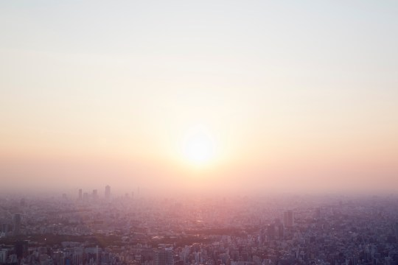

<https://metro.co.uk/2018/06/23/hazy-sunshine-mean-weather-symbol-7654431/>

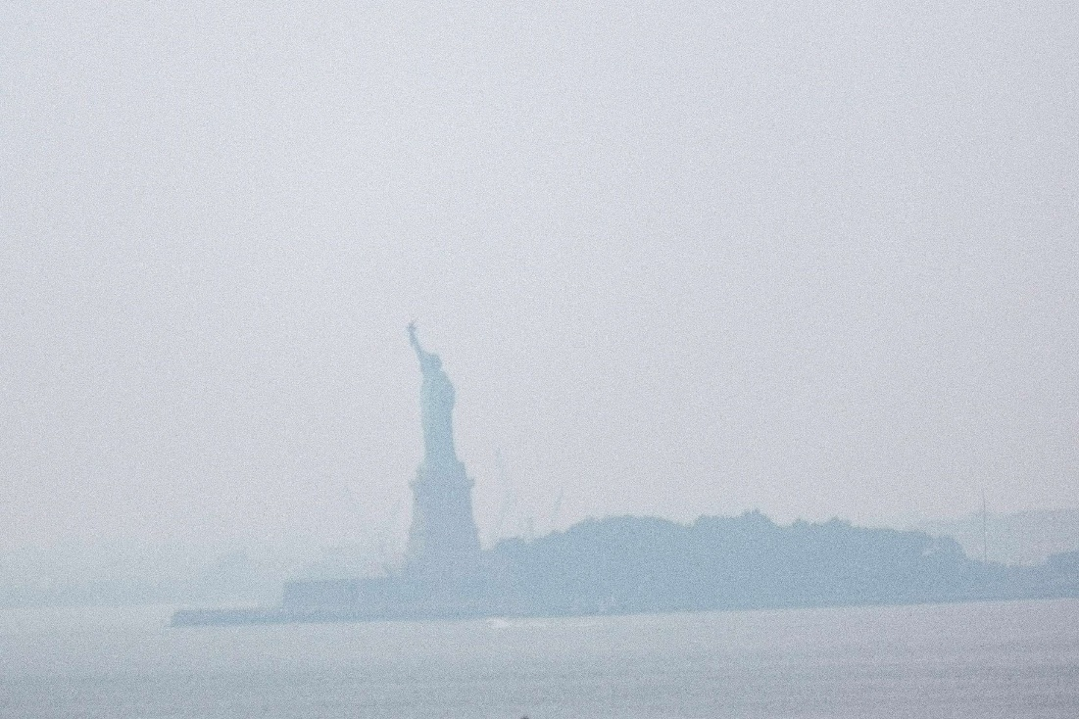

<https://abcnews.go.com/US/us-ominous-hazy-sky-smoke-spreads-western-wildfires/story?id=78948371>

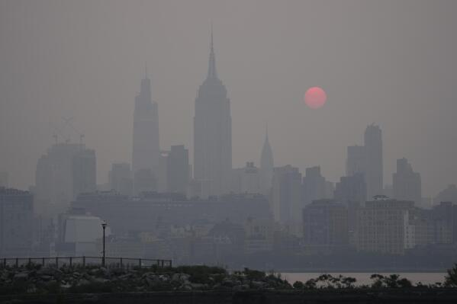

<https://apnews.com/article/wildfire-haze-canada-new-york-washington-0d24be8f977dc3e43fbbf17e363edfed>

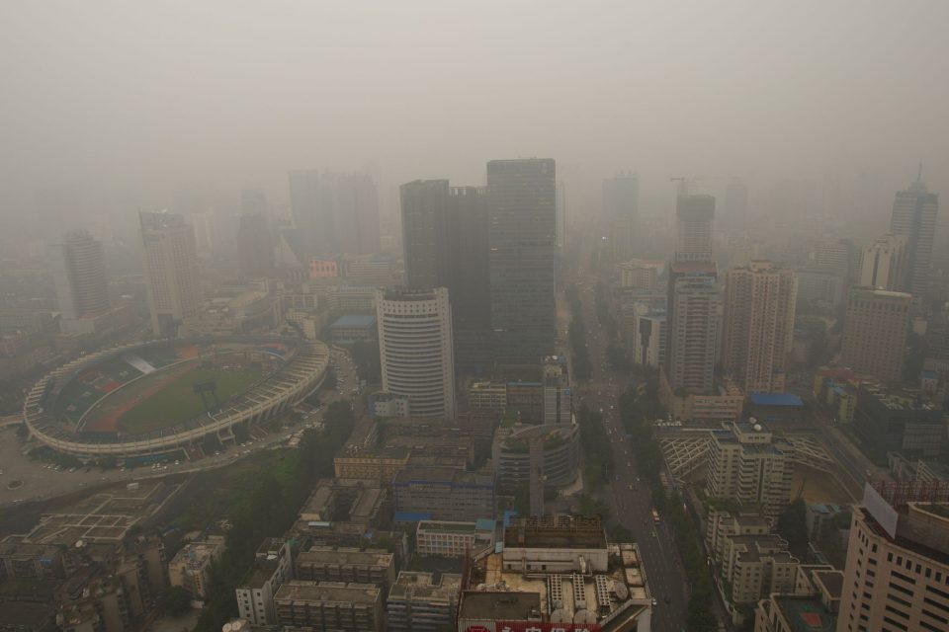

https://www.earth.com/earthpedia-articles/haze/