AnyBlog

Design Document

# Main Page

## Design:

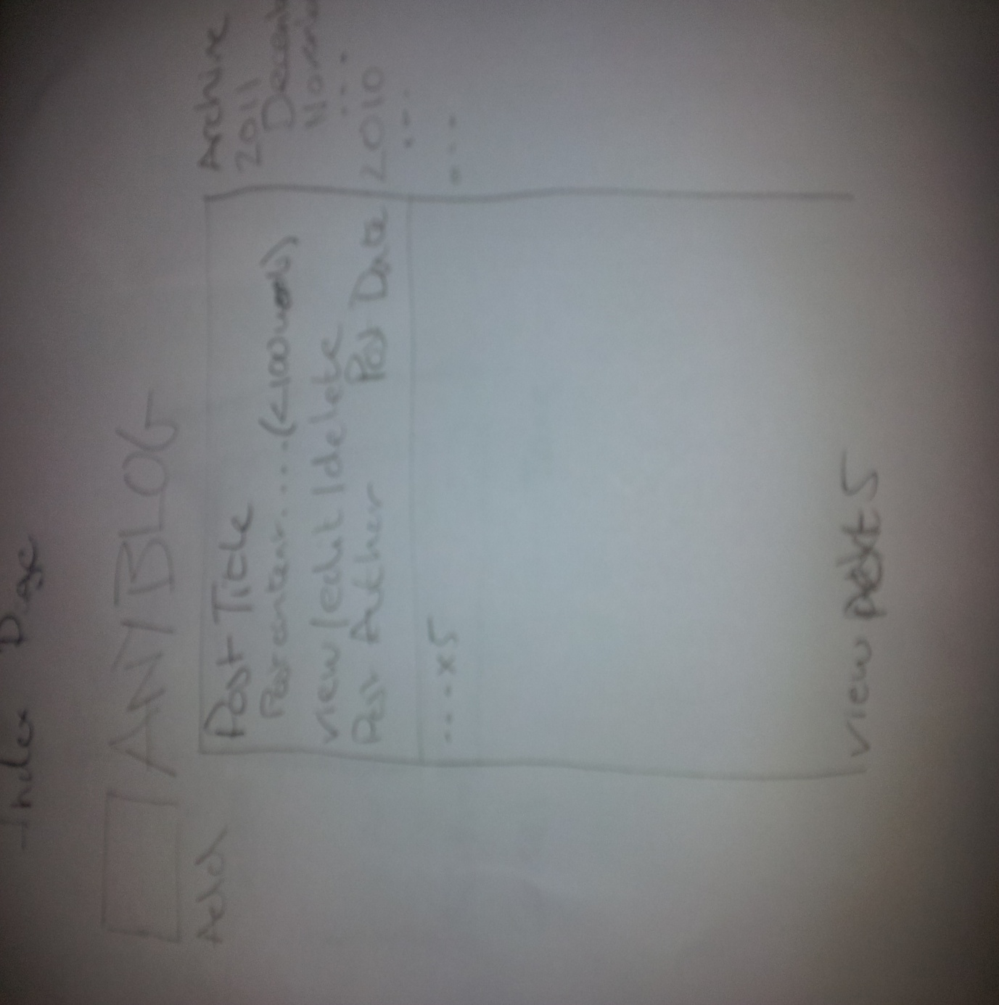

## Behaviours:

Page Title: Clicking the title/logo will reload the main index page

Left Hand Nav:

Add Button: Clicking the button will take the user to the Add/Edit Page

Page Content:

Content:

Displays the last 5 Posts

Post:

Content :

Post Title

Post Date

Post Content (First 100 words)

Post Author

Actions:

View Button: Clicking will take the user to the View Page (This Post)

Edit Button: Clicking will take the user to the Add/Edit Page (This Post)

Delete Button: Clicking will display dialog asking user to confirm deletion. Will delete post if confirmed.

Actions:

View Next 5: Will load the next 5 posts after the current last post displayed.

Right Hand Nav:

Content:

Will display all years and months that have posts associated with them.

Actions:

“Year”: Clicking a year will show/hide the list of months that have posts

“Month”: Clicking a month will take the user to the View Page (All posts for selected month)

# Add/Edit Page

## Design:

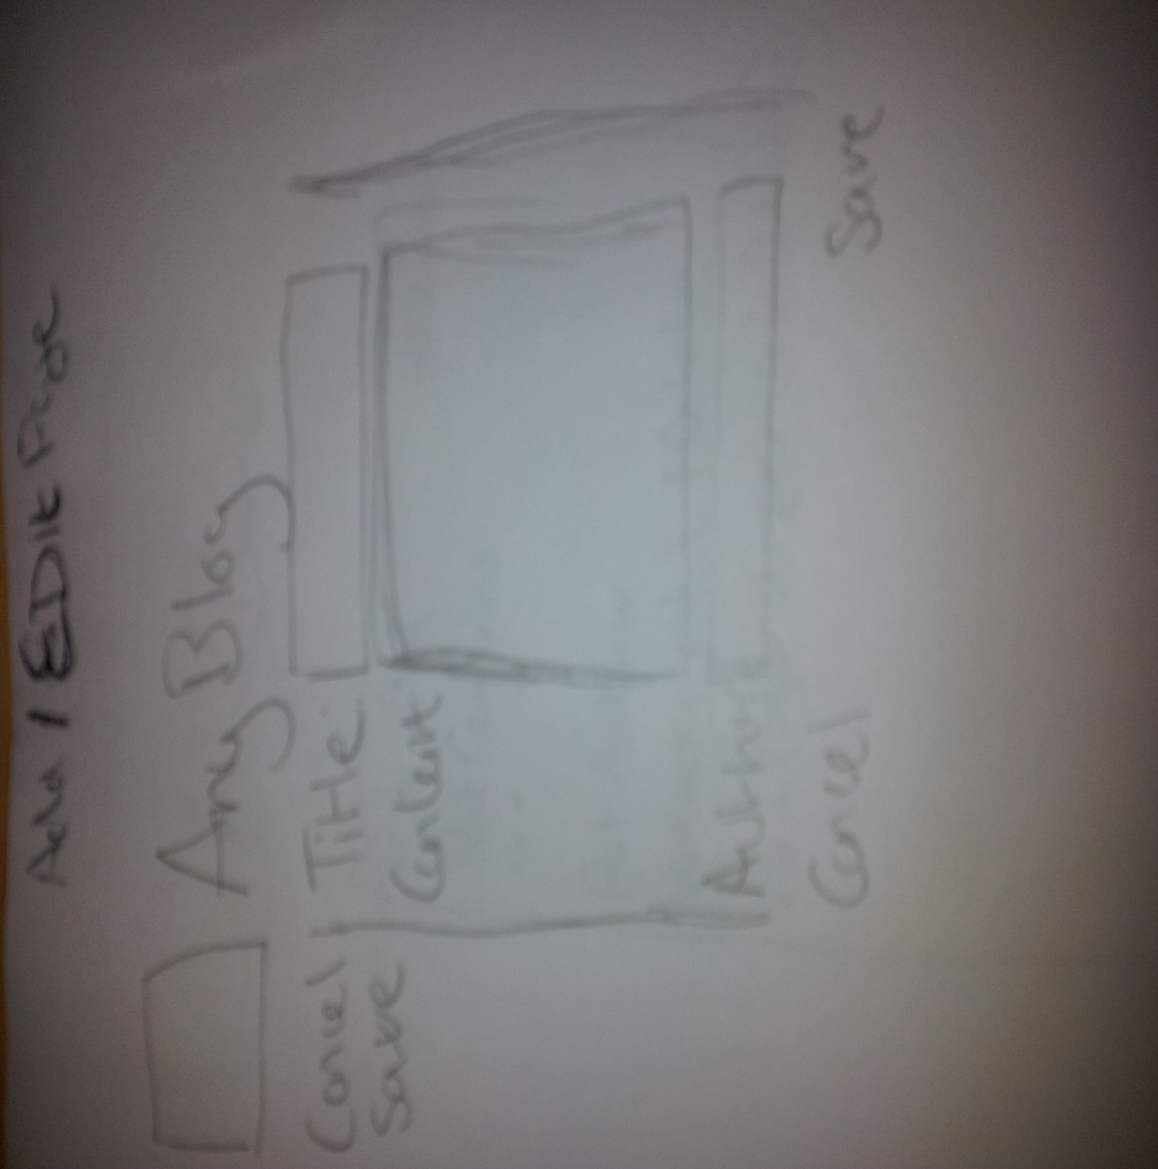

## Behaviours:

Page Title: Clicking the title/logo will reload the main index page

Left Hand Nav:

Cancel Button: Return user to last page

Save Button: Save the current content of the page

Page Content:

Form:

Title: Text input field

Content: Text input field

Author: Text input field

Cancel Button: Return user to last page

Save Button: Save the current content of the page

# View Page

## Design:

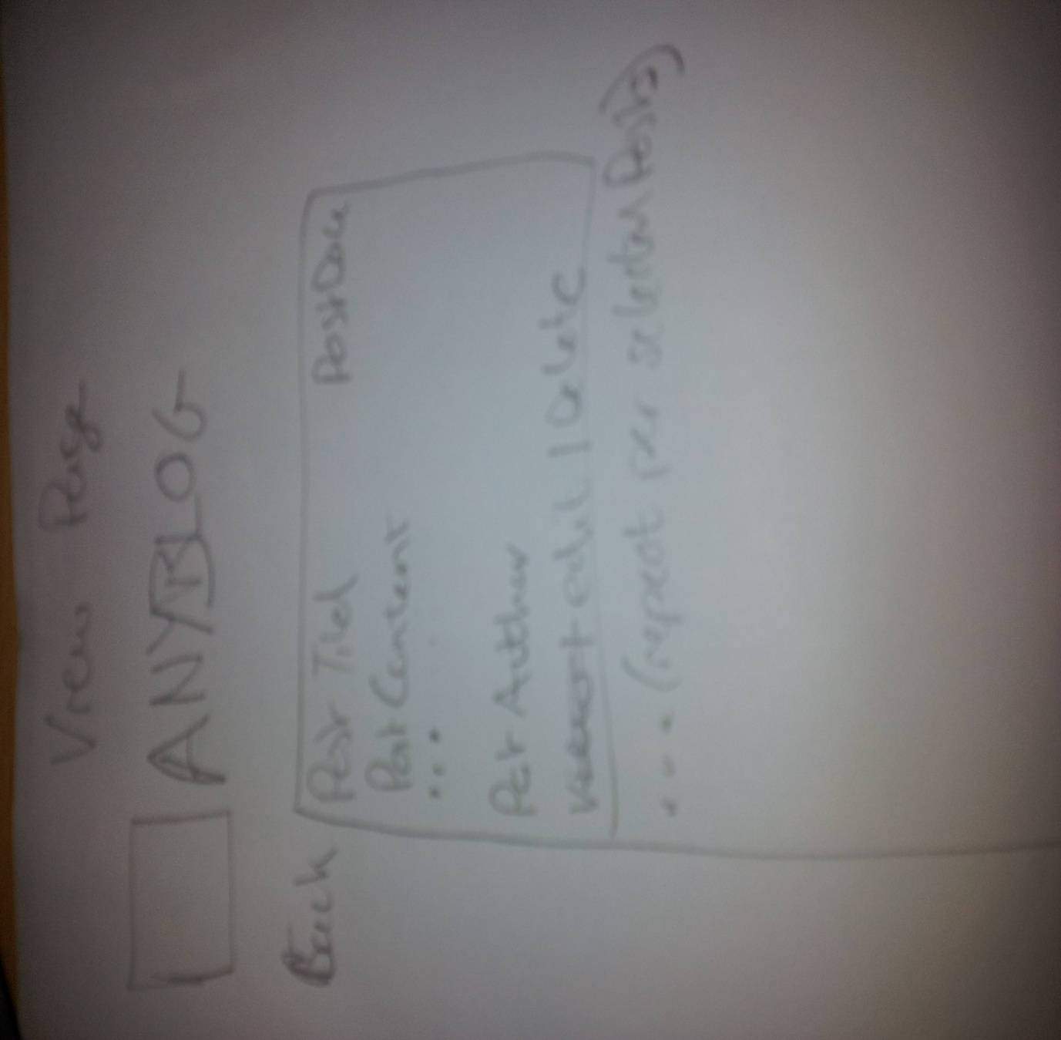

## Behaviours:

Page Title: Clicking the title/logo will reload the main index page

Left Hand Nav:

Back Button: Return user to last page

Page Content:

Content:

Displays specified posts

Post:

Content :

Post Title

Post Date

Post Content

Post Author

Actions:

Edit Button: Clicking will take the user to the Add/Edit Page (This Post)

Delete Button: Clicking will display dialog asking user to confirm deletion. Will delete post if confirmed.