

UVC-LED Water Disinfection System

Installation, Operation & Maintenance Manual
Industrial UVC-LED Inline Water Disinfector Series
B-W10T

Document Rev. 1.3 · June 2026
For installation contractors, operators, and facility maintenance personnel

Bolb Inc.
52 Wright Brothers Avenue, Livermore, CA 94551 USA https://bolb.co/

Table of Contents
Important Notices .............................................................................................. 3
Chapter 1 — System Overview & Pre-Installation ........................................... 4
Chapter 2 — Detailed Installation Procedure .................................................. 8
Chapter 3 — Touchscreen Operation Guide ................................................... 12
Chapter 4 — Startup Operation Steps .............................................................. 23
Chapter 5 — Shutdown Operation Steps ......................................................... 24
Chapter 6 — Operation Norms ......................................................................... 25
Chapter 7 — Routine Maintenance & Functional Checks .............................. 26
Chapter 8 — Safety & Operating Precautions ................................................ 29
Appendices ........................................................................................................ 31

Important Notices
Read this manual completely before installing, operating, or servicing the equipment. Keep this manual readily available for the duration of the equipment's service life.

⚠ UV-C RADIATION HAZARD
Direct exposure to UV-C light can cause severe injury to skin and eyes within seconds. Never look directly at energized LED modules. Always isolate power and verify zero- voltage at the control cabinet before opening any chamber, removing quartz sleeves, or servicing the LED assembly. Wear UV-rated eye and skin protection during inspection.
⚠ ELECTRICAL HAZARD
All electrical connections must be performed by a licensed electrician. Disconnect main power and verify lockout/tagout before any service work. Never operate the control cabinet with wet hands. Independent equipotential grounding with a resistance of 4 Ω or less is required.
Qualified Personnel
Installation, commissioning, and major repair must be performed by trained personnel familiar with industrial water and UV equipment. Unauthorized modification or repair voids the warranty and may create unsafe conditions.

This manual covers the BOLB UVC-LED inline water disinfection systems of flow rates at 10 TPH. The system uses 265–275 nm UV-C light-emitting diodes housed in a 304/316 stainless-steel pressure vessel. The wetted-path materials meet drinking-water contact requirements.

Chapter 1 — System Overview & Pre-Installation

System Description

Operating Principle
The BOLB UVC-LED inline water sterilizer is a high-flow disinfection module that exposes flowing water to germicidal ultraviolet light in the 265–275 nm band. The reactor body is fabricated from stainless steel and meets potable-water contact requirements. UV-C dose is delivered continuously to inactivate bacteria, viruses, and protozoa in a single pass.

Physical Drawings
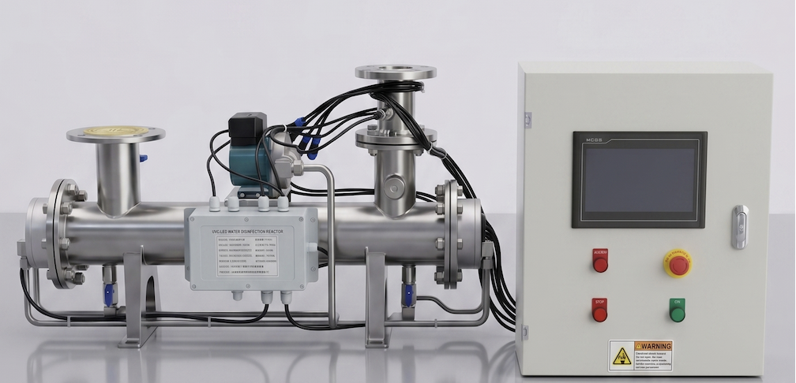
Water Outlet
Cooling Water Pump
Water Inlet
Control Cabinet

Item | Component | Quantity
1 | UVC-LED reactor (sterilizer chamber) | 1
2 | Control cabinet (driver, PLC, HMI) | 1
3 | Reactor-to-cabinet interconnect cable assembly | 1
Customer-Supplied Items
Valves, pipe fittings, gaskets, anchor bolts, and bypass piping are not included with the unit and must be supplied and installed by the customer or contractor.

Technical Specifications

Parameter | Technical Specification
Product Model | B-W10T
Dimensions | 876 × 238 × 365 mm
Rated Input Voltage | AC 200~240V 50Hz
Rated Power | 500W
Rated Flow Rate | 10 T/H
UVC-LED Wavelength Range | 265 ~ 280 nm
Chamber Shell Material | 304 Stainless Steel
Design Working Pressure | < 0.6 MPa
Target Disinfection Rate | ≥ 99.9% (Tested against E. coli)
Inlet Water Temperature Range | 0°C ~ 30°C
Fluid Connection Interface | DN65-PN16 Flange
Deep UV Light Source Lifespan | 20,000 Hours

Site Requirements
Foundation: The reactor must be mounted on a reinforced concrete pad or welded steel frame with a minimum thickness of 200 mm. The base must be level and capable of supporting the filled-equipment weight without deflection.
Enclosure protection: Mount the control cabinet a minimum of 500 mm above finished floor. In high-humidity, washdown, or splash-prone environments, specify a cabinet with a higher IP rating (IP54 or above).
Grounding: An independent equipotential ground bond is required. Ground resistance must be 4 Ω or less. Proper grounding is essential to protect electronics from voltage surges and to maintain personnel safety.

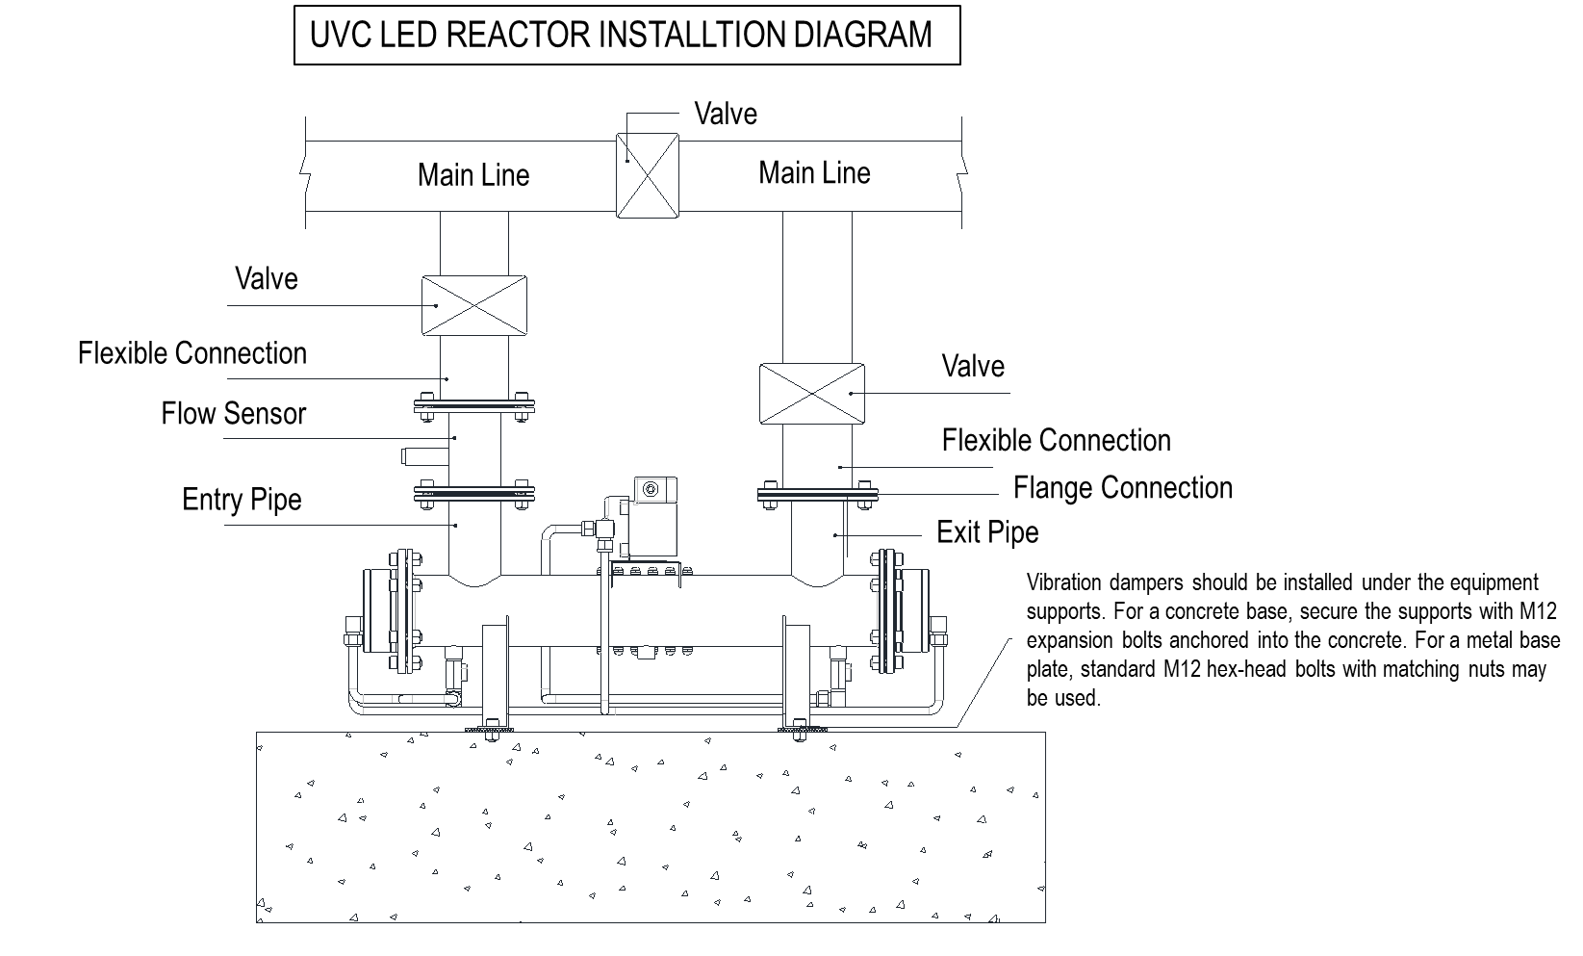

Installation Standards

Why a Bypass Loop is Required
In industrial water service, a bypass loop is not an optional backup — it is a system survivability requirement:
      - Service without supply interruption: the bypass allows the unit to be isolated and serviced offline while the facility continues to receive water through the main line.
      - Reactor protection during commissioning flush: during initial pipe flushing, water may carry dust or residual debris from production, inspection or accumulated during transit. Routing this debris through the bypass line — not through the reactor — prevents scoring of the quartz sleeves and damage to the LED windows.

Key Installation Practices
Valve selection: Use ball valves on the reactor inlet and outlet branches. Ball valves seat tightly and prevent pressurized water from leaking past during service. Use a butterfly valve as the main-line shutoff.
Mechanical stress control: Branch piping must align naturally with the reactor flanges. Never force misaligned flanges together with bolts — this stresses the housing, distorts seals, and shortens service life.
      - Flexible couplings: install metal flex connectors (bellows-type expansion joints) on the inlet and outlet to absorb pipe vibration and minor thermal/dimensional movement.
      - Anti-vibration support: install anti-vibration pads under the reactor support feet to prevent resonant transmission from pumps and piping.
      - Service clearance: maintain at least 500 mm of clear space around the reactor for inspection, quartz-sleeve cleaning, and LED-module replacement.

Chapter 2 — Detailed Installation Procedure
Recommended Piping Configuration
Main line with butterfly shutoff valve, parallel to a reactor branch with ball valves on inlet and outlet, metal flex couplings at both reactor flanges, and a flow meter on the inlet branch. The reactor sits on anti-vibration pads anchored to the foundation with M12 expansion bolts (concrete) or M12 hex bolts (steel frame).

Pre-Installation Site Inspection
Before beginning installation, verify that the site meets the requirements in Section 1.2.
    - Confirm the model number on the control cabinet nameplate matches the model number on the reactor nameplate.
    - Inspect the reactor housing, the inlet/outlet ports, and the cooling-loop connections. Reject any unit showing transit damage, cracked welds, or loose components.
    - Open the control cabinet and confirm there are no loose terminals, dislodged components, or broken devices.

Setting and Anchoring the Reactor
Place high-resilience rubber anti-vibration pads between the reactor support feet and the foundation. Lift the reactor into position over the foundation, align the mounting holes, and anchor with M12 expansion bolts (for concrete) or M12 hex bolts (for steel frame).
Tighten anchor bolts in a diagonal cross-pattern in two passes. Verify the unit is level and shows no rocking before proceeding.

Bypass Piping
Build out the piping per the configuration shown in Chapter 2 introduction. The intent is to create a system that allows full bypass of the reactor without interrupting downstream service.
    - Close the main inlet to the building/process loop.
    - Install the main-line butterfly shutoff valve.
    - Install the reactor inlet and outlet branches, including ball valves on each branch.
    - Mate the branch flanges to the reactor flanges. If the flanges do not align naturally, do not pull them together with bolts. Add metal bellows couplings to take up misalignment, or re-shim the reactor.

Pressure Test and Leak Check
    - Close the main-line shutoff so all flow is directed through the reactor branch.
    - Slowly fill the reactor and bleed off trapped air. Open the LED cooling-pump bleed valve; close it as soon as a steady stream of water (no air bubbles) is observed.

    - Pressurize the system to 1.5 × the design working pressure and hold for 1 hour.
    - Inspect every flange joint, fitting, and threaded connection for visible weeping or leakage. Repair any leak before proceeding.
    - Once the test passes, depressurize to normal operating pressure before beginning electrical work.

Electrical Connections

2.5.1 Power Supply & Control System Check

Before performing any functional commissioning steps, complete a thorough pre-power checks audit:
- Voltage Verification: Confirm that the facility’s main line input voltage matches the equipment’s rated naming parameters exactly (AC 200–240V, 50/60Hz). Ensure the main power supply lines are firmly clamped and that the wire insulation layer shows zero tears or damage.
- Component Functional Check: Open the distribution cabinet door and verify that internal wiring terminal blocks are tight and free of surface oxidation. Inspect the leakage protection breaker, AC relay contactors, and associated control components to confirm normal physical working status.
- Safety Grounding Requirement: The system must be connected to a dedicated, highly reliable main equipment grounding line loop to guarantee complete electrical safety for plant operators.

2.5.2 Mounting the Control Cabinet
    - Wall or Bracket Mounting: Mount the control cabinet securely on a level wall or structural steel support frame.
    - Clearance Height: The bottom of the cabinet enclosure must be positioned a minimum of 500 mm above the finished floor level to prevent water-immersion or splash damage.
    - Environmental Controls: Ensure adequate open clearance around the cabinet perimeter for cooling airflow. Avoid mounting locations exposed to direct sunlight, high ambient heat, or moisture, as excessive temperatures degrade the internal PLC, HMI, and LED drivers over time.

2.5.3 Wiring Procedure
⚠ ELECTRICAL HAZARD > All electrical connections must be performed exclusively by a licensed electrician. Verify that the main facility power source is completely disconnected and that standard Lockout/Tagout (LOTO) protocols are active before opening the enclosure or handling internal terminations. Never operate switches or touch internal components with wet hands.
Important Note: All wiring paths must be executed in strict accordance with the provided B-W10T Control Wiring Diagram or by referencing the Appendix Electrical Schematic. To simplify field deployment, all internal RVV and RVSP interconnecting cable arrays have been fully pre-wired and terminated at the factory prior to delivery. The customer's installation contractor is exclusively responsible for landing the primary incoming facility power feed and system grounding lines.

Step 1: Main Incoming Facility Power Feed
Connect the facility’s main incoming power supply line (AC 200–240V, 50/60Hz) directly to the top line-side terminals of the Leakage Protector Switch (indicated by the black arrow on the cabinet overview):
- Live Line (L): Terminate on the top-left port.
- Neutral Line (N): Terminate on the top-right port.

Step 2: Main System Grounding

Terminate the incoming facility power ground wire onto the primary equipment ground landing spot on the first terminal block track (indicated by the yellow arrow).
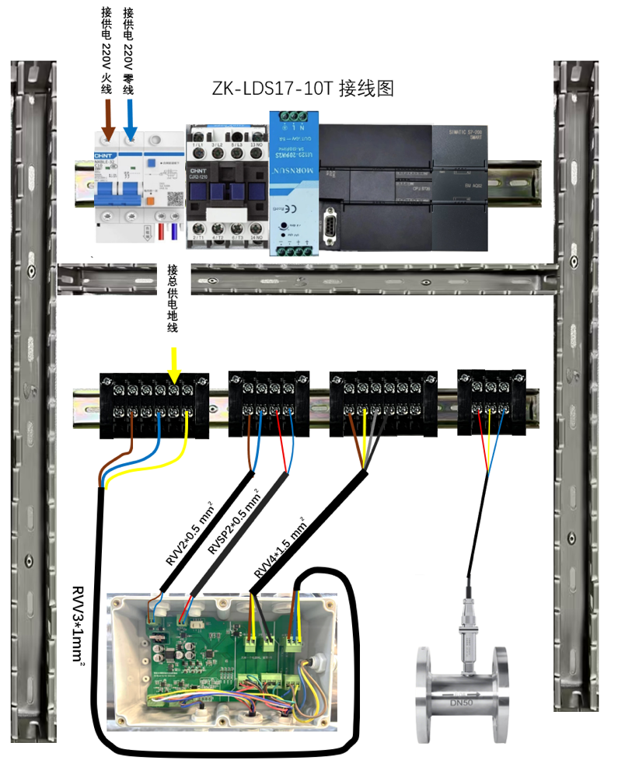
CRITICAL SAFETY REQUIREMENT: Bond the system to a dedicated, independent equipotential ground loop. Using a certified multimeter, verify that the total ground loop resistance reads 4 Ω or less.
Connect Main Power 220V Live Line (L)

Connect Main Power 220V Nature Line (N)

Leakage Protector Switch
B-W10T Wiring Diagram

Connect Ground Line (PE/GND)

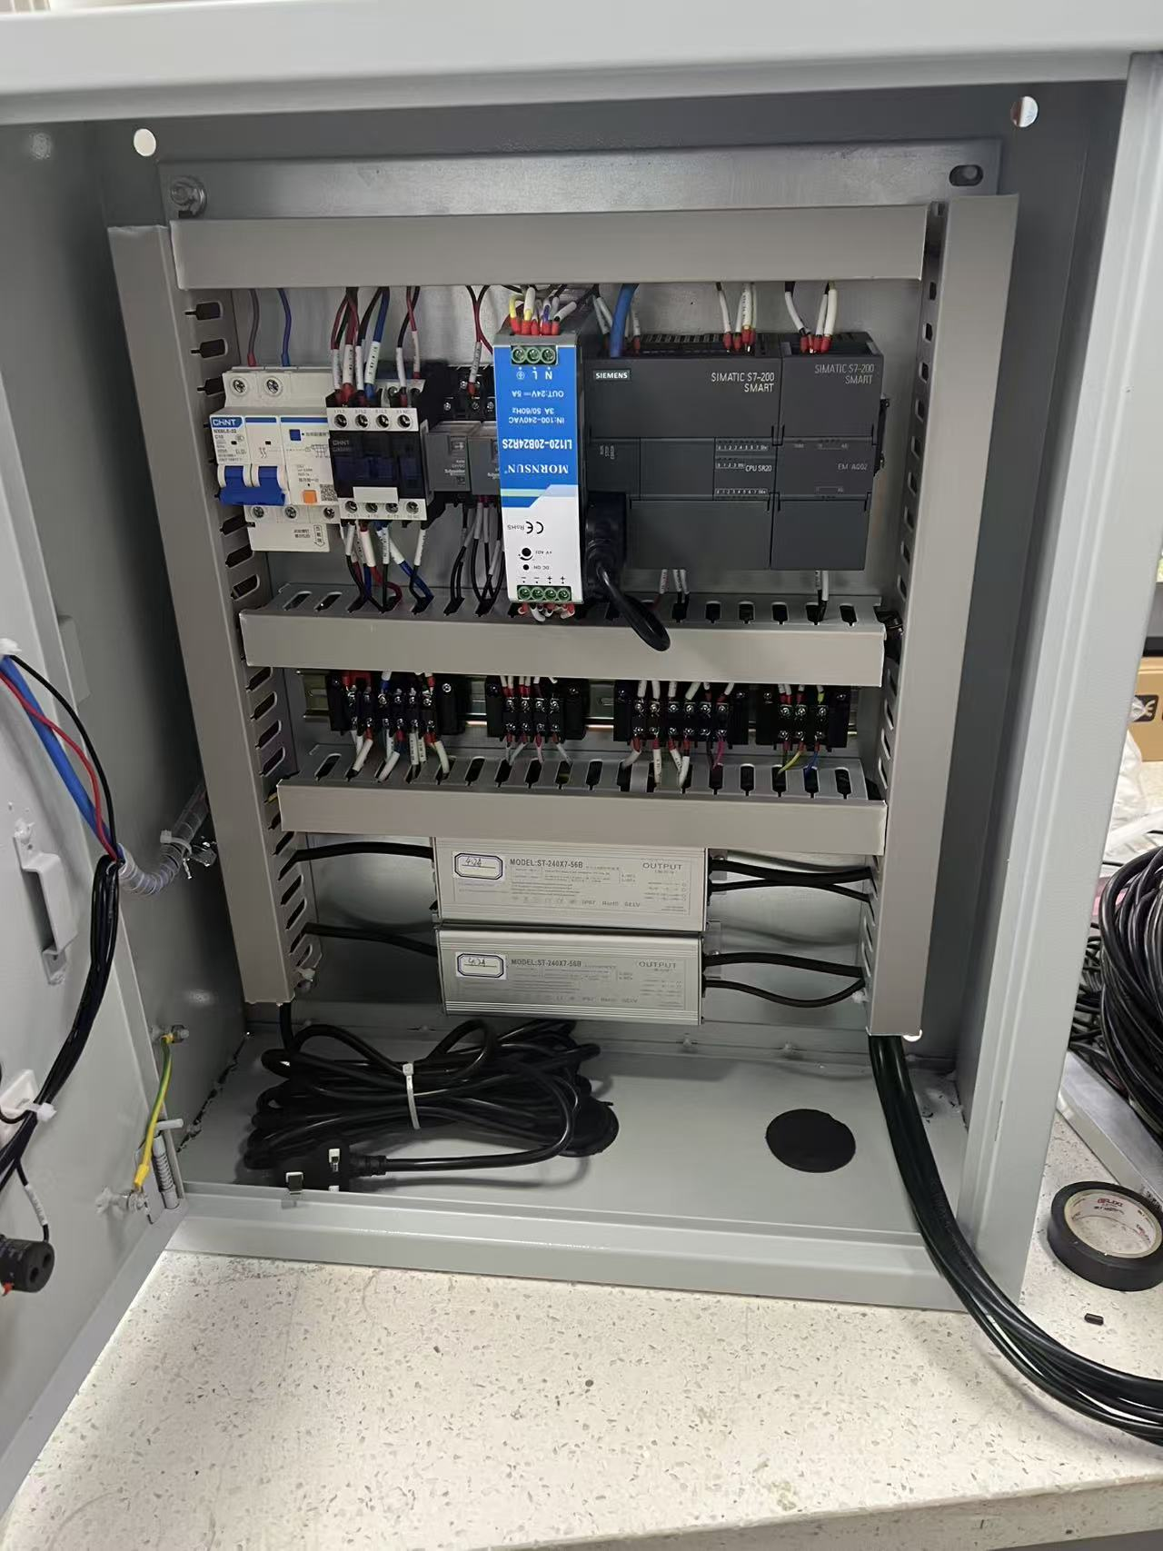
Control Cabinet Internal Hardware Configuration. View of the factory pre-terminated assembly, featuring the main leakage protector switch (top left), AC relay contactor, 24V DC rail power supply, Siemens SIMATIC PLC unit, and bottom-mounted constant current LED drivers. Lower track DIN rail blocks arrive fully wired; field installation requires incoming AC power (L/N) and ground (PE) connections only.

Chapter 3 — Touchscreen Operation Guide

The entire operating interface is structured around a left-hand navigation menu divided into six core functional modules: Home, Parameter, Timer, Data&ALM, Export, and Setting.
3.1 Permission Management (User Login)
Click the Login button in the upper right corner of the screen to call up the system access dialog box. Select the appropriate user tier from the left-hand rail and enter the access credentials:
- Operator: The default account for daily equipment operations. It logs in automatically upon startup and does not require a password.
- Administrator: Used to configure system parameters such as alarm thresholds, light source lifespan, and data storage intervals. Password: 123456.
- Engineer: Reserved exclusively for the equipment manufacturer's engineering personnel.
- UVLED: A single-purpose utility account used exclusively to reset the hardware lifespan counter following an optical engine rebuild.
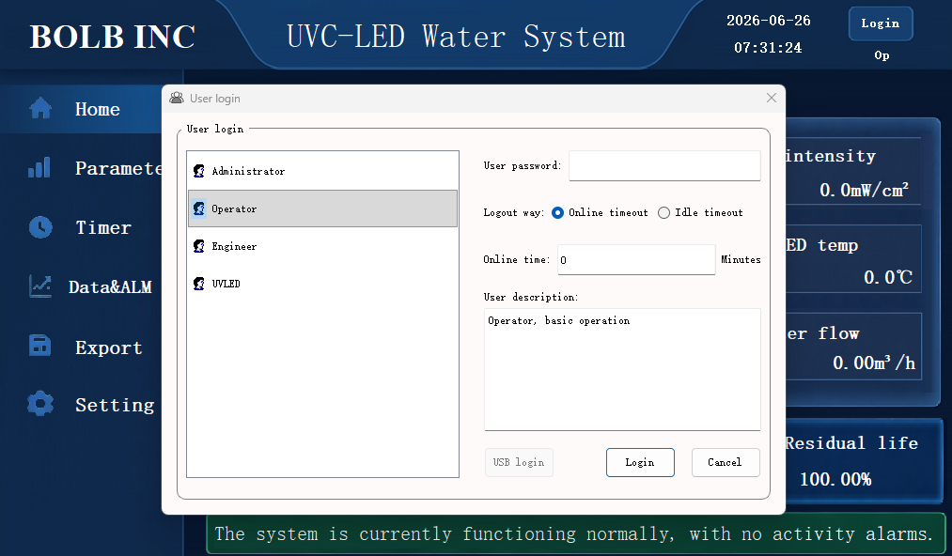

3.2. Home Dashboard
The Home screen serves as the primary data hub for real-time facility monitoring and manual process intervention.
- Device Status Indicator: Displays a high-visibility dynamic status beacon: a green Run icon indicates an active sterilization cycle, while a red Stop icon indicates standby mode
- Running Mode Toggle: Features a slide switch to alternate between AUTO (flow-paced automation) and MAN (manual intensity override). In AUTO mode, the system monitors the inlet loop and automatically scales UV output dynamically alongside changes in water flow velocity.
- Run Control Interlock: Manual cycle intervention is managed via the ▶Start and ■Stop touchscreen buttons.
- Core Parameter Display: The right side of the screen provides a direct readout of the measured UV intensity and the current light source temperature.
- Duration & Lifespan Statistics: The bottom section tracks cumulative usage, displaying "Running minutes today" and "Total running time". The lifespan monitoring module displays the elapsed hours against the rated lifespan (20,000 hours) and calculates the "Residual life percentage".
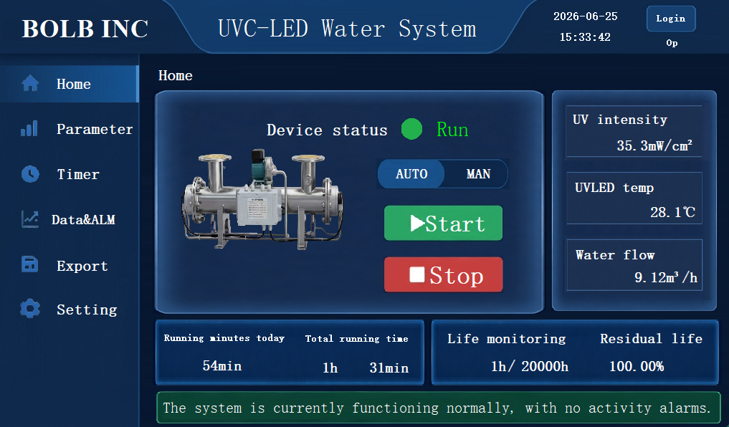

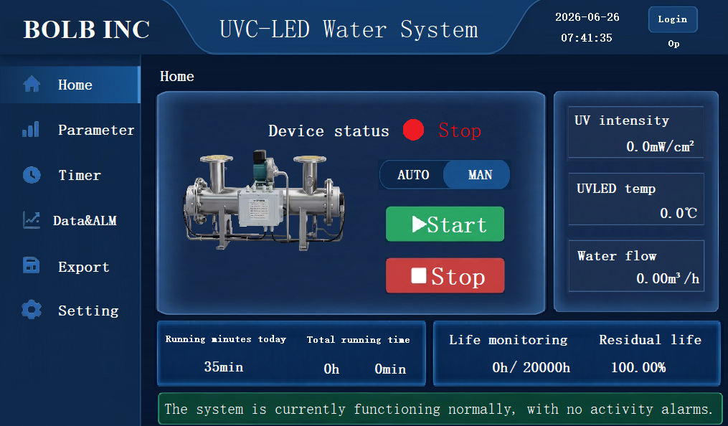
- Alarm Scrolling Display: The status bar at the bottom remains green under normal conditions. If a fault occurs, this bar turns red and scrolls the active alarm description.
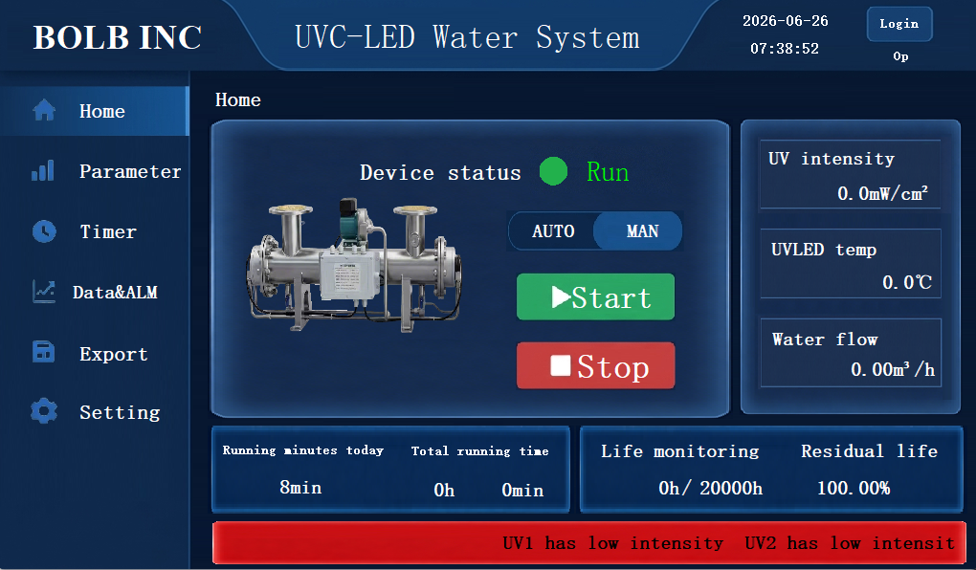

3.3. Parameters
This interface monitors the specific, low-level data for the individual UV light-emitting modules (e.g., Light Source 1 / UV1, Light Source 2 / UV2) to accurately assess the health of each unit:
- Independent Intensity Display: Shows the real-time measured irradiation intensity for each individual UV light source, alongside its configured "Lower limit of UV intensity alarm" (factory default is 15.0 mW/cm²).
- Independent Temperature Display: Shows the real-time thermal management temperature of each light source substrate, alongside its configured "Upper limit of LED Temp. alarm" (factory default is 40.0°C).
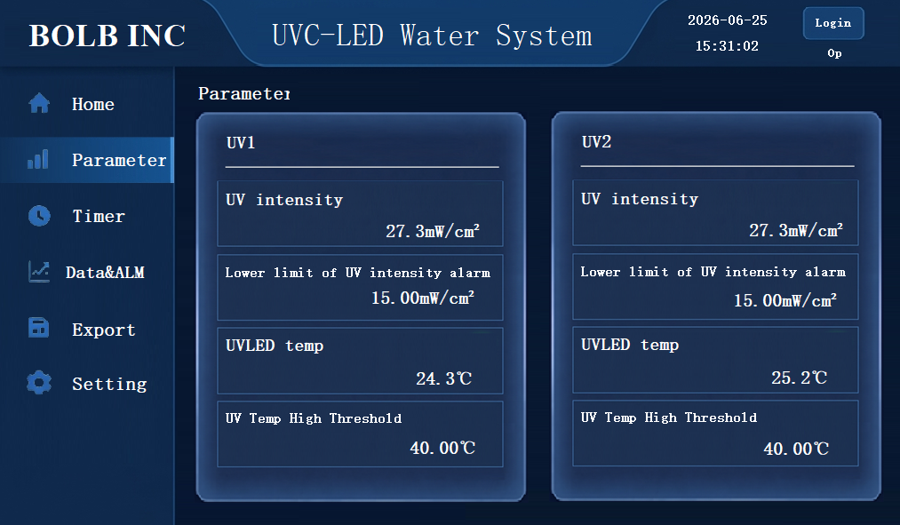

3.4 Timer
The Timer menu configures autonomous plant operation schedules using the internal hardware clock
- Scheduled Automation: Operators can program up to 5 discrete, chronological start/stop intervals across 24 hours by selecting the Enable timer function checkbox and setting the target hours. (e.g., setting an automatic run period from 08:00 >> 14:00).
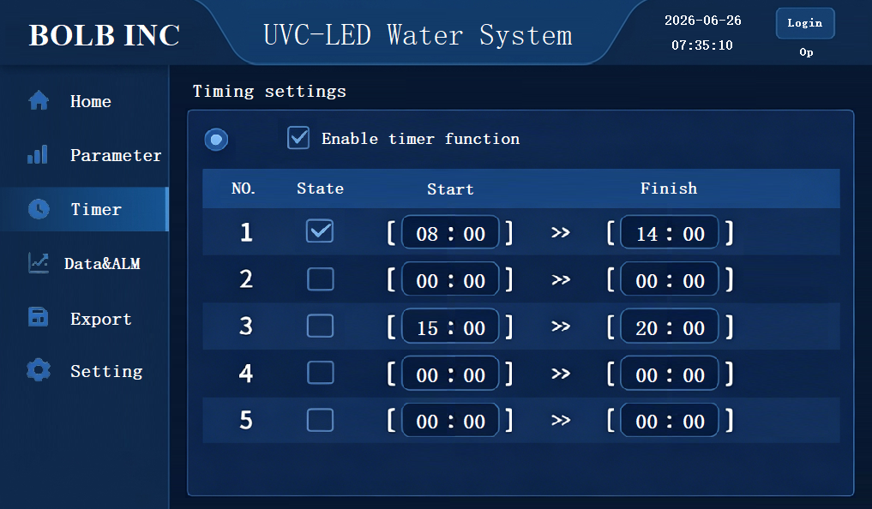
- Continuous Operations Bypass: For facility loops requiring non-stop 24/7 continuous disinfection, select the Disabled timer function checkbox at the top of the interface to lock the system into constant operation mode.
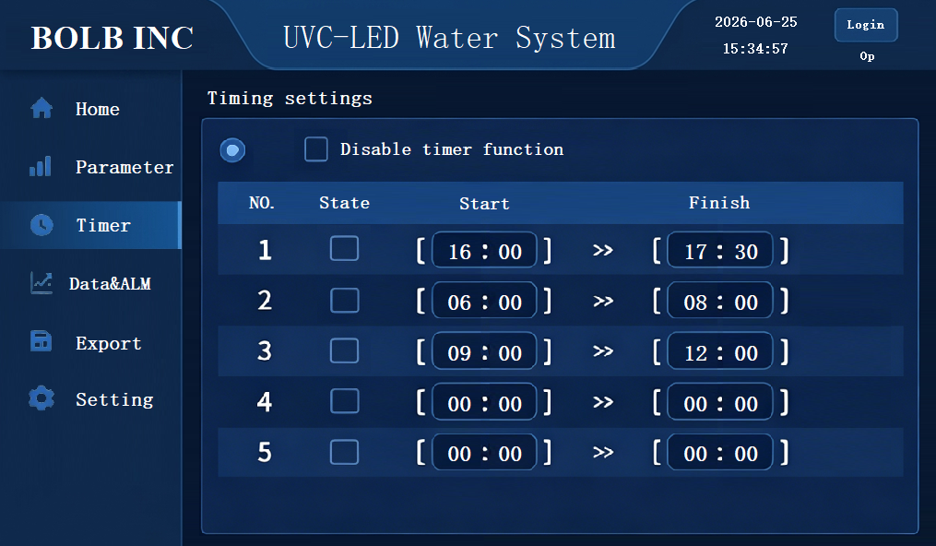

- Automation Priority Override: If an automated timing schedule is active, manual start/stop commands are overridden to prevent operator error. The system will display a yellow notification banner reading: "The timed start/stop function is enabled". Attempting to force manual controls will trigger a safety block window stating: "The timing function is turned on. Please turn it off first."
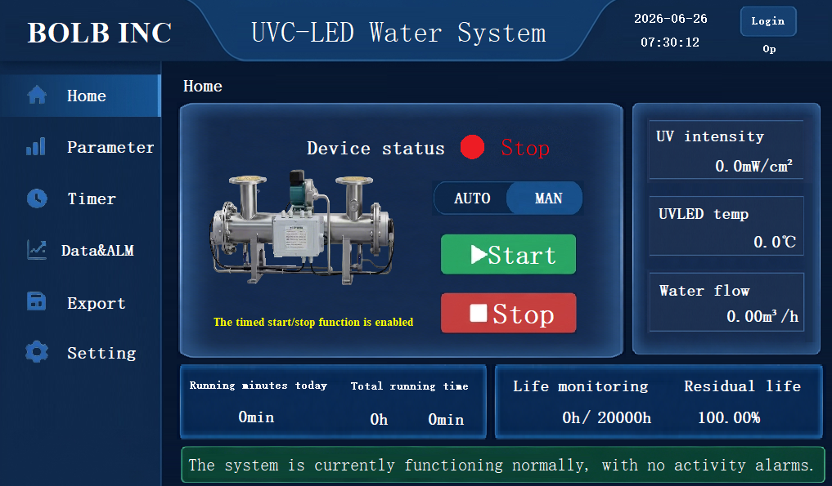
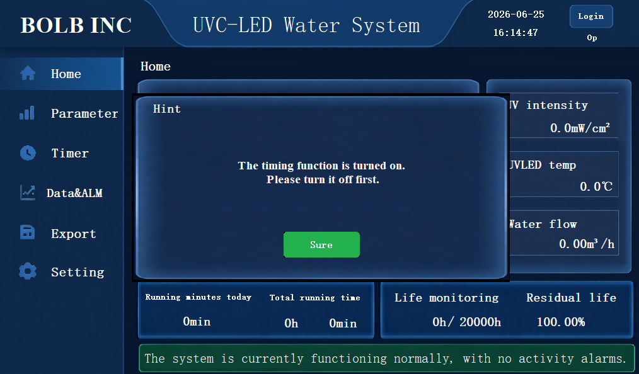

3.5. Data & ALM
- Historical Data: Displays continuous linear trend graphs tracking UV intensity, UV temperature, and Water flow across a rolling 24-hour timeline. This data helps spot premature fouling on quartz sleeves or cooling line blocks before they trigger a system shutdown.
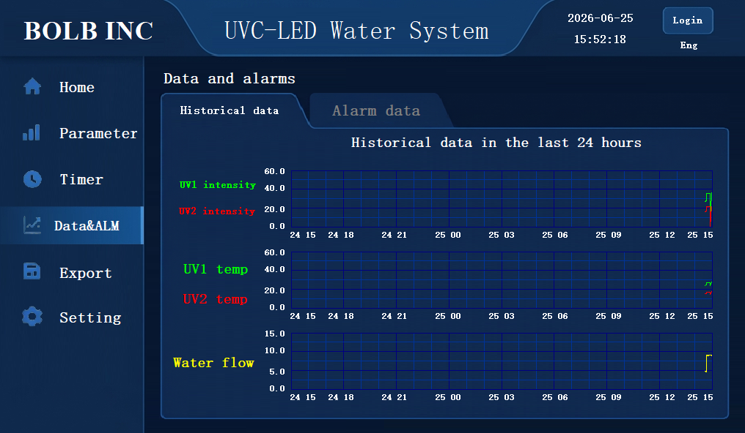
- Alarm Data: Maintains a local log list of all system faults, recorded strictly in reverse chronological order. Note that the on-screen UI only displays data for up to one month; to retrieve older historical logs, utilize a USB flash drive to export the database as detailed in the Data Export section below.


3.6. Data Export
- Upon inserting a standard USB flash drive, the interface indicator will illuminate and display "USB drive inserted".
- Select your desired time range and data type, then click [Start export] to transfer the locally stored CSV data to the USB drive.
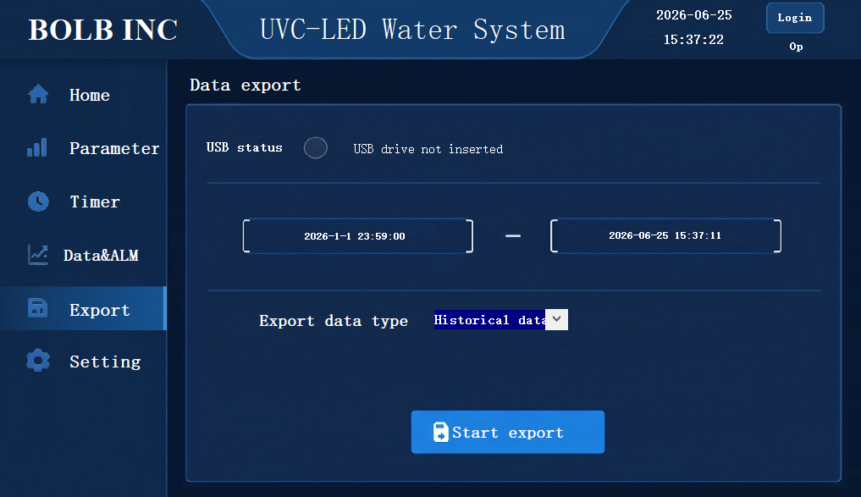

3.7. Settings
Basic Settings Sub-Tab
- Basic Settings: Configures the default state upon system boot (Auto mode vs. Manual mode) and allows for language toggling (between Chinese and English).
- Manual Intensity Adjustment: Utilized for factory debugging, light attenuation compensation, or specialized water treatment processes. Users can input a target output percentage (e.g., 90%), and the system will adjust the power consumption of the light source accordingly (Note: This feature is only active when the system is in Manual mode).
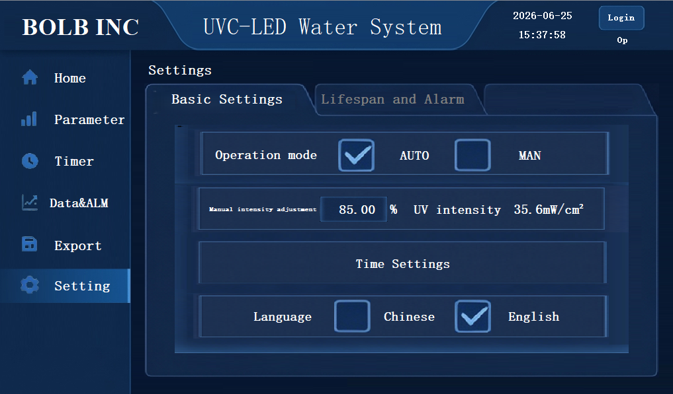
- Time Settings: Opens an on-screen digital clock calibration window. Operators can manually enter local calendar parameters (Years, Month, Day, Hour, Minute, Second) and click Save to align the system clock with the physical facility time zone.
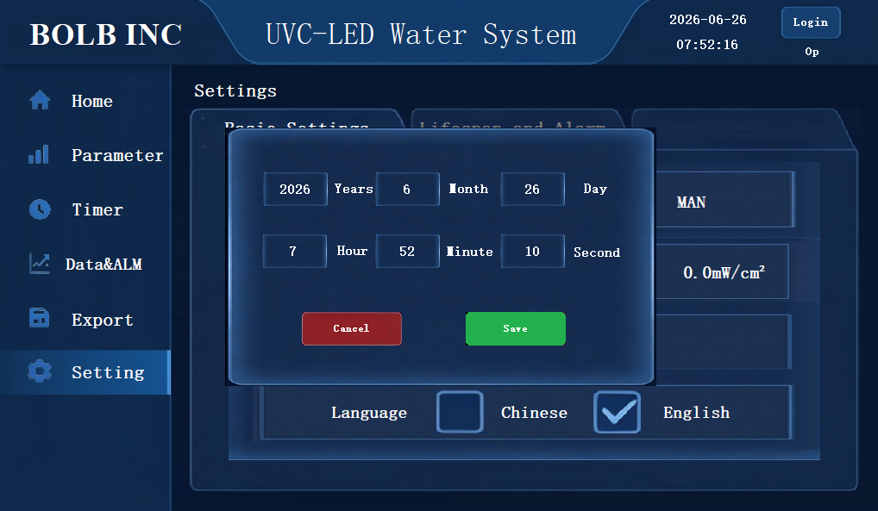

Lifespan and Alarm Sub-Tab
Allows configuration of the upper limit for light source temperature alarms, the lower limit for UV intensity alarms, and the upper limit for flow rate alarms (if a flow meter is equipped) ( Requires Administrator account login).
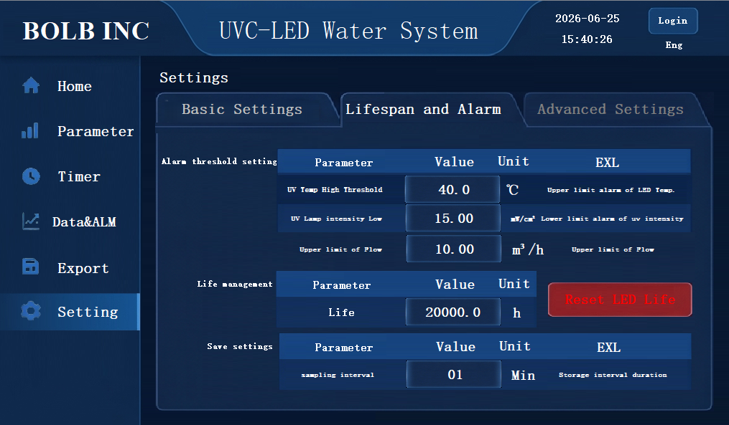
- Reset LED Life (Requires Engineer account login): Once a degraded optical module is swapped out for a fresh array, click the red Reset LED Life button. This prompts a verification confirmation layout stating: "Are you sure the new light source has been replaced". Confirming by clicking the green The LED has been replaced. button resets the internal countdown logic back to 100.00%
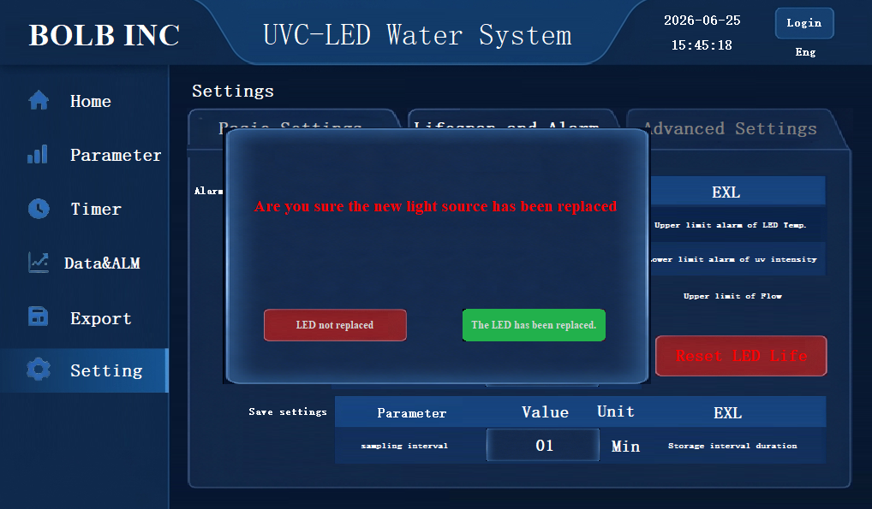

- Thermal Shutdown Protection: The system features an automated hardware emergency interlock to protect the high-purity LED arrays from permanent thermal degradation. If cooling loop efficiency drops or stagnant fluid allows internal temperatures to cross the critical safety limit, the controller will automatically kill power to the UV arrays.

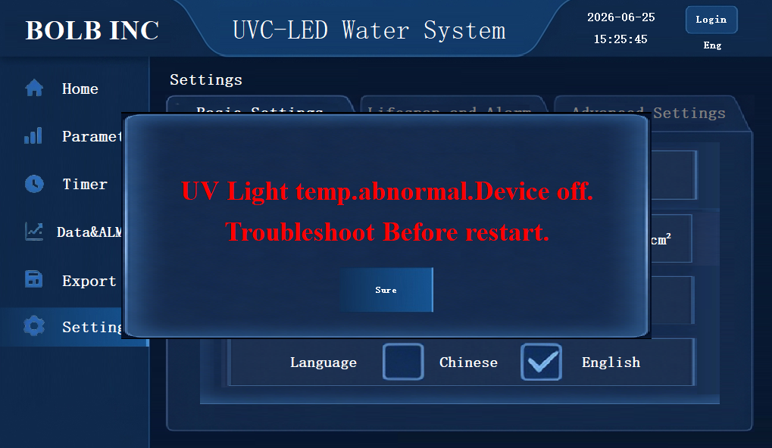

Chapter 4 — Startup Operation Steps

- Power On: Close the main Leakage Protector Switch in the Control Cabinet (located at the top-left section of the internal control panel rail). Confirm that the physical red "Stop" indicator light on the external cabinet door activates and verify that the "Stop" status light is active on the UVC reactor dashboard screen. The treatment equipment will now remain in a safe, fully energized standby state.

- System Start: Click the start button on the screen. The equipment contactor will automatically engage, the "Stop Indicator" will turn off, and the "Run Indicator" will light up, signaling the equipment has officially entered its working state: the UV lamps will light up simultaneously, and the cooling water pump will start running.

- Cooling Water Pump Exhaust: If the equipment is being run for the first time or if the water in the pipeline has been emptied, the cooling water pump exhaust operation must be completed according to the specifications (use a flathead screwdriver to unscrew the silver screw on the side of the cooling water pump; wait until water flows out, then tighten the screw to complete the exhaust process).

- Initial Status Monitoring: Within 5 minutes after startup, closely monitor the equipment's operational status:
  - No abnormal sounds or odors.
  - The alarm indicator on the power distribution cabinet remains off (normal state).
  - The cooling water pump runs smoothly without abnormal high temperatures.
  - If the alarm indicator lights up or other faults occur, immediately shut down the system and troubleshoot according to the fault handling procedures.

Chapter 5 — Shutdown Operation Steps

1. Normal Shutdown
- Click the stop button on the screen to enter the shutdown state. If the main power needs to be turned off, you must turn off the leakage protection switch and verify that the power indicator is completely off.
- When there is no water in the pipeline or the water is stagnant for a long time, the equipment must be manually shut down.
2. Emergency Shutdown
- Trigger Conditions: When the equipment experiences a severe fault (such as violent vibration, smoke, or electrical leakage) or a sudden safety incident (such as fire or gas leakage), immediately press the emergency stop button or directly cut off the main power supply.

- Follow-up Actions: After an emergency shutdown, the root cause of the fault must be investigated. The emergency stop button can only be reset and the machine restarted after being inspected and approved by professionals. Document the time, cause, and handling process of the emergency shutdown in detail, and report it to the relevant management departments promptly.

Chapter 6 —Operation Norms
- Regular Inspections: During equipment operation, regular inspections must be conducted, focusing on:
  - Control Panel: Indicator lights show normal status without any alarm prompts.
  - Equipment Status: The cooling water pump runs smoothly with no abnormal noise or excessive vibration.
  - Special Circumstance Handling: If the water flow inside the equipment is stagnant for a long time or there is no water, the equipment should be shut down promptly; otherwise, it may cause permanent damage to the light source.

- Alarm Handling: If a light source temperature alarm, light source intensity alarm, or other abnormality occurs during operation, immediately press the "Stop" button to shut down the machine. Troubleshoot the cause according to the fault handling process in the manual; the equipment can only be restarted after the fault is eliminated and reset. Operating the equipment with an active fault is strictly prohibited.

- Prohibited Actions:
  - It is strictly forbidden to open the equipment shell or the UV lamp chamber cover while the equipment is running.
  - It is strictly forbidden to touch the electrical components inside the power distribution cabinet.
  - It is strictly forbidden to shut off the cooling water pump or cut off the cooling water circuit without authorization.
  - It is strictly forbidden to keep the equipment turned on for extended periods without water.

Chapter 7 — Routine Maintenance & Functional Checks

UV Intensity Monitoring
Why it matters: The UV intensity sensor is the system's eyes. Its reading is the basis for the controller's dose calculation and dimming decisions, and it is the primary indication of LED degradation, sleeve fouling, or sensor drift.
Daily action: Check the HMI display and confirm the UV-intensity reading (mW/cm²) is within the operating range for your installed model. Log the value in the operations record.

Flow-Paced Dimming
Operating principle: The controller receives a 4–20 mA signal from the inlet flow meter. As flow drops, the controller reduces LED drive current via PWM modulation, which conserves energy and extends LED service life while still delivering target UV dose.
Monthly self-test: Manually throttle one of the main-line valves to reduce flow. Watch the UV- intensity readout on the HMI. Confirm the LED drive output drops in step with the flow change, in real time. If the system does not respond, log a maintenance ticket for control-loop calibration.

Daily Operations Tasks
    - Exterior cleanliness: wipe the reactor housing, control cabinet, and HMI window with a dry, soft cloth. Remove dust and grime so the inspection window stays readable and the housing is not damaged.
    - Piping inspection: walk the inlet, outlet, and cooling-loop piping. Look for weeping joints, cracked or sun-degraded hoses, and loose fittings. Replace seals or hose immediately if a leak is found.
    - Parameter logging: record LED operating hours, light-source temperature, and UV intensity. Compare to historical trend. Investigate any sudden drop in intensity or sustained rise in temperature before the next shift.
    - Cooling-system check: listen to the cooling pump. The motor should run smoothly with no rattling, knocking, or unusual heating.

Lifetime Maintenance Schedule

Maintenance Activity | Interval | Scope of Work
Parameter logging | Daily | Record UV intensity and LED temperature; review and clear the alarm log.
Cooling-system check | Weekly | Confirm the cooling pump runs smoothly, with no rattling, knocking, or abnormal heat.
Piping inspection | Semi-annual | Confirm the inlet, outlet, and cooling connections are tight;

Maintenance Activity | Interval | Scope of Work
 |  | check for weeping, hose aging, or surface cracks.
Electrical tightening | Semi-annual | Re-torque all electrical terminations. Verify flow-meter signal accuracy against a reference.
Optical-path cleaning | Annual | Remove the quartz sleeve(s) and wipe clean. Descale with 5% citric acid solution if mineral fouling is observed.
Major overhaul | Every 1–2 years | Replace all O-ring seals as a set (preventive — rubber hardens with age, even when no leak is yet visible).
LED module replacement | Every 2–3 years | Remove and replace LED light-source modules as a set. Reset the LED-hours counter on the HMI.

Troubleshooting

Alarm / Symptom | Immediate Action | Diagnostic Sequence
Temperature alarm active | Press the system Stop button to de-energize the unit and prevent thermal damage.  Log the operating parameters and ambient conditions at the time of alarm. | - Confirm water is flowing through the reactor. Check for blockage; clear or refill the loop as needed.  - Verify the RS-485 communication link is intact; repair or replace cabling if compromised.  - Test the cooling pump: start it and observe operation. Check for blockage, leaks, or failure to start. Repair or replace if defective.  - Check the temperature sensor: inspect for damage or contamination. Measure resistance with a multimeter — expected value is approximately 10 kΩ. Replace or recalibrate if out of spec.
Low UV intensity alarm active | Record the alarm time and the LED cumulative operating hours from the HMI. | - Verify the RS-485 communication link is intact; repair or replace cabling if compromised.  - Inspect the LEDs: if they are not lit, check the wiring. If they are lit but intensity is low, compare LED hours against expected service life — if near or beyond rated life, replace the LED module.  - Clean the UV-intensity sensor probe. If the alarm persists after cleaning, replace the sensor.  - Inspect the quartz sleeve. Heavy fouling blocks UV transmission; descale and clean per Section 3.4.

Alarm / Symptom | Immediate Action | Diagnostic Sequence
 |  | 5. Verify the LED driver output voltage is stable and within spec. Voltage instability can cause intensity dropouts.
Cooling pump overheating | Press the system Stop button to de-energize the unit and prevent thermal damage. | Check whether the cooling pump is air-bound. Bleed trapped air and restart. If the pump still does not run normally, it is either failed or seized — repair or replace the pump.

Chapter 8 — Safety & Operating Precautions

8.1 Power and Equipment Integrity
    - Confirm that supply voltage is within the rated range printed on the equipment nameplate. Operating outside this range may cause permanent damage.
    - After unpacking and before installation, inspect the equipment for transit damage. If any damage is found, stop and notify the supplier. Do not place a damaged unit into service.
    - Install the unit on a stable, level base. Vibration and rocking will damage the optical assembly and shorten service life.
    - Failure to follow the operating procedures in this manual voids the warranty. The supplier is not liable for losses caused by improper operation.

8.2 Personnel Qualification
    - Operators must complete training on the equipment's structure, safety procedures, and operating routines before being allowed to run the unit.
    - Electrical work must be performed by a licensed electrician. Personnel without the appropriate license may not work on the cabinet or reactor wiring.
    - All repairs must be performed by the manufacturer or a manufacturer-authorized service center. Repair by unauthorized parties voids the warranty.
    - Do not modify the equipment's mechanical structure or internal layout.

8.3 Electrical Safety
    - Before any service work, isolate main power and apply lockout/tagout. Verify zero- voltage at the cabinet.
    - Never operate the disconnect or any switch with wet hands.
    - If a power cable, terminal, or connector shows damage, scorching, or abnormal heat, take the unit out of service immediately.

UV-C Radiation Safety
DIRECT UV-C EXPOSURE CAUSES INJURY
UV-C light at 265–280 nm causes severe burns to skin and corneal injury to the eye within seconds of direct exposure. Effects may not appear until hours later. Always assume an LED module is energized until proven otherwise.

- Never look directly at an energized LED emission surface.
- Before inspecting any LED component, isolate power at the cabinet, verify zero-voltage, and confirm the indicator on the HMI shows the LEDs are de-energized.
- Wear UV-C-rated eye protection (UV400 or equivalent, certified for the 200–280 nm band) and skin protection during any inspection of the optical assembly.
- Follow the documented service procedure when removing LED modules or quartz sleeves. Do not improvise.

Emergency Response
- Leak or fire: isolate main power immediately. Use a dry-chemical (Class C) fire extinguisher — do not use water on an electrical fire. Call emergency services.
- Burn from contact with a hot component: cool the affected area with running cold water or a cold compress. Seek medical attention.
- Suspected UV-C exposure (skin or eye): move the affected person away from the source. UV burns may not be apparent for several hours. Cool the affected area and seek medical attention without delay; describe the wavelength and exposure circumstances to the treating clinician.

Bolb Inc.
52 Wright Brothers Avenue, Livermore, CA 94551 USA www.bolbinc.com
© 2026 Bolb Inc. All rights reserved.

Appendix 1 — UVC LED reactor dimension (units: mm)

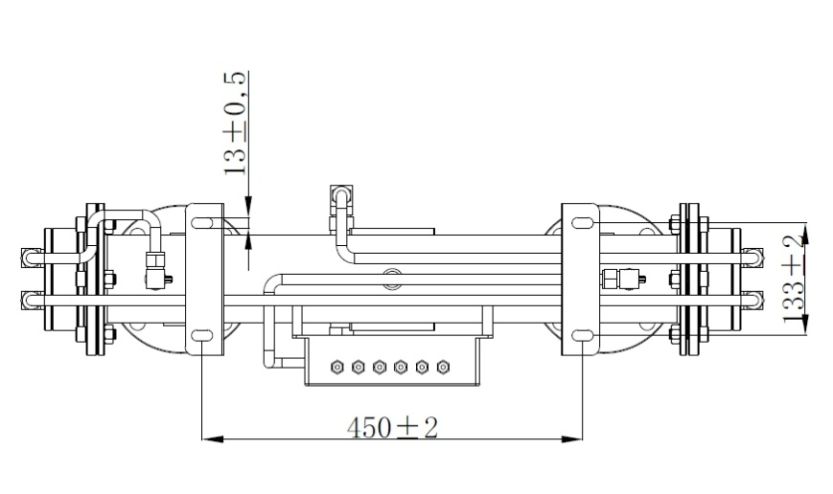
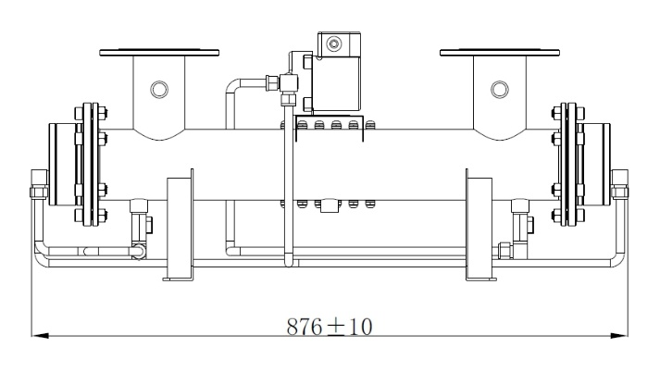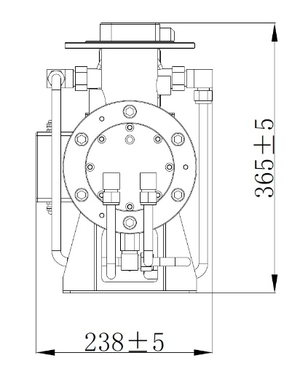
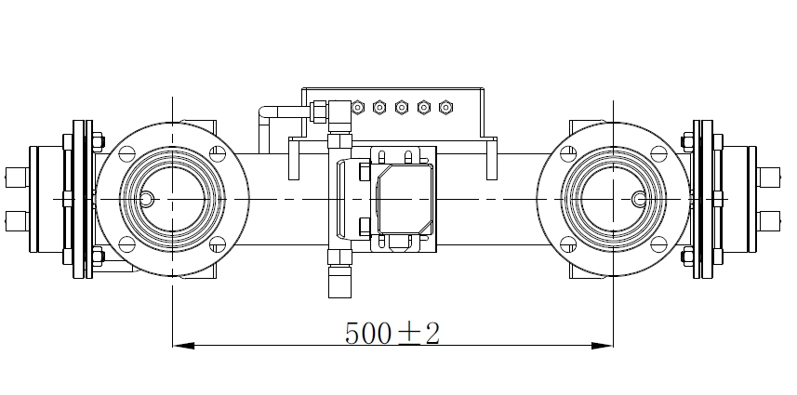

Appendix 2 — Electric wiring configuration

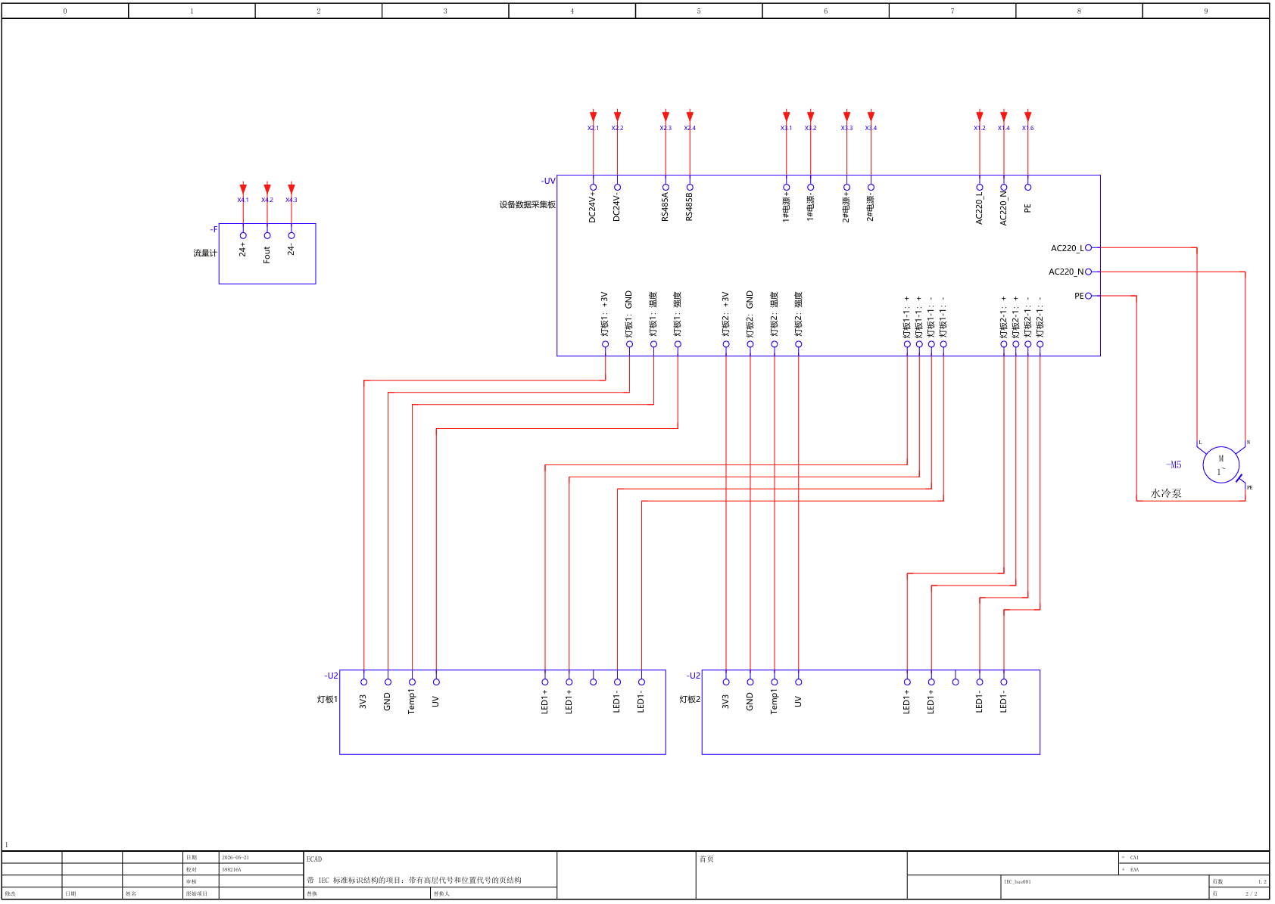

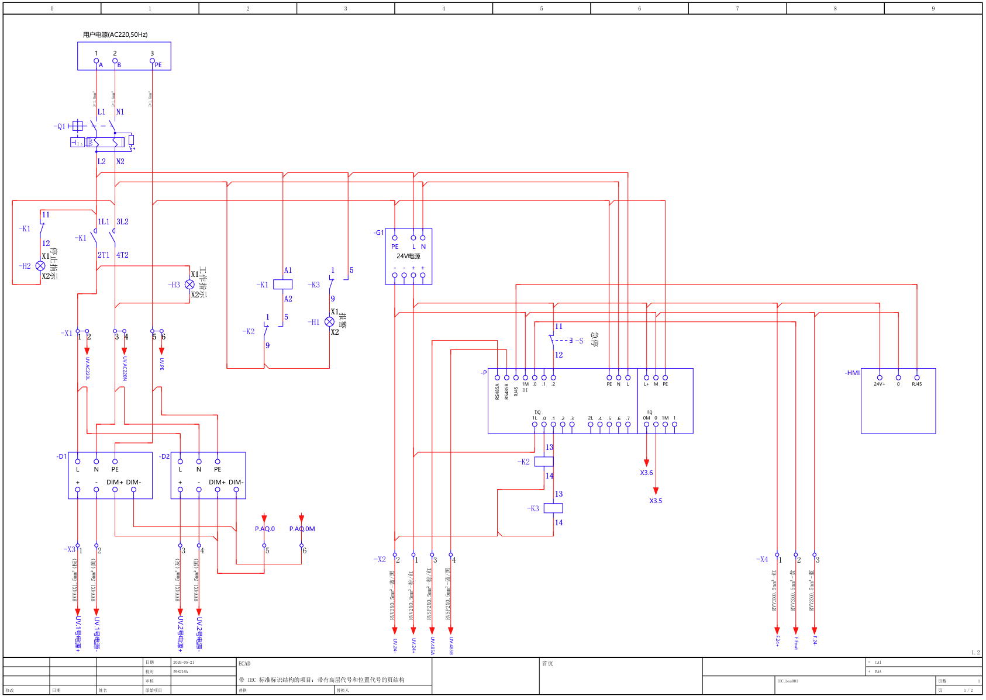

Appendix 3 — Control Cabinet Dimension (units: mm)

