**CASA0002 Urban Simulation Assessment**

**Part 1: London’s underground resilience**

**I. Topological network**

I.1. Centrality measures

Centrality measure is used for investigating the most central nodes in a graph (Lorenzo *et al.* 2020). To characterize the nodes within the context of London's underground network, there are 3 centrality measure being selected: Degree Centrality, Betweenness Centrality and Closeness Centrality. The table below demonstrates their equations, definitions, characteristics for the underground network context.

Table 1 Summary of Degree Centrality, Betweenness Centrality and Closeness Centrality.

|  |  |  |  |
| --- | --- | --- | --- |
|  | **Degree centrality** | **Betweenness Centrality** | **Closeness Centrality** |
| **Equation** | $$C_{D}(v)=deg(v)$$ Where deg(v) is the degree of the vertex | $$C_{B}(v)=\sum_{i≠v≠j∈V}{\frac{σ_{ij}(v)}{σ_{ij}}}$$ Where i, j are different nodes, $σ_{ij}$ is the number of shortest paths between i, j, $σ_{ij}(v)$ is the number of shortest paths between i, j containing the node v | $$C_{C}(v)=\frac{n}{\sum_{j}{d(i,j)}}$$ Where d(i,j) is the distance between the nodes i and j, n is the total number of nodes |
| **Definition** | It is determined by the number of neighbors (edges) connected to the node, the node with more edges is more central (Freeman, 1978). | It highlights that if the node is on the shortest path of many pairs of adjacent nodes, it is the most important one (Freeman, 1977). | It emphasizes that the shorter the distance between the node and all other nodes, the more important the node is (Freeman, 1980). |
| **Meaning for underground and reason for finding the most crucial station** | For the underground context, it is the number of stations connected to a station. When more stations are connected to the station, it is more possible that more commuters will transfer through this station. Therefore, the station with the most connections will be considered as the most crucial one for underground functioning. | For the underground context, a more central station is on more shortest paths between two any other stations and it determines the necessity of commuters transferring through this station. Therefore, the station with larger possibility to perform as a hub on the shortest path between other two stations, will be considered as the most crucial one for underground functioning. | For the underground context, a more central station travels shorter distance to all other stations and thus consumes less time for commuters to transfer. Therefore, the station with the shortest distance to other stations in total will be considered as the most crucial one. |

The attribute for each node is calculated by python, and the script is attached in Appendix.

The top 10 ranked nodes for the 3 measures are sorted out and listed below:

Table 2 First 10 ranked nodes with attributes for 3 measures

|  |  |  |  |  |  |
| --- | --- | --- | --- | --- | --- |
| **Degree Centrality** | | **Betweenness Centrality** | | **Closeness Centrality** | |
| **Node** | **Attribute** | **Node** | **Attribute** | **Node** | **Attribute** |
| Stratford | 0.0225 | Stratford | 23768.093434 | Green Park | 0.114778 |
| Bank and Monument | 0.0200 | Bank and Monument | 23181.058947 | Bank and Monument | 0.113572 |
| King's Cross St. Pancras | 0.0175 | Liverpool Street | 21610.387049 | King's Cross St. Pancras | 0.113443 |
| Baker Street | 0.0175 | King's Cross St. Pancras | 20373.521465 | Westminster | 0.112549 |
| Earl's Court | 0.0150 | Waterloo | 19464.882323 | Waterloo | 0.112265 |
| Oxford Circus | 0.0150 | Green Park | 17223.622114 | Oxford Circus | 0.111204 |
| Liverpool Street | 0.0150 | Euston | 16624.275469 | Bond Street | 0.110988 |
| Waterloo | 0.0150 | Westminster | 16226.155916 | Farringdon | 0.110742 |
| Green Park | 0.0150 | Baker Street | 15287.107612 | Angel | 0.110742 |
| Canning Town | 0.0150 | Finchley Road | 13173.758009 | Moorgate | 0.110314 |

I.2. Impact measures

There are two selected measures presenting for evaluating the impact of node removal on the network, which are clustering coefficient and the largest component. The table below lists the summary of the two measures

Table 3 Summary of impact measures

|  |  |  |
| --- | --- | --- |
|  | **Clustering coefficient** | **The largest component** |
| **Equation** | $$C=\frac{(Number of triangles) x 3}{(Number of connected triplets) }$$ Where C is between 0 and 1 |  |
| **Definition** | It is a measure of the extent to which nodes in a graph tend to cluster together (Watts and Strogatz, 1998). | It is a connected component of a network that comprises the largest proportion of the overall vertices in the network (*FutureLearn*, 2017). |
| **Meaning for London underground** | For London underground graph, the clustering coefficient will greater than random network with the same number of nodes and edges, and be smaller than regular one. The station removal can lead to the decrease of clustering coefficient, but the decreasing rate will be different from different centrality measures. | Generally, the giant component contains increasing fraction of nodes with the expanding network, and vice versa. For London underground graph, station removal can result in the reduction of the largest component, if the removed node is important enough, the size of largest component will be significantly decreased. |
| **Meaning for Other networks** | For other network application, for example, in social networks, nodes tend to form tight groups with potentially high density of ties, and it has higher possibility than randomly-built links between two nodes (Paul and Samuel, 1971); it also has been used for habitat network analysis, which can perform as an indicator to boost the robustness of the wild animal habitat network (Heer *et al.*, 2020); power grid network is another application, it can reflect network performance and enhance grid resilience (Mtawa and Haque, 2021). | For other network application, giant component is commonly applied instead of the largest component. Social network such as Facebook tends to form giant component for analyzing ego network structure (Arnaboldi *et al.*, 2015); it can also apply for power grids to support complex network analysis (Dong, Xiong and Hou, 2012); for genome-scale network, it justifies the application of dynamic complex networks (Huang, 2006). |

I.3. Node removal

For non-sequential removal method, the largest component and average clustering coefficient are calculated by removing top 10 nodes one by one, the results are displayed below.

Table 4 Results of non-sequential removal method

|  |  |  |  |  |  |  |
| --- | --- | --- | --- | --- | --- | --- |
|  | **Degree Centrality** | | **Betweenness Centrality** | | **Closeness Centrality** | |
| **Removed Nodes** | **Largest Component** | **Average clustering coefficient** | **Largest Component** | **Average clustering coefficient** | **Largest Component** | **Average clustering coefficient** |
| 0 | 401 | 0.03038 | 401 | 0.03038 | 401 | 0.03038 |
| 1 | 379 | 0.03063 | 379 | 0.03063 | 400 | 0.02979 |
| 2 | 378 | 0.03003 | 378 | 0.03003 | 399 | 0.02928 |
| 3 | 377 | 0.02705 | 377 | 0.0301 | 398 | 0.02952 |
| 4 | 374 | 0.02729 | 371 | 0.03035 | 397 | 0.02808 |
| 5 | 371 | 0.02441 | 370 | 0.02933 | 396 | 0.02815 |
| 6 | 356 | 0.02447 | 369 | 0.02831 | 395 | 0.02991 |
| 7 | 355 | 0.02343 | 346 | 0.02499 | 394 | 0.03003 |
| 8 | 354 | 0.02197 | 345 | 0.02506 | 393 | 0.03011 |
| 9 | 352 | 0.02372 | 342 | 0.0216 | 392 | 0.03019 |
| 10 | 346 | 0.02379 | 339 | 0.02165 | 389 | 0.03026 |

In order to visualize the trend of variation among the node removing process, line chart is used for plotting as shown below.



Figure 1 Largest component variation by using non-sequential removal method



Figure 2 Average clustering coefficient variation by using non-sequential removal method

From Figure 1, it can be noticed that the trends are all declining for the three measures, which is reasonable as critical nodes removal can lead to isolation of several small-size community, the size of largest component will be subsequently reduced. However, closeness centrality is more stable than the others, the reason might be that the critical nodes of the centrality are on the shortest path to all the other nodes, if these nodes are removed, alternative path can be used, and the underground network is still able to normally work. The other two measures following relatively close trends: degree centrality highlights nodes with more edges, betweenness centrality highlights nodes on the shortest path of many pairs of adjacent nodes. The node removal might result in significant separation between nodes, hence the decrease trend is sharper. For Figure 2, it is obvious that the variation of closeness centrality is different from the other two measures, whose value is fluctuating around 0.03. The reason might be the removed nodes not only decrease the number of triangles but also decrease roughly the same number of connected triplets. While the other two measures impact greater on the number of triangles, which also indicate the importance of the nodes.

Next, for sequential removal method, after each removal of the top node, the centrality measures are recomputed, then the largest component and average clustering coefficient are calculated, until 10 nodes are removed.

Table 5 Results of sequential removal method

|  |  |  |  |  |  |  |  |  |  |
| --- | --- | --- | --- | --- | --- | --- | --- | --- | --- |
|  | **Degree Centrality** | | | **Betweenness Centrality** | | | **Closeness Centrality** | | |
| **Removed Nodes** | **Top Node** | **Largest Component** | **Average Clustering Coefficient** | **Top Node** | **Largest Component** | **Average Clustering Coefficient** | **Top Node** | **Largest Component** | **Average Clustering Coefficient** |
| 0 | Stratford | 401 | 0.03038 | Stratford | 401 | 0.03038 | Green Park | 401 | 0.03038 |
| 1 | Bank and Monument | 379 | 0.03063 | King's Cross St. Pancras | 379 | 0.03063 | King's Cross St. Pancras | 400 | 0.02979 |
| 2 | Baker Street | 378 | 0.03003 | Waterloo | 378 | 0.03087 | Waterloo | 399 | 0.03003 |
| 3 | King's Cross St. Pancras | 377 | 0.02705 | Bank and Monument | 377 | 0.02997 | Bank and Monument | 398 | 0.02872 |
| 4 | Canning Town | 374 | 0.02729 | Canada Water | 376 | 0.02926 | West Hampstead | 397 | 0.02808 |
| 5 | Green Park | 360 | 0.02441 | West Hampstead | 375 | 0.02933 | Canada Water | 396 | 0.02815 |
| 6 | Earl's Court | 359 | 0.02338 | Earl's Court | 227 | 0.0294 | Stratford | 226 | 0.02822 |
| 7 | Waterloo | 358 | 0.01658 | Shepherd's Bush | 226 | 0.02263 | Earl's Court | 226 | 0.02838 |
| 8 | Oxford Circus | 357 | 0.0151 | Euston | 196 | 0.02268 | Shepherd's Bush | 225 | 0.02158 |
| 9 | Willesden Junction | 355 | 0.01684 | Baker Street | 173 | 0.01934 | Oxford Circus | 195 | 0.02164 |
| 10 | Turnham Green | 341 | 0.01688 | Acton Town | 170 | 0.01628 | Paddington | 194 | 0.0234 |

Line chart below exhibits the variation among the node removal of sequential method.



Figure 3 Largest component variation by using sequential removal method



Figure 4 Average clustering coefficient variation by using sequential removal method

From Figure 3, the declining trends are the same as Figure 1, which is due to the similar reason. However, there is a drastic decrease occurring after removing the 5th node among the lines of betweenness and closeness measures. Checking the removed stations from the Table 5, it could be noticed that the previously removed nodes are the same except the first node, hence the reason might be that these nodes are significantly important and connecting a large number of nodes under each measure condition, the removal can lead to considerable separations between nodes. As for degree measure, the recalculation does not affect the node ranking since it is depending on the number of edges, and multiple nodes have the same number of edges, hence the variation for both strategies are almost identical. For Figure 4, all the measures are showing apparent decrease among the removal, which is better for resilience analysis comparing to largest component measure. The rates of betweenness and closeness are close, which might because most of the removed 10 stations are the same within both measures, the calculated results tend to be close. And degree centrality has the most remarkable variation, since the removed nodes contain a large number of edges, the removal can lead to the triangles drastically reduction.

Subsequently, in order to compare the difference between the non-sequential and sequential strategies, Figure 1 and 3, Figure 2 and 4 are combined respectively.



Figure 5 Largest component variation of both methods



Figure 6 Average clustering coefficient variation of both methods

Combining the previous analysis and the figures above, for centrality measures: degree centrality is easily interpreted and generally well response to the node removal process. However, this measure can only collect the local information of a node, multiple nodes contain the same amount of degree, resulting in distinguishing difficulty (Kang *et al.*, 2011). In addition, this measure only depends on the topology of the graph, weights cannot be involved for measure. Therefore, it cannot reflect the complexity of the underground network. Betweenness centrality also responds well to the removal process, since the communication between two indirectly connected nodes relies on the third-party nodes between them, in other words, the nodes in-between control the most paths of information delivery ( Sci.unich.it., 2022). For the underground network, the removal of the higher betweenness nodes might considerably affect the functioning between other nodes, which emphasizes the significance of this measure in the underground context. Closeness centrality can present the close relationships as well as the average shortest path between stations. However, the high closeness station is not robust as the most critical one within underground network, alternative communication might exist, and the factor of distance is not considered for the topology network, therefore, it is not sensitive to underground node removal. Overall, betweenness centrality can reflect better the importance of a station for the function of the underground.

For node-removal strategies: both strategies can reflect the importance of the removed nodes, although the non-sequential method is easy for operating, the sequential one is more practical, since the network is dynamic, once a station is closed (removed), the rest should be regarded as a new network for normal functioning and this is the reason for resilience analysis, hence the centrality need to be recalculated.

For impact measures: from Figure 5 and 6, the variations for both impact measures are decreasing. The largest component measure is relatively understandable for the changes, while clustering coefficient can generate significant variations among different centrality measures, which would be more valuable for evaluating damage after node removal.

**II. Flows: weighted network**

II.1.

According to the topological analysis, betweenness centrality indicates that Stratford station is considered as the most relevant stations for assessing the vulnerability of the underground. Regarding weighted network, the measure should add a factor of weight, which is the inverted flows, the reason is because the flow weights represent the distances, the higher the flow value is, the closer the two nodes are. Table 6 shows the calculated results of betweenness centrality for a weighted network. It is not the same as the one derived in I.1, although most of nodes are still in the top 10, the order is totally different since the flows of the stations are varied from each other.

Table 6 First 10 ranked nodes with weighted attributes for betweenness centrality

|  |  |
| --- | --- |
| **Node** | **Weighted Attribute** |
| Green Park | 44892.50 |
| Bank and Monument | 39758.50 |
| Waterloo | 31904.25 |
| Westminster | 29664.50 |
| Liverpool Street | 26530.00 |
| Stratford | 26125.00 |
| Bond Street | 22996.50 |
| Euston | 22314.00 |
| Oxford Circus | 21207.00 |
| Warren Street | 19916.00 |

II.2.

For the weighted network, the largest component is excluded as it only considers the number of nodes in the biggest sub-network. While the clustering coefficient can still be applied to weighted network, since it represents a statistically significant level of cohesiveness that measures the global density of network triplets (Barrat *et al.*, 2004), additionally, the measure is adjusted to add flow weights and calculate the weighted clustering coefficient.

A new measure for assessing node removal is average degree, which is the average number of edges for a node, the value is associated with the correlations between the degree of connected nodes (Barrat *et al.*, 2004).

II.3.

Table 7 exhibits the average clustering coefficient and average degree results for non-removal and removing highest ranked node in topological network. Under the condition of betweenness centrality, the results of topological network indicate that the clustering coefficient result is slightly increased, while the average degree is decreased. Hence for average degree performs better outcome of node removal.

Table 8 displays the results with the same process within weighted network. Since the considerable flow weights are involved in the calculation, the average clustering coefficient results are much smaller than the topological results, and average degree results are significantly larger than the topological one. In addition, since the highest ranked node is not the same as topological one, the top node is removed, and the results indicate that both the clustering coefficient and average degree are decreased, which indicate better performance than topological network. Since in real world, each station has different commuter flows, even if one station is not quite important in topological network, it might contain a large number of flows, which should also pay attention and be considered for studying resilience. However, such factor cannot be detected based on the amount of topological information alone. In weighted network, the flow factor is involved in the degree of each node, and the ranking results therefore is more robust than topological one. Consequently, the closure of Green Park station within weighted network will make the greatest impact on the commuters.

Table 7 Node removal results of topological network

|  |  |  |
| --- | --- | --- |
|  | **Average clustering coefficient** | **Average degree** |
| **Non-removal** | 0.03038 | 2.3292 |
| **Top node removed** | 0.03063 | 2.29 |

Table 8 Node removal results of weighted network

|  |  |  |
| --- | --- | --- |
|  | **Average clustering coefficient** | **Average degree** |
| **Non-removal** | 0.001579 | 49530.4090 |
| **Top node removed** | 0.001318 | 46511.025 |

**Part 2: Spatial Interaction models**

**III. Models and calibration**

III.1.

Table 9 briefly demonstrates four types of spatial interaction models and their features.

Table 9 The Family of Spatial Interaction Models

|  |  |  |  |  |
| --- | --- | --- | --- | --- |
|  | **The Unconstrained Model** | **The Singly Constrained Models** | | **The Doubly Constrained Model** |
| **The Origin–Constrained Model** | **The Destination–Constrained Model** |
| **Equation** | $T_{ij}=KO_{i}D_{j}exp⁡(-βc_{ij})$ subject to $\sum_{i=1}^{n}{\sum_{j=1}^{m}{T_{ij}}=T}$ | $T_{ij}=A_{i}O_{i}D_{j}exp⁡(-βc_{ij})$ subject to $\sum_{j=1}^{m}{T_{ij}}=O_{i}$ | $T_{ij}=O_{i}B_{j}D_{j}exp⁡(-βc_{ij})$ subject to $\sum_{i=1}^{n}{T_{ij}}=D_{j}$ | $T_{ij}=A_{i}O_{i}B_{j}D_{j}exp⁡(-βc_{ij})$ subject to $\sum_{j=1}^{m}{T_{ij}}=O_{i}$& $\sum_{i=1}^{n}{T_{ij}}=D_{j}$ |
| **Parameters** | Where $i$ denotes origins; $j$ denotes destinations; $T_{ij}$ denotes the flow from $i$ to $j$; $O_{i}$ and $D_{j}$ denotes origin and destination activities; $K$ denotes scaling constant, which adjusts the trips to ensure the sum of them reaches the total number of trips $T$; $c_{ij}$ denotes generalized travel cost; $β$ denotes friction of distance parameter, which controls the impact of generalized travel costs | | | |
| **Constraint** | There is an overall constraint for the model that is the trips add up to $T$ | The constraint is the trips attracted to the origin | The constraint is the trips attracted to the destination | The constraint is the trips attracted to both origin and destination |

III.2.

In order to utilizing all of the population, jobs and flows, unconstrained model is selected, as each parameter can be considered during the calculation. The model is built and calibrated in the Python script attached in Appendix. Table 10 shows that the fitting effect is significantly improved after calibration.

Table 10 Goodness-of-fit

|  |  |  |  |
| --- | --- | --- | --- |
|  | **R2** | **RMSE** | **Beta** |
| **Initial model** | 0.03464 | 485.365 | 0.0001 |
| **Calibrated model** | 0.3212 | 108.334 | 0.6228 |

IV. **Scenarios**

IV.1. Scenario A

The flows with adjusted jobs are calculated by Python, the results are shown in Table 11.

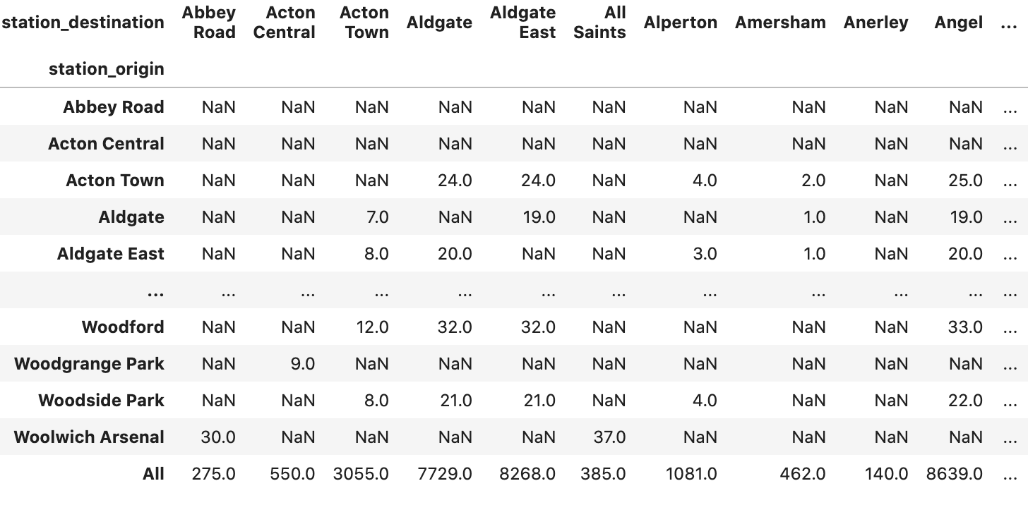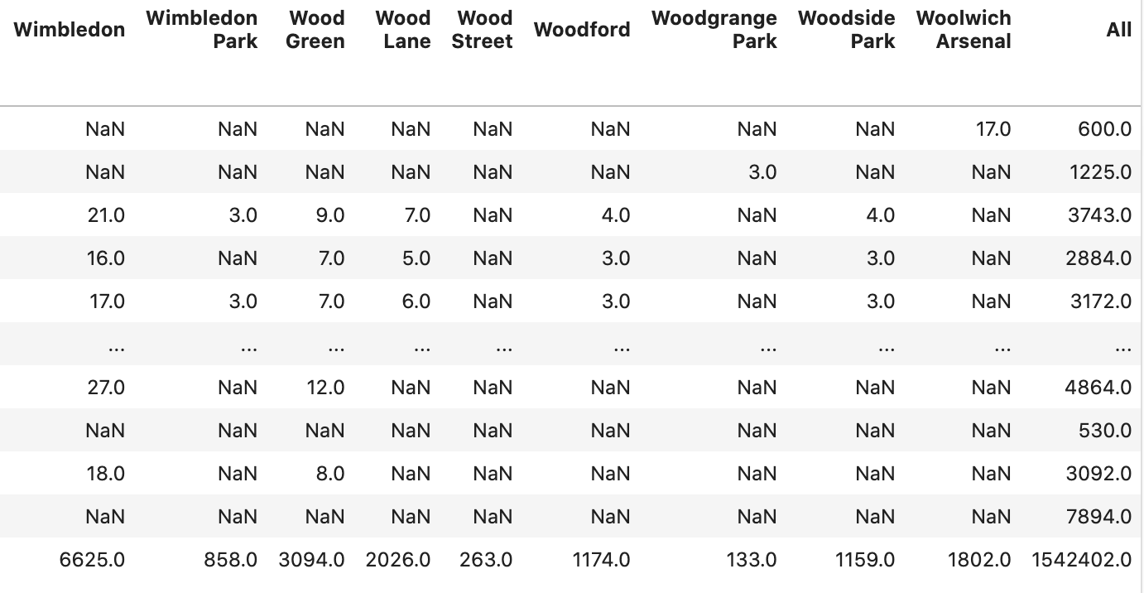

Table 11 Flow results for Scenario A

IV.2. Scenario B

To increase the cost of transport, 2 values are selected. for the power model, and the results are displayed in Table 12 and 13.

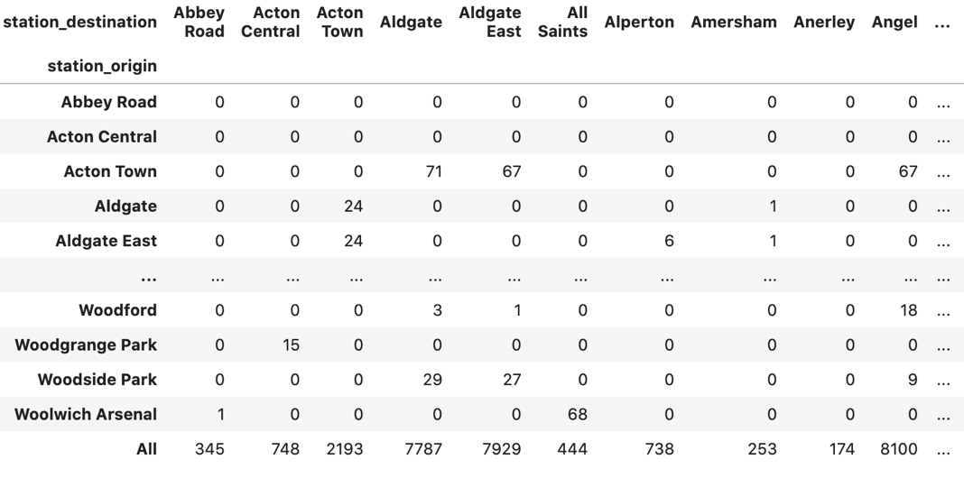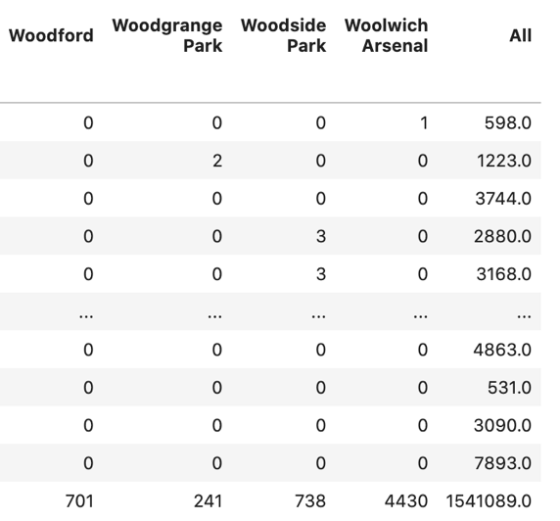

Table 12 Flow results for Scenario B 1

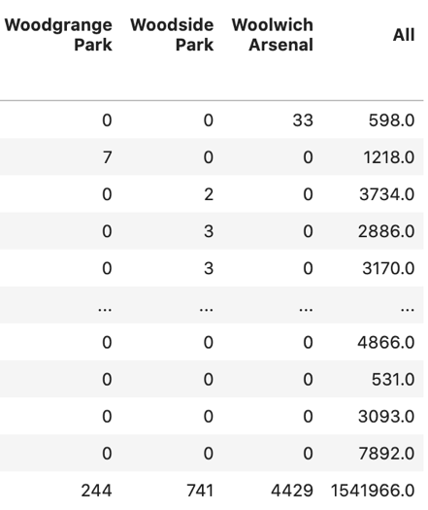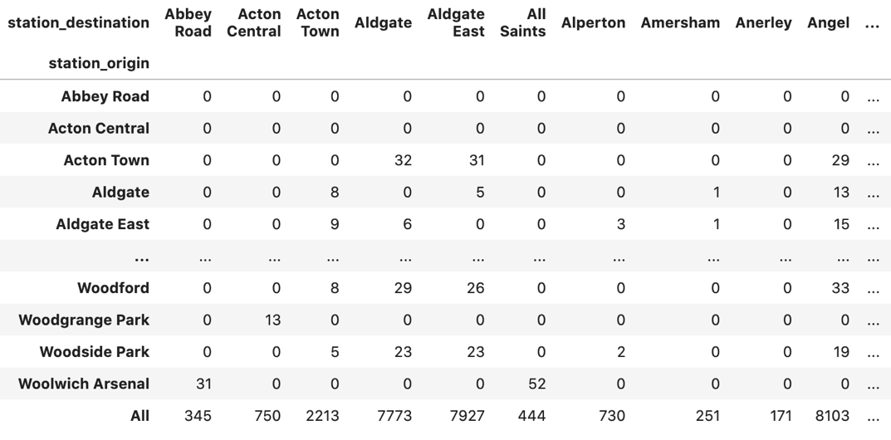

Table 13 Flow results for Scenario B 2

IV.3. Comparison

For the results of the three scenarios, 50% decrease of jobs can result in more impact on flow redistribution. Since the prediction of this situation is more far from the data flows (as shown in Table 14), which results in more significant variation, while other two are exhibited relatively robust results.

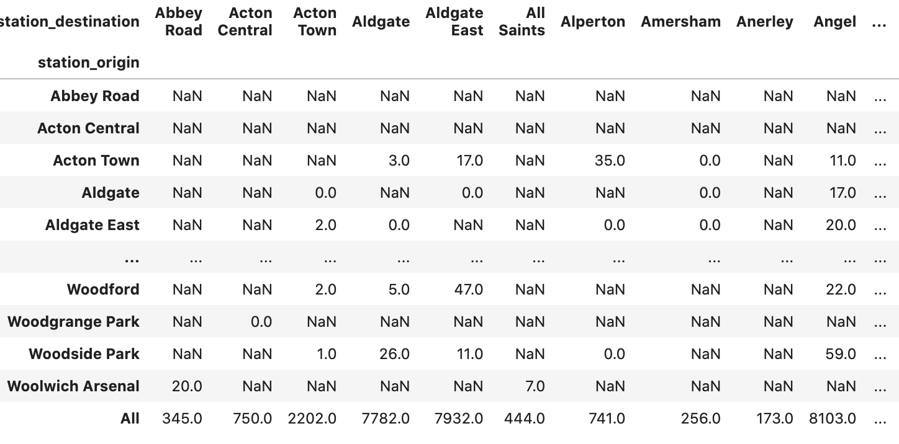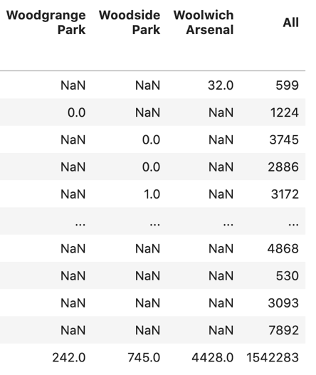

Table 14 Data flow distribution

(word count: 1670)

**Bibliography**

Arnaboldi, V. *et al.* (2015) ‘Chapter 3 - Tie Strength and Ego Network Structure in Facebook’, in Arnaboldi, V. et al. (eds) *Online Social Networks*. Boston: Elsevier (Computer Science Reviews and Trends), pp. 37–60. doi:10.1016/B978-0-12-803023-3.00003-5.

Barrat, A. *et al.* (2004) ‘The architecture of complex weighted networks’, *Proceedings of the National Academy of Sciences of the United States of America*, 101(11), pp. 3747–3752. doi:10.1073/pnas.0400087101.

*Betweenness Centrality* (no date). Available at: https://www.sci.unich.it/~francesc/teaching/network/betweeness.html (Accessed: 4 May 2022).

Dong, X., Xiong, G. and Hou, J. (2012) ‘Chapter 14 - Construction of Artificial Grid Systems Based on ACP Approach’, in Xiong, G. et al. (eds) *Service Science, Management, and Engineering:* Boston: Academic Press, pp. 285–304. doi:10.1016/B978-0-12-397037-4.00014-4.

Freeman, L.C. (1977) ‘A Set of Measures of Centrality Based on Betweenness’, *Sociometry*, 40(1), pp. 35–41. doi:10.2307/3033543.

Freeman, L.C. (1978) ‘Centrality in social networks conceptual clarification’, *Social Networks*, 1(3), pp. 215–239. doi:10.1016/0378-8733(78)90021-7.

Freeman, L.C. (1980) ‘The gatekeeper, pair-dependency and structural centrality’, *Quality and Quantity*, 14(4), pp. 585–592. doi:10.1007/BF00184720.

FutureLearn. 2017. Network Components and the Giant Component. [online] Available at: <https://www.futurelearn.com/info/courses/social-media/0/steps/16048> [Accessed 30 April 2022].

Heer, H. *et al.* (2020) ‘Maximising the clustering coefficient of networks and the effects on habitat network robustness’, *PLoS ONE*, 15(10), p. e0240940. doi:10.1371/journal.pone.0240940.

Huang, S. (2006) ‘Chapter 14 - Multistability and Multicellularity: Cell Fates as High-Dimensional Attractors of Gene Regulatory Networks’, in Kriete, A. and Eils, R. (eds) *Computational Systems Biology*. Burlington: Academic Press, pp. 293–326. doi:10.1016/B978-012088786-6/50033-2.

Kang, U., Papadimitriou, S., Sun, J. and Tong, H., 2011, April. Centralities in large networks: Algorithms and observations. In *Proceedings of the 2011 SIAM international conference on data mining* (pp. 119-130). Society for Industrial and Applied Mathematics.

Lorenzo, M., Hiva, V. and Roberto, N. (2020) *A TOPOLOGICAL ANALYSIS OF UNDERGROUND NETWORK PERFORMANCE UNDER DISRUPTIVE EVENTS*. Available at: https://re.public.polimi.it/retrieve/handle/11311/1147706/543664/ETC-2020-MVN_sub.pdf (Accessed: 20 April 2022).

Mtawa, Y.A. and Haque, A. (2021) ‘Clustering-Coefficient Based Resiliency Approach for Smart Grid’, in *2021 International Wireless Communications and Mobile Computing (IWCMC)*. *2021 International Wireless Communications and Mobile Computing (IWCMC)*, pp. 1569–1574. doi:10.1109/IWCMC51323.2021.9498658.

Paul, W.H. and Samuel, L. (1971) *Transitivity in Structural Models of Small Groups*. Available at: https://journals.sagepub.com/doi/10.1177/104649647100200201 (Accessed: 30 April 2022).

Sci.unich.it. 2022. *Betweenness Centrality*. [online] Available at: <https://www.sci.unich.it/~francesc/teaching/network/betweeness.html> [Accessed 30 April 2022].

Watts, D.J. and Strogatz, S.H. (1998) ‘Collective dynamics of “small-world” networks’, *Nature*, 393(6684), pp. 440–442. doi:10.1038/30918.

**Appendix**

Github link of Python script:

<https://github.com/joeylizh/Urban_sim_assessment/blob/main/Assessment/Assessment.ipynb>