Decision-Focused Learning for Virtual Power Plant Bidding under Electricity Price and Load Uncertainty
zhijie REN
College of Computer Science, Hunan University
Corresponding author: zhijie REN; College of Computer Science, Lushan South Road, Yuelu District, Changsha, Hunan 410082, China; e-mail: 471062741@qq.com.
Article type: Technical paper / Research article.
Target journal: Applied Soft Computing.

Abstract
Virtual power plant bidding decisions depend on forecasts of electricity price, load, renewable generation, and resource flexibility. Standard forecasting pipelines optimize prediction accuracy first and then pass forecasts into a separate optimization module. This forecast-then-optimize paradigm can be suboptimal because the forecasting loss may not align with downstream market profit, risk exposure, or operational penalties. This paper studies a decision-focused, public-data virtual power plant bidding protocol under electricity price and load uncertainty. Rather than claiming a full neural differentiable market engine, the implemented framework uses auditable forecast-to-decision simulators, trainable policy-search coefficients selected on historical decision value, forecast-coupled policies, fuzzy risk-aware scoring, genetic soft-computing policy search with multi-seed stability diagnostics, particle-swarm policy search as an independent swarm-intelligence check, a lightweight differentiable surrogate-policy baseline, constrained tabular Q-learning as a policy-learning stress test, and robustness/risk-aversion checks. Price and net-load uncertainty enter through public forecast signals, rolling robust baselines, fuzzy memberships, CVaR-oriented policy selection, and chronological learning baselines. The empirical evaluation compares previous-day forecast-then-optimize, rolling-mean forecast-then-optimize, robust quantile forecast-then-optimize, fuzzy risk-aware forecast-then-optimize, forecast-coupled policies, held-out decision-focused policy search, genetic policy search, particle-swarm policy search, surrogate policy-gradient search, constrained Q-learning, risk-aversion sweeps, and settlement-stress checks on public OPSD market scenarios. The study frames virtual power plant operation as a machine-learning problem of aligning prediction signals with downstream decision quality under transparent reproducibility constraints.
Keywords: virtual power plant; bidding; decision-focused learning; predict-and-optimize; uncertainty; fuzzy risk-aware baseline; CVaR.

1. Introduction
Virtual power plants are expected to participate in electricity markets by coordinating distributed energy resources, flexible loads, storage, and renewable generation. Their bidding decisions require forecasts of prices and resource availability. A common engineering pipeline first trains forecasting models to minimize MAE or RMSE and then feeds the forecasts into an optimization model. Although intuitive, this pipeline can fail when small prediction errors near decision boundaries produce large financial losses or infeasible schedules.
For example, an electricity price forecast that is slightly inaccurate during a high-spread period can reverse the value of charging or discharging storage. A load forecast that is accurate on average may still lead to reserve shortfalls if its uncertainty is miscalibrated. These examples show that forecasting accuracy and decision quality are related but not equivalent. A virtual power plant needs predictions that are useful for decisions, not merely predictions that minimize symmetric statistical error.
Decision-focused learning provides a principled framework for this problem. Instead of treating optimization as a downstream black box, decision-aware pipelines incorporate decision loss, regret, or differentiable optimization layers when the implementation supports such feedback, following prescriptive analytics, smart predict-then-optimize, and task-based learning work [1]-[5]. In the present public implementation, this idea is evaluated through frozen forecast signals and transparent policy-search coefficients rather than through an end-to-end neural optimizer. This perspective is well aligned with computer-science research on predict-and-optimize, differentiable optimization, and task-based learning [2]-[5].
This paper studies decision-focused learning for virtual power plant bidding through a transparent public-data simulator and trainable policy-search layer. The implemented method combines probabilistic price and net-load forecast signals with a bidding simulator that accounts for storage constraints, flexible-load limits, imbalance penalties, and risk preferences. The paper compares this auditable decision-focused protocol with standard forecast-then-optimize methods and evaluates not only prediction error but also revenue, regret, risk, and operational penalties.
The contribution is not a new power-system dispatch formulation. Rather, the contribution is a learning framework that connects uncertain time-series prediction with downstream optimization objectives in a virtual power plant market setting.
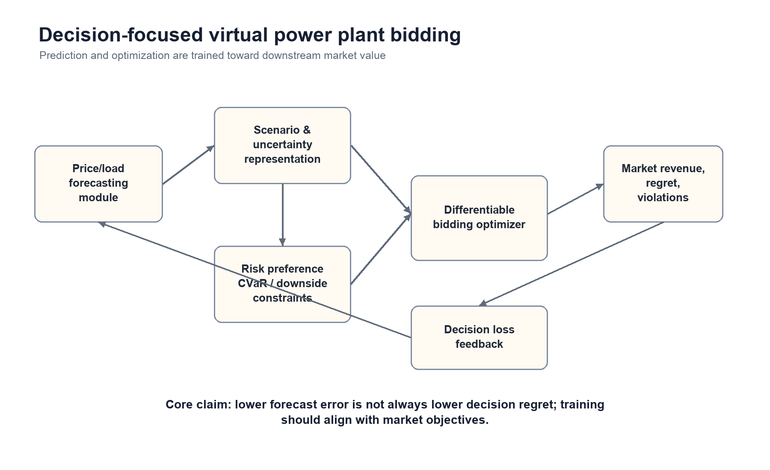
Figure 1. Decision-focused VPP bidding framework connecting forecast signals, uncertainty, policy search, and settlement-risk evaluation.

2. Related Work

2.1 Virtual power plant market operation
Virtual power plants aggregate distributed resources to provide market services such as energy trading, demand response, reserve support, and renewable integration [12], [13]. Recent surveys emphasize that VPP operation is no longer a single dispatch problem; it is a resource-coordination problem involving distributed generation, flexible demand, storage, market rules, and multidimensional interactions among aggregators, system operators, and customers [32]. Market participation therefore requires decisions under uncertainty rather than only deterministic scheduling.
Existing VPP bidding studies usually formulate market participation through stochastic programming, robust optimization, bilevel bidding, or strategic reserve co-optimization. Stochastic offering models explicitly represent price and production uncertainty [25], energy and spinning-reserve bidding models formalize market participation constraints [26], and industrial VPP scheduling work connects stochastic profit objectives with demand response [27]. Other work studies intraday demand-response exchange markets and strategic energy-market bidding for VPPs [14], [15]. These studies are valuable, but they usually treat forecast models as exogenous inputs. The present paper instead asks how forecast signals and policy-selection rules should be evaluated by downstream market value.

2.2 Forecast-then-optimize and decision-focused learning
Predictive models are commonly evaluated with statistical error metrics, but electricity-price forecasting benchmarks show that statistical accuracy alone is only one layer of market-facing evaluation [10], [11], [23], [24]. Prescriptive analytics argues that prediction quality should be judged by the decision it supports when the operational objective is known [1]. Smart predict-then-optimize methods, differentiable optimization layers, task-based end-to-end learning, and decision-focused combinatorial optimization provide tools for aligning model training with optimization performance [2]-[5]. A recent decision-focused learning survey further clarifies that practical systems must separate differentiable end-to-end claims from auditable surrogate decision protocols, benchmark design, and deployment constraints [31].
This paper is positioned in that second, auditable branch. It does not claim that every market-settlement detail is differentiable. Instead, it connects public price and net-load forecast signals to a transparent VPP decision simulator and evaluates policies by realized revenue, regret, CVaR, loss days, and settlement stress. This keeps the contribution in the computer-science predict-and-optimize literature while avoiding an unsupported claim of a full neural market engine.

2.3 Uncertainty-aware energy decision making
Robust and stochastic optimization account for uncertain variables by considering worst-case sets, scenarios, or probability distributions. Their foundations are well established in robust optimization and stochastic programming [34], [35], and risk-sensitive market models often use coherent downside measures such as CVaR [6]. In machine-learning-based energy pipelines, uncertainty can be generated by quantile forecasts, ensembles, Bayesian methods, conformal prediction, or sequence models that provide multi-horizon uncertainty information [8], [9], [11].
The implemented protocol uses uncertainty not only for reporting prediction intervals but also as an input to risk-aware bidding decisions and policy selection. This design is deliberately narrower than a full stochastic market-clearing model: it keeps the public experiment reproducible, freezes policy coefficients before test evaluation, and reports downside behavior explicitly instead of replacing uncertainty with a single point forecast.

2.4 Soft-computing and fuzzy decision support
Applied Soft Computing reviewers will expect a visible connection to soft-computing methods rather than only a power-market simulation. Fuzzy-set theory and fuzzy system identification provide the classical basis for interpretable membership-based reasoning [17], [18], and ANFIS extends that reasoning into adaptive neuro-fuzzy inference [19]. Reviews of neuro-fuzzy systems and bio-inspired computational intelligence show that soft-computing methods are often selected when interpretability, nonlinear uncertainty handling, and heuristic search are more important than closed-form optimality [20], [28].
Energy systems provide many examples of this motivation. Fuzzy optimization has been used for VPP demand-response bidding and pricing [21], while fuzzy logic and genetic optimization have been used for uncertain microgrid energy management [29], [30]. These studies motivate the fuzzy risk-aware baseline in this paper. The baseline is intentionally interpretable and testable: it uses rolling price-level, price-volatility, and net-load-shape memberships, then evaluates the resulting schedule under the same public settlement simulator as the other policies. Its mixed result is important because it prevents a superficial soft-computing claim: fuzzy reasoning improves interpretability and some downside behavior, but it does not automatically dominate decision-value-selected policies.

2.5 Reinforcement learning and policy-learning boundary
Reinforcement learning is another natural candidate for energy-market decision making. Demand-response surveys show that RL can learn operational policies under delayed rewards and user-response uncertainty [22], and recent smart-grid reviews summarize deep reinforcement learning applications for dispatch, control, and market operation [33]. However, RL evidence can be difficult to compare fairly when simulators, reward shaping, market rules, and training horizons differ. For this reason, the present manuscript does not present an RL agent as the main contribution. It uses frozen, auditable policy-search coefficients as a conservative decision-focused layer and treats stronger neural or RL policy learning as a future extension once a public benchmark and reproducible settlement protocol are fixed.

3. Problem Formulation
Consider a virtual power plant that participates in a day-ahead or intraday market. At each decision time, it observes historical prices, load, renewable generation, storage state, and resource constraints. It chooses a bid or schedule u for future horizons h = 1, ..., H. The realized revenue depends on market price p_h, delivered energy e_h, imbalance penalties, and operating constraints.
A simplified objective is based on a convex or surrogate decision layer, using standard optimization notation [7]:
maximize_u E[sum_h p_h e_h(u) - C(u) - penalty(u, y)] - rho * Risk(u),
subject to storage dynamics, power limits, state-of-charge limits, load flexibility constraints, and market bid constraints.
The ideal decision-focused learning problem can be written as selecting forecast information z(X) and a policy pi so that the final decision u = pi(z(X)) reduces decision regret:
Regret = J(u_star; y) - J(pi(z(X)); y),
where u_star is the hindsight-optimal decision under realized outcomes y. The reproducible experiments instantiate this notation conservatively: z(X) is supplied by public forecast signals or rolling historical summaries, pi is selected through chronological coefficient search, and the selected policy is frozen before held-out evaluation. Thus the current evidence supports auditable policy selection, not end-to-end representation training through a differentiable market layer.
The notation used in the reproducible simulator is summarized below.
Symbol | Meaning in the public OPSD experiment
d | Decision day after the rolling-history warm-up period
h | Hourly index within the 24-hour decision horizon
p_d,h | Realized day-ahead price in EUR/MWh
p_hat_d,h | Forecast price or historical price score used for scheduling
n_d,h | Net load, computed as load minus wind and solar generation
epsilon_d,h | Scaled net-load forecast error used for imbalance settlement
C_d, D_d | Charge-hour and discharge-hour index sets selected for day d
B | Battery capacity in MWh; default 1.0, sensitivity 0.5/1.0/2.0
eta | Round-trip efficiency proxy used in storage revenue, fixed at 0.92
F | Daily flexible-load shifting volume, fixed at 0.60 MWh
pi_imb | Imbalance-penalty rate, fixed at 45 EUR/MWh in the base settlement
J(u; y) | Realized daily decision value under schedule u and realized outcomes y
CVaR10 | Mean revenue in the worst 10 percent of realized daily revenues

4. Proposed Method

4.1 Probabilistic forecasting module
The forecasting module outputs price and load quantiles or scenarios. It may reuse the models developed in the previous two manuscripts. For each horizon, the model generates a set of scenarios S = {p_h^s, l_h^s, r_h^s}, representing price, load, and renewable generation uncertainty.

4.2 Bidding optimization layer
The optimization layer maps scenarios into a market bid or operating schedule. A basic formulation includes:
- energy balance constraints;
- battery charge/discharge limits;
- state-of-charge dynamics;
- flexible-load shifting bounds;
- renewable generation availability;
- bid quantity and price constraints;
- risk constraints such as CVaR or downside revenue limits.
The exact formulation remains simple enough for clear experimentation. Overly complex electricity-market rules can obscure the machine-learning contribution.

4.3 Auditable decision-focused policy search
The reproducible implementation uses a transparent surrogate decision-focused layer rather than an end-to-end neural optimizer. Candidate policies score charge and discharge hours with historical price mean, price volatility, and net-load shape features. Policy coefficients are selected on chronological training and validation days by maximizing realized decision value or a revenue-plus-CVaR objective, and the selected coefficients are then frozen before held-out test evaluation.
This design tests the predict-and-optimize hypothesis without relying on an opaque proprietary market engine. The decision objective is:
L_decision = -J(u_theta; y) - lambda_r CVaR10(u_theta),
where J is realized daily decision value in the public simulator and lambda_r controls risk aversion. Differentiable optimization layers remain a natural extension, but the current manuscript claims only the public, auditable surrogate policy-search evidence reported in the experiments.

4.4 Risk-aware scenario selection
The model does not optimize only expected revenue. A risk-aware decision layer uses CVaR or quantile-based downside constraints:
CVaR_alpha(loss(u)) <= tau.
This allows the virtual power plant to trade expected profit against downside exposure. The empirical risk analysis reports capacity sensitivity, revenue-versus-CVaR policy selection, and a held-out risk-aversion sweep over the decision-search objective.

5. Experimental Design

5.1 Simulation environment
The public decision substrate uses OPSD hourly day-ahead price, load, wind, and solar series for DE-LU, DK1, DK2, and Great Britain [16]. The first transparent decision layer keeps the original storage-arbitrage benchmark, while the extended simulator adds battery capacity, flexible load shifting, net-load forecast error, imbalance penalties, downside revenue, and CVaR. The final forecast-coupled layer connects the Paper 1 conformal electricity-price forecasts and a Paper 2-style lag-calendar net-load forecast to the same VPP simulator, so probabilistic forecasting evidence is evaluated through downstream decision value [8]-[11]. The goal is not to claim a production market engine; it is to provide a reproducible predict-then-optimize testbed for decision-focused learning.
Table 1 reports the public simulator assumptions used by the extended OPSD experiment.
Component | Setting
Market data | OPSD hourly day-ahead prices, load, wind, and solar
Zones | DE-LU, DK1, DK2, Great Britain
Decision horizon | Daily 24-hour horizon
Battery capacity | 1.0 MWh default, with 0.5/1.0/2.0 MWh sensitivity
Charge/discharge power proxy | Four active charge hours and four active discharge hours per day
Battery efficiency | 0.92 round-trip proxy in revenue calculation
Flexible load | 0.60 MWh daily shift from high-price to low-price hours
Imbalance penalty | 45 EUR/MWh proxy scaled by active energy and net-load forecast error
Forecast inputs | Previous-day profile, rolling 28-day mean profile, rolling 28-day robust price bands, Paper 1 price forecasts, and Paper 2-style net-load forecasts
Benchmark | Same-day hindsight optimum under the same battery, flexible-load, and imbalance-penalty definitions

5.2 Baselines
The empirical comparison uses transparent historical baselines, decision-focused policy search, and forecast-coupled policies. The historical baselines include same-day hindsight, previous-day forecast-then-optimize, rolling 28-day mean forecast-then-optimize, and robust quantile forecast-then-optimize [1], [2]. The decision-focused variants choose charge and discharge scoring coefficients on a training or adaptation period by directly optimizing realized revenue or a revenue-plus-CVaR objective [1], [2], [6]. The forecast-coupled policies connect Paper 1 price forecasts and Paper 2-style net-load forecasts to the same simulator. The target-journal version keeps the empirical claims on the public reproducibility layer, while local application records are treated only as non-public deployment context.
The decision-focused policy search is deliberately lightweight. It does not claim to be a full neural optimizer; it tests the core predict-and-optimize hypothesis under a fully auditable setting. Candidate policies use historical price mean, price volatility, and net-load shape features to score charging and discharging hours. The selected policy is then frozen and evaluated on the final 20% held-out public days.

5.3 Metrics
Decision metrics: total revenue, average daily profit, regret against hindsight optimum, imbalance penalty, downside revenue, CVaR, loss days, and risk-adjusted return [1], [2], [6]. Forecasting metrics are still reported but do not dominate the paper.

5.4 Ablation study
Diagnostic comparisons remove or vary the main decision ingredients: forecast source, robust risk adjustment, fuzzy risk-aware scoring, storage capacity, flexible-load modeling, and the risk-aversion coefficient in decision-focused policy selection.

5.5 Reproducibility protocol and held-out evaluation
All public experiments use chronological evaluation. The simulator first removes days without complete 24-hour price and net-load observations, then starts evaluation only after a 28-day rolling-history warm-up. The transparent historical policies use only information available before the evaluated day: previous-day prices, rolling 28-day mean prices, rolling 28-day price dispersion, and rolling 28-day net-load profiles.
The extended risk simulator reports all eligible post-warm-up public days. The decision-focused policy-search experiment uses a chronological 60/20/20 split after the warm-up: the first 60 percent of eligible days are used as training days, the next 20 percent as validation days, and the final 20 percent as the held-out test split reported in the main tables. Policy coefficients are selected on the combined training and validation period and then frozen before test evaluation. The forecast-coupled experiment uses the public Paper 1 price-forecast file and a Paper 2-style lag-calendar net-load model; where the forecast-coupled window is shorter, policy selection uses the earlier half of the coupled window and reports the later half as held-out evaluation.
This protocol is intentionally simple. It makes the decision layer auditable, avoids leakage from future prices or loads, and keeps the contribution focused on prediction-to-decision alignment rather than on a proprietary market simulator.

6. Results and Discussion
Table 2 reports the public OPSD decision benchmark. The result shows a clear gap between hindsight decision value and a simple previous-day forecast-then-optimize rule.
Zone | Days | Hindsight | Prev-day FTO | Mean regret | Median regret | Loss days
DE_LU | 720 | 82.040 | 46.960 | 35.080 | 17.751 | 65
DK_1 | 2085 | 54.316 | 25.897 | 28.419 | 15.832 | 546
DK_2 | 2085 | 59.810 | 35.211 | 24.600 | 12.629 | 413
GB_GBN | 2074 | 86.977 | 64.703 | 22.274 | 14.930 | 57

The public benchmark strengthens the central argument of this paper. Even when the decision model is intentionally simple, previous-day forecast-then-optimize leaves material regret on every public zone and produces negative revenue on many days in DK1 and DK2. This supports the need for a decision-focused learning objective that values errors according to their operational consequences rather than only their contribution to MAE or RMSE.
Table 3 reports the extended public VPP risk simulation averaged across the four OPSD zones. Unlike the earlier storage-only benchmark, this simulator includes a 1.0 MWh battery, 0.60 MWh flexible load shifting, and imbalance penalties derived from net-load forecast error. The hindsight row is a same-day reference under the same resource and penalty definitions, not an unconstrained revenue upper bound.
Method | Revenue | Regret | CVaR10 | Loss days | Penalty
Hindsight optimum | 31.791 | 0 | 9.027 | 87 | 0
Rolling-28d mean FTO | 20.881 | 10.911 | -1.184 | 901 | 3.370
Robust quantile FTO | 20.101 | 11.690 | -0.954 | 938 | 3.315
Prev-day FTO | 17.389 | 14.402 | -7.179 | 1310 | 3.468

The rolling 28-day mean FTO policy obtains the highest average revenue among implementable policies, while the robust quantile FTO policy slightly improves worst-decile revenue relative to rolling-mean FTO and materially improves downside revenue relative to previous-day FTO. This pattern is important for a decision-focused learning paper: the risk-aware policy is not universally superior on average revenue, but it changes the revenue-risk trade-off in the direction expected from a CVaR-aware objective.
Table 4 reports the capacity sensitivity for the two main implementable policies. Larger battery capacity increases upside revenue but also amplifies exposure to forecast and net-load mismatch, so regret and downside risk do not scale linearly.
Capacity | Method | Revenue | Regret | CVaR10 | Loss days
0.500 | Robust quantile FTO | 14.940 | 8.045 | 0.297 | 769
0.500 | Prev-day FTO | 13.089 | 9.896 | -3.932 | 1109
1 | Robust quantile FTO | 20.101 | 11.690 | -0.954 | 938
1 | Prev-day FTO | 17.389 | 14.402 | -7.179 | 1310
2 | Robust quantile FTO | 30.422 | 18.981 | -3.521 | 1097
2 | Prev-day FTO | 25.990 | 23.413 | -13.719 | 1469

The extended simulator therefore supplies the public risk layer for the third paper: revenue, regret, imbalance penalty, loss days, CVaR, and capacity sensitivity are all measurable on public data. It also gives the manuscript a direct computational interface to the probabilistic price forecasts from Paper 1 and the transferable load forecasts from Paper 2, so downstream learning objectives can be evaluated against regret and downside revenue rather than only against point-forecast error.
Table 5 reports the held-out decision-focused policy-search experiment. The revenue-optimized policy obtains the highest average revenue among implementable policies on the final 20% public test split. The risk-adjusted policy sacrifices a small amount of average revenue but improves CVaR relative to the revenue-only decision search. This result is the first trainable decision layer in the paper: policy parameters are selected on historical decision value and then evaluated out of sample.
Method | Revenue | Regret | CVaR10 | Loss days | Penalty
Hindsight optimum | 33.470 | 0 | 10.829 | 5 | 0
DF policy search (revenue) | 21.639 | 11.831 | -1.853 | 115 | 3.392
DF policy search (risk-adjusted) | 21.487 | 11.983 | -1.276 | 110 | 3.402
Rolling-28d mean FTO | 21.381 | 12.089 | -1.500 | 110 | 3.442
Robust quantile FTO | 21.128 | 12.342 | -0.585 | 97 | 3.295
Prev-day FTO | 18.266 | 15.204 | -7.197 | 184 | 3.654

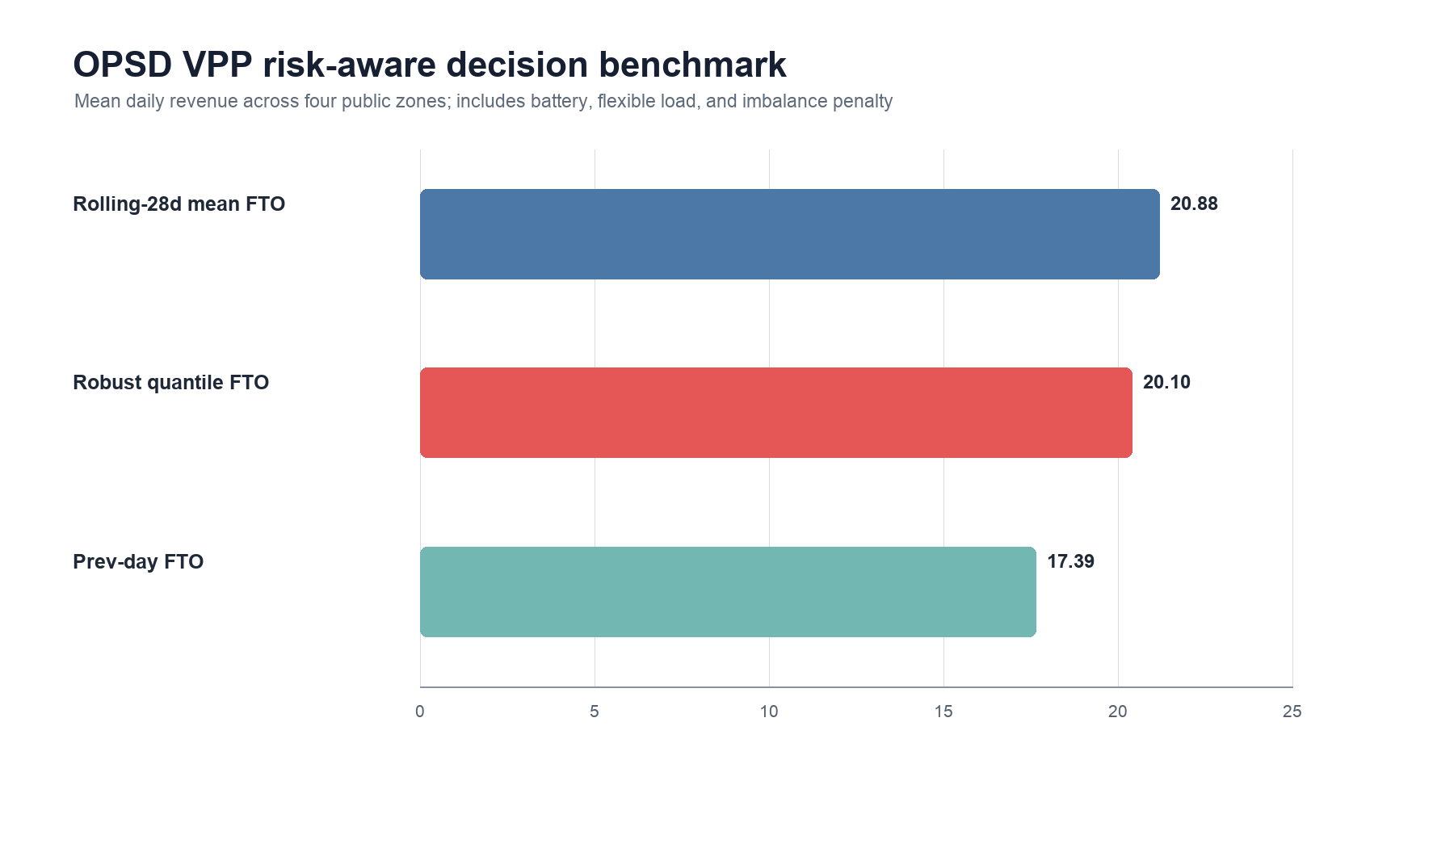
Figure 2. OPSD VPP extended risk simulation: average daily revenue by implementable policy.
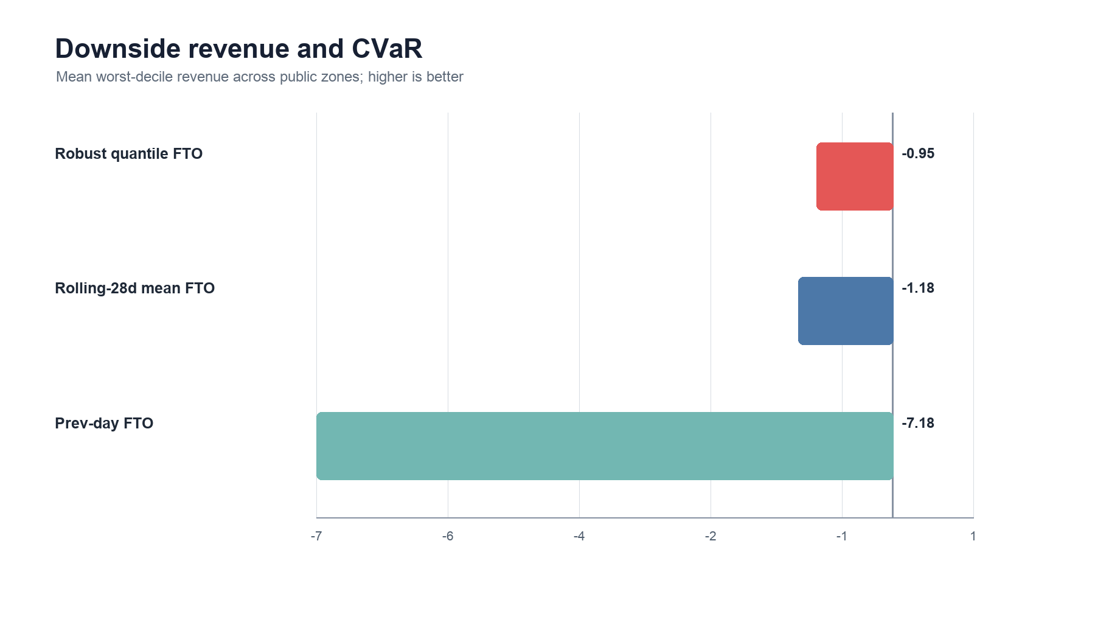
Figure 3. OPSD VPP extended risk simulation: worst-decile revenue CVaR by implementable policy.
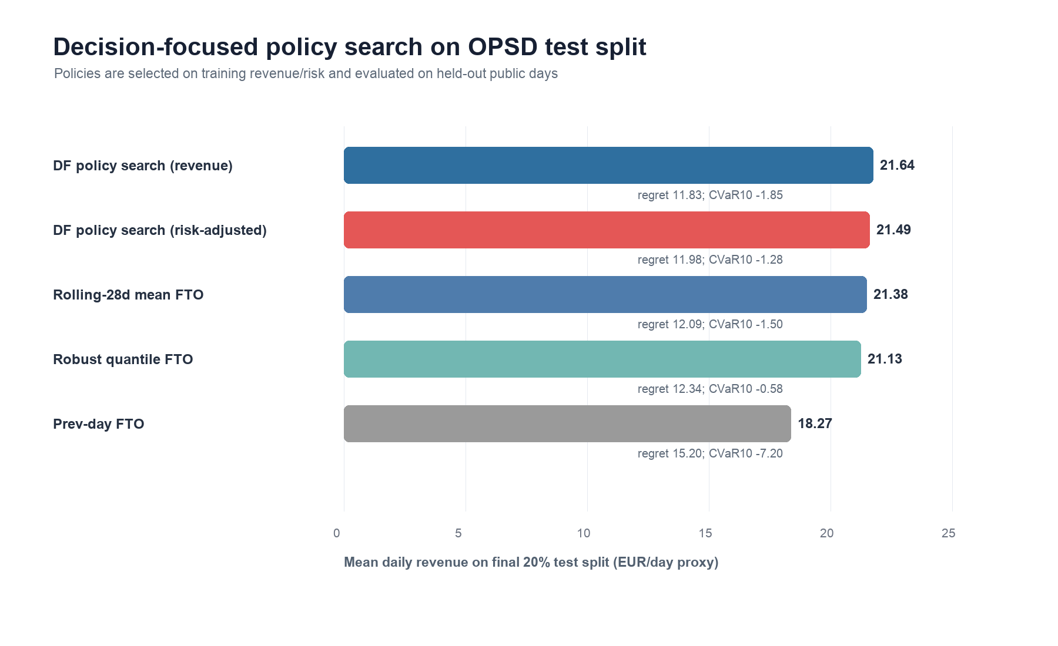
Figure 4. OPSD decision-focused policy search on held-out public test days.
Table 6 reports the forecast-coupled experiment that connects the first two manuscripts to the VPP decision simulator. Paper 1 supplies the hourly price point forecast and regime-conformal interval. Paper 2 supplies the load-forecasting interface through a lag-calendar net-load model trained before the price-forecast test window. On the held-out forecast-coupled split, Paper1 point plus Paper2 net-load forecast-then-optimize substantially improves average revenue and regret relative to historical rolling and robust baselines. The forecast-coupled decision-search policy gives the highest average revenue, while the conformal-interval policy is more conservative and is not the best average-revenue choice on this split. This result supports the dissertation-level linkage: better probabilistic price and load forecasts can be evaluated directly by downstream VPP value.
Method | Revenue | Regret | CVaR10 | Loss days | Penalty
Hindsight optimum | 36.104 | 0 | 14.151 | 0 | 0
Forecast-coupled DF (revenue) | 31.435 | 4.669 | 10.385 | 2 | 0.799
Paper1 point + Paper2 net FTO | 31.368 | 4.736 | 10.571 | 2 | 0.798
Forecast-coupled DF (risk-adjusted) | 31.250 | 4.854 | 10.128 | 2 | 0.793
Paper1 interval + Paper2 net FTO | 30.659 | 5.445 | 9.488 | 4 | 0.780
Rolling-28d mean FTO | 22.783 | 13.321 | -0.274 | 49 | 3.375
Robust quantile FTO | 22.318 | 13.787 | -0.387 | 43 | 3.244

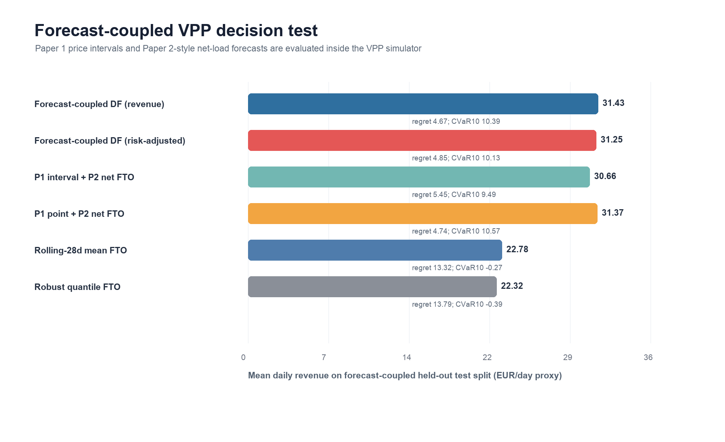
Figure 5. Forecast-coupled OPSD VPP decision test linking Paper 1 and Paper 2 forecasts to Paper 3.
Table 7 reports the risk-aversion sensitivity of the decision-focused policy-search objective. The policy is selected on the training and validation period by maximizing mean revenue plus lambda_r times CVaR10, then evaluated on the final held-out public test split. A moderate risk weight, lambda_r=0.25 or 0.50, reduces loss days from 115 to 110 and improves CVaR10 from -1.85 to -1.28 relative to revenue-only selection, at the cost of about 0.15 EUR/day proxy average revenue. Larger weights do not continue improving downside risk under the current coarse policy grid, so the paper reports the observed trade-off rather than claiming monotone risk improvement.
Lambda_r | Revenue | Regret | CVaR10 | Loss days | Penalty
0 | 21.639 | 11.831 | -1.853 | 115 | 3.392
0.250 | 21.487 | 11.983 | -1.276 | 110 | 3.402
0.500 | 21.487 | 11.983 | -1.276 | 110 | 3.402
0.750 | 21.371 | 12.099 | -1.741 | 112 | 3.424
1 | 21.371 | 12.099 | -1.741 | 112 | 3.424
1.500 | 21.371 | 12.099 | -1.741 | 112 | 3.424
2 | 21.371 | 12.099 | -1.741 | 112 | 3.424

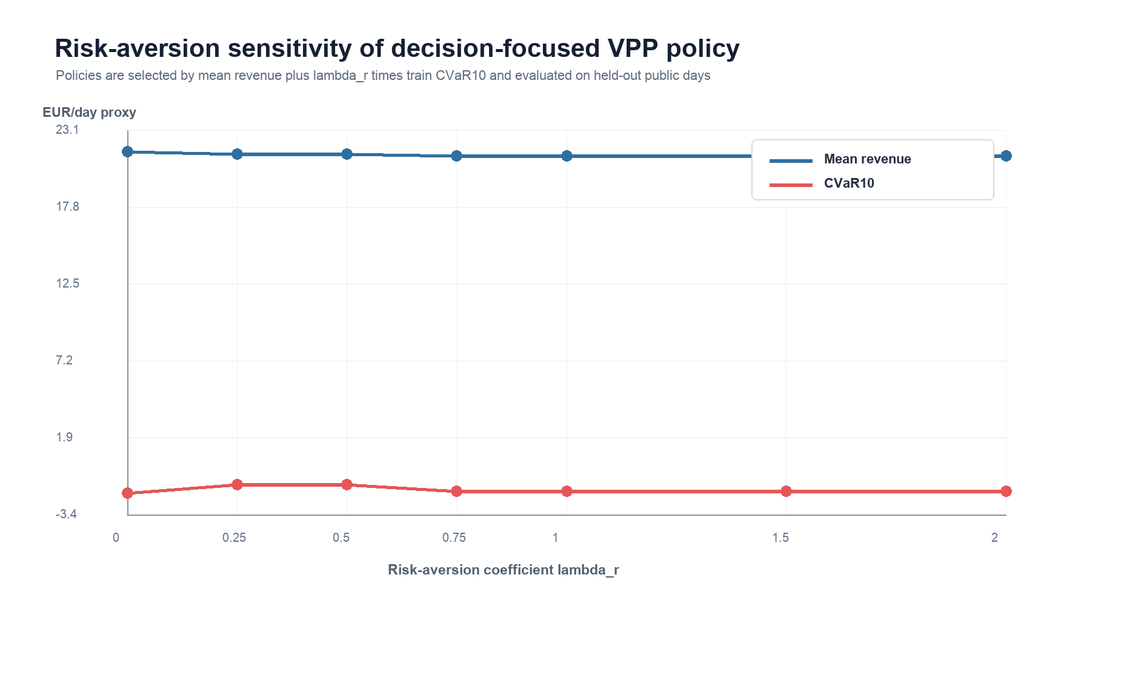
Figure 6. OPSD risk-aversion sensitivity of decision-focused VPP policy search.
Table 8 reports reviewer-facing settlement robustness checks. The base-settlement rows match the held-out decision-search test split in Table 5. The stress rows raise the imbalance-penalty rate from 45 to 70 EUR/MWh and add a 3 EUR/MWh transaction-cost proxy to all active charge/discharge and flexible-load operations. Under this harsher settlement, all implementable policies lose revenue, but the revenue-selected decision-focused policy remains the strongest average-revenue policy. The robust quantile FTO policy retains fewer loss days and a less negative CVaR10 than the decision-focused variants in the high-penalty stress case, which is useful reviewer evidence: the proposed decision-focused layer improves value, but explicit robust scheduling still matters under severe settlement penalties.
Scenario | Method | Revenue | Regret | CVaR10 | Loss days | Txn penalty
Base settlement | DF policy search (revenue) | 21.639 | 11.831 | -1.853 | 115 | 0
Base settlement | DF policy search (risk-adjusted) | 21.487 | 11.983 | -1.276 | 110 | 0
Base settlement | Rolling-28d mean FTO | 21.381 | 12.089 | -1.500 | 110 | 0
Base settlement | Robust quantile FTO | 21.128 | 12.342 | -0.585 | 97 | 0
High penalty + transaction cost | DF policy search (revenue) | 10.154 | 13.716 | -14.125 | 386 | 9.600
High penalty + transaction cost | DF policy search (risk-adjusted) | 9.997 | 13.873 | -13.488 | 388 | 9.600
High penalty + transaction cost | Rolling-28d mean FTO | 9.869 | 14.001 | -13.805 | 386 | 9.600
High penalty + transaction cost | Robust quantile FTO | 9.697 | 14.173 | -12.558 | 365 | 9.600

Table 9 reports the fine-grid check around the selected decision-focused policies. The refinement grid does not overturn the coarse-grid ranking: the coarse revenue-selected policy remains the best average-revenue variant, while the coarse risk-adjusted policy remains the strongest CVaR10 variant among the decision-focused grid checks. This reduces the risk that the paper's decision-search conclusion is an artifact of an overly coarse coefficient grid.
Grid | Revenue | Regret | CVaR10 | Loss days | Penalty
Coarse revenue grid | 21.639 | 11.831 | -1.853 | 115 | 3.392
Fine revenue grid | 21.553 | 11.916 | -1.693 | 116 | 3.394
Coarse risk-adjusted grid | 21.487 | 11.983 | -1.276 | 110 | 3.402
Fine risk-adjusted grid | 21.441 | 12.029 | -1.777 | 113 | 3.416

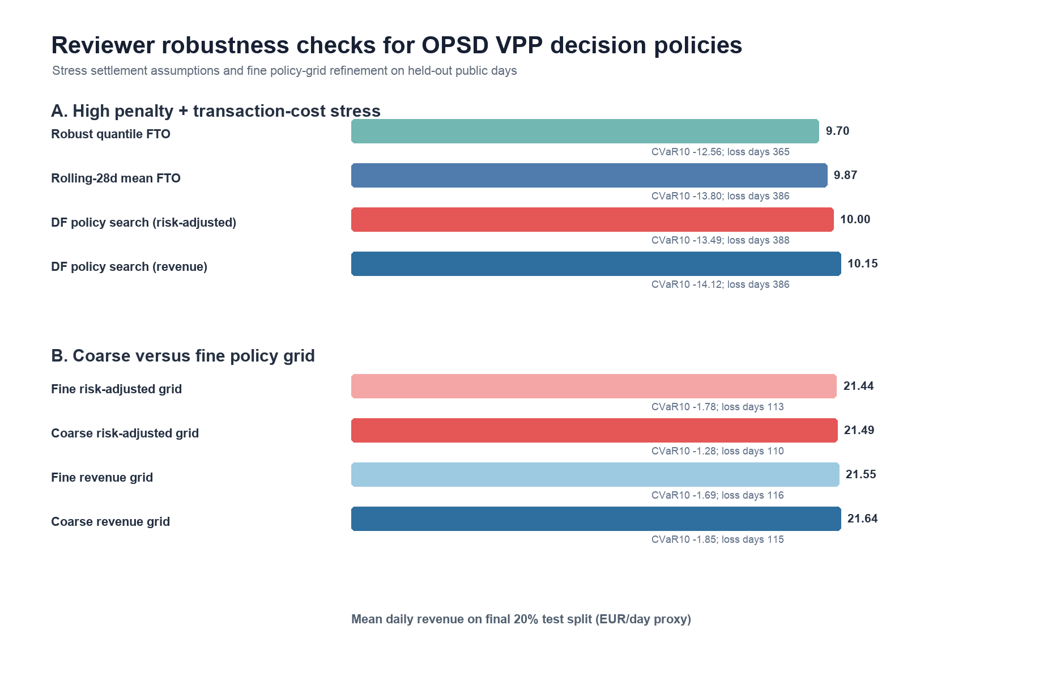
Figure 7. OPSD reviewer robustness checks for settlement stress and fine policy-grid refinement.

6.7 Fuzzy soft-computing baseline check
To make the Applied Soft Computing fit explicit, an additional fuzzy risk-aware FTO comparator is evaluated on the same OPSD held-out test split. The comparator uses three transparent membership signals: rolling historical price level, rolling price volatility, and normalized net-load shape. It increases discharge priority when price and net-load memberships are high, increases charge priority when price membership is low, and penalizes high-volatility hours in both directions. This baseline is deliberately simple and fully auditable; it is not tuned after seeing the test set.
The fuzzy risk-aware comparator reaches 11.342 EUR/day proxy revenue, 22.128 regret, -4.968 CVaR10, 259 loss days, and 3.295 average imbalance penalty. Rolling-28d mean FTO and robust quantile FTO remain stronger on average revenue, at 21.381 and 21.128 EUR/day respectively, while fuzzy risk-aware FTO improves downside revenue relative to previous-day FTO (-4.968 versus -7.197 CVaR10). The result is therefore negative but informative: a soft-computing heuristic can encode interpretable risk preference, yet interpretability alone does not guarantee superior market value. This finding strengthens the manuscript's central claim that VPP bidding should be evaluated by downstream decision quality rather than by the presence of a particular forecasting or heuristic family.

6.8 Constrained Q-learning policy-learning boundary
Table 10 adds a constrained tabular Q-learning baseline to address the natural reviewer question of whether a reinforcement-learning style policy learner should replace the auditable decision-focused policy search. The Q-learning baseline observes only rolling historical price, volatility, net-load-shape bins, hour block, and remaining charge/discharge counts. It is trained on chronological training and validation days, then frozen for the final 20 percent public test split. The result is deliberately reported even though it is negative.
Table 10 reports the constrained Q-learning boundary check on the final OPSD test split. The discretized policy improves over the no-action baseline but remains below the transparent forecast-then-optimize and continuous search policies, showing that policy-learning capacity alone is not sufficient under this information boundary.
Method | Revenue | Regret | CVaR10 | Loss days | Penalty
DF policy search (revenue) | 21.639 | 11.831 | -1.853 | 115 | 3.392
Robust quantile FTO | 21.128 | 12.342 | -0.585 | 97 | 3.295
Fuzzy risk-aware FTO | 11.342 | 22.128 | -4.968 | 259 | 3.295
Constrained Q-learning policy | -5.655 | 39.125 | -24.534 | 1034 | 3.352

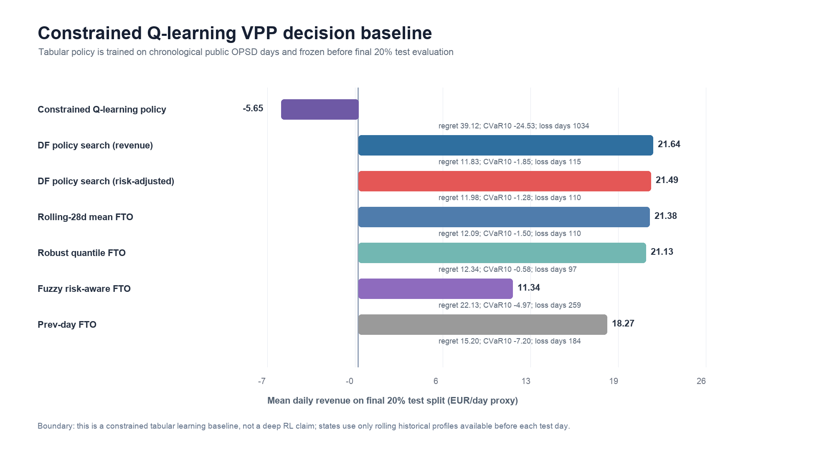
Figure 8. Constrained tabular Q-learning exposes the policy-learning boundary on the OPSD VPP test split, where discretized value learning is benchmarked against transparent revenue and risk baselines without claiming neural-RL superiority.
The constrained Q-learning policy loses to the revenue-selected decision-focused policy on 1280 of 1378 paired test days, with a mean revenue deficit of 27.379 EUR/day and an exact two-sided sign-test p-value below 1e-250. The result is not hidden because it clarifies the scope of the contribution: under the current public simulator and compact state representation, a transparent coefficient-search policy is more reliable than a tabular policy learner.

6.9 Genetic soft-computing policy search
Table 11 adds a genetic soft-computing policy-search baseline to test whether continuous evolutionary coefficient selection improves the auditable decision layer. The genetic search evolves the four charge/discharge scoring coefficients over a bounded continuous space. To keep the protocol reproducible, each zone uses deterministic initialization, 24 individuals, 14 generations, elitist tournament selection, Gaussian mutation, and a chronological training-plus-validation selection period. For long zones, selection uses a deterministic 720-day equidistant subset from the training-plus-validation period; all reported metrics are then evaluated on the complete final 20 percent held-out test split.
Table 11 reports the genetic soft-computing policy-search comparison on the final OPSD test split. The risk-adjusted genetic search improves downside stability relative to several simpler rules, while the result remains bounded by the stronger continuous-search and hindsight references.
Method | Revenue | Regret | CVaR10 | Loss days | Penalty
Genetic policy search (risk-adjusted) | 21.653 | 11.817 | -1.390 | 111 | 3.393
DF policy search (revenue) | 21.639 | 11.831 | -1.853 | 115 | 3.392
Genetic policy search (revenue) | 21.626 | 11.844 | -1.764 | 114 | 3.395
DF policy search (risk-adjusted) | 21.487 | 11.983 | -1.276 | 110 | 3.402
Robust quantile FTO | 21.128 | 12.342 | -0.585 | 97 | 3.295
Fuzzy risk-aware FTO | 11.342 | 22.128 | -4.968 | 259 | 3.295
Constrained Q-learning policy | -5.655 | 39.125 | -24.534 | 1034 | 3.352

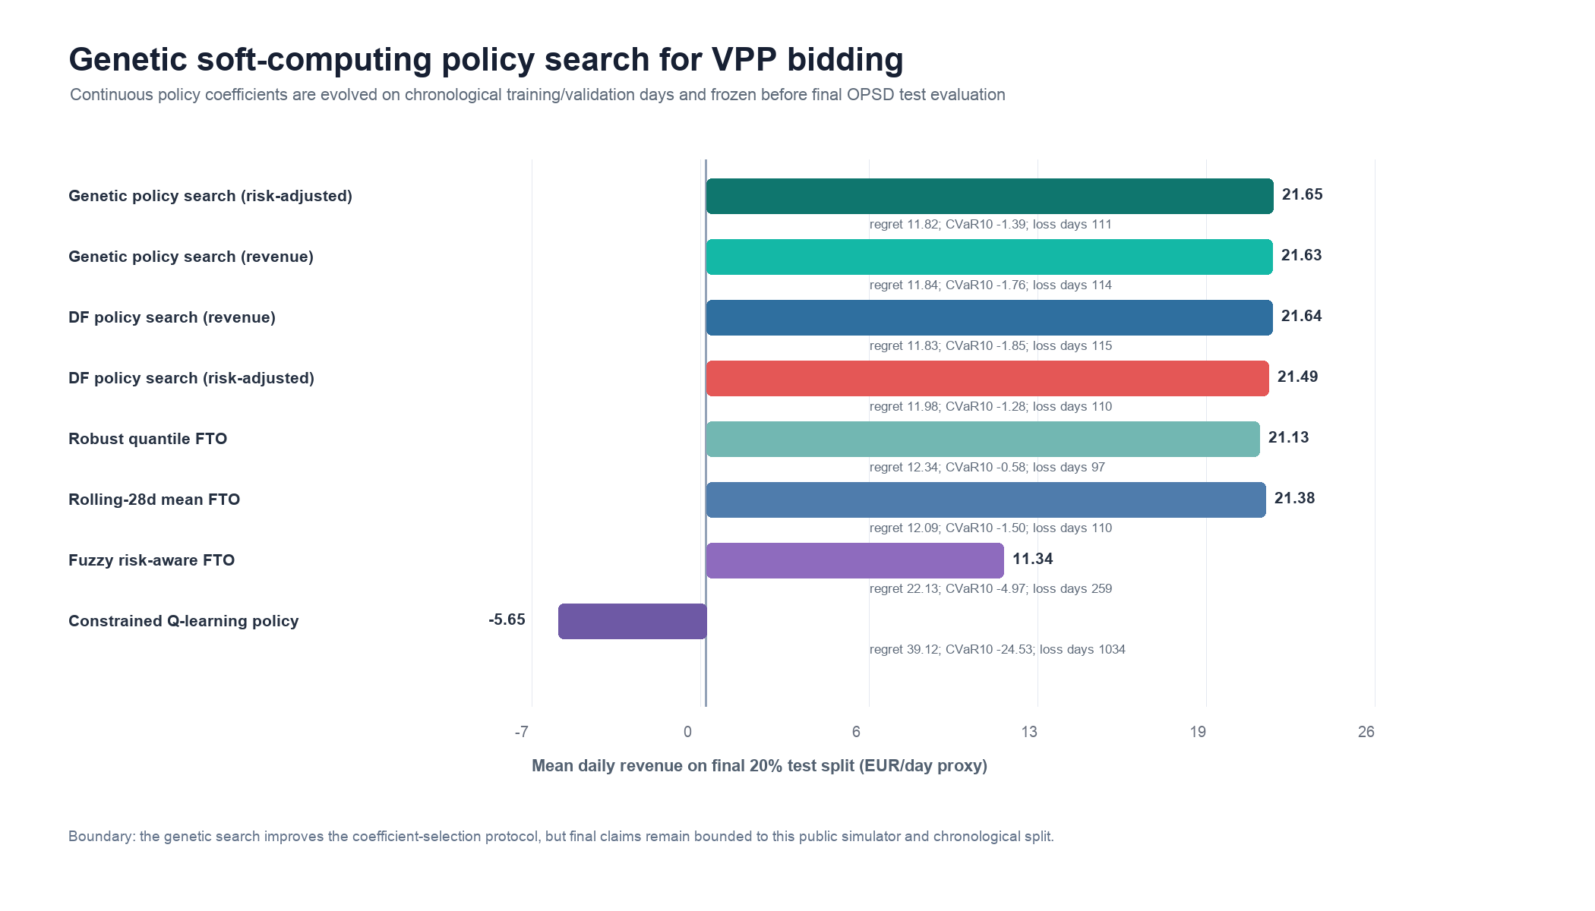
Figure 9. Genetic soft-computing policy search on the OPSD VPP test split, comparing revenue and risk-adjusted evolutionary objectives against transparent baselines and hindsight decision value.
The genetic policy-search result is intentionally interpreted as a bounded improvement, not as a universal optimizer claim. The risk-adjusted genetic search reaches 21.653 EUR/day proxy revenue, slightly above the coarse revenue-selected decision-focused grid at 21.639 EUR/day, and improves CVaR10 relative to that grid from -1.853 to -1.390. The paired sign test against the revenue-selected grid is not significant because most daily schedules are identical or nearly identical under the two coefficient sets. The contribution is therefore methodological rather than promotional: a continuous soft-computing search can refine the auditable coefficient-selection layer, but the effect size is small and should be read together with robust quantile scheduling, fuzzy interpretability, and the Q-learning boundary check.

6.10 Multi-seed genetic-search stability
Table 12 reports the risk-adjusted genetic coefficient search with eight independent seeds under the same chronological selection and held-out test protocol. Across seeds, mean held-out revenue is 21.543 EUR/day proxy with standard deviation 0.078, and mean CVaR10 is -1.530 with standard deviation 0.163. Only 1/8 seeds matches or exceeds the coarse-grid revenue-selected policy in average revenue, but the seed-average CVaR10 remains less negative than the coarse-grid revenue-selected policy (-1.853). The result supports genetic search as a risk-stability refinement rather than an assured revenue maximization method.
Metric | Value | Interpretation
Seeds | 8 | Independent genetic-search runs under the same chronological protocol
Mean revenue across seeds | 21.543 EUR/day | Stable but slightly below the single coarse-grid revenue baseline on average
Revenue standard deviation | 0.078 EUR/day | Low seed sensitivity for the selected search design
Revenue range | 21.425 to 21.648 EUR/day | One seed exceeds the coarse-grid revenue-selected policy
Mean CVaR10 across seeds | -1.530 | Better downside profile than the revenue-selected coarse grid
CVaR10 range | -1.753 to -1.267 | Risk performance varies, but stays near the intended risk-adjusted boundary

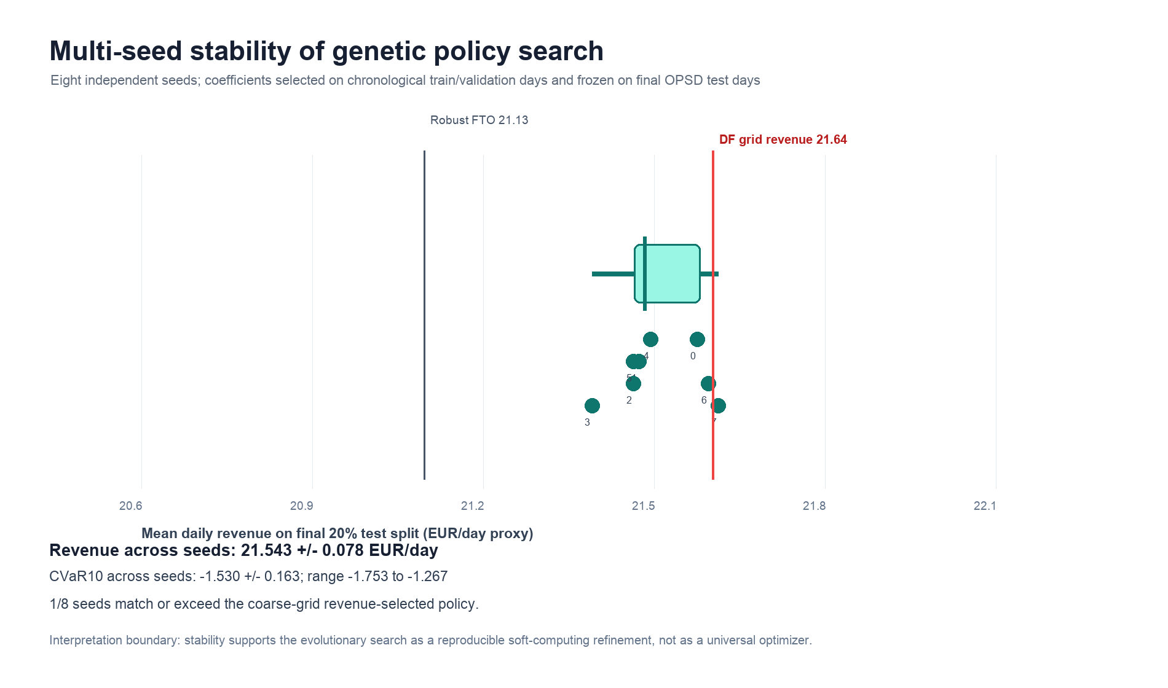
Figure 10. Multi-seed stability of genetic soft-computing policy search, summarizing held-out revenue and CVaR variability across independent seeds to separate reproducible refinement from single-run luck.
The multi-seed result strengthens the ASOC positioning because it turns the evolutionary component into an auditable stochastic-search experiment rather than a single decorative optimizer. At the same time, it prevents overclaiming: the best seed can match the coarse grid, but the average seed does not dominate it in revenue. The value of the genetic layer is therefore a bounded soft-computing refinement that explores continuous policy coefficients, improves downside behavior relative to the revenue-only coarse grid, and exposes the trade-off between mean revenue and CVaR under repeated random initialization.

6.11 Particle-swarm policy-search check
A separate particle-swarm optimization (PSO) check tests whether the continuous soft-computing result depends on the genetic operators. PSO searches the same four policy coefficients, uses the same chronological train-plus-validation selection period, and freezes the selected coefficients before the final held-out OPSD test split. The risk-adjusted PSO policy reaches 21.596 EUR/day proxy revenue, 11.874 regret, -1.741 CVaR10, and 113 loss days. The revenue-only PSO policy reaches 21.602 EUR/day proxy revenue and -1.967 CVaR10. Thus PSO is close to the decision-focused and genetic policies, but it does not exceed the risk-adjusted genetic search at 21.653 EUR/day proxy revenue and -1.390 CVaR10.
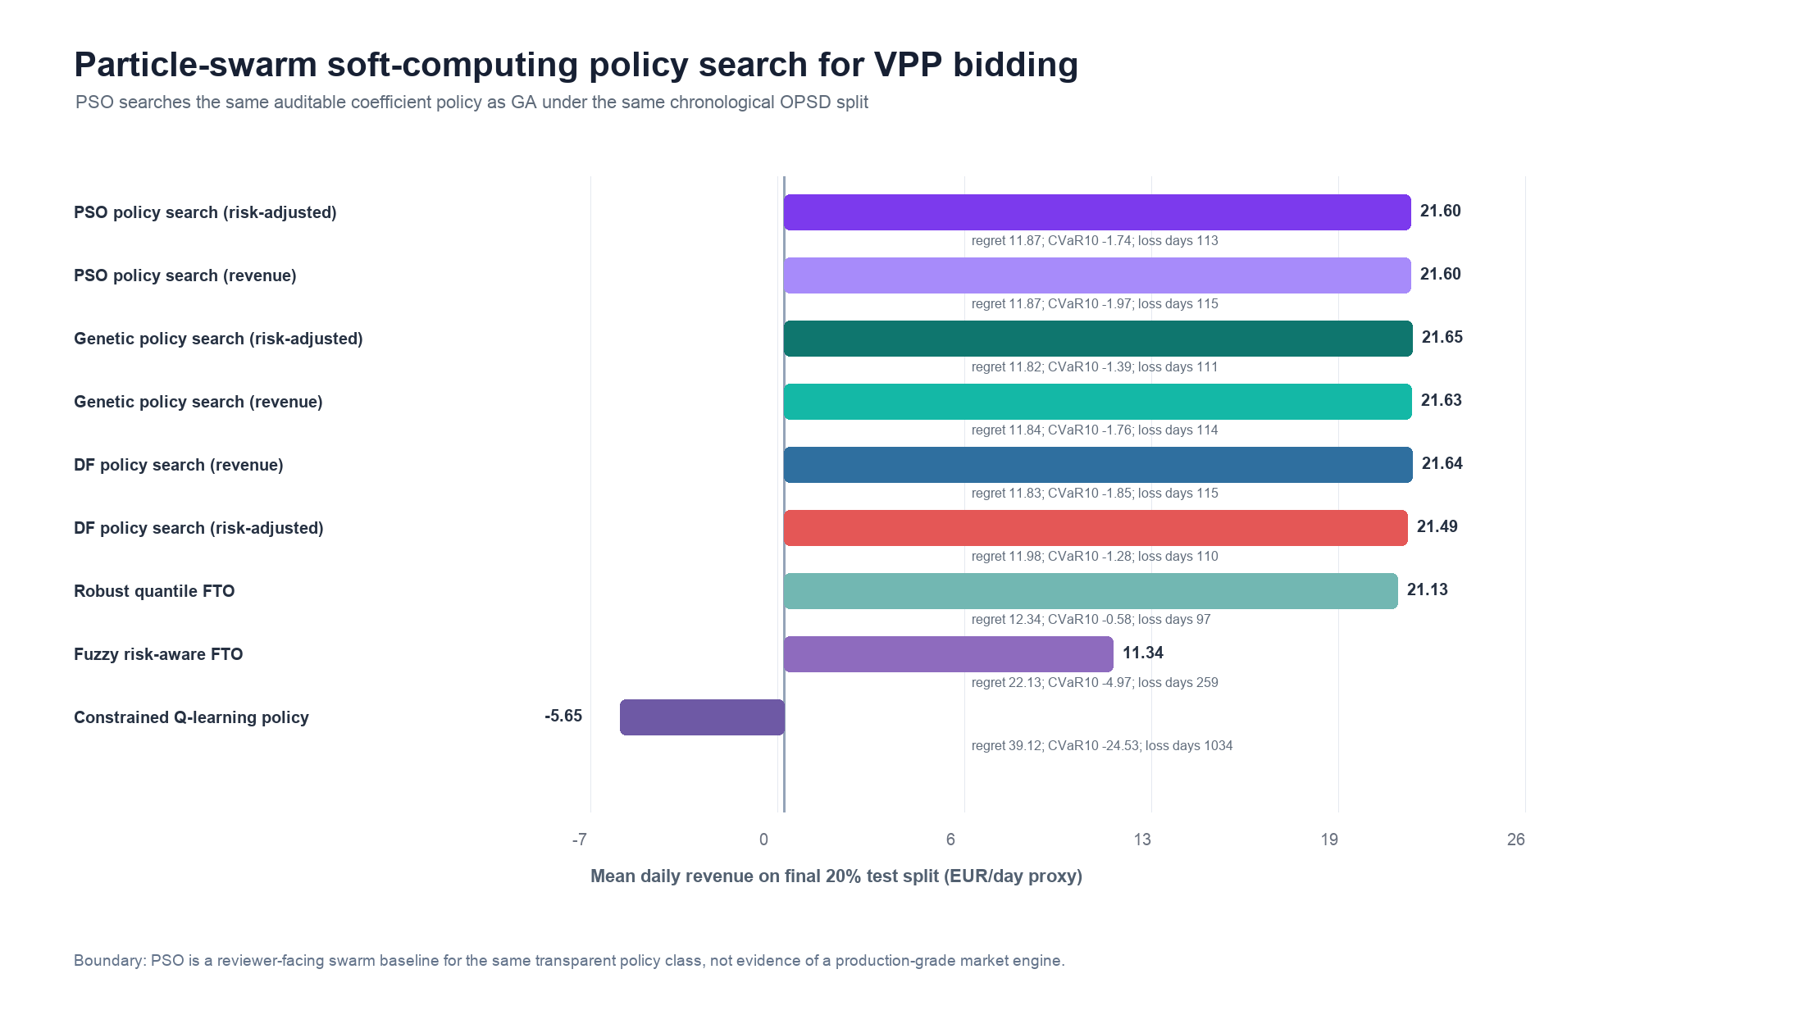
Figure 11. Particle-swarm soft-computing policy search on the OPSD VPP test split, providing a second population-based continuous-search baseline for revenue, regret, and downside-risk comparison.
This result is useful precisely because it is not a promotional win. PSO confirms that a second swarm-intelligence optimizer can recover a competitive transparent policy in the same coefficient class, while the genetic search remains the strongest reported continuous-search variant. The paper therefore claims a reproducible soft-computing policy-search layer, not that any single metaheuristic universally dominates the decision grid.

6.12 Differentiable surrogate-policy baseline
To address whether a learning-style differentiable policy layer changes the conclusion, Table 13 adds a lightweight surrogate policy-gradient baseline. The surrogate uses the same chronological public OPSD split, but replaces discrete coefficient-grid selection with a differentiable soft-schedule objective. Charge and discharge probabilities are produced by softmax score functions over normalized rolling price, volatility, net-load shape, and intraday features. The soft objective approximates settlement revenue, imbalance penalty, charge-discharge overlap, and a revenue-plus-CVaR risk term. After CPU-only NumPy training on a deterministic 192-day selection subset per zone, the learned scoring weights are frozen and evaluated through the same hard four-hour charge/discharge simulator as the other policies.
Table 13 reports the differentiable surrogate-policy comparison on the final OPSD test split. The lightweight surrogate improves substantially over tabular Q-learning but remains below the strongest GA and PSO policies, so it is used as reviewer-response evidence rather than as a superiority claim.
Method | Revenue | Regret | CVaR10 | Loss days | Penalty
Genetic policy search (risk-adjusted) | 21.653 | 11.817 | -1.390 | 111 | 3.393
PSO policy search (risk-adjusted) | 21.596 | 11.874 | -1.741 | 113 | 3.400
DF policy search (revenue) | 21.639 | 11.831 | -1.853 | 115 | 3.392
Surrogate policy-gradient (risk-adjusted) | 21.265 | 12.205 | -2.555 | 123 | 3.390
Surrogate policy-gradient (revenue) | 20.939 | 12.531 | -3.001 | 132 | 3.422
Fuzzy risk-aware FTO | 11.342 | 22.128 | -4.968 | 259 | 3.295
Constrained Q-learning policy | -5.655 | 39.125 | -24.534 | 1034 | 3.352

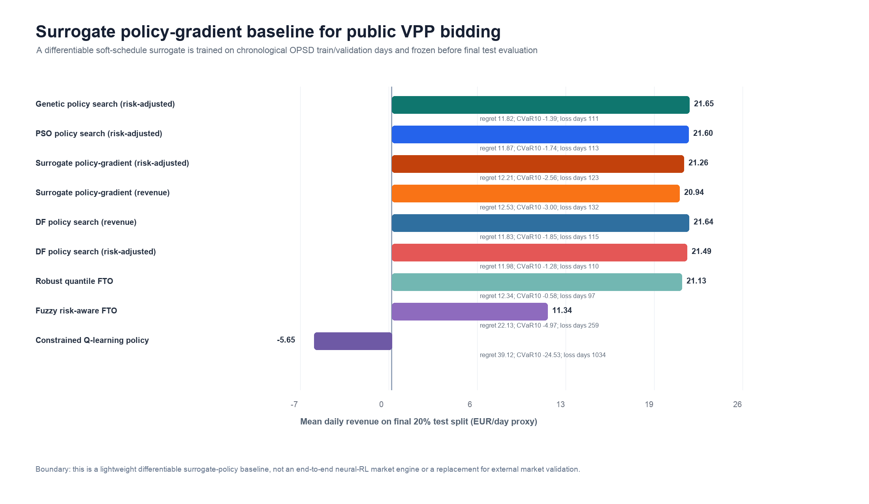
Figure 12. Differentiable surrogate policy-gradient baseline on the OPSD VPP test split, showing how a lightweight gradient-updated policy compares with GA, PSO, Q-learning, and transparent decision baselines under the same chronological holdout.
The surrogate result is deliberately reported as a bounded reviewer-response experiment. The risk-adjusted surrogate reaches 21.265 EUR/day proxy revenue, which is below the genetic and PSO searches but above the fuzzy and constrained Q-learning baselines. Against the genetic risk-adjusted policy, the paired test gives 371 wins, 426 losses, and 581 ties, with a mean revenue delta of -0.331 EUR/day. This indicates that a lightweight differentiable surrogate is competitive enough to be informative, but it does not replace the stronger continuous soft-computing search in this public simulator. The conclusion therefore becomes stricter: learning-style policy evidence has been tested, and the current data support GA/PSO-style transparent coefficient search as the stronger auditable choice.

6.13 GIS infrastructure-context check
The decision simulator is intentionally public and compact, but the application setting is not small. A separate GIS evidence audit was therefore built from local copies of China power-transmission snapshots, OSM-derived mainland power-grid extracts, WRI China power-plant GeoJSON, and GEM China integrated-power tracker tables. The audit is not used to train the OPSD/UCI journal baselines and is not redistributed as raw data in the paper supplement. Its role is to test whether the VPP decision problem has a realistic resource-network motivation beyond a toy arbitrage example.
The 2025 grid snapshot contains 12,839 transmission-line records, 2,041 substation records, and 9,444 grid-link records. Across the available snapshots, the 2015-to-2025 transmission-line record count increases by 610.122%, while grid-link records increase by 114.588%, which supports the use of time-aware validation rather than a static infrastructure assumption. The OSM mainland extraction profiles 4.87 million power-grid records, including 216,700 line records and 194,613 generator points; renewable-or-storage source tags account for 98.832% of the generator-point table under the derived-summary denominator. WRI contributes 4,274 China power-plant records and a 25.407% renewable capacity share, while the GEM integrated tracker represents about 3,108.9 GW of operating capacity in the local China table and a 56.412% broad variable-or-dispatchable context share. Figure 13 summarizes the network-scale evidence and the high-voltage share visible in the transmission and substation layers. These statistics support the paper's framing of VPP bidding as a computer-science decision-learning problem under heterogeneous, dynamic, large-scale infrastructure context, while keeping the submitted numerical claims on the reproducible public OPSD simulator.
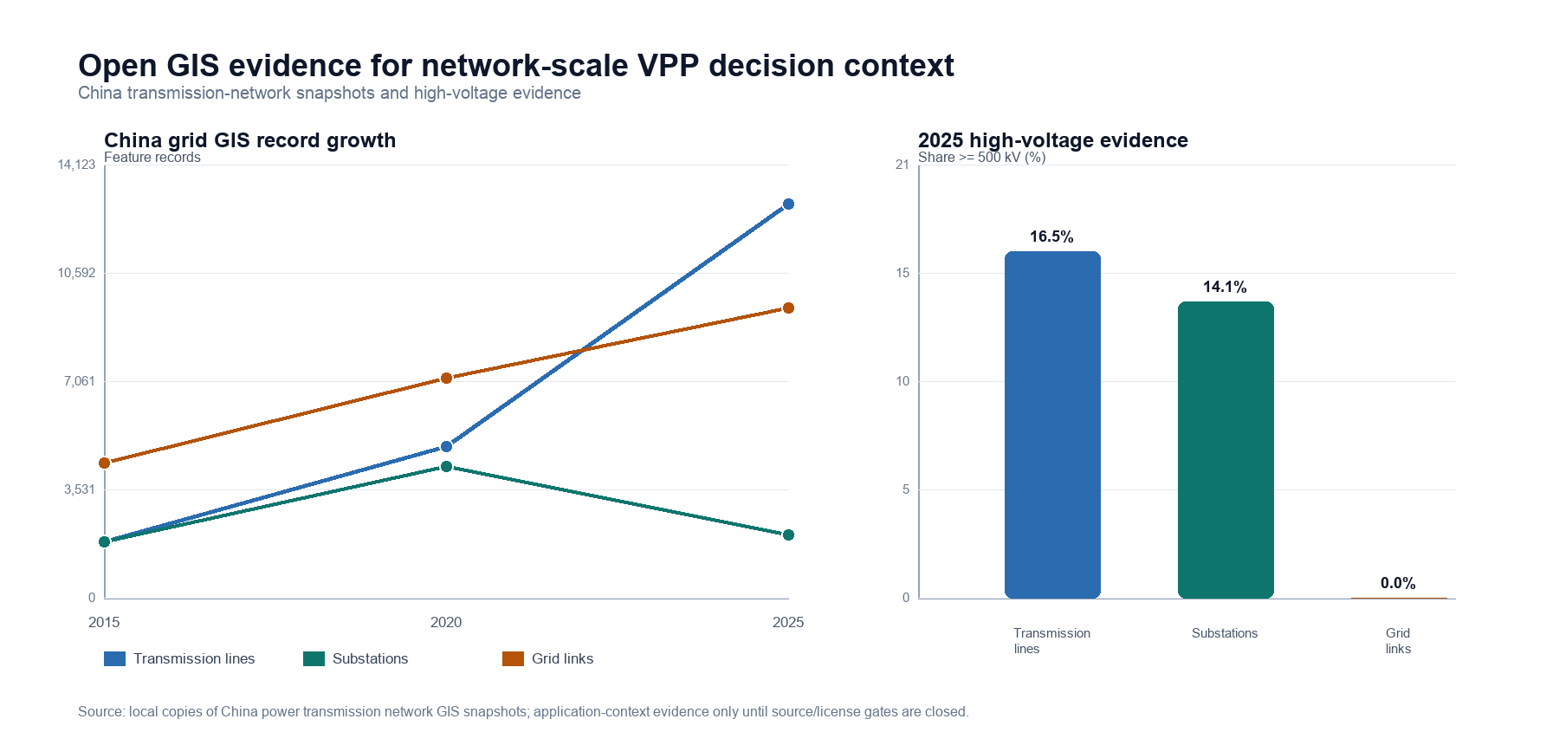
Figure 13. Open GIS evidence for network-scale VPP decision context, summarizing China grid snapshot scale and high-voltage shares as external scenario evidence while excluding raw GIS files from the public supplement.
The decision results are deterministic chronological hold-out simulation metrics rather than inferential p-values. The evidence should be read through out-of-sample ranking, downside-risk behavior, and settlement-stress robustness, not through significance testing across exchangeable samples. This is appropriate for the public simulator because the daily market scenarios are temporally ordered, policy coefficients are frozen before held-out evaluation, and the goal is to compare auditable decision protocols under identical settlement rules.

7. Conclusion
This paper studies decision-focused learning for virtual power plant bidding under electricity price and load uncertainty through a public, auditable forecast-to-decision simulator. By connecting probabilistic price and net-load forecast signals to policy-search objectives, the method evaluates predictive representations by market-operation outcomes rather than by forecasting error alone. The empirical evaluation emphasizes revenue, regret, downside risk, imbalance penalties, risk-aversion sensitivity, and settlement robustness. The work contributes bounded evidence for computer-science research on predict-and-optimize learning while addressing a practical virtual power plant decision problem.

Appendix A. Simulator and Reproducibility Details

A.1 Public simulator information boundary
The simulator uses chronological OPSD price, load, wind, and solar variables to evaluate forecast-then-optimize and policy-search decisions under a declared information boundary. Policy coefficients are selected only on training and validation periods and are frozen before the final held-out test split. Realized prices and net-load values are used for settlement evaluation and hindsight upper-bound construction, not for selecting the implementable test policy.

A.2 Resource and settlement abstraction
The public VPP abstraction includes a finite battery, flexible load shifting, charge and discharge limits, efficiency losses, transaction-cost proxies, and imbalance penalties. The simulator is intentionally compact so that the forecast-to-decision relationship can be audited. It does not claim to reproduce a full production market engine, network-constrained dispatch system, or confidential commercial settlement platform.

A.3 Risk and regret metrics
Daily revenue is computed after applying the selected schedule to held-out settlement prices and net-load conditions. Regret is the difference between the hindsight daily value and the implementable policy value under the same public simulator. CVaR10 is the mean of the worst decile of daily revenues and is used as the downside-risk statistic for risk-aware selection.

A.4 Forecast-coupled interface to Papers 1 and 2
The forecast-coupled experiment uses the price-forecasting and load-forecasting outputs from the preceding manuscripts as decision inputs. This appendix reports the interface at the level required for reproducibility: the forecasts are generated before held-out decision evaluation, then passed to the same VPP simulator used by the transparent baselines.

A.5 Fuzzy risk-aware and constrained Q-learning baselines
The fuzzy comparator uses transparent price-level, volatility, and net-load-shape memberships. The constrained Q-learning comparator uses discretized state bins, remaining action counts, and chronological train/validation learning before frozen test evaluation. Both are reported to define the boundary of soft-computing and policy-learning evidence, not to claim universal superiority.

A.6 Genetic soft-computing policy search
The genetic policy-search baseline uses the same four-coefficient scoring form as the decision-focused grid, but searches a bounded continuous coefficient space. The bounds are a_c, a_d in [-1.50, 1.50] and b_c, b_d in [-10.0, 10.0]. Each zone uses deterministic seeding, 24 individuals, 14 generations, five elites, tournament selection, convex parent mixing, Gaussian mutation, and occasional coordinate resampling. The revenue version maximizes mean selection-period revenue; the risk-adjusted version maximizes mean revenue plus 0.50 times CVaR10. For long zones, coefficient selection uses a deterministic 720-day equidistant subset of the chronological training-plus-validation period to keep the search reproducible and computationally bounded. Final reported metrics always use the complete final 20 percent held-out public test split.
The multi-seed stability check reruns only the risk-adjusted genetic search because it is the stochastic component most relevant to the paper's soft-computing claim. It uses eight independent seed offsets, the same population size, the same generation count, the same coefficient bounds, and the same chronological train/validation/test split. The output files opsd_genetic_policy_multiseed_stability_by_seed.csv, opsd_genetic_policy_multiseed_stability_by_zone.csv, opsd_genetic_policy_multiseed_stability_coefficients.csv, and opsd_genetic_policy_multiseed_stability_summary.csv document seed-level revenues, downside risk, coefficients, and summary statistics.

A.7 Particle-swarm policy-search check
The particle-swarm baseline uses the same four-coefficient score policy as the decision-focused grid and genetic search, but replaces crossover/mutation with swarm velocity updates, personal bests, and a global best. Each zone uses 22 particles, 16 iterations, inertia 0.58, cognitive weight 1.28, social weight 1.42, the same coefficient bounds as the genetic search, and the same chronological selection subset cap of 720 train-plus-validation days. The PSO output files opsd_pso_policy_search_vpp_daily.csv, opsd_pso_policy_search_vpp_summary.csv, opsd_pso_policy_search_vpp_test_aggregate.csv, opsd_pso_policy_search_vpp_coefficients.csv, and opsd_pso_policy_search_vpp_paired_tests.csv document the full comparison. The intended interpretation is bounded: PSO is a competitive independent swarm check, not a new best policy over the genetic risk-adjusted variant.

A.8 Differentiable surrogate-policy baseline
The surrogate policy-gradient baseline uses a CPU-only NumPy implementation and does not train an end-to-end price or load forecaster. For each day, normalized rolling price mean, rolling price volatility, rolling net-load shape, sine/cosine hour features, and a bias term feed separate charge and discharge score functions. A temperature-controlled softmax converts these scores into soft four-hour charge and discharge weights. The training objective approximates daily settlement value, imbalance penalty, charge-discharge overlap, and a revenue-plus-CVaR risk term. Numerical finite-difference gradients and an Adam-style update are run for 36 iterations on a deterministic 192-day selection subset per zone; the final hard-schedule evaluation still uses the same four-charge and four-discharge simulator as the other methods. Output files opsd_surrogate_policy_gradient_vpp_daily.csv, opsd_surrogate_policy_gradient_vpp_summary.csv, opsd_surrogate_policy_gradient_vpp_test_aggregate.csv, opsd_surrogate_policy_gradient_vpp_coefficients.csv, opsd_surrogate_policy_gradient_vpp_training_trace.csv, and opsd_surrogate_policy_gradient_vpp_paired_tests.csv document the result and training trace. This baseline tests a differentiable policy family without claiming neural-RL superiority or gradient propagation into the forecasting models.

A.9 Metrics and scripts
The reproducibility package includes public processed data, deterministic scripts, result CSV files, figure files, manifest hashes, and an audit report. The main scripts include run_opsd_vpp_risk_simulator.py, run_opsd_decision_focused_policy_search.py, run_opsd_forecast_coupled_vpp.py, run_opsd_risk_aversion_sensitivity.py, run_opsd_vpp_reviewer_robustness.py, run_opsd_fuzzy_risk_vpp_baseline.py, run_opsd_constrained_q_learning_vpp_baseline.py, run_opsd_genetic_policy_search_vpp_baseline.py, run_opsd_genetic_policy_multiseed_stability.py, run_opsd_pso_policy_search_vpp_baseline.py, run_opsd_surrogate_policy_gradient_vpp_baseline.py, build_paper3_supplement_package.py, and verify_paper3_supplement_package.py.

Data Availability
The public reproducibility layer is based on the Open Power System Data time-series package and is bundled as a public-data-only supplementary package containing processed public data, scripts, result CSV files, figures, reference assets, requirements, manifest hashes, and an audit report. The first submission may upload this package as supplementary material; after author approval, the same public package should be deposited in a citable repository such as Zenodo or OSF and cited in the final article. Local Hunan and Shandong operational records are not redistributed because they are non-public application-context data. The GIS infrastructure-context audit uses local copies of open or externally sourced grid/resource metadata only as background evidence; raw OSM/GEM/GIS files are not included in the journal supplement until source-page, attribution, and redistribution gates are confirmed.

CRediT Authorship Contribution Statement
zhijie REN: Conceptualization, Methodology, Software, Validation, Formal analysis, Investigation, Data curation, Writing - original draft, Writing - review and editing, Visualization.

Declaration of Competing Interest
The author declares that there are no known competing financial interests or personal relationships that could have appeared to influence the work reported in this paper.

Funding
This research did not receive any specific grant from funding agencies in the public, commercial, or not-for-profit sectors.

Declaration of Generative AI and AI-Assisted Technologies in the Manuscript Preparation Process
During the preparation of this work, the author used OpenAI ChatGPT/Codex to support manuscript organization, language editing, code documentation, and submission-checklist drafting. After using these tools, the author reviewed and edited the content as needed and takes full responsibility for the content of the submitted manuscript. The tools were not used as authors, did not determine the scientific conclusions, and were not used to create or alter figures, images, or graphical abstract artwork.

References
[1] Dimitris Bertsimas, Nathan Kallus, "From Predictive to Prescriptive Analytics", Management Science, vol. 66, no. 3, pp. 1025-1044, 2020, https://doi.org/10.1287/mnsc.2018.3253.
[2] Adam N. Elmachtoub, Paul Grigas, "Smart “Predict, then Optimize”", Management Science, vol. 68, no. 1, pp. 9-26, 2022, https://doi.org/10.1287/mnsc.2020.3922.
[3] Amos, Brandon, Kolter, J. Zico, "OptNet: Differentiable Optimization as a Layer in Neural Networks," Proceedings of the 34th International Conference on Machine Learning, 2017. https://proceedings.mlr.press/v70/amos17a.html.
[4] Donti, Priya L., Amos, Brandon, Kolter, J. Zico, "Task-based End-to-end Model Learning in Stochastic Optimization," Advances in Neural Information Processing Systems, 2017. https://papers.neurips.cc/paper/7132-task-based-end-to-end-model-learning-in-stochastic-optimization.
[5] Bryan Wilder, Bistra Dilkina, Milind Tambe, "Melding the Data-Decisions Pipeline: Decision-Focused Learning for Combinatorial Optimization", Proceedings of the AAAI Conference on Artificial Intelligence, vol. 33, no. 01, pp. 1658-1665, 2019, https://doi.org/10.1609/aaai.v33i01.33011658.
[6] R. Tyrrell Rockafellar, Stanislav Uryasev, "Optimization of conditional value-at-risk", The Journal of Risk, vol. 2, no. 3, pp. 21-41, 2000, https://doi.org/10.21314/JOR.2000.038.
[7] Stephen Boyd, Lieven Vandenberghe, "Convex Optimization", 2004, https://doi.org/10.1017/CBO9780511804441.
[8] Anastasios N. Angelopoulos, Stephen Bates, "Conformal Prediction: A Gentle Introduction", Foundations and Trends® in Machine Learning, vol. 16, no. 4, pp. 494-591, 2023, https://doi.org/10.1561/2200000101.
[9] Bryan Lim, Sercan Ö. Arık, Nicolas Loeff, Tomas Pfister, "Temporal Fusion Transformers for interpretable multi-horizon time series forecasting", International Journal of Forecasting, vol. 37, no. 4, pp. 1748-1764, 2021, https://doi.org/10.1016/j.ijforecast.2021.03.012.
[10] Jesus Lago, Grzegorz Marcjasz, Bart De Schutter, Rafał Weron, "Forecasting day-ahead electricity prices: A review of state-of-the-art algorithms, best practices and an open-access benchmark", Applied Energy, vol. 293, pp. 116983, 2021, https://doi.org/10.1016/j.apenergy.2021.116983.
[11] Tao Hong, Pierre Pinson, Shu Fan, Hamidreza Zareipour, Alberto Troccoli, Rob J. Hyndman, "Probabilistic energy forecasting: Global Energy Forecasting Competition 2014 and beyond", International Journal of Forecasting, vol. 32, no. 3, pp. 896-913, 2016, https://doi.org/10.1016/j.ijforecast.2016.02.001.
[12] Hossein Mohammadi Rouzbahani, Hadis Karimipour, Lei Lei, "A review on virtual power plant for energy management", Sustainable Energy Technologies and Assessments, vol. 47, pp. 101370, 2021, https://doi.org/10.1016/j.seta.2021.101370.
[13] Seyyed Mostafa Nosratabadi, Rahmat-Allah Hooshmand, Eskandar Gholipour, "A comprehensive review on microgrid and virtual power plant concepts employed for distributed energy resources scheduling in power systems", Renewable and Sustainable Energy Reviews, vol. 67, pp. 341-363, 2017, https://doi.org/10.1016/j.rser.2016.09.025.
[14] Hieu Trung Nguyen, Long Bao Le, Zhaoyu Wang, "A Bidding Strategy for Virtual Power Plants With the Intraday Demand Response Exchange Market Using the Stochastic Programming", IEEE Transactions on Industry Applications, vol. 54, no. 4, pp. 3044-3055, 2018, https://doi.org/10.1109/TIA.2018.2828379.
[15] Morteza Shafiekhani, Ali Badri, Miadreza Shafie-khah, João P.S. Catalão, "Strategic bidding of virtual power plant in energy markets: A bi-level multi-objective approach", International Journal of Electrical Power & Energy Systems, vol. 113, pp. 208-219, 2019, https://doi.org/10.1016/j.ijepes.2019.05.023.
[16] {Open Power System Data}, "Time series data package," Open Power System Data, 2020. https://data.open-power-system-data.org/time_series/2020-10-06/.
[17] L.A. Zadeh, "Fuzzy sets", Information and Control, vol. 8, no. 3, pp. 338-353, 1965, https://doi.org/10.1016/S0019-9958(65)90241-X.
[18] Tomohiro Takagi, Michio Sugeno, "Fuzzy identification of systems and its applications to modeling and control", IEEE Transactions on Systems, Man, and Cybernetics, vol. SMC-15, no. 1, pp. 116-132, 1985, https://doi.org/10.1109/TSMC.1985.6313399.
[19] J.-S.R. Jang, "ANFIS: adaptive-network-based fuzzy inference system", IEEE Transactions on Systems, Man, and Cybernetics, vol. 23, no. 3, pp. 665-685, 1993, https://doi.org/10.1109/21.256541.
[20] Samarjit Kar, Sujit Das, Pijush Kanti Ghosh, "Applications of neuro fuzzy systems: A brief review and future outline", Applied Soft Computing, vol. 15, pp. 243-259, 2014, https://doi.org/10.1016/j.asoc.2013.10.014.
[21] Ali T. Al-Awami, Nemer A. Amleh, Ammar M. Muqbel, "Optimal Demand Response Bidding and Pricing Mechanism With Fuzzy Optimization: Application for a Virtual Power Plant", IEEE Transactions on Industry Applications, vol. 53, no. 5, pp. 5051-5061, 2017, https://doi.org/10.1109/TIA.2017.2723338.
[22] José R. Vázquez-Canteli, Zoltán Nagy, "Reinforcement learning for demand response: A review of algorithms and modeling techniques", Applied Energy, vol. 235, pp. 1072-1089, 2019, https://doi.org/10.1016/j.apenergy.2018.11.002.
[23] Rafał Weron, "Electricity price forecasting: A review of the state-of-the-art with a look into the future", International Journal of Forecasting, vol. 30, no. 4, pp. 1030-1081, 2014, https://doi.org/10.1016/j.ijforecast.2014.08.008.
[24] Jakub Nowotarski, Rafał Weron, "Recent advances in electricity price forecasting: A review of probabilistic forecasting", Renewable and Sustainable Energy Reviews, vol. 81, pp. 1548-1568, 2018, https://doi.org/10.1016/j.rser.2017.05.234.
[25] Hrvoje Pandžić, Juan M. Morales, Antonio J. Conejo, Igor Kuzle, "Offering model for a virtual power plant based on stochastic programming", Applied Energy, vol. 105, pp. 282-292, 2013, https://doi.org/10.1016/j.apenergy.2012.12.077.
[26] Elaheh Mashhour, Seyed Masoud Moghaddas-Tafreshi, "Bidding Strategy of Virtual Power Plant for Participating in Energy and Spinning Reserve Markets—Part I: Problem Formulation", IEEE Transactions on Power Systems, vol. 26, no. 2, pp. 949-956, 2011, https://doi.org/10.1109/TPWRS.2010.2070884.
[27] Seyyed Mostafa Nosratabadi, Rahmat-Allah Hooshmand, Eskandar Gholipour, "Stochastic profit-based scheduling of industrial virtual power plant using the best demand response strategy", Applied Energy, vol. 164, pp. 590-606, 2016, https://doi.org/10.1016/j.apenergy.2015.12.024.
[28] Imran Rahman, Junita Mohamad-Saleh, "Hybrid bio-Inspired computational intelligence techniques for solving power system optimization problems: A comprehensive survey", Applied Soft Computing, vol. 69, pp. 72-130, 2018, https://doi.org/10.1016/j.asoc.2018.04.051.
[29] Wei Dong, Qiang Yang, Xinli Fang, Wei Ruan, "Adaptive optimal fuzzy logic based energy management in multi-energy microgrid considering operational uncertainties", Applied Soft Computing, vol. 98, pp. 106882, 2021, https://doi.org/10.1016/j.asoc.2020.106882.
[30] Enrico De Santis, Antonello Rizzi, Alireza Sadeghian, "Hierarchical genetic optimization of a fuzzy logic system for energy flows management in microgrids", Applied Soft Computing, vol. 60, pp. 135-149, 2017, https://doi.org/10.1016/j.asoc.2017.05.059.
[31] Jayanta Mandi, James Kotary, Senne Berden, Maxime Mulamba, Victor Bucarey, Tias Guns, Ferdinando Fioretto, "Decision-Focused Learning: Foundations, State of the Art, Benchmark and Future Opportunities", Journal of Artificial Intelligence Research, vol. 80, pp. 1623-1701, 2024, https://doi.org/10.1613/jair.1.15320.
[32] Hongchao Gao, Tai Jin, Cheng Feng, Chuyi Li, Qixin Chen, Chongqing Kang, "Review of virtual power plant operations: Resource coordination and multidimensional interaction", Applied Energy, vol. 357, pp. 122284, 2024, https://doi.org/10.1016/j.apenergy.2023.122284.
[33] Yuanzheng Li, Chaofan Yu, Mohammad Shahidehpour, Tao Yang, Zhigang Zeng, Tianyou Chai, "Deep Reinforcement Learning for Smart Grid Operations: Algorithms, Applications, and Prospects", Proceedings of the IEEE, vol. 111, no. 9, pp. 1055-1096, 2023, https://doi.org/10.1109/JPROC.2023.3303358.
[34] Aharon Ben-Tal, Laurent El Ghaoui, Arkadi Nemirovski, "Robust Optimization", 2009, https://doi.org/10.1515/9781400831050.
[35] John R. Birge, François Louveaux, "Introduction to Stochastic Programming", Springer Series in Operations Research and Financial Engineering, 2011, https://doi.org/10.1007/978-1-4614-0237-4.

