Documentation For Usage Of CSC468P1
Mammoth Site Kiosk Software

Upon starting the application the user will see a blank window with a menu bar on the top for selecting the data you wish to display.
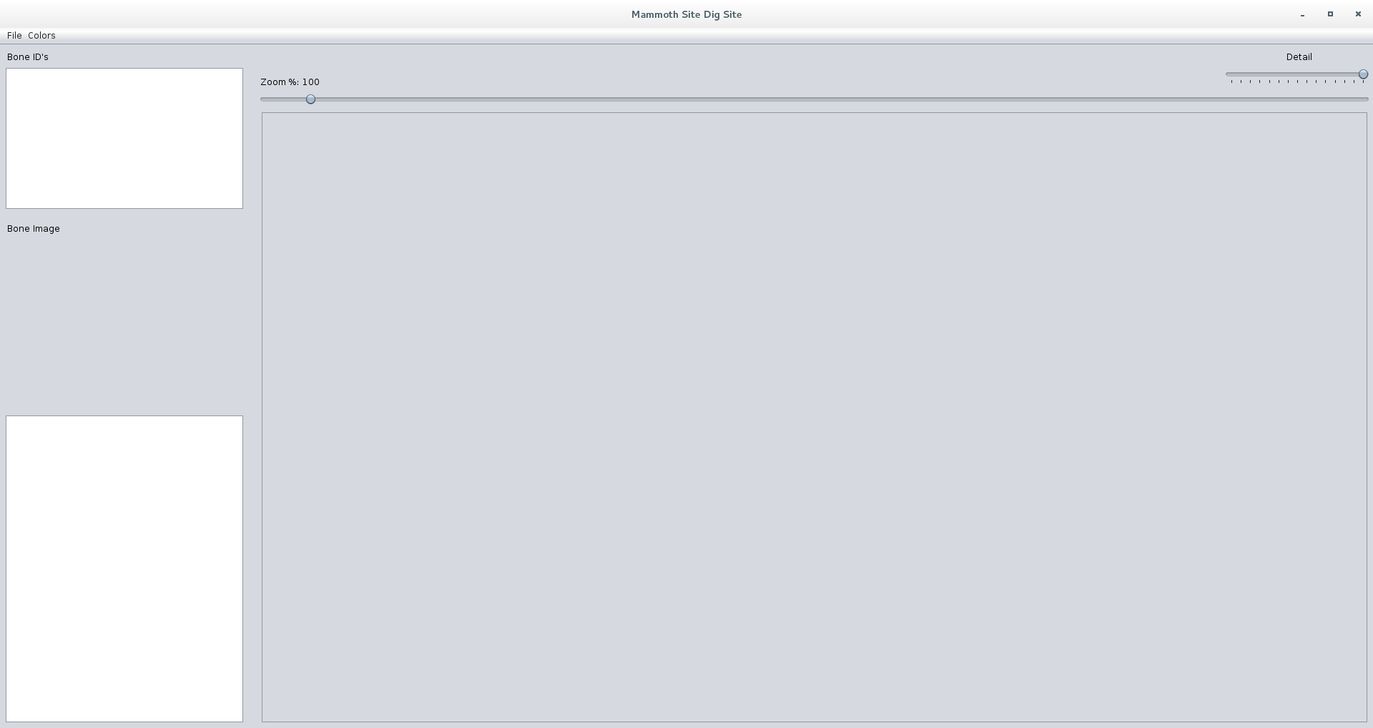
Selecting Data File will give an option to select a file for import.
Upon finding your .xml file that has the bone info for the Mammoth Kiosk a new display will show up that has the path and the bones on it.
All the ID's of the bones will be on the left side of the window in the Bone ID window.
Clicking on one of the ID's will bring up a picture with all information regarding the Bone.

In the menu bar there is a color menu that will change the colors of the bones dependent on which you pick.
Elevation – lighter red for higher and darker red for lower
Gender – Female = Red, Male = Magenta, Cyan = unidentified
Completeness – Complete = green, Partially = Yellow, Not Complete = Red

The slider across the top of the window will zoom in or out on the window with the bones.
Right will zoom out left will zoom in.

The slider labeled detail will leave bones based on the number of elements/sub-elements in them.

The bottom left most panel will display the bone detail based on the ID selected in the Bone ID file.

