Revenue Platform | Clari

**Company Overview and Description**

Description: Clari is a revenue operations platform that improves efficiency, predictability, and growth across the entire revenue process. The platform leverages automation, AI, and real-time big data analytics for meeting preparation and follow-up, updating the contact database, and forecasting sales revenues, enabling teams to have total visibility into their business to make their revenue process more connected, efficient, and predictable.

Product / Problem They Solve: Most sales teams struggle to access high-quality, actionable data to guide reps towards what will move a deal forward in the pipeline. Clari brings together data from disparate enterprise systems and leverages advanced AI and automation to help companies increase win rates, shorten sales cycles, and improve forecast accuracy. It does this by capturing and consolidating massive amounts of data stored in different business systems, such as CRMs, marketing software, client emails, files, and contract exchanges, to create full-funnel accountability across go-to-market teams. Clari is building towards an end-to-end revenue platform with features such as forecasting and pipeline management, sales engagement and prospecting, conversational intelligence, mutual action plans and deal collaboration, etc.

Competitors: Gong, People.ai, Salesforce, 6Sense, ZoomInfo

**Fundraising History and Most Recent Valuation**

* Last round was $225M Series F in January 2022 at $2.65B post-$ valuation led by Blackstone Growth
* Other investors include B Capital, BCV, Silver Lake, Light Street, Maverick, Madrona, Sapphire, Sequoia, Tenaya, etc.
* $496M capital raised to date

**Opportunities**

* Clari’s recent acquisition of Groove, the leader in sales engagement software, will allow Clari to convert Groove’s raw engagement data into actionable intelligence and strengthen sales productivity for teams, furthering Clari’s revenue platform capabilities
* Clari sells to a diverse customer base, largely enterprise (Adobe, Zoom, Datadog, Palo Alto), across industries ranging from tech, healthcare, financial services, business services, and manufacturing, signaling a massive TAM opportunity
* End-to-end platform across multiple RevTech categories operating as the “system of engagement and enablement” bridging sales, marketing, finance, and customer success departments

**Concerns**

* Competitive space with many RevTech players such as Gong People.ai, 6Sense, ZoomInfo
* Salesforce may create its own native capability in the future
* Potential customer concentration in the tech segment

**Founder Background:** Cofounders [Andy Byrne](https://www.linkedin.com/in/byrneandy/) (CEO) and [Venkat Rangan](https://www.linkedin.com/in/venkatrangan01/) (CTO) bring extensive leadership and experience in their respective roles. The two previously founded and scaled Clearwell Systems, Gartner’s highest-ranking e-Discovery company, until its acquisition by Symantec.

**Key Questions**

* Any metrics you can share?
  + ARR / Growth
  + Retention - Gross / Net / Customer
  + Engagement? DAU / MAU?
    - How does this differ between products?
  + Gross margins / cash burn / EBITDA
  + What KPIs do you manage the business to?
  + Win rates across products?
* What does the GTM motion look like?
  + What competitors do you come across most often?
  + When customer churn why do they churn and where do they go?
  + Where do most of your leads come from / what does your sales funnel look like?
    - Can you walk us through how a lead is generated and how it progresses through the sales funnel to revenue / ARR
    - Paid / organic mix?
  + How has the multi product strategy played out?
    - What other areas do you want to go into? Sales intelligence? ABM? Others?
* How big do you view your TAM?
* How difficult is implementation / how long does it take?
* What do you view as the biggest barrier to faster topline growth?
* What are the top 3 things that you think will determine the success of Clari vs competitors?
  + How do you think the market for Sales Software plays out?
    - Further consolidation?
    - Partnerships?
    - Bankruptcies?
* Tell us about how you thought through the acquisition of Groove?
  + What was the purchase price?
  + How was this structured?
  + How much ARR did they have?
  + Strategic rational on data / improving core forecasting?
* Where are you investing R&D dollars? / what are you most excited about for the next 2-5 years?
* Capital needs?
  + Any potential raises?
  + What are you looking for in a partner?

**Company Overview and Description**

Description: Postman is a collaboration platform designed to help developers build, design, test, and iterate their APIs. The company's platform creates and sends HTTP requests, creates collections and folders to group requests logically, saves requests, switches contexts, and customizes with scripts to simplify collaboration across teams and organizations, enabling developers to build an application programming interface and improve developer productivity.

Product / Problem They Solve: The exponential increase in the number of APIs has led to many challenges that legacy platforms are unable to solve. Challenges for API producers include difficulty in producing reliable and high-quality APIs, development tools are disconnected, and lack of governance over or visibility into the API landscape. For API customers, challenges include difficulty in getting started with an API, APIs being complicated or often buggy to use, and inability to find useful documentation. Companies have generally developed their APIs tactically at the end of the development of a system and Postman is designed to streamline the API development process via its “API-first” approach. Products include Postman’s public API network, Postman on the web, public workspaces, the Private API Network, the Public API Network, API security validations, OpenAPI validations, etc.

Competitors: Stoplight, Kong, RapidAPI, MuleSoft, Insomnia, Swagger, SmartBear

**Fundraising History and Most Recent Valuation**

* Last round was $225M Series D in August 2021 at $5.6B post-$ valuation (~100x ARR) led by Insight
* Other investors include Coatue, Battery Ventures, BOND, CRV, Nexus Venture Partners
* $433M capital raised to date

**Opportunities**

* API flywheel network effect where developers first discover Postman through public APIs 🡪 use Postman to run, test, and master APIs 🡪 advocate for Postman to be used at work 🡪 let development teams use Postman to build and maintain internal APIs 🡪 companies encourage cross-functional development and collaboration via Postman 🡪 companies create and share public APIs through Postman 🡪 developers discover Postman through these public APIs
* Postman sells to large enterprise customers including Salesforce, Microsoft, Stripe, Cisco, PayPal, Kroger, etc. – 98% of the Fortune 500 companies are customers of Postman
* SOC 2 Type 2 security-validation has helped create new partnerships with Datadog, New Relic, Opsgenie, and AWS API Gateway and will continue to drive new meaningful partnerships

**Concerns**

* Primarily used during the development phase for testing vs. later API stages
* Weaker on analytics and can be less integrated with the actual code vs. competitors
* As the world has moved towards greater API adoption, the space has similarly become significantly more competitive with many players entering the space

**Founder Background:** Abhinav Asthana (CEO and Co-founder) along with fellow co-founders, Ankit Sobti and Abhijit Kane founded Postman back in 2012. Previously Abhinav was the CTO of photo app, TeliportMe.

**Key Questions**

* Would love an update on key metrics
  + ARR/Revenue
  + Top-line growth rate
  + NDR / GDR, churn
  + Margin profile
  + Number of users
* User conversion funnel
  + Free to paid conversion funnel
  + Enterprise go to market motion (it seems like PLG – at what point do people upgrade to the paid version? What prompts them to pay for the product)
  + Sales efficiency
  + Any new partnerships of note / new sales channels or is it still largely PLG and direct sales?
  + Pricing model on enterprise offering; upsell opportunities; product expansion opportunities?
* Product Roadmap
  + Postman has typically been a dominant player in the development phase for testing APIs; how are they expanding into production / rest of API lifecycle? Have they been able to successfully upsell / cross sell enterprise customers into other offerings
  + How do they compare with Insomnia, Swagger, etc
  + How are they incorporating genAI into their product offering (automated API testing? API documentation? Other features?)
  + How have customers responded to their pricing increases?
* Team
  + Gaps in management team
  + Recent new hires
* Capital Needs
  + Plans to raise in the future
  + Current burn / runway
  + Valuation expectations

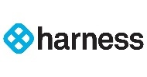

**Company Overview and Description**

Description: Harness is the “Modern Software Delivery Platform” that provides a simple, safe and secure way for engineering and DevOps teams to rapidly release applications into production.

Product / Problem They Solve: Developers are often spending too much time doing mundane tasks that don’t need to be done manually – Harness was created to build developer tools that are much more efficient. Harness uses machine learning to detect the quality of deployments and automatically roll back failed ones, saving time and reducing the need for custom scripting and manual oversight, giving engineers their weekends back. Harness modules include CI/CD, continuous integration, continuous deployment & GitOps, security testing orchestration, service reliability management, continuous error tracking, cloud cost management, infrastructure as code management, etc. Harness supports multiple open source and source-available projects, including Drone, LitmusChaos, and Harness CD Community Edition.

Competitors: GitLab, CircleCI, CloudBees, Opsera, Travis CI, Buildkite

**Fundraising History and Most Recent Valuation**

* Last round was $230M Series D in April 2022 at $3.7B post-$ valuation led by Norwest
* Other investors include JPM, Capital One Ventures, Splunk Ventures, Adage Capital Partners, Balyasny Asset Management, Menlo Ventures, IVP, Unusual Ventures, Citi Ventures, Battery Ventures, Alkeon Capital, GV, Thomvest
* $424M capital raised to date

**Opportunities**

* Logical applications from “generative AI” – Harness recently released generative AI assistant “AIDA” to help increase developer efficiency by finding security vulnerabilities and automatically fixing them after the developer approves the fix
* Serves a broad range of large ACV enterprise customers ranging from GovTech Tyler Technologies to United Airlines to Siemens and more
* Known for strong cost monitoring abilities – this is typically the entry point for many customers; very short sales cycle of 1-1.5 months

**Concerns**

* GitLab continues to be the dominant player in the space – Harness is not as successful in uprooting GitLab from many places and would frequently lose if potential customer was already using GitLab
* Known for being stronger in CI vs. CD
* CI/CD competitive landscape is very crowded and open-source Jenkins is the leading free automation server that provides hundreds of plugins to support building deploying, and automating any project

**Founder Background:** CEO and co-founderJyoti Bansal is a serial entrepreneur who previously founded AppDynamics, which was acquired by Cisco for $3.7B a day before it was supposed to go public in 2017.

**Key Questions**

* Would love an update on key metrics
  + ARR/Revenue
  + Top-line growth rate
  + NDR / GDR, churn
  + Margin profile
  + Number of users / customers
* Sales
  + Sales efficiency
  + % direct sales v. through channel partners / VARs
  + ACV
  + Pricing model on enterprise offering (it looks like per service but could also be a component that is seat based?); upsell opportunities
  + Is there typically a product that they land with and expand into the rest of CI/CD? Sounds like it could be cost monitoring as an entry point / quick ROI
  + Typical sales cycle / key decision makers
  + Are they typically replacing Gitlab, CircleCI, open source Jenkins? How do they compare v. these alternatives
  + How do customers measure ROI of the product?
* Product Roadmap
  + Breakdown in typical usage – are customers using their entire platform or are folks adding on specific modules like feature flags, chaos engineering, security testing, etc over time?
  + What are typical plugins people are using on the platform?
  + Saw that they recently launched AIDA AI development assistant [https://www.harness.io/products/aida](https://nam12.safelinks.protection.outlook.com/?url=https%3A%2F%2Fwww.harness.io%2Fproducts%2Faida&data=05%7C01%7Cvxu%40bdtmsd.com%7C62e6c127cbfa49a33db408dbe4a3f549%7C7245201b545c4a33abf3b675eba220fb%7C0%7C0%7C638355165077705388%7CUnknown%7CTWFpbGZsb3d8eyJWIjoiMC4wLjAwMDAiLCJQIjoiV2luMzIiLCJBTiI6Ik1haWwiLCJXVCI6Mn0%3D%7C3000%7C%7C%7C&sdata=iHXUvC7%2BB3GkW8aybhNH1sysyxKt222VggeJEcTdpPw%3D&reserved=0) - what has been uptake on this product? What data is this trained on? Is it their own LLM or finetuned open source model?
    - How do they think impact of incorporating AI into product on margin profile
    - What are their future plans for incorporating AI into their product offering
* Team
  + Gaps in management team
  + Recent new hires
* Capital Needs
  + Plans to raise in the future
  + Current burn / runway
  + Valuation expectations

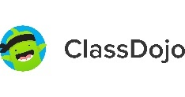

**Company Overview and Description**

Description: ClassDojo is an edtech communication app that provides teachers with feedback and lesson planning tools and parents with features to communicate and receive updates on their children’s progress at school.

Product / Problem They Solve: Effective communication between parents and teachers is [essential](https://soeonline.american.edu/blog/parent-teacher-communication/) to improving student achievement. However, many [obstacles](https://www.parentpay.com/parentpaygroup/blog/5-common-barriers-to-communication-between-parents-and-teachers/) can prevent this two-way flow of information from either side. Teachers not being able to provide information in a timely manner can obstruct parents from stepping in promptly to tackle issues related to their child in the context of their education. It also leaves teachers in the dark as they lack this additional support from families, having to navigate these issues alone with a child in real-time in the classroom. Despite having to often time spend more time managing children’s behavior vs. teaching, teachers were rarely provided with tools to improve behavior; most solutions focused on punishment. ClassDojo provides a direct communication channel between teachers and parents (i.e. posting of story updates, direct messaging, progress reports), a classroom management toolkit for teachers, and a “Big Idea” series that provides teachers with an unconventional yet thought-provoking set of topics to educate kids on.

Competitors: Schoology, Remind, Seesaw, Bloomz, K20 Educators

**Fundraising History and Most Recent Valuation**

* Last round was $125M Series D in January 2021 at ~$1.25B post-$ valuation led by Tencent
* Other investors include Shasta Ventures, SignalFire, General Catalyst, Reach Capital, YC, Josh Buckley
* $221M capital raised to date

**Opportunities**

* Secular tailwinds from the COVID pandemic led to an increase in virtual gaming spaces for kids – Roblox grew its daily user base 85%+ and an increase in adoption for remote/digital learning for children
* ClassDojo is evolving from being just a communication app to being a platform that can help students get better learning experiences beyond the one they get from schools
* Opportunity to expand into international markets, provide more professional development and support resources for teachers, integrate student data analytics, and bring more students into the metaverse

**Concerns**

* Remote learning from COVID tailwind is likely to have been a massive contributor to the company’s success and lower post-COVID demand for such a service is likely to slow business growth
* Content to some extent is commoditized given the amount of free tutorials available on YouTube or Khan Academy – ClassDojo’s content thus needs to be quite differentiated and targeted
* Roblox, Meta, and Microsoft have been active in either developing or acquiring new games focused on education – i.e. Meta has already signed partnerships with online course providers edX and Coursera
* Operates in a highly regulated sector focused on children’s online privacy

**Founder Background:** Co-founders are Liam Don and CEO Sam Chaudhary. Sam is a teacher-turned McKinsey consultant and Liam is a self-taught programmer who had worked as a developer on the RuneScape online game franchise before pursuing a PHD in computer science.

**Key Questions**

* Any metrics you can share?
  + ARR / Growth
  + Retention - Gross / Net / Customer
  + Engagement? DAU / MAU?
    - How does this split between teachers / parents?
  + Gross margins / cash burn / EBITDA
  + What KPIs do you manage the business to?
  + Win rates vs competitors?
* What does the GTM motion look like?
  + What competitors do you come across most often?
    - How does pricing work? Per Student per month?
      * What are your views on this remaining a separate category vs consolidating into an SIS?
  + When customer churn why do they churn and where do they go?
  + Where do most of your leads come from / what does your sales funnel look like?
    - Can you walk us through how a lead is generated and how it progresses through the sales funnel to revenue / ARR
    - Paid / organic mix?
* How important is data privacy / security given the segment?
* How big do you view your TAM?
* How difficult is implementation / how long does it take?
* What do you view as the biggest barrier to faster topline growth?
* What are the top 3 things that you think will determine the success of ClassDojo vs competitors?
* Where are you investing R&D dollars? / what are you most excited about for the next 2-5 years?
* Capital needs?
  + Any potential raises?
  + What are you looking for in a partner?

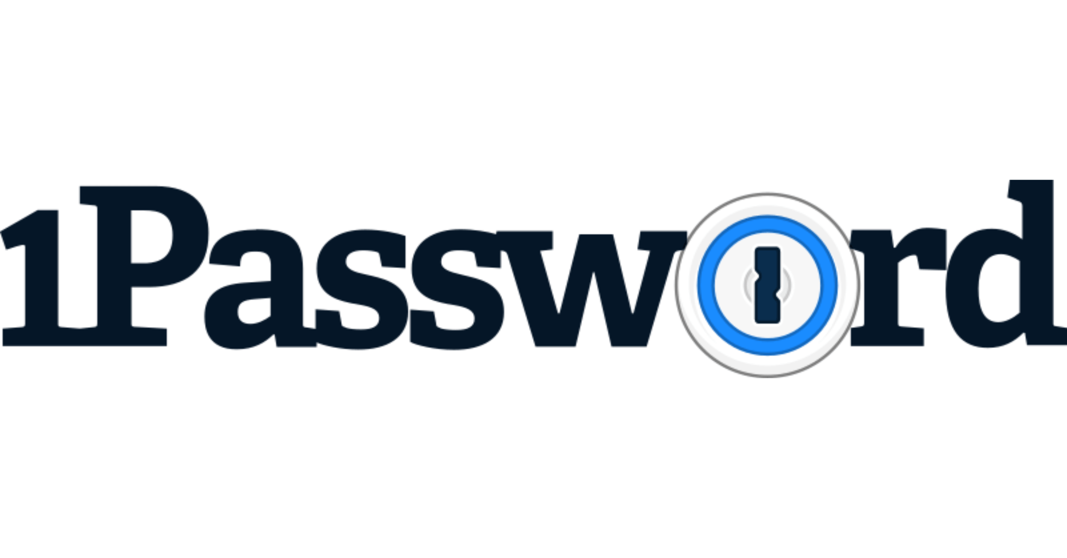

**Company Overview and Description**

Description: 1Password is a password manager that maintains strong credentials, manages access to services, reports on usage, and also provides private, secure, and user-friendly password management.

Product / Problem They Solve: Internet users have many usernames and passwords to manage and to make it easier to remember, they will often reuse the same passwords. This however exposes users to potential data breaches. Companies understand that passwords remain a major security threat, and the proliferation of cloud-based services and the rise in online security breaches have prompted CISOs and IT teams to take action. Single-sign on (SSO) and multi-factor authentication (MFA) are now commonplace in workplaces. However, many enterprises remain vulnerable given SSO covers limited applications and MFA adds difficulty for users. 1Password is a password manager providing businesses and consumers with a safe way to store and share passwords. It keeps important information secure with [Advanced Encryption Standard](https://en.wikipedia.org/wiki/Advanced_Encryption_Standard) (AES) 256-bit encryption and allows users to keep information organized with tags and find what they need with a customizable search. 1Password securely stores and organizes passwords in one central location called the [vault,](https://support.1password.com/create-share-vaults/) which is only accessible through a master password or biometric authentication. 1Password’s password manager creates strong, unique passwords for each online account and has a browser plug-in to fill in login credentials on websites and applications automatically. Users can also get a 360-degree view of their security through 1Password’s Security Watchtower offering. 1Password Business gives security admins a centralized view of their businesses’ security posture and allows them to manage their team, generate reports, and track important info from one dashboard. 1Password also integrates into large enterprises’ existing security stack to streamline workforce security.

Competitors: Bitwarden, NordPass, LastPass, Dashlane, Keeper Security

**Fundraising History and Most Recent Valuation**

* Last round was $620M Series C in January 2022 at ~$6.8B post-$ valuation led by ICONIQ Growth
* Other investors include Tiger, Lightspeed, Accel
* $950M capital raised to date

**Opportunities**

* Remote work and cloud app adoption tailwinds continue in the post-pandemic world
* Universal sign on could help 1Password become the end-to-end sign-on management tool for its diverse customer base of millions of consumers and 100k+ businesses and enterprises – 1Password is already the clear market leader
* New partnerships and integrations (Azure integration upcoming) continue to drive customer acquisition
* Continuous new integrations with identity and access management (IAM) infrastructure allow customers to unlock 1Password with more identity providers (IdPs) that support the generic OIDC configuration like Duo, OneLogin, JumpCloud, etc., which simplifies adoption and improves auditing, compliance, and reporting workflows

**Concerns**

* Low switching costs in the sense that importing and exporting solutions are not difficult from the 1Password platform
* Regulatory compliance challenges – 1Password has to continue to ensure compliance with constantly evolving privacy and data protection regulations
* AI can increasingly be trained to crack passwords

**Founder Background:** Co-founders Dave Teare and Roustem Karimov used to work for IBM Canada and Sony respectively and were previously running a web development consultancy where they struggled with managing multiple website logins, which prompted them to embark on a 3-month project to build a tool that could streamline their internal password use that ended up evolving into 1Password.

**Key Questions**

* **TAM:**Who do you think of as within your addressable TAM? Is there any concentration within your customer base from a sector / industry perspective?
  + How is your sales force structured to go after this TAM on the enterprise?
  + What's the acquisition funnel for the consumer business?
* **Competition:**Who do you view as competitive / who do you run up against in RFPs?
  + When you win, why do you win? When you lose, why do you lose?
  + Have you lost any enterprise customers in the past 12-24 months? If so, why?
* **Product:**Could you talk about each part of the business touching on how each product has evolved, how pricing has changed, and adoption rates from free trial to paid tiers?
  + Individual: 2.99/month
  + Families: 4.99/month
  + Teams: 19.95/month
  + Business: 7.99/month
* **Business:**Could you give us a high level update on the business metrics including?
  + ARR, growth, ACV including segmentation of the business across individual, families, teams and business
  + Gross margin
  + For enterprise: NRR / GRR, sales efficiency
  + For consumer: MAU retention, CAC payback
  + Burn / cash position
* **Vision and Roadmap:**What's your five year vision for 1Password? What are the biggest untapped areas for growth?
* **Capital Requirements:**How are you thinking about future financing needs / path to IPO?

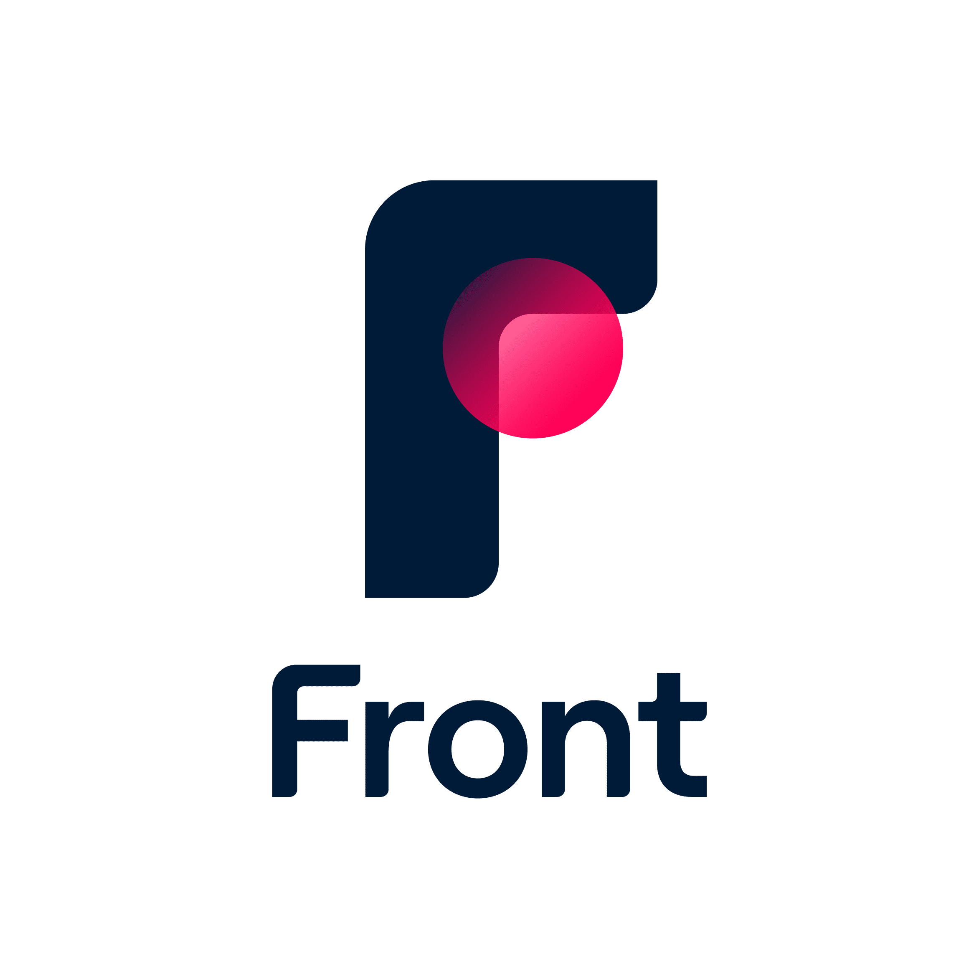

**Company Overview and Description**

Description: Front is a communication hub for building strong customer relationships on digital channels. Front puts customer conversations at the center of a team’s attention and surrounds them with collaboration capabilities and contextual data from multiple systems, allowing teams to stay focused on delivering timely, accurate and deeply personalized communications.

Product / Problem They Solve: Front is upending two of the largest and most deeply entrenched markets in SaaS: email and customer support software. Businesses that rely on strong customer relationships to differentiate themselves are underserved by the incumbents: email is inefficient for teams with no support for workflows, analytics or meaningful integration while support software creates efficiencies and makes customers feel like numbers. Front surrounds every high-stakes conversation with team collaboration capabilities and customer data. Front’s collaboration tools are intended to help teams work more easily together to respond to customers - these include shared inboxes, AI summaries, project management, internal discussion capabilities, collision detection (preventing duplicate replies), a slack integration, and the ability to loop in non-Front users to a message as a conversation “guest”. Front also provides [analytics](https://help.front.com/t/p8hz4m4/understanding-analytics) and reporting capabilities that capture insights into team performance, conversation response times, customer satisfaction metrics, and other key data points. Furthermore, Front's omnichannel inbox consolidates messages from various channels, such as email, SMS, live chat, and social media, into a unified interface. Users can leverage advanced features, including workflow rules and assignments based on keywords, senders, and time of day, ensuring messages are directed to the appropriate recipients in a timely manner.

Competitors: Zendesk, Intercom, Freshworks, Hiver, Slack, Asana

**Fundraising History and Most Recent Valuation**

* Last round was $65M Series D in June 2022 at ~$1.7B post-$ valuation led by Salesforce Ventures and Battery
* Other investors include Sequoia, Threshold Ventures, Uncork Capital
* $200M+ capital raised to date

**Opportunities**

* High customer satisfaction and engagement illustrated by ~98% Customer Satisfaction Score (CSAT) and ~75% of monthly active users also being daily active users
* Best-in-class SaaS metrics – 120% YoY growth and 130%+ net retention at the time of last funding
* Growing TAM due to automation and commoditization and opportunity for Front to take on the lower-value inbound communications currently covered by more generic support tools as well as the more valuable outbound sales and marketing communications relating to Salesforce, Outreach-type tools
* Logical applications from generative AI – already launched AI-powered features like Compose with AI and Summarize with AI that help draft automatic responses faster and provide AI-generated summaries
* Various APIs and integrations with CRMs like Salesforce, project management systems like Jira, communication tools like Slack, automation/productivity tools like Zapier, etc.

**Concerns**

* Still primarily used for email collaboration only
* Highly competitive landscape consisting of customer experience SaaS platforms like Zendesk (leader in the space) and Intercom which can embed in customers’ websites to provide traffic detail as well as workplace collaboration tools like Slack and Asana
* Content collaboration platforms like Google Workspace and Microsoft 365 could potentially create their own competing native tools given Front requires users to bring their own email domains to the platform, which Google and Microsoft already provide

**Founder Background:** CEO and co-founder Mathilde Collin is one of only 11 women to found and hold the role as CEO at both public and private SaaS companies valued at $1B+.

**Key Questions**

* **TAM:** Who do you think of as within your addressable TAM? Is there any concentration within your customer base from a sector / industry perspective?
  + How is your sales force structured to go after this TAM?
* **Competition:** Within your current end to end platform (customer support), who do you view as competitive / who do you run up against in RFPs?
  + When you win, why do you win? When you lose, why do you lose?
  + Have you lost any enterprise customers in the past 12-24 months? If so, why?
* **Product:** Could you talk about the product evolution of the business from "single view emails / chat" to broader customer support?
  + Have you seen legacy platforms like Zendesk or Freshdesk build more workflow / collaboration tools for customer support?
  + How many of your customers are using more than one of your products?
  + What has been the adoption / impact of your generative AI products? How do you think AI will continue to impact your business / customer support software at large?
* **Business:** Could you give us a high level update on the business metrics including?
  + ARR, growth, ACV
  + Gross margin
  + NRR / GRR
  + Sales efficiency
  + Burn / cash position
* **Vision and Roadmap:** What's your five year vision for Front?
* **Capital Requirements:** How are you thinking about future financing needs / path to IPO?



**Company Overview and Description**

Description: Smarsh provides comprehensive archiving solutions for compliance, e-discovery and risk management to companies.

Product / Problem They Solve: Firms need a better way to archive, store and monitor a growing amount of electronic communications data. Smarsh’s platform provides capture, archiving, e-discovery and supervision solutions across several communication channels, helping clients to identify regulatory and reputational risks within their communications data. Its centralized platform provides a unified compliance and e-discovery workflow across the entire range of digital communications, including email, social media, websites, instant messaging, mobile text messaging, and voice.

Competitors: Shield FC, Symantec Vault, Global Relay, Behavox, NICE Actimize, Relativity, Proofpoint, Veritas, Mimecast

**Fundraising History and Most Recent Valuation**

* Majority-owned by K1 Investment Management (acquired in Jan 2016 through a $215M LBO)
  + In November 2017, K1 acquired Actiance, a pioneer in communications compliance, archiving, and analytics, to combine with Smarsh
* Other debt investors include Ares, SC Ventures,
* $737M capital raised to date

**Opportunities**

* Strategic acquisitions (i.e. Digital Reasoning, TeleMessage, Actoamce, Cognia, etc.) continue to add onto their capabilities (i.e. surveillance, mobile archiving, voice communication capabilities, etc.) to help them become an all-in-one compliance archiving platform
* Leading comprehensive channel coverage for archiving ranging from email, social media, to mobile and voice and more
* Logical applications from generative AI – ChatGPT can be used for “Compliance-as-a-Service” to help answer questions quickly

**Concerns**

* Crowded competitive landscape of players doing compliance/archiving (see above list)
* Operates in a highly regulated industry with constantly evolving data privacy laws and regulations
* Unlikely to be a standalone asset – potential strategic value to a buyer like Microsoft

**Founder Background:** Founder Stephen Marsh started Smarsh in 2001 and prior to Smarsh, Stephen led product management and development efforts at CCBN, which is now a division of Thomson Financial, and spent time in key roles at Fidelity and Morgan Stanley Dean Witter. A veteran of the financial services industry, Stephen recognized that traditional regulatory retention and oversight requirements applied to new and emerging communications technology.

**Key Questions**

* Would love an update on key metrics
  + ARR/Revenue by product (archive, e-discovery, communications compliance, surveillance and supervision)
  + Top-line growth rate
  + NDR / GDR, churn
  + Margin profile
  + Profitability
  + Number of customers
  + Customer concentration
  + Industry exposure – breakdown by end market – finservices, gov’t, healthcare, insurance, law enforcement, technology
* Sales
  + Sales efficiency
  + ACV
  + Pricing model (based on amount of data archived? Do you charge data extraction fees for e-discovery?)
  + Is there typically a product that they land with and expand into the rest of?
  + Recent industry trends prompting people to invest in their compliance solutions
  + Typical sales cycle / key decision makers
  + Is there any greenfield or are they typically replacing solutions like Global Relay, Behavox, Nice Actimize? How do they compare v. these alternatives
  + What is the level of custom integration required?
* Product
  + What does it take to actually integrate the product?
  + How does Smarsh get access to all digital communications for employees?
  + What is the false positive rate for supervision alerts?
  + Level of integration of strategic acquisitions Digital Reasoning, TeleMessage, Actiance, Cognia => potential areas of the product portfolio they would like to add capabilities in
  + Innovation on the genAI side – automated e-discovery or better AI driven alerting?
* Team
  + Gaps in management team
  + Recent new hires

Ironclad Contract Management Status

**Company Overview and Description**

Description: Ironclad is a leading digital contract lifecycle management (CLM) platform that automates workflows and approvals to help business and legal teams manage every aspect of the contracting process across all contract types – legal, sales finance, HR, marketing procurement, etc.

Product / Problem They Solve: Dealing with contracting or contract management can be a highly inefficient process. Ironclad’s platform automatically identifies key terms and entities, turns contracts into code, and allows users to search, tag, and manage their contracts, enabling legal, sales, and operations teams to streamline the way they create, store, and leverage contracts as intelligence assets. Ironclad’s core CLM product includes several modules: workflow designer, editor, repository, and reporting. Workflow Designer is a simple drag-and-drop tool to create contracts while ensuring the components of each contract are tracked, correct, and easy to adjust. Ironclad’s editing module is similar to Google Docs in functionality where users can collaborate on specific sections of a contract, leave comments, review different versions, and assign each other responsibilities in the creation process for a contract. Ironclad’s reporting module allows customers to visualize their contracts as they move through the CLM process and identify any potential bottlenecks for specific contracts. In addition to their core CLM product suite, Ironclad also has a product called ClickWrap specifically designed for embedding legal agreements online.

Competitors: Icertis, ContractPodAI, SirionLabs, Evisort, LinkSquares, DocuSign CLM

**Fundraising History and Most Recent Valuation**

* Last round was $150M Series E in January 2022 at ~$3.2B post-$ valuation led by Franklin Templeton
* Other investors include BOND, YC Continuity, Emergence, Lux, Haystack, Accel, Sequoia
* $332M capital raised to date

**Opportunities**

* Diverse customer base including large ACV customers such as Mastercard, Doordash, Canva, Rippling, L’Oreal, etc.
* Growth lever in entering contract analytics and visualization to become an end-to-end CLM platform
* Logical AI applications – announced an AI layer for their product (Ironclad AI) in September 2022 that automatically extracts contract data so that companies can search, sort, and read them faster 🡪 opportunity to do AI-driven data insights next

**Concerns**

* Crowded, highly fragmented competitive landscape of players tackling CLM with many notable venture-backed players including Icertis, ContractPodAI, LinkSquares, etc. as well as incumbents such as DocuSign CLM which acquired SpringCM (see above list)
* Expensive solution relative to competitors
* Some complaints around AI capabilities and customer service not being as strong as competitors’

**Founder Background:** Co-founders Jason Boehmig and Cai GoGwilt founded Ironclad in 2015. Previously, Jason was an attorney and an adjunct professor at Notre Dame Law School while Cai was a former software engineer at Palantir.

**Key Questions**

* Any metrics you can share?
  + ARR / Growth
  + Retention - Gross / Net / Customer
  + Engagement? DAU / MAU?
  + Gross margins / cash burn / EBITDA
  + What KPIs do you manage the business to?
  + Win rates vs competitors?
* What does the GTM motion look like?
  + What competitors do you come across most often?
    - What are your view on companies having separate CLMs for different parts of the organization
      * Sales, legal, supply chain, etc.
  + When customer churn why do they churn and where do they go?
  + Where do most of your leads come from / what does your sales funnel look like?
    - Can you walk us through how a lead is generated and how it progresses through the sales funnel to revenue / ARR
    - Paid / organic mix?
* How big do you view your TAM?
* How difficult is implementation / how long does it take?
* What do you view as the biggest barrier to faster topline growth?
* What are the top 3 things that you think will determine the success of Ironclad vs competitors?
* Where are you investing R&D dollars? / what are you most excited about for the next 2-5 years?
* Capital needs?
  + Any potential raises?
  + What are you looking for in a partner?



**Company Overview and Description**

Description: Restaurant365 provides all-in-one restaurant management software for 40,000+ small businesses, franchises and chains, and accounting firms that work with restaurants.

Product / Problem They Solve: Accounting, store operations, and workforce systems are often disparate and manual at restaurants. Restaurant365 bridges the gap between accounting and operations at restaurants by centralizing all data and seamlessly integrating with POS, banks, vendors, etc. to provide an all-in-one back-office software. R365 Accounting integrates and automates restaurant’s critical finance; R365’s Store Operations tracking tools provide a pulse on restaurants’ inventory, labor, and scheduling; R365 Workforce provides solutions for hiring, onboarding, scheduling, payroll, and benefits to streamline administrative work throughout the employee lifecycle; and R365 Intelligence provides out-of-the-box and custom reports to give restaurants leverageable insights.

Competitors: Toast, MarketMan, Square, Paytronix, CrunchTime

**Fundraising History and Most Recent Valuation**

* Last round was $135M round at a ~$1B post-$ co-led by KKR and L Catterton in May 2023
  + At the same time, crossed $100M in revenue
* Other investors include ICONIQ Growth and Bessemer
* $322M capital raised to date

**Opportunities**

* Increasing amount of new restaurants and consumer desire to go to restaurants in their leisure time post-pandemic widens the base of potential customers for Restaurant365
* Diverse customer base of small businesses, multi-location groups, enterprise businesses, franchise brands, accounting firms serving all types of restaurants – from QSR, fast casual and casual dining to fine dining
* 500+ integrations with leading restaurant vendor, technology, channel and service partners including Oracle, Toast, Sysco, US Foods, etc.
* Inherent stickiness and high switching costs in being the all-in-one vertical software for restaurants in a fragmented industry
* Tailwinds from increasing adoption of cloud-based software services within the restaurant industry (i.e. Toast is currently worth ~$8B)

**Concerns**

* Recessionary macro environment may drive lower consumer spending at restaurants
* Predominantly suited for mid-market customers and not as optimized for larger enterprises currently
* Customers primarily use R365 for select use cases vs. all (inventory management in particular)

**Founder Background:** 3 co-founders Tony Smith (CEO), John Moody (Chief Strategist), and Morgan Harris (Chief Customer Advocate) previously worked at Dynamic Methods together selling Microsoft solutions across a number of different industries where they realized one solution never worked for all companies.

**Key Questions**

* **Customer Profile:**
* **What is the ideal customer profile for R365 in terms of restaurant type/style/size? How has that trended over time and what will that look like in 5 years?**
* **Please give us a sense of the current customer footprint by key segment (i.e., business types): Small business** vs **Multi-location groups** vs **Enterprise** vs **Franchise brands** vs **Accounting firms**
* **Which ‘customer segment’ has been the growth driver?**
* **Product offering to the customers**:
* **Four core products include:**
  + ***R365 Accounting*** (accounting software with POS integration, general ledger connection, AP automation)
  + ***R365 Workforce*** (hiring, paying and retaining workforce)
  + ***R365 Store Operations*** (inventory management)
  + ***R365 Intelligence*** (data & analytics)
* **What are the strengths and weaknesses across the products offered?**
* **What is the ACV for each of the four core products?**
* **How should we think about the trending attach rate for each of the four core products?**
* **Product roadmap for next 5 years?**
  + Any expected product launches?
  + Is the product-suite optimized to service all kinds of customers (including larger enterprise level customers)?
* **Competition:**
* **Who do you view as competitors and who do you run up against in RFPs?**
  + **Point solutions:** Sage (accounting), Toast (POS + restaurant back office functionality), MarginEdge/MarketMan/Craftable (inventory & cost management), Jolt (workforce management)
* **When you win, why do you win?**
* **When you lose, why do you lose?**
* **Business Metrics**
* **ARR, Growth**
  + What’s the split between expansion-driven versus new customer-driven growth?
* **NRR/GRR**
* **Sales efficiency**
* **Burn/Cash Position**
* **Capital Needs**



**Company Overview and Description**

Description: Kong is an API platform designed to manage, monitor, and scale application programming interface and micro-services. The company's platform offers API gateways, developer portals, and API analytics, enabling development teams to distribute, monetize, manage, analyze, and consume APIs.

Product / Problem They Solve: Organizations are increasingly building out APIs both internally and externally; as this complexity has increased, challenges have arose including API traffic management, security (authentication, logging), performance and scalability, managing data sharing between microservices, monitoring and analytics. Kong’s primary product is Kong Gateway, a tool to manage external / internal APIs for an organization; this gateway streamlines API traffic, manages performance, ensures security, and proves analytics. Kong also offers a service mesh, a configurable infrastructure layer for microservices applications. Lastly, Kong has its Insomnia product which is a collaborative API development platform that competes more directly with Postman or SmartBear’s SwaggerHub.

Competitors: IBM, Mulesoft, Apigee, Gravitee, Tyk; on the service mesh side, Solo.io; for the Insomnia product, Postman

**Fundraising History and Most Recent Valuation**

* Last round was $100M Series D in Dec 2020 at $1.45B post led by Tiger Global
* Other investors include Index, CRV, A16Z, GGV, Sapphire, LombardStreet, GS, NEA
* Company raised $9.2m in debt from Blackrock in Nov 2022
* The company has raised $180M total to date.

**Opportunities**

* Company may finally be growing into last round valuation. Expect $120-125M of ARR by EOY 2023 (40-50% growth)
* Strong business fundamentals. Gross Margins at 87% up from 85% last year. 120-121% NDR; enterprise clients with high gross retention 90%+. Classic open-source to paid enterprise playbook with strong open source community engagement; ability to service customers at scale.
* Growing TAM as API use is growing significantly. Ability to replace legacy incumbents like Mulesoft and Apigee. Expansion opportunities on the product side to monetize API security, workflow, authentication, usage based pricing, testing
* Burn is coming down. Expects $1.5 to 1m burn per month; plan to be breakeven late next year.
* Potentially actionable early 2024 – expect to raise $100M but need closer to $60-80M

**Concerns**

* API management space is really competitive; long sales cycles to disrupt legacy incumbents and potentially a lot of custom integration work to manage enterprise clients requiring on-prem/hybrid cloud implementations. Low end of the market (SMBs) has a number of new entrants including Gravitee, Tyk.
* Macro conditions can reduce pricing power or make customers more budget conscious. Long-term competition against cloud providers who also offer API gateways with fewer bells and whistles.

**Founder Background:** Augusto “Aghi” Marietti (CEO) was previously the CEO/co-founder of Mashape, the largest API marketplace which was acquitted by RapidAPI in 2017. He was previously CEO of MemboxX, a cloud service for storing documents. BS in economics from Catholic University of Milan, UC Berkeley. Marco Palladino is CTO, also worked with Augusto on Mashape and MemboxX.

We spoke previously with the CFO, Chirag, who was previously CFO of Cornerstone OnDemand, and banker at Houlihan Lokey. He has a BS in Finance from Georgetown and MBA from Northwestern Kellogg.

**Key Questions**

Financial:

* How is the company trending toward topline growth for this year?
  + Themes on drivers of growth?
  + Are they seeing lengthening sales cycle due to macro environment
  + Breakdown of revenue between SMB, mid market, enterprise
  + Customer concentration?
* Any updates on NDR (last update was 120% NDR)
  + Are all of the pricing models consumption based?
  + Any implementation revenue?
  + Have you implemented any pricing increases / upsells?
* GM has increased to 87% this year – where do you think it’ll get to long-term? Key drivers of GM improvements?
* Key client updates? Any key channel partnerships or is it all direct sales?
* How has sales efficiency trended

Product Updates:

* Update on Insomnia product (competes directly with Postman) – what has uptake been on this product? Have you begun to monetize it?
* What is uptake / penetration of Konnect (end-to-end API lifecycle management) and Service Mesh products?
* Opportunities to incorporate genAI into product (API documentation generated automatically, etc)?
* Key strategic priorities for the business over the next 3-5 years

Capital Needs:

* Burn – are you still burning $1.5-1M per month? Still planning to be breakeven late next year?
* Still thinking about raising next year?
  + If so, how much / valuation expectations?