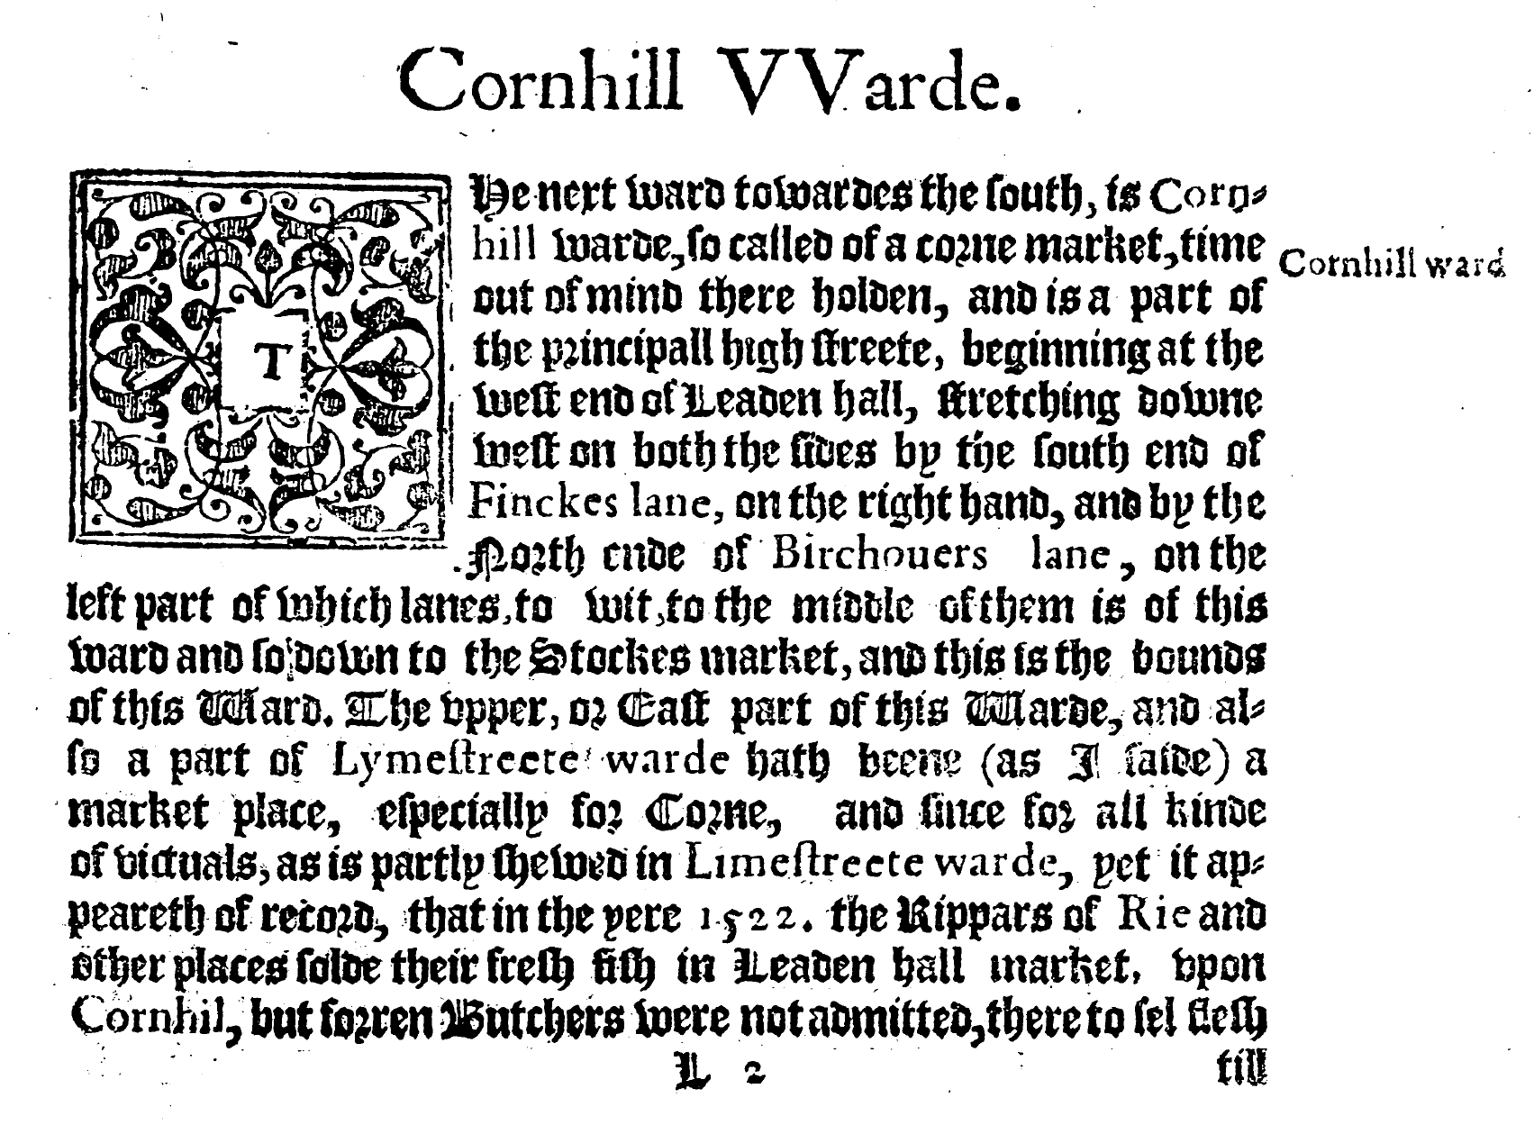

**CHOOSE 6 WITH DIFFERENT COLOURS**

* Punctuation
* Word
* Sentence
* Place name
* Direction
* Roman type
* Italic
* Gothic type
* Interchangeable u/v
* Long S (ſ)
* Occupation
* Date
* Heading
* Typographic line
* Line beginning
* ______________
* ______________