Obesity in the U.S.

By Yanbin Zhou

Introduction

As an international student coming from China, I have been studying and living in the United States for almost 6 years. When I first arrived in the states, I was amazed by the portion size that is being served in the restaurants. I see more people who are overweight than back in China.

What is a typical American meal you can think of? Burgers and fries, along with a bottle of coke. There is a restaurant in Arizona called Heart Attack Grill, which serves large size burgers up to quadruple paddies (weighs 2 pounds) and unlimited lard fries. Customers over 350Lbs can eat there for free. That tells you the issue with overweight and obesity in the United States. Otherwise, the restaurant will not be able to survive.

Coming to college, fitness is such a hot topic on campus. Among other people around me, I started working out regularly. I also start paying attention to the nutrition fact labels on food and snacks. Are people getting healthier and fit? Little did I know, the obesity is such a big issue in this country, and college campus cannot represent the social norm when it comes to obesity issues.

What is the difference between overweight and obesity? We often use Body Mass Index (BMI) as the measurement to differentiate overweight and obese. BMI is an individual’s weight in kilograms divided by the square of height in meters. If BMI is between 25.0 and 29.9, the person is overweight; if BMI is 30 or higher, then the person is considered “obese”. Let me use myself as an example, I am 1.8 meters tall, and weigh 76 kilograms; so my BMI is 76 / (1.8)2 = 23.45679, which means I am in the range of healthy weight.

Behavioral Risk Factor Surveillance System gathered samples that reflect the percent of adults aged 18 years and older who have obesity. They also recorded their location, gender, age, race, level of education, and level of income. We are interested to see if there is any correlations between these factors and the obesity rate? Additionally, how does the obesity issue trend from 2012 to 2016?

* 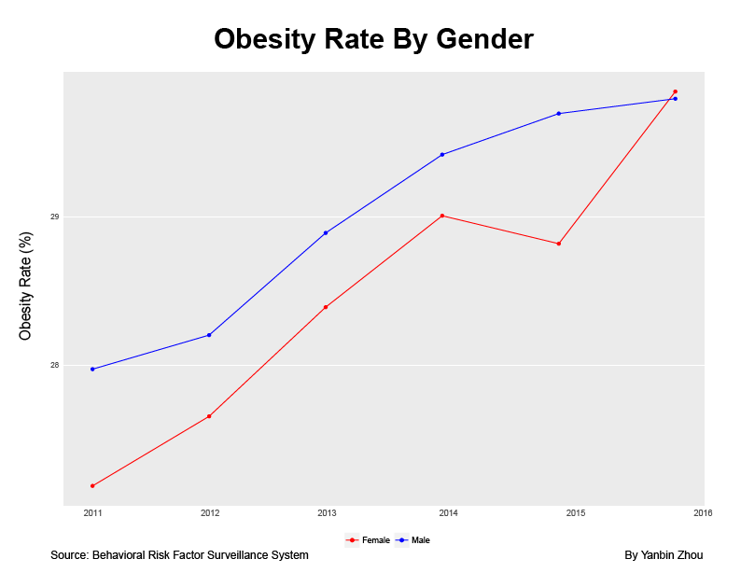Gender

Comparatively, women are more aware of their body weight. The obesity rate for women have been lower than the obesity rate for men almost every year except 2016.

* 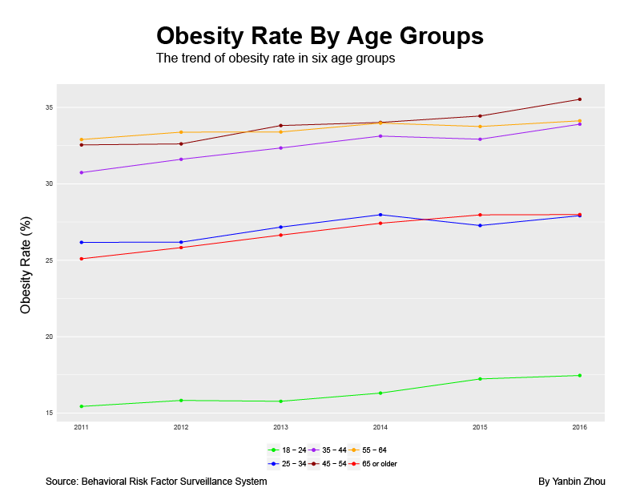Age

The obesity rate exists more between age 35 – 64. People aged 18 – 24 have the lowest obesity rate among all age groups. Age 25 – 34 and age 65 or above share similar obesity rates.

* 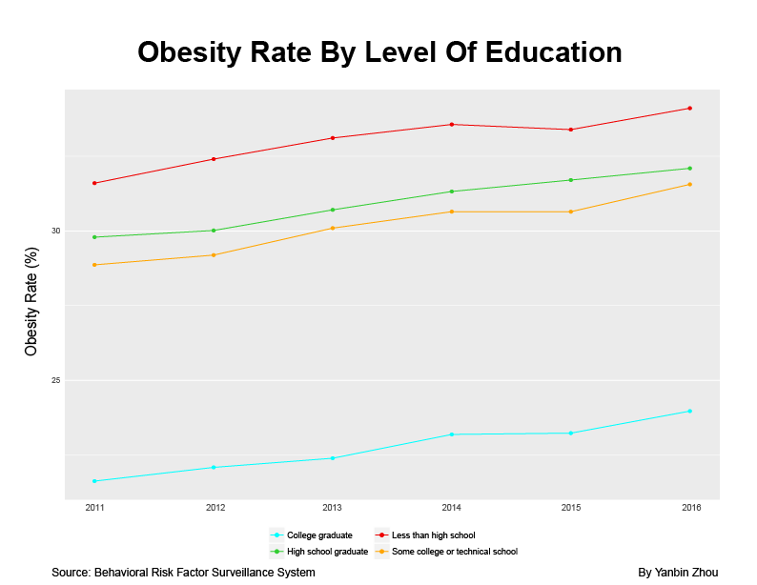Level of Education

This chart shows that the higher level of education received by an individual, he/she has less obesity problem.

* 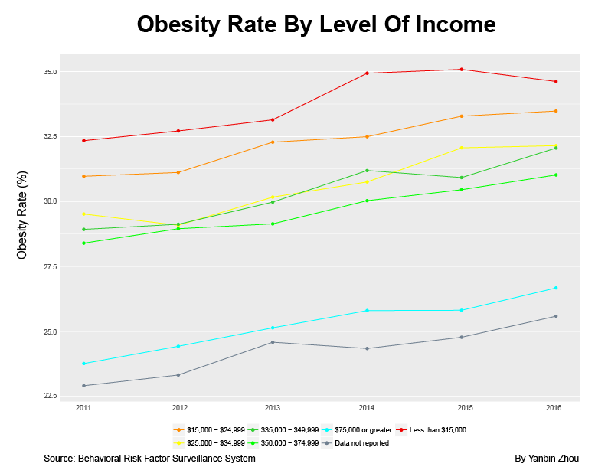Level of Income

Similar to the chart on level of education, this chart shows that the obesity rate is higher among people with lower income.

Analysis

In conclusion, males in age between 35 and 64, who are lack of formal education or income, are more likely to have obesity issues. When people are going into middle age, of course, they tend to have more responsibilities at work and at home. They might not be able to have set amount of time to exercise or really cook healthy meals; however, I believe what they put in their mouth every day is what makes them gain unnecessary weight. Like a lot of people, I used to think the only way to not spend much money is to eat at fast food restaurants. A typical meal at fast food franchise like McDonald’s is usually under $5. This is definitely cheap but unhealthy. To be fair, it is comparatively more costly to buy organic food and supplements; however, with the proper meal planning, we are capable of maintaining a clean diet while not spending too much money on food.

The main issue is that people are lack of knowledge on nutrition and exercise. I think that even if people cannot find time to do workout, but with the right diet and stay active in daily life, they are still able to maintain their weight. They will live a healthy life. Pay attention to what you eat and their nutrition factors next time you eat.

Bonus

Want to find out which states have higher obesity rates? Which ones have lower obesity rates? Click the link below to find out how the obesity issue trends from 2011 to 2016.