CS396 Project 2 Reports Yichun Zhou

**Link for Screen Capture Video:**

https://drive.google.com/file/d/1XLZcA4lD_RWHKeP_jhuDcgBmwZYDWWZM/view?usp=sharing

**Summary of requirement:**

A voting system (web based) with the database. In which a user can create polls with multiple choices (up to 6) and visitors can see all polls and choose a poll and then select an answer to vote, and voting results of that poll should be shown to them (including their own vote) in the form of bar or pie chart.

**Project analysis and design:**

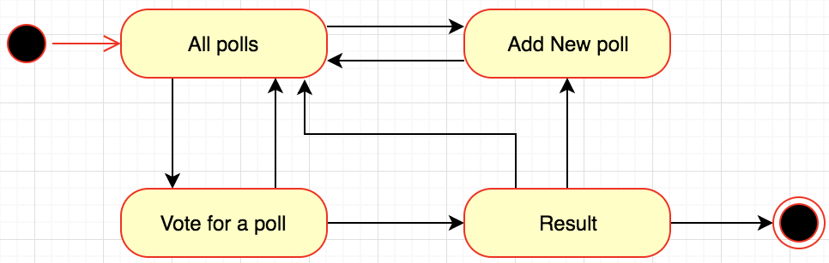

The index page would display all the polls in the database, if there is no poll yet, it will show a line of text says “no polls yet”. The user could choose to create a new poll or to vote in an existing poll. After user create a new poll, he/she will be automatically direct back to the index page. User could choose a poll to vote by clicking the poll question, the answer choice will be displayed. Next user could pick a choice to vote, after voting, user would be directed to the result page, which shows some data about the poll he/she voted.

The results contain the question for the poll, total number of votes, and the user’s voting choice. Also, information for each answer choices will be shown with both bar and pie chart, in the bar chart, it will contain the value of the choice, number of votes for the specific choice, and percentage. In the pie chart, it contains the percentage and show different percentage with area accordingly.

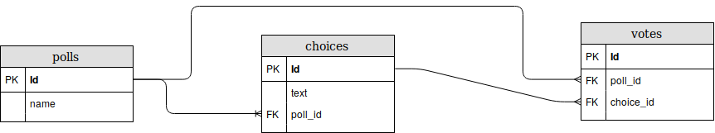**Database design:**

The database has three main tables, polls, choices, and votes. They all have their different ids, which are their primary keys. The polls name is the question for each poll. Text in choice tale is the several choices for each poll, the foreign key poll_id in choice and votes table is connect to the id in polls table, also the choice_id in votes table is connect with the id in choice table.

**User manual:**

1. click on add poll to create a new poll
2. Enter poll name and select number of choices from dropdown and then fill those choices.
3. Click on a poll question from the list.
4. You can see all the multiple choices of that poll.
5. Click on the vote button for which you want to vote.
6. After voting you will see the results of that poll with a bar and pie chart.

**Known problems, bugs, limitations, unimplemented features:**

The voting system has no user authentication, anyone can create new poll. Also, user can vote multiple time for any poll and any choice in the polls.

If the user wants to add or modified the number of choices when he already got something choice typed in, after user change the number of choices, the input will be gone, and user need to type them in again.

**References, acknowledgements, and outside sources:**

<https://www.w3schools.com/graphics/canvas_intro.asp>

<https://www.w3schools.com/jquery/>

<https://jquery.com/>

<https://www.w3schools.com/bootstrap/default.asp>

<https://getbootstrap.com/>

<https://www.w3schools.com/html/html_css.asp>

<https://www.w3schools.com/css/default.asp>

<https://www.w3schools.com/php/>

<https://www.w3schools.com/php/php_mysql_intro.asp>