CS396 Project 4 Reports Yichun Zhou

In this project, I created a bird shooting game. This game is made in JavaScript and HTML using canvas. Image is used for background and different objects like the cannon, the bird and the cannonball are also images. Cannon can be rotated using mouse and dragging on the canvas screen. For rotation canvas has a technique in which we have to first translate the canvas to the center of the image that is to be rotated and then rotate the image with the canvas and when rotation is done the canvas is restored to its original position and form. And at which angle the cannon gun is pointing when we shoot the cannon the cannon will go to that direction and if it hits the bird a score will be added and if it doesn’t hit him the ball will go out of the window and disappear.

To play this game user has 60 seconds and 10 cannon balls. Remaining time and balls are shown to the user. User can change difficulty level of the game at any time and can also start a new game at any time. After the game is completed a message to the user is shown that the game is over. And all the controls and movements of the objects are turned off.

**Instructions**

User can use mouse and drag anywhere in the canvas (the game box) to rotate the cannon gun and set the angle towards the bird. And to fire the cannonball, simply press any key from the keyboard. One game can only last 60 seconds, the time remaining can be view on the top left corner of the game box. Also, user could only fire 10 cannon balls in one game. To start a new game, “start new game” button is placed below the canvas, after pressing it and new game will start.

To change difficulty level, press the button on the left of the start new game button. At the beginning, it is set to have easy mode. To change the mode, simply press the button. It will change the mode from easy to medium and if user want to play hard mode he has to click it once more, and then the game will be in difficult mode. To go back to easy mode just click it one more time. *Fig 1* showsa screenshot of the game in action.

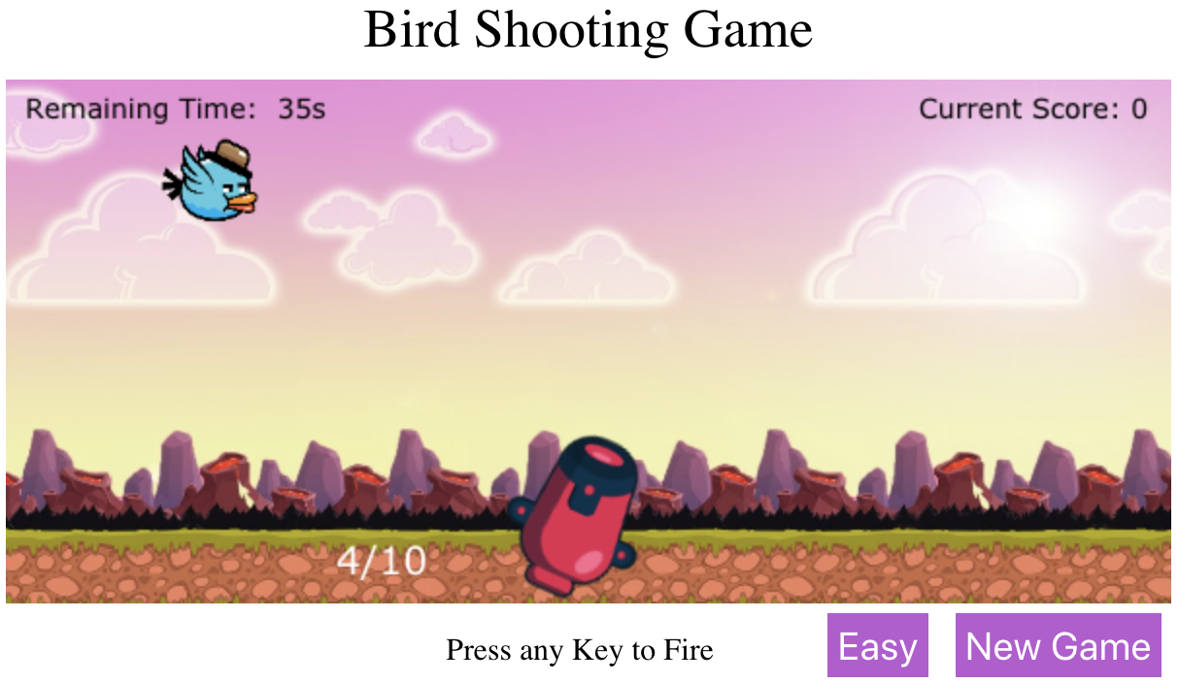

*Fig 1*

When the countdown reached 0 seconds, or all 10 cannon balls have fired by user in the 60 seconds game time, the game will be ended, and a message will be shown to user, also the movements of the all objects will be feezed. *Fig 2* showsa screenshot of the game when is game is over.

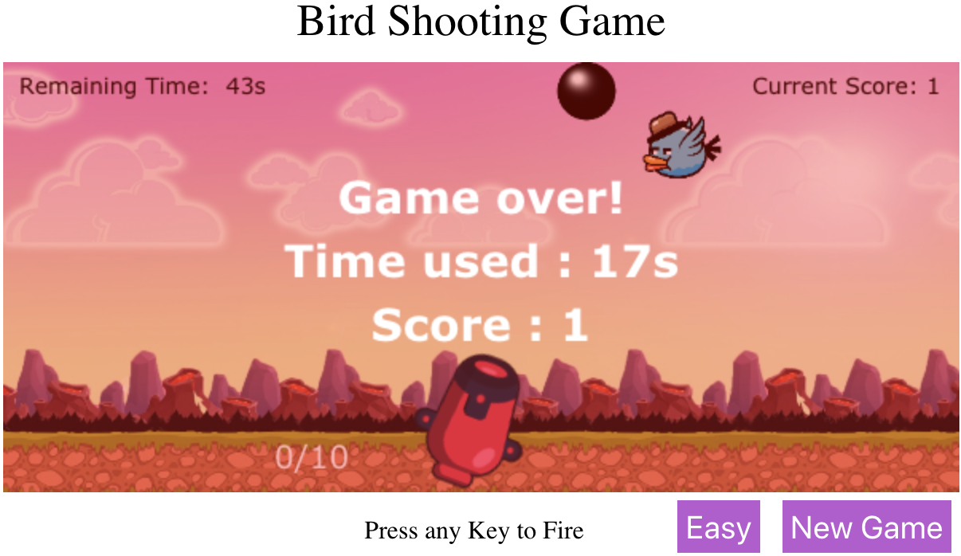

*Fig 2*

**Lessons learnt**

I learnt how to draw different type of objects on a html canvas, also learnt how to manipulate them and put different operations on them. The most interesting thing I learnt from this project is how an image can be brought to life with animating/moving it by flipping several similar pictures.

**Known problem/ limitations**

Two buttons, difficulty selector button and start new game button, are not on the game playing canvas, they are below the canvas, which cause some issue when user tries to control the cannon by dragging on the screen. User can only control the cannon by dragging on the canvas, not anywhere else on the interface.

A known bug is, when the cannon ball hit the bird, the bird will have an animation which indicates it is being hit, however the animation takes about 1 second. While in the 1 second, if the user fire another cannon ball to the bird, it will guarantee a hit, and it will result another 1 second animation of the target. If the user does that for several times, the bird will stay in the position for a period of time and might cause the game crush.

Flowchart of the program can be viewed next page.

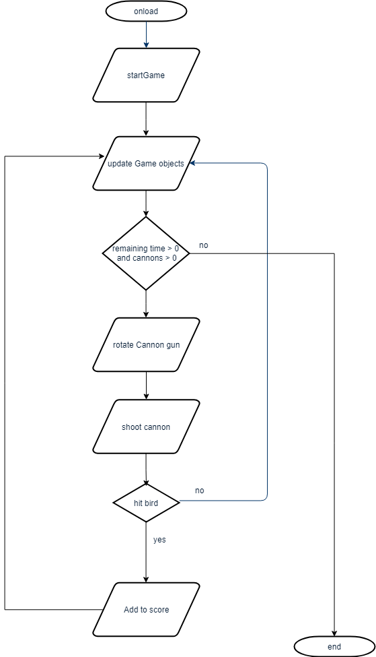

**References:**

<https://www.w3schools.com/graphics/canvas_intro.asp>

Cannon ball image is taken from this url: <https://opengameart.org/sites/default/files/cannon%20ball_2.png>

Background image is taken from:

<https://chupacdn.s3.amazonaws.com/catalog/product/cache/1/thumbnail/1280x/17f82f742ffe127f42dca9de82fb58b1/2/d/2d-game-backgrounds-10024_imgs_10024_1.jpg>

Cannon gun is taken from:

<https://opengameart.org/sites/default/files/component_cannon_2.png>

Bird is taken from:

<https://opengameart.org/sites/default/files/Flappy%20grumpy%20bird%20game%20character.zip>