KODE PROGRAM

import mysql.connector

class Karyawan:

    def __init__(self, id, nama, jabatan, gaji):

        self.id = id

        self.nama = nama

        self.jabatan = jabatan

        self.gaji = gaji

    @staticmethod

    def select_all():

        conn = mysql.connector.connect(user='root', password='', host='localhost', database='5220411214')

        cursor = conn.cursor()

        query = "SELECT * FROM karyawan"

        cursor.execute(query)

        result = cursor.fetchall()

        cursor.close()

        conn.close()

        karyawans = []

        for row in result:

            karyawan = Karyawan(row[0], row[1], row[2], row[3])

            karyawans.append(karyawan)

        return karyawans

    def insert(self):

        conn = mysql.connector.connect(user='root', password='', host='localhost', database='5220411214')

        cursor = conn.cursor()

        query = "INSERT INTO karyawan (nama, jabatan, gaji) VALUES (%s, %s, %s)"

        data = (self.nama, self.jabatan, self.gaji)

        cursor.execute(query, data)

        conn.commit()

        cursor.close()

        conn.close()

    def delete(self):

        conn = mysql.connector.connect(user='root', password='', host='localhost', database='5220411214')

        cursor = conn.cursor()

        query = "DELETE FROM karyawan WHERE id=%s"

        data = (self.id,)

        cursor.execute(query, data)

        conn.commit()

        cursor.close()

        conn.close()

    def update(self):

        conn = mysql.connector.connect(user='root', password='', host='localhost', database='5220411214')

        cursor = conn.cursor()

        query = "UPDATE karyawan SET nama=%s, jabatan=%s, gaji=%s WHERE id=%s"

        data = (self.nama, self.jabatan, self.gaji, self.id)

        cursor.execute(query, data)

        conn.commit()

        cursor.close()

        conn.close()

# Contoh penggunaan

karyawans = Karyawan.select_all()

for karyawan in karyawans:

    print(karyawan.id, karyawan.nama, karyawan.jabatan, karyawan.gaji)

karyawan_baru = Karyawan(0, 'Jofran', 'Software Engineer', 50000)

karyawan_baru.insert()

karyawan_baru = Karyawan(0, 'Anggi', 'Hardware Engineer', 100000)

karyawan_baru.insert()

karyawan_baru = Karyawan(0, 'Jerry', 'Software Engineer', 2000000)

karyawan_baru.insert()

karyawan_baru = Karyawan(0, 'Manusia', 'Hardware Engineer', 2000000)

karyawan_baru.insert()

karyawan_baru = Karyawan(0, 'Sumba', 'Software Engineer', 2000000)

karyawan_baru.insert()

karyawan_baru = Karyawan(0, 'Merry', 'Software Engineer', 2000000)

karyawan_baru.insert()

karyawan_to_delete = Karyawan(0, '', '', '')

karyawan_to_delete.id = 2

karyawan_to_delete.delete()

karyawan_to_update = Karyawan(2, 'Karyawan Diperbarui', 'Senior Software Engineer', 70000)

karyawan_to_update.id = 3

karyawan_to_update.update()

HASIL RUNNING PROGRAM

Menambahkan 5 Data ke Dalam Tabel karyawan

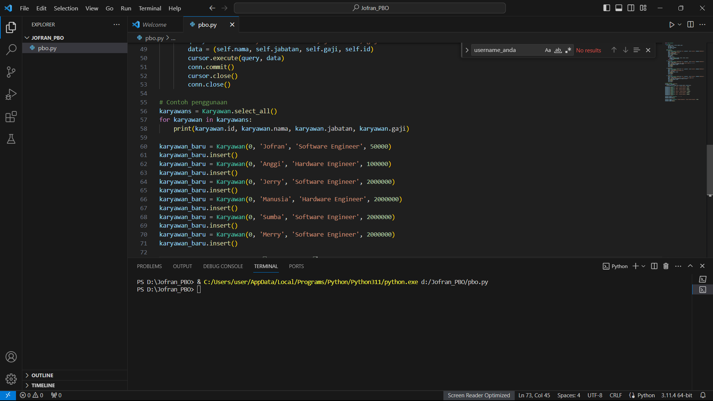

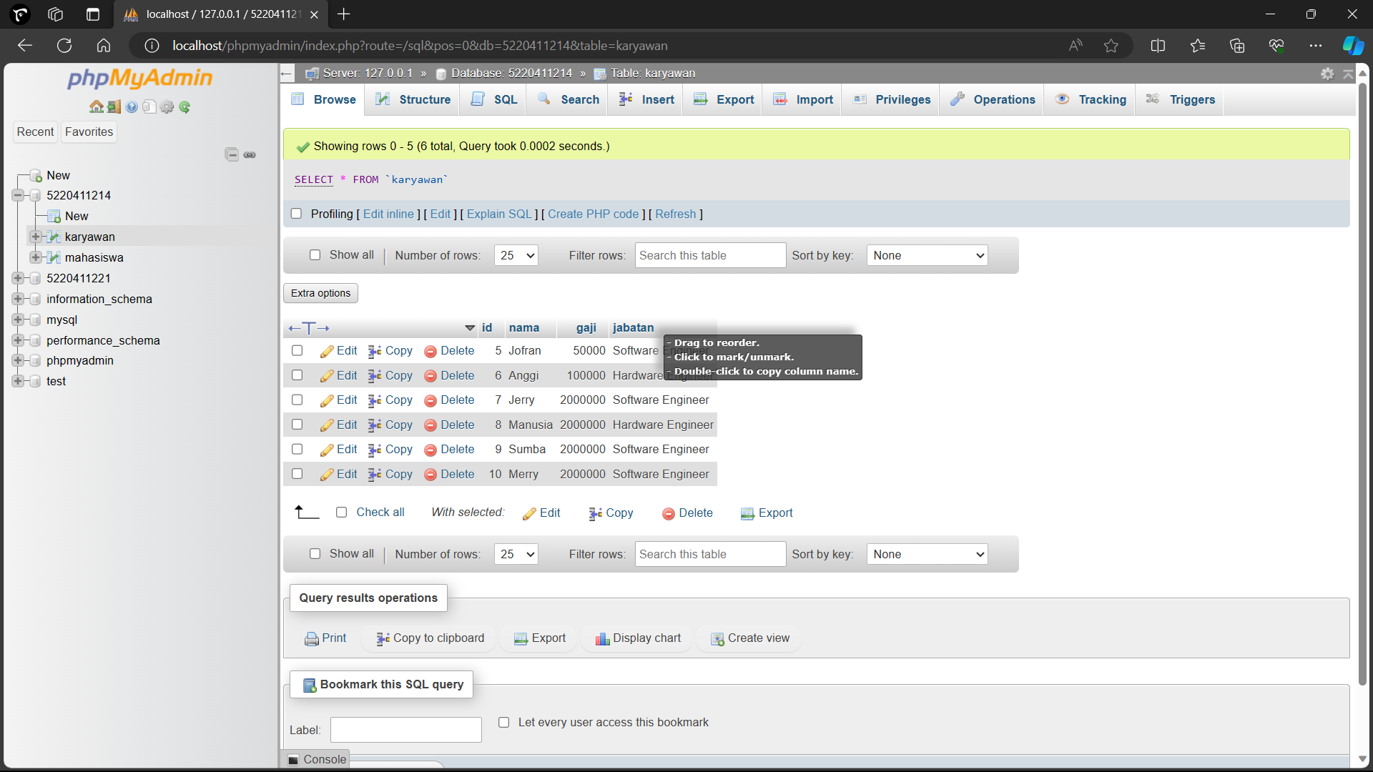

DELETE

Menghapuskan Data Anggi dalam tabel karyawan

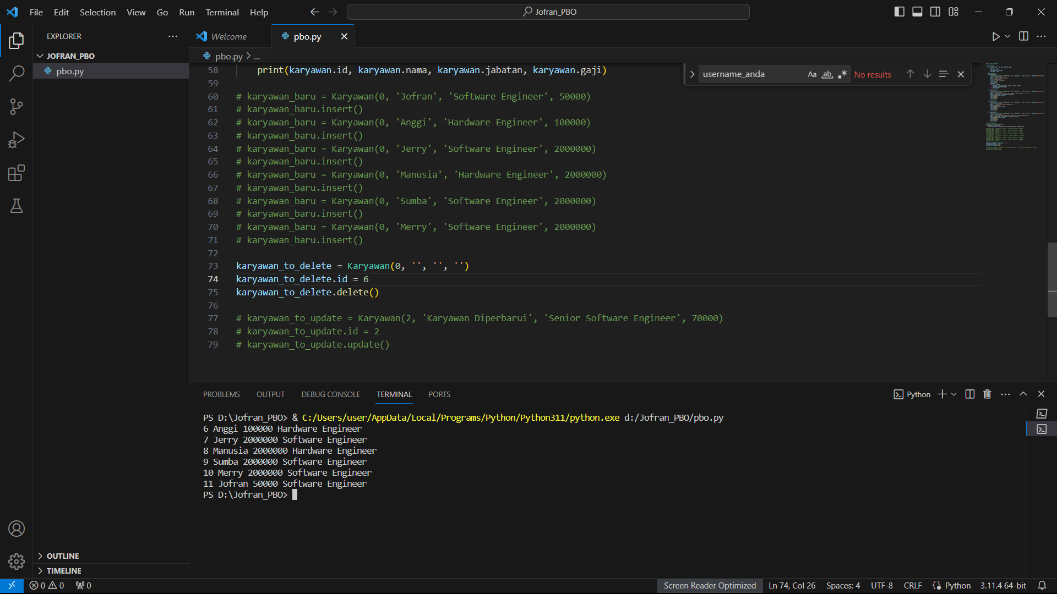

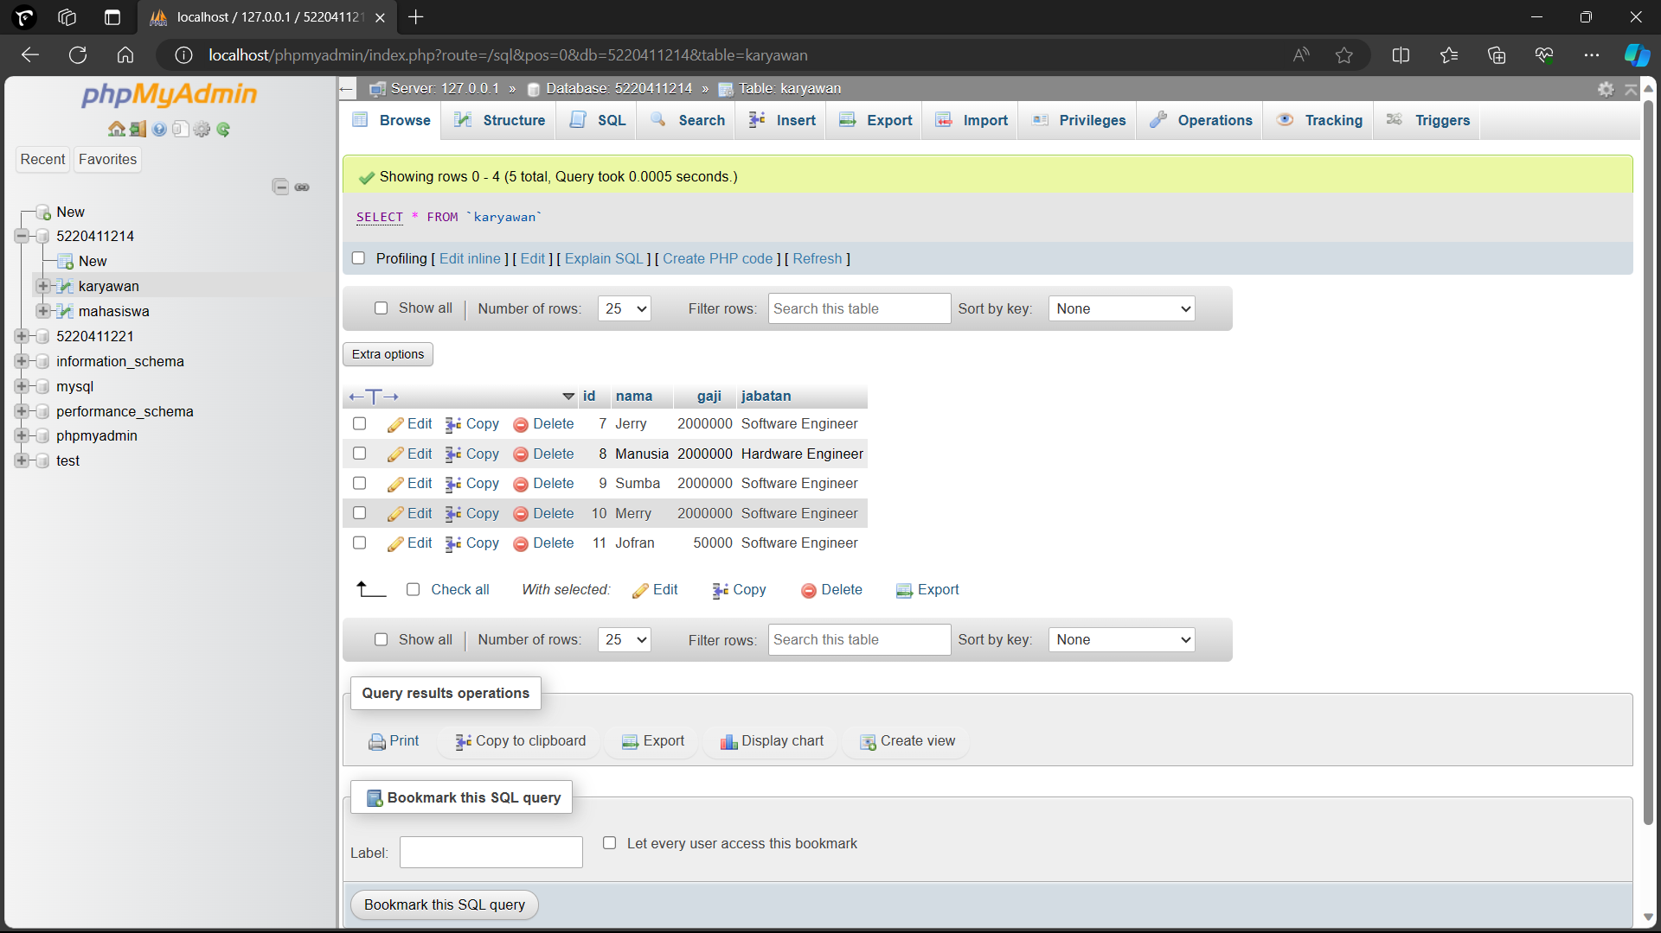

UPDATE

Mengubah Data dalam tabel

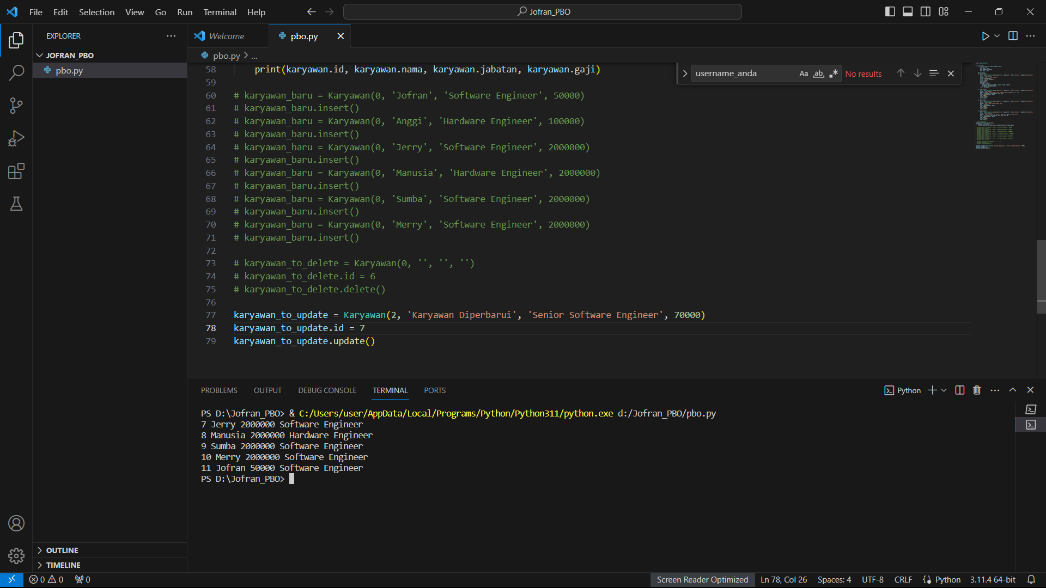

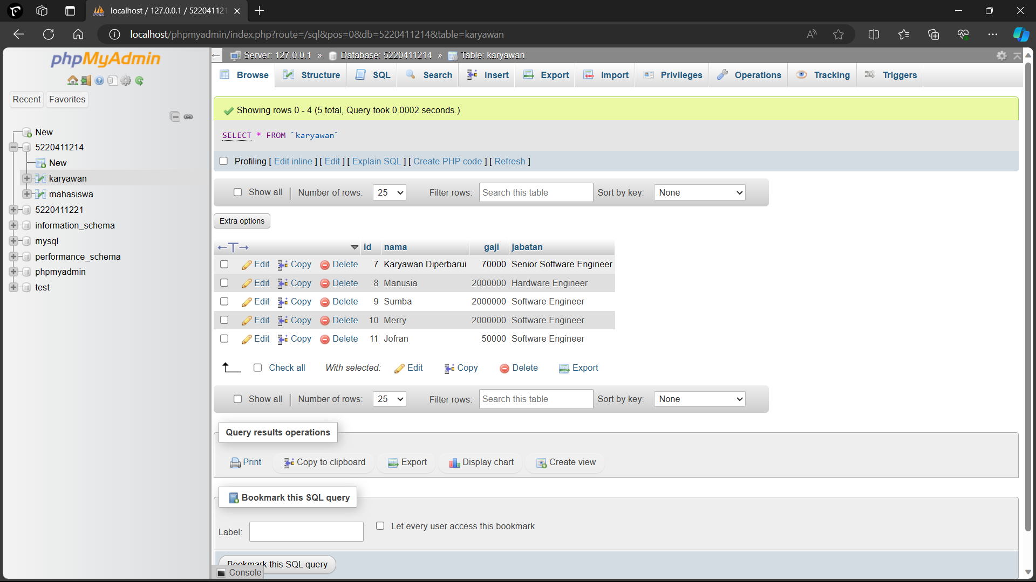

LINK GITHUB

<https://github.com/jofranalbhinata07/PBOVI_5220411214_JOOFRAN_ALBHINATA.git>