From the Azure AD portal under App Registrations, please hit New Registration

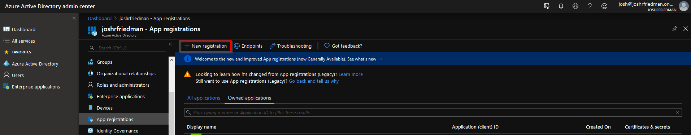

You may call the App Registration whatever you like, I chose "O365 Service Health" for simplicity, once done with naming you can hit register

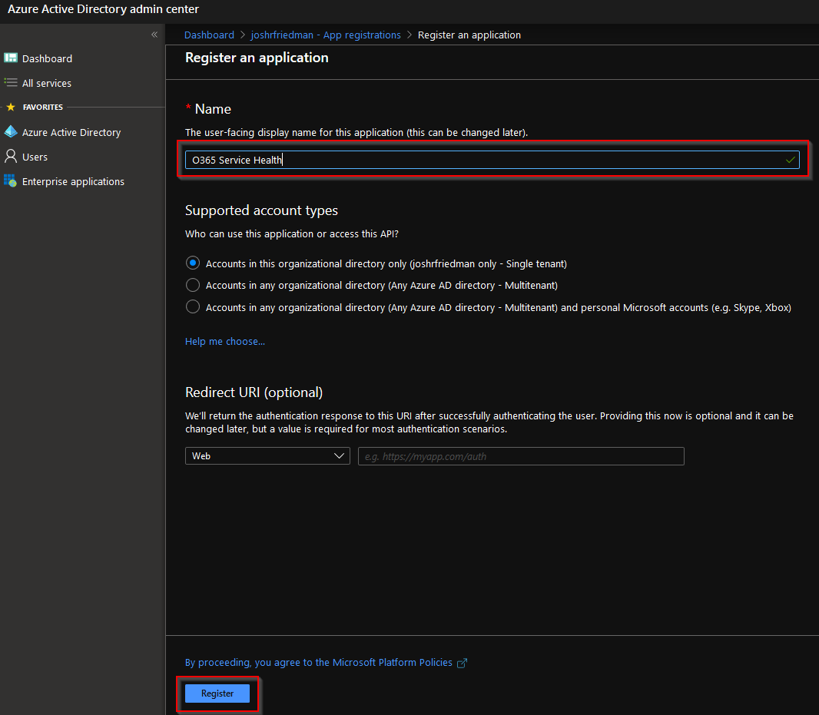

Once you are in the overview of your app registration hit "Add a Redirect URI"

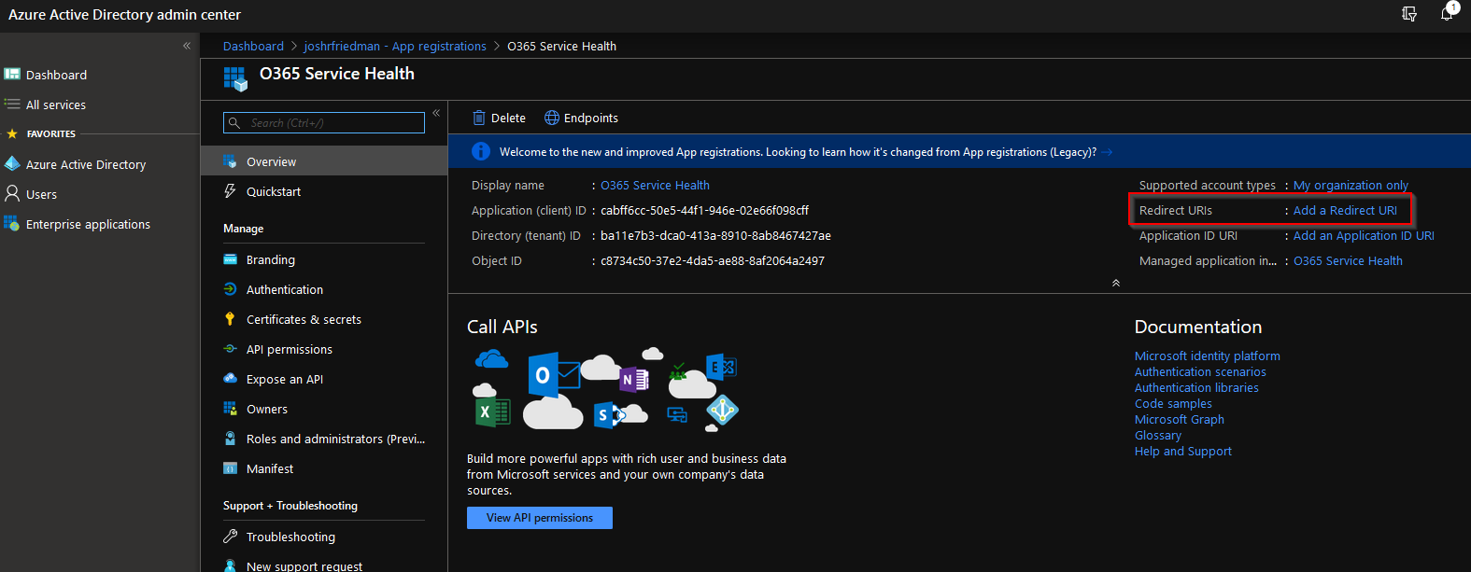

Once on the Redirect URIs page you can select <https://login.microsoftonline.com/common/oauth2/nativeclient> and then save that

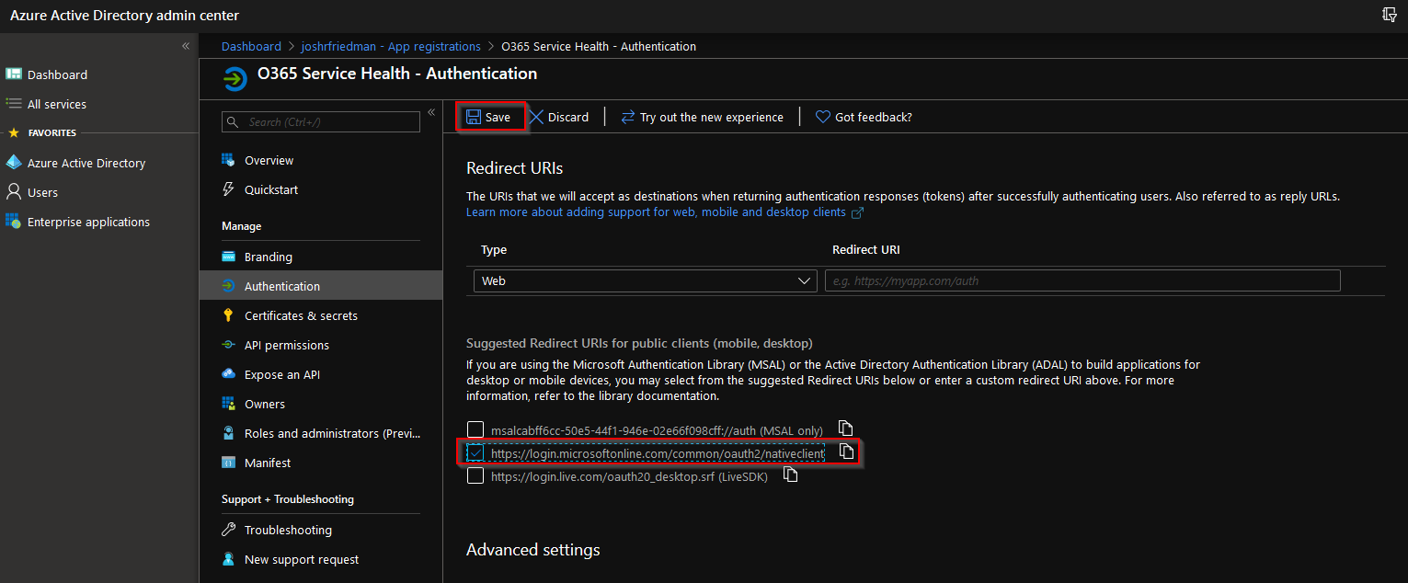

Now we need to create a client secret. Navigate to Certificate & secrets and click "New Client Secret"

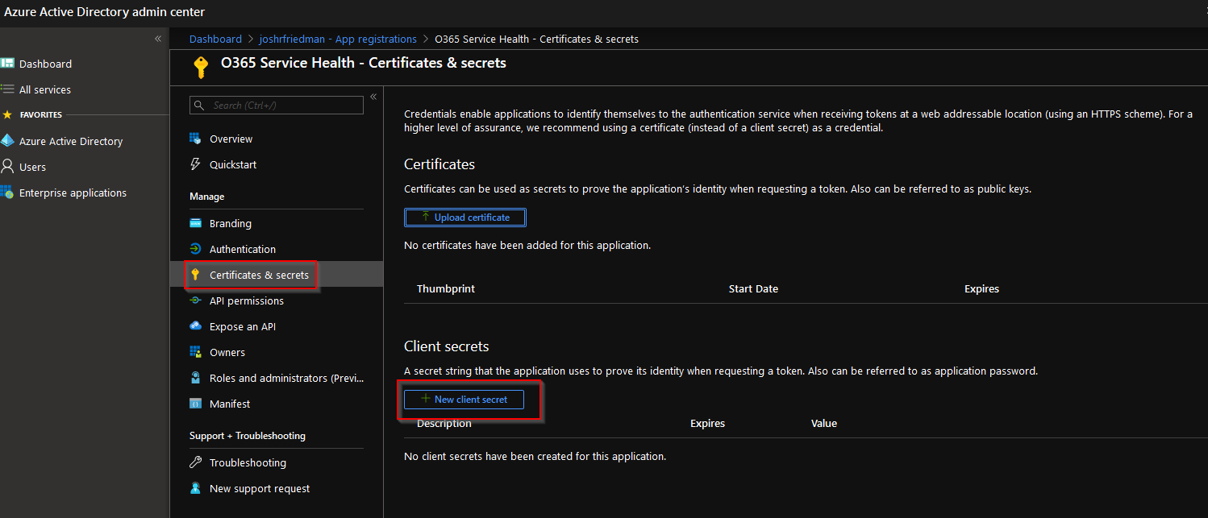

Give the Client Secret a Description and then hit add. (you can set this expiration to 1 year, 2 years, or never)

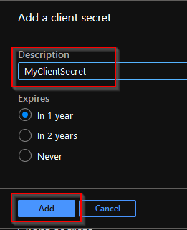

Once you hit add, copy the client secret value, and save it in a secure place. (once we click away from this screen you will no longer be able to view it, and we will need it later.)

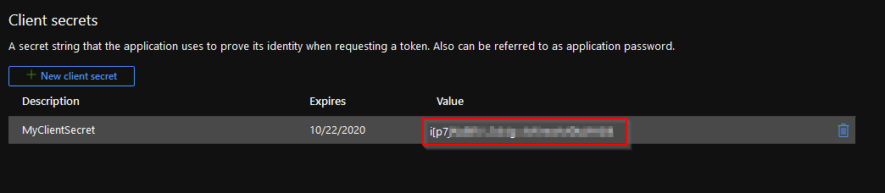

Now we need to navigate to API permissions and hit "Add a permission"

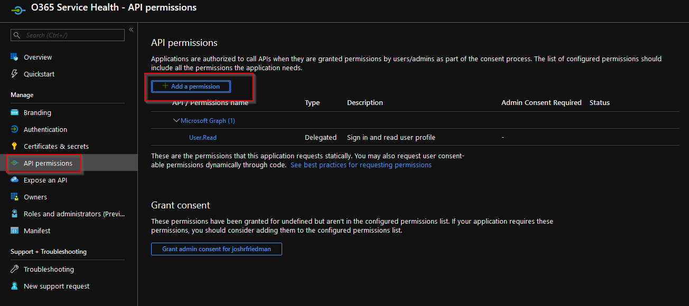

You should be able to select "Office 365 Management APIs"

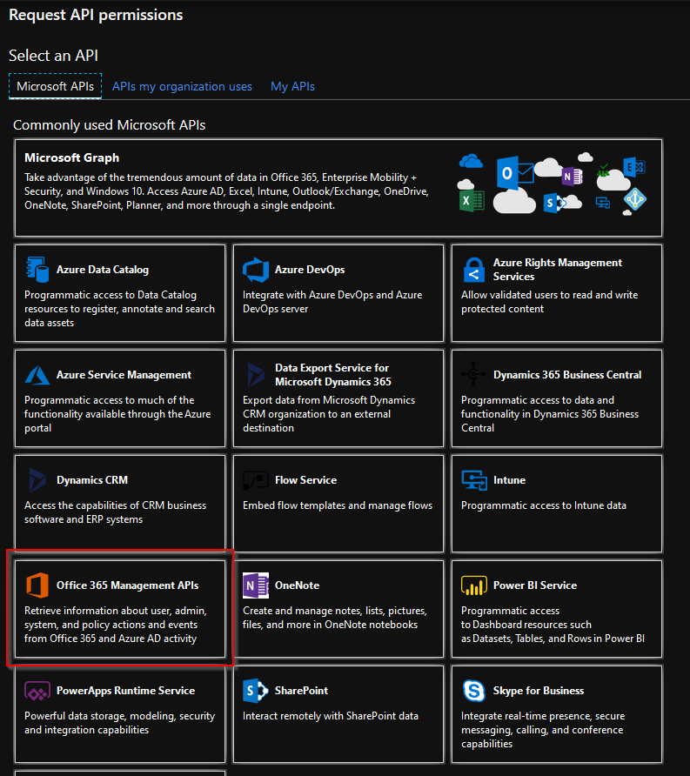

Now select Application permissions then drop down the ServiceHealth permission and check the box for ServiceHealth.Read and then hit add permission

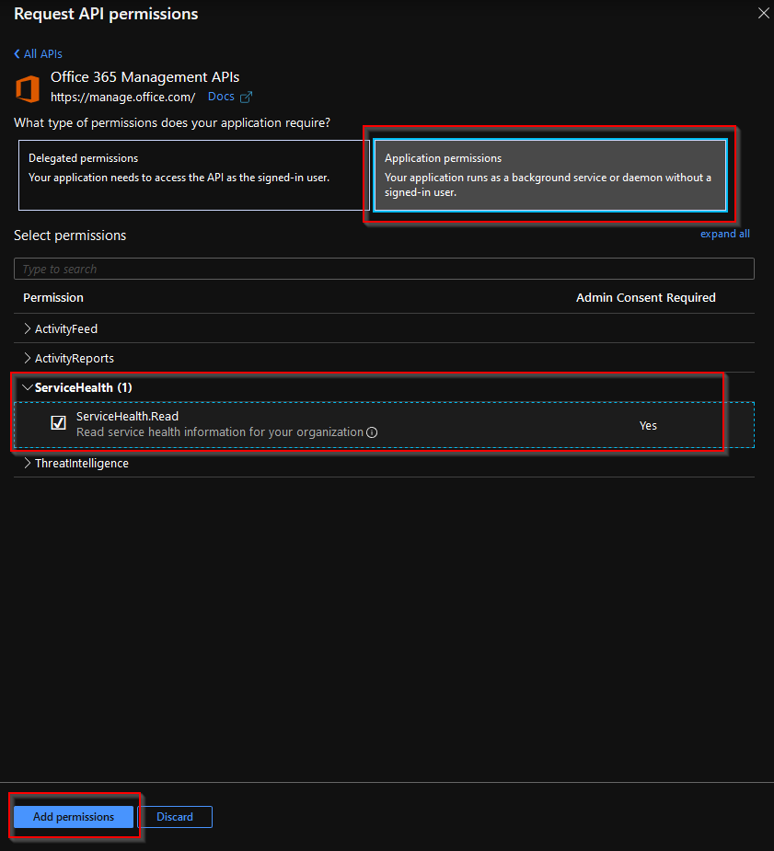

You will also need to grant admin consent to this app registration

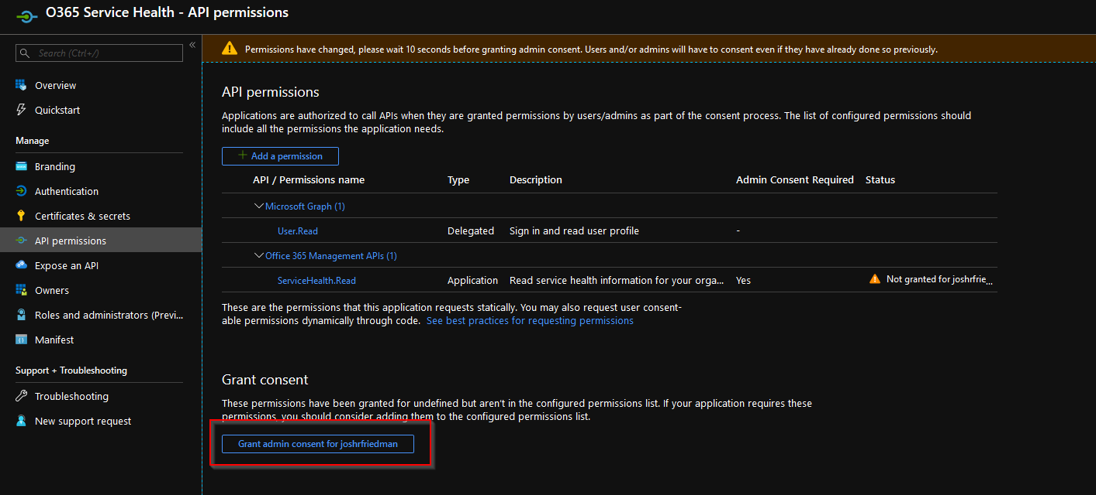

Now that you have the app registration, please go back to the overview tab as we will need to collect some information from there. You will need to copy the Client ID and the Tenant ID, as we will need to use these in powershell.

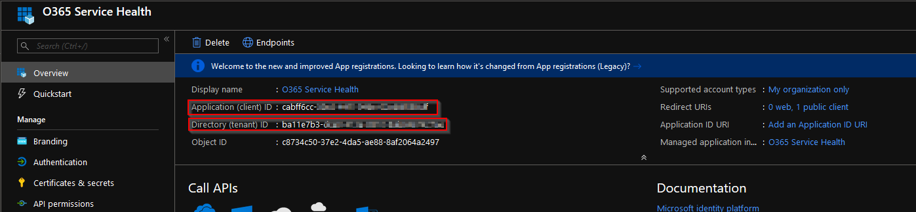

Open the O365ServiceHealth.ps1 to edit the Client and Tenant ID, as well as the Secret. This will need to match the App Registration we have just created.

