Question 4, Homework 1

Joe Froelicher

9/10/2020

# Part A

setwd("C:/Users/jofro/OneDrive/cu/sem1/methods1/hw1")  
naws <- read.csv("NAWS2014.csv", header = TRUE)  
head(naws$A09)

## [1] 14 6 6 7 12 4

# Part B

hist(  
 naws$A09,  
 main = "Years of school completed by migrant workers",  
 xlab = "Number of years of school completed",  
 ylab = "Number of workers"  
)

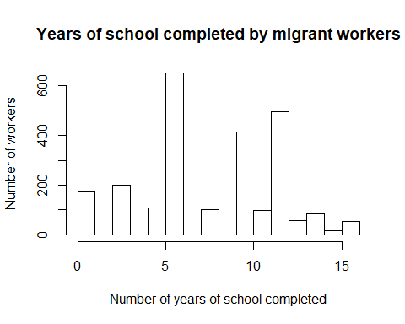

# Part C

mean(naws$A09)

## [1] 7.674814

median(naws$A09)

## [1] 7

# https://stackoverflow.com/questions/2547402/how-to-find-the-statistical-mode #  
getMode <- function(v) {  
 uniqv <- unique(v)  
 uniqv[which.max(tabulate(match(v, uniqv)))]  
}  
  
getMode(naws$A09)

## [1] 6

Referencing the histogram, as well as measures of median and mode, we know that data that has a heavy right tail (in this case) or left tail, tend to be better estimated by a median than a mean. It is worth noting that the buckets with the most number of workers are 6, 8 and 12, the years we would expect the most people to drop out of school (For much of the United States those would be the years you are transitioning to a new school).

# Part D

naws["category_edu"] <- NA  
iter <- 0  
  
for (a in naws$A09) {  
 iter <- iter + 1  
   
 if (a <= 5) {  
 naws$category_edu[iter] <- "00-05"  
   
 } else if (a <= 8) {  
 naws$category_edu[iter] <- "06-08"  
   
 } else if (a <= 11) {  
 naws$category_edu[iter] <- "09-11"  
   
 } else {  
 naws$category_edu[iter] <- "12+"  
 }  
}  
  
head(naws$category_edu)

## [1] "12+" "06-08" "06-08" "06-08" "12+" "00-05"

# Part E

cat_table <- table(naws$category_edu) / length(naws$category_edu)  
cat_table

##   
## 00-05 06-08 09-11 12+   
## 0.2479632 0.2890542 0.2118314 0.2511513

# Part F

mockdata <- data.frame(subject = 1:800, random = runif(n = 800))  
head(mockdata)

## subject random  
## 1 1 0.5999170  
## 2 2 0.3670378  
## 3 3 0.5511275  
## 4 4 0.8173483  
## 5 5 0.8456245  
## 6 6 0.5023489

mockdata["educ_cat"] <- NA  
mockdata["educ_years"] <- NA  
mockdata["educ_stop_yn"] <- NA  
  
level1 <- cat_table[1]  
level2 <- cat_table[1] + cat_table[2]  
level3 <- cat_table[1] + cat_table[2] + cat_table[3]  
iter <- 0  
  
for (r in mockdata$random) {  
 iter <- iter + 1  
   
 if (r <= level1) {  
 mockdata$educ_cat[iter] <- "00-05"  
 mockdata$educ_years[iter] <- runif(1, 0, 6)  
 mockdata$educ_stop_yn[iter] <- rbinom(1, 1, 0.8)  
   
 } else if ( r > level1 & r <= level2 ) {  
 mockdata$educ_cat[iter] <- "06-08"  
 mockdata$educ_years[iter] <- runif(1, 6, 9)  
 mockdata$educ_stop_yn[iter] <- rbinom(1, 1, 0.8)  
   
 } else if ( r > level2 & r <= level3 ) {  
 mockdata$educ_cat[iter] <- "09-11"  
 mockdata$educ_years[iter] <- runif(1, 9, 12)  
 mockdata$educ_stop_yn[iter] <- rbinom(1, 1, 0.8)  
   
 } else {  
 mockdata$educ_cat[iter] <- "12+"  
 mockdata$educ_years[iter] <- runif(1, 12, 17)  
 mockdata$educ_stop_yn[iter] <- rbinom(1, 1, 0.8)  
   
 }  
}  
  
iter <- 0  
for (c in mockdata$educ_cat) {  
 iter <- iter + 1  
   
 if ( c == "06-08" & mockdata$educ_stop_yn[iter] == 1 ) {  
 mockdata$educ_years[iter] <- 6  
 } else if ( c == "09-11" & mockdata$educ_stop_yn[iter] == 1 ) {  
 mockdata$educ_years[iter] <- 9  
 } else if ( c == "12+" & mockdata$educ_stop_yn[iter] == 1 ) {  
 mockdata$educ_years[iter] <- 12  
 }  
}  
  
mockdata$educ_years <- trunc(mockdata$educ_years)  
head(mockdata)

## subject random educ_cat educ_years educ_stop_yn  
## 1 1 0.5999170 09-11 9 1  
## 2 2 0.3670378 06-08 6 1  
## 3 3 0.5511275 09-11 9 1  
## 4 4 0.8173483 12+ 16 0  
## 5 5 0.8456245 12+ 15 0  
## 6 6 0.5023489 06-08 6 1

# Part G

hist(  
 mockdata$educ_years,  
 main = "Years of school completed (mockdata)",  
 xlab = "Number of years of school completed",  
 ylab = "Number of workers",  
 breaks = 16  
)

