Question 1

Joseph Froelicher

9/17/2020

# Part A Poisson

set.seed(8675309)  
LAMBDA <- 1.5  
rps <- rpois(10000, LAMBDA)  
head(rps)

## [1] 0 1 2 2 1 2

# Part B Poisson

p.theoretical_mean <- LAMBDA  
p.theoretical_sd <- LAMBDA  
p.theoretical_mean

## [1] 1.5

p.theoretical_sd

## [1] 1.5

p.simulated_mean <- mean(rps)  
p.simulated_sd <- sd(rps)  
p.simulated_mean

## [1] 1.4943

p.simulated_sd

## [1] 1.216847

Theoretical mean and sd from Miller I and Miller M, ‘John E. Freund’s Mathematical Statistics with Applications’; eigth edition, p. 162

# Part C Poisson

hist(  
 rps,  
 breaks = -2:8,  
 main = "Simulated Poisson distribution (N = 10,000)",  
 xlab = "value",  
 ylab = "n"  
)

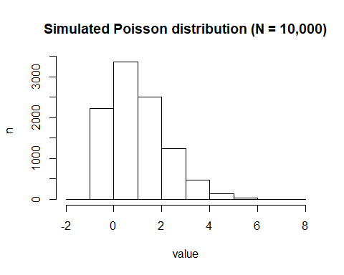

boxplot(  
 rps,  
 ylab = "value",  
 main = "Simulated Poisson distribution (n = 10,000)"  
)

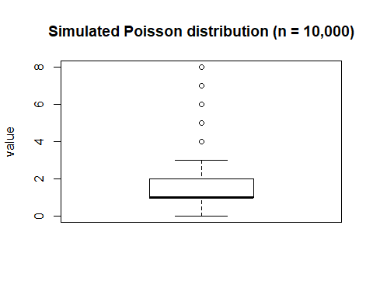

# Part A Binomial

set.seed(8675309)  
N <- 5  
THETA <- 0.15  
rbs <- rbinom(10000, N, THETA)  
head(rbs)

## [1] 0 1 1 1 0 1

# Part B Binomial

b.theoretical_mean <- N * THETA  
b.theoretical_sd <- sqrt( N * THETA * (1 - THETA) )  
b.theoretical_mean

## [1] 0.75

b.theoretical_sd

## [1] 0.798436

b.simulated_mean <- mean(rbs)  
b.simulated_sd <- sd(rbs)  
b.simulated_mean

## [1] 0.7387

b.simulated_sd

## [1] 0.7966717

Theoretical mean and sd from Miller I and Miller M, ‘John E. Freund’s Mathematical Statistics with Applications’; eigth edition, p. 149

# Part C Binomial

hist(  
 rbs,  
 breaks = -2:8,  
 main = "Simulated Binomial distribution (N = 10,000)",  
 xlab = "value",  
 ylab = "n"  
)

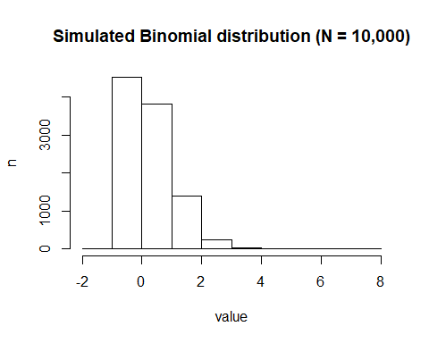

boxplot(  
 rbs,  
 ylab = "value",  
 main = "Simulated Binomial distribution (n = 10,000)"  
)

