Question 2

Joseph Froelicher

9/24/2020

# Part A

set.seed(8675309)  
  
rand.norm <- rnorm(10000, 125, 8)  
rand.exp <- rexp(10000, 1.5)  
head(rand.norm)

## [1] 117.0273 130.7746 120.0623 141.2351 133.5233 132.8978

head(rand.exp)

## [1] 0.339438411 0.026667161 0.003152321 0.303097170 0.248417867 0.267030615

# Part B

rand.norm.mean <- mean(rand.norm)  
rand.norm.sd <- sd(rand.norm)  
rand.norm.mean

## [1] 124.9968

rand.norm.sd

## [1] 8.045119

rand.exp.mean <- mean(rand.exp)  
rand.exp.sd <- sd(rand.exp)  
rand.exp.mean

## [1] 0.6711797

rand.exp.sd

## [1] 0.6707688

For the normal distribution the mean and standard deviation are $μ=125$ and $σ=8$. Our simulated mean and standard deviations look appropriate.

<https://en.wikipedia.org/wiki/Normal_distribution>

The mean and standard deviation are both $\frac{1}{λ}$ for the exponential distribution. Our simulated results are close enough to the theorhetical mean of .

<https://en.wikipedia.org/wiki/Exponential_distribution>

# Part C

hist(rand.norm, main = "Random Normal with n = 10,000")

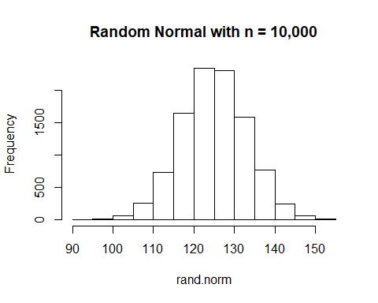

boxplot(rand.norm, main = "Random Normal with n = 10,000")

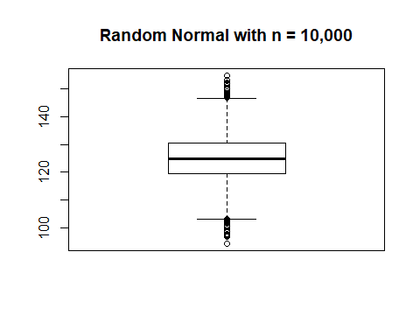

hist(rand.exp, main = "Random Exponential with n = 10,000")

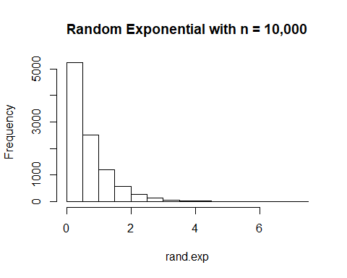

boxplot(rand.exp, main = "Random Exponential with n = 10,000")

