Question 3

Joseph Froelicher

9/24/2020

# Part A

N = 1000  
mmv_mat <- matrix(NA, nrow = N, ncol = 3)  
  
for (i in 1:N) {  
 rand_norm <- rnorm(10, 40, 10)  
 mmv_mat[i, 1] <- mean(rand_norm)  
 mmv_mat[i, 2] <- median(rand_norm)  
 mmv_mat[i, 3] <- var(rand_norm)  
}  
  
hist(mmv_mat[,1], main = "1000 simulated means")

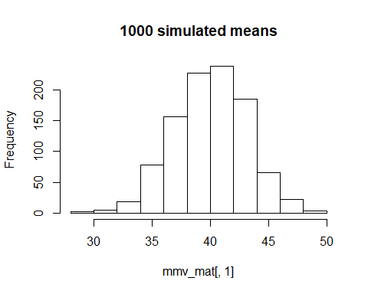

hist(mmv_mat[,2], main = "1000 simulated medians")

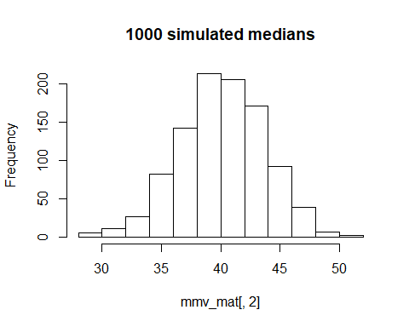

hist(mmv_mat[,3], main = "1000 simulated Variances")

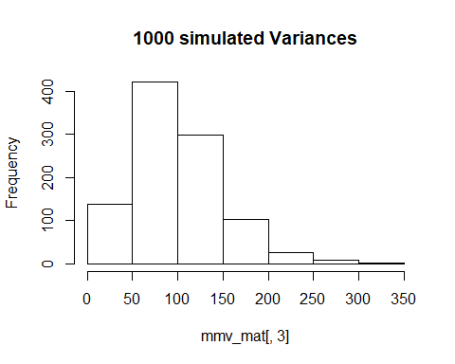

# Part B

We would expect both the sample means and the sample medians to be normally distributed. The property of expectations for linear combinations of random variables tells us that for a sum of linear combinations of variables, the expectations for the sum of linear combinations is just the sum of the expectations of each of the linear combinations. So we would expect the sample means and sample medians of simulated normal distributions to also be normally distrbuted.

# Part C

n = 10  
sigma <- 10  
var <- mmv_mat[,3] * (n - 1) / sigma ** 2  
  
hist(  
 var,  
 breaks = 35,  
 probability = TRUE,  
 main = "theoretical distribution and sample variances",  
 col = 'red'  
)  
  
lines(  
 curve(  
 dchisq(x, n - 1),  
 min(var) - 1,  
 max(var) + 1,  
 add = TRUE  
 ),  
 col = 'blue',  
 lwd = 2  
)

