Question 5

Joseph Froelicher

9/24/2020

# individual sample size  
n <- c(10, 50, 100, 1000)  
  
# the number of simulations per sample size  
N <- 500  
  
# number of columns in the matrices  
C <- 4  
  
sample_mean <- matrix(NA, N, C)  
  
iter <- 0  
  
for (j in 1:length(n)) {  
 for (i in 1:N) {  
 draws <- rcauchy(n[j])  
 sample_mean[i, j] <- mean(draws)  
 }  
}  
  
# Part C  
means_table <- data.frame(  
 mean(sample_mean[,1]),  
 mean(sample_mean[,2]),  
 mean(sample_mean[,3]),  
 mean(sample_mean[,4])  
)  
  
colnames(means_table) <- c('n = 10', 'n = 50', 'n = 100', 'n = 1000')  
means_table

## n = 10 n = 50 n = 100 n = 1000  
## 1 -0.3480872 0.3262719 -1.313404 -11.09059

sd_table <- data.frame(  
 sd(sample_mean[,1]),  
 sd(sample_mean[,2]),  
 sd(sample_mean[,3]),  
 sd(sample_mean[,4])  
)  
  
colnames(sd_table) <- c('n = 10', 'n = 50', 'n = 100', 'n = 1000')  
sd_table

## n = 10 n = 50 n = 100 n = 1000  
## 1 21.3073 15.4616 36.21611 221.4516

# Part D  
par(mfrow = c(2,2))  
  
hist(  
 sample_mean[,1],  
 breaks = 50,  
 main = 'Sample means n = 10',  
 xlab = expression(mu),  
 col = 'blue'  
)  
  
hist(  
 sample_mean[,2],  
 breaks = 50,  
 main = 'Sample means n = 50',  
 xlab = expression(mu),  
 col = 'red'  
)  
  
hist(  
 sample_mean[,3],  
 breaks = 50,  
 main = 'Sample means n = 100',  
 xlab = expression(mu),  
 col = 'orange'  
)  
  
hist(  
 sample_mean[,4],  
 breaks = 50,  
 main = 'Sample means n = 1000',  
 xlab = expression(mu),  
 col = 'yellow'  
)

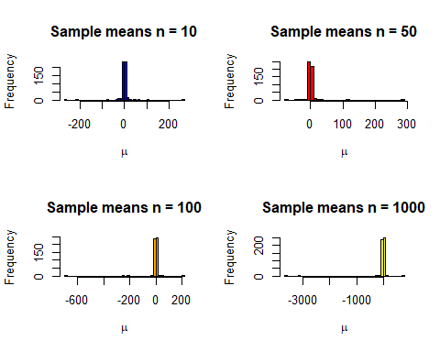

The CLT states that as n gets large, we would expect the sample means to behave normally, however it appears with the cauchy distribution that no amount of increase to the sample size will cause this distribution to behave normally. For the previous problem it only took a sample size of (arguably) 30 to start to look normal.