Question 2

Joseph Froelicher

11/12/2020

# Part A

fit_a <- lm(ln_cells ~ temp, data = amniotic)  
summary(fit_a)

##   
## Call:  
## lm(formula = ln_cells ~ temp, data = amniotic)  
##   
## Residuals:  
## Min 1Q Median 3Q Max   
## -0.168328 -0.049781 -0.002362 0.048546 0.114505   
##   
## Coefficients:  
## Estimate Std. Error t value Pr(>|t|)   
## (Intercept) -0.6681674 0.0527461 -12.67 2.1e-10 ***  
## temp 0.0185546 0.0007178 25.85 1.1e-15 ***  
## ---  
## Signif. codes: 0 '***' 0.001 '**' 0.01 '*' 0.05 '.' 0.1 ' ' 1  
##   
## Residual standard error: 0.07178 on 18 degrees of freedom  
## Multiple R-squared: 0.9738, Adjusted R-squared: 0.9723   
## F-statistic: 668.2 on 1 and 18 DF, p-value: 1.103e-15

coeff <- fit_a$coefficients  
  
coeff_t <- exp(fit_a$coefficients)  
ci_t <- exp(confint(fit_a))

log(cells) = -0.6681674 + 0.0185546 $X_{temp}$

For a unit increase in temperature, we would expect an average increase 0.0185546 in log cells. And for temperature 0 the expected log cells is -0.6681674.

For a unit increase in temperature, we would expect an average of 1.8727835 increase in cells. And for temperature 0 the geometric mean of expected cells is 0.5126472.

# Part B

par(mfrow = c(2, 2))  
  
plot(x = amniotic$temp, y = amniotic$ln_cells, main = 'Scatterplot')  
abline(fit_a)  
  
plot(x = amniotic$temp, y = rstudent(fit_a), main = "Jackknife Scatterplot")  
abline(h = 0, lty = 2)  
  
hist(x = rstudent(fit_a), freq = FALSE, main = "Jacknife Histogram")  
curve(dnorm(x, mean = 0, sd = 1), add = TRUE)  
  
plot(ppoints(length(rstudent(fit_a))), sort(pnorm(rstudent(fit_a))), main = "Normal P-P")  
abline(a = 0, b = 1)

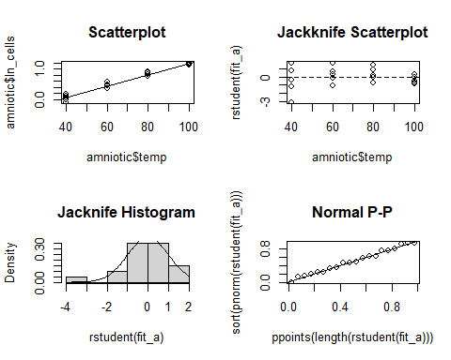

There are so few data, it is really hard to see whether any of our assumptions are being violated. There is some evidence from the Jackknife Scatterplot that the error variance is not distributed equally, but again, I would call that minimal evidence, and not necessarily cause for concern.

# Part C

There is a significant increase in the number of human amniotic cells grown in a tissue culture of a certain medium (p < 0.0001). On average, the number of human amniotic cells grown in a tissue culture of a certain medium increases by 1.8727835% (95% CI: 1.7192743% to 2.0265245%) for a unit increase in temperature.