Library pickup instructions
This fictional library example explains how to collect reserved books. Choose a pickup location and wait for a ready notice before travelling.

Collection deadline

How to collect
- Submit a request with your name and pickup location.
- Wait for the library to review the request and send a ready notice.
- Bring your library card when collecting the books.

Pickup locations
Location | Limit | Hours
North desk | 2 books | 09:00 to 12:00
South desk | 5 books | 13:00 to 17:00
Mobile stop | 1 book | 15:00 to 16:00

Request progress
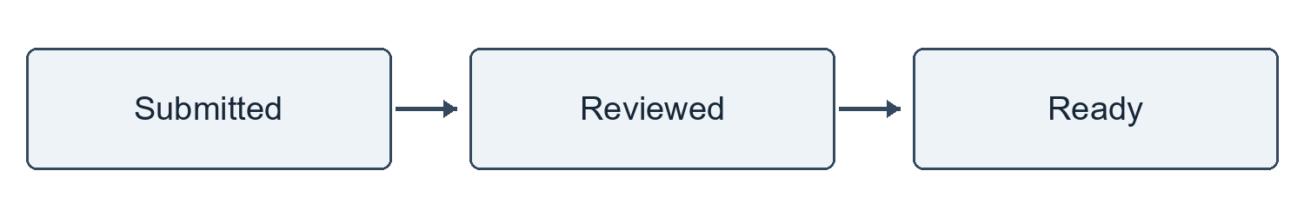
Reference link for this fictional example: Pickup information

