# ­­Brain Tumor Detection using Machine Learning Techniques

## A PROJECT REPORT

*Submitted by*

JOGESWAR PANIGRAHI [RA2011003010470]

ANINDYA MANDAL [RA2011003010623]

*Under the Guidance of*

Dr. Muruganandham B

(Associate Professor, Department of Computing Technologies)

*In partial fulfillment of the Requirements for the Degree of*

**BACHELOR OF TECHNOLOGY**

COMPUTER SCIENCE AND ENGINEERING



**DEPARTMENT OF COMPUTING TECHNOLOGIES FACULTY OF ENGINEERING AND TECHNOLOGY SRM INSTITUTE OF SCIENCE AND TECHNOLOGY KATTANKULATHUR– 603 203**

**NOVEMBER 2023**

**SRM INSTITUTE OF SCIENCE AND TECHNOLOGY**

(Under Section 3 of UGC Act, 1956)

**BONAFIDE CERTIFICATE**

Certified that this project report titled “**Brain Tumor Detection Using Machine Learning Techniques”** is the bonafide work of Jogeswar Panigrahi[Reg No. RA2011003010470], Anindya Mandal[Reg No. RA2011003010623] who carried out the project work under my supervision. Certified further, that to the best of my knowledge the work reported herein does not form part of any other thesis or dissertation on the basis of which a degree or award was conferred on an earlier occasion for this or any other candidate.

Dr. Muruganandham B Dr. Muruganandham B

Project Guide Panel Head

Associate Professor Associate Professor

Dept. of Computing Technologies Dept. of Computing Technologies

Dr. M. Pushpalatha Head of the Department

Dept. of Computing Technologies

Signature of Internal Examiner Signature of External Examiner

Department of Computing Technologies

SRM Institute of Science & Technology Own Work Declaration For

**Degree/Course: Bachelor of Technology, Computer Science Engineering**

**Student Name:** JOGESWAR PANIGRAHI, ANINDYA MANDAL

**Registration Number:** RA2011003010470, RA2011003010623

**Title of Work: Brain Tumor Detection Using Machine Learning Techniques**

We hereby certify that this assessment compiles with the University’s Rules and Regulations relating to Academic misconduct and plagiarism, as listed in the University Website Regulations, and the Education Committee guidelines.

We confirm that all the work contained in this assessment is my / our own except where indicated, and that we have met the following conditions:

* Clearly references/listed all sources as appropriate
* Referenced and put in inverted commas all quoted text(from books, web, etc)
* Given the sources of all pictures, data etc. that are not my own
* Not made any use of the report(s) or essay(s) of any other student(s) either past or present
* AcknowledgedinappropriateplacesanyhelpthatIhavereceivedfromothers(e.g.fellowstude nts, technicians, statisticians, external sources)
* CompiledwithanyotherplagiarismcriteriaspecifiedintheCoursehandbook/Universitywebs ite

IunderstandthatanyfalseclaimforthisworkwillbepenalizedinaccordancewiththeUniversitypolici esand regulations.

|  |
| --- |
| **DECLARATION:** |
| I am aware of and understand the University’s policy on Academic misconduct and plagiarism and I certify that this assessment is my / our own work, except were indicated by referring, and that I have followed the good academic practices noted above. |
| JOGESWARPANIGRAHI [RA2011003010]  ANINDYA MANDAL [RA2011003010623] |

# Abstract

Our project aims to develop an efficient and accurate method for detecting brain tumors in medical images using machine learning (ML) approaches. Brain tumors pose a significant health risk, and early detection is crucial for effective treatment. The project involves multiple stages, including preprocessing of MRI images to enhance quality, extraction of relevant features, and utilization of these features to train and test different ML models. In the preprocessing phase, standardization, noise reduction, and feature extraction techniques, including wavelet transformation and texture analysis, were employed. A comprehensive dataset encompassing both benign and malignant brain tumors was utilized for training and validation. Classifiers, including K Nearest Neighbors (KNNs), Support Vector Machines (SVMs), Naïve Bayes, Decision Trees, and Logistic Regression were employed and carefully fine-tuned. The proposed approach leverages the power of ML to discern intricate patterns and relationships within the images, enabling accurate tumor classification. Our system demonstrated exceptional performance, achieving an accuracy of 98.78% in brain tumor detection. Comparative analyses confirmed its superiority over existing state-of-the-art methods. Successful implementation of this project stands to significantly impact the medical field by providing a reliable tool for timely and accurate brain tumor diagnosis. This would facilitate better patient care and treatment planning. The flexible framework of our system allows for seamless adaptation to emerging imaging modalities, ensuring its relevance in the evolving landscape of medical diagnostics. In conclusion, our study presents a robust machine learning-based approach for early detection of brain tumors using multi-modal imaging data. The proposed system offers high accuracy and sensitivity, holding significant potential for aiding healthcare professionals in timely and accurate diagnosis. Its integration into clinical workflows can lead to improved patient outcomes and more efficient healthcare delivery.

# INDEX

|  |  |  |
| --- | --- | --- |
| **S. No.** | **Topic** | **Page. No.** |
| I | Acknowledgement | 1 |
| II | Abstract | 2 |
| III | List of Tables | 5 |
| IV | List of Abbreviations | 6 |
| V | List of Figures | 7 |
| 1 | Introduction | 8 |
| 1.1 | Aim and Objectives | 10 |
| 1.2 | Research Questions | 11 |
| 1.3 | Organization of Report | 11 |
| 2 | Literature Survey | 12 |
| 3 | Architecture and Analysis of Brain Tumor Detection | 15 |
| 3.1 | Understanding of MRI | 15 |
| 3.1.1 | MRI Related Definitions | 16 |
| 3.2 | Understanding Histogram of Oriented Gradients | 20 |
| 3.2.1 | Image Gradient | 21 |
| 3.2.2 | Image Normalization | 23 |
| 3.2.3 | Representation of Cells | 24 |
| 3.2.4 | Normalization of Blocks | 24 |
| 3.3 | SVM Over Neural Networks | 24 |
| 3.3.1 | Advantages of SVM | 25 |

|  |  |  |
| --- | --- | --- |
| 3.3.2 | Disadvantages of SVM | 25 |
| 3.3.3 | Uses Of SVM | 26 |
| 3.3.4 | Hyper-Parameter Tuning | 27 |
| 3.3.5 | Support Vectors | 28 |
| 3.3.6 | Hyperplane | 28 |
| 3.3.7 | Data Augmented Segregation | 29 |
| 3.3.8 | SVM Major Goals | 30 |
| 3.4 | Evaluation | 31 |
| 4 | Implementation | 33 |
| 5 | Results and Discussions | 44 |
| 5.1 | Result | 44 |
| 5.2 | Discussions | 45 |
| 5.2.1 | Accuracy | 45 |
| 5.2.2 | False Positive Rate | 45 |
| 5.2.3 | Fowlkes-Mallows Score | 46 |
| 5.2.4 | Comparative Analysis of Classifiers | 47 |
| 6 | Conclusion | 48 |
| 7 | Future Enhancements | 49 |
| 8 | References | 52 |
| 9 | Appendices | 54 |
| 10 | Plagiarism Report | 56 |

**List of Tables**

TABLE I MODALITIES WITH TE AND TR VALES 19

TABLE II RECEIVER OPERATING CHARACTERISTICS 31

# List of Abbreviations

**BRATS/BraTS**: BRAIN TUMOR SEGMENTATION

**FP:** FALSE POSITIVE

**FN:**FALSE NEGATIVE

**HOG:** HISTOGRAM OF ORIENTED GRADIENT

**ID:** IMAGE DATA

**MRI:** MAGNETIC RESONANCE IMAGE

**NN:** NEURAL NETWORKS

**RF:** RADIO FREQUENCY

**ROC:** RECEIVER OPERATING CHARACTERISTICS

**SD:** SYNTHETIC DATA

**SVM:** SUPPORT VECTOR MACHINE

**TP:** TRUE POSITIVE

**TN:** TRUE NEGATIVE

**LIST OF FIGURES**

FIGURE 3.1 SCANNING MRI 15

FIGURE 3.2 CSF 16

FIGURE 3.3 IMAGE T1-WEIGHTED. 17

FIGURE 3.4 IMAGE T2-WEIGHTED. 18

FIGURE 3.5 FLAIR 19

FIGURE 3.6 IMAGE T1C-WEIGHTED 19

FIGURE 3.7 SAME SLICE DIFFERENT MODALITIES IMAGE 20

FIGURE 3.8 T1 VS T2 COMPARISON 20

FIGURE 3.9 HOG CELLS 21

FIGURE 3.10 GRADIENT VECTOR 21

FIGURE 3.11 PIXEL ORIENTATION IN A CELL 23

FIGURE 3.12 HISTOGRAM BINS 23

FIGURE 3.13 HYPERPLANE BASED CLASSIFICATION 26

FIGURE 3.14 SEGREGATION MARGIN 29

FIGURE 3.15 KERNELLING 30

# Chapter 1 Introduction

Detecting brain tumors through medical imaging has always been a formidable task. The human brain, a vital control center for bodily functions, is vulnerable to a range of conditions, including infections, strokes, and neoplasms. A brain neoplasm refers to an abnormal growth or proliferation of cells within the cranial region, which can manifest as either malignant, containing cancerous cells, or benign, lacking malignancy [1].

Cerebral neoplasms are typically categorized as primary or secondary. Primary cerebral neoplasms originate within the brain and can be either malignant or benign. In contrast, secondary or metastatic cerebral neoplasms occur when malignant cells from distant anatomical sites spread to the brain and undergo proliferation [2]. These neoplasms are commonly evaluated using image-based diagnostic methods, utilizing techniques such as X-rays, powerful magnetic resonance imaging, or radiopharmaceutical agents to generate detailed brain visualizations [3].

A variety of scans play a crucial role in diagnosing brain conditions. These imaging techniques produce highly detailed images that provide valuable information about the presence and precise location of cerebral neoplasms [4].

## COMPUTED TOMOGRAPHY:

This scan is a diagnostic technique that utilizes X-ray technology to create a three-dimensional representation of the brain. Unlike traditional X-rays, which capture single snapshots, a CT scan involves the acquisition of numerous images. During the procedure, the CT scanner orbits around the patient while they lie on a table. These multiple images are then combined to generate cross-sectional images of the body. CT scans provide essential data about the tumor's dimensions and its potential effects on the integrity of the cranial bones [4].

## CT ANGIOGRAM :

It is a diagnostic procedure that utilizes a series of X-ray images to visualize the complex network of arteries and blood vessels in the brain. During this process, contrast material is injected through an intravenous (IV) line while the patient is inside the CT scanner. This diagnostic technique is crucial for surgical planning as it provides detailed information about the vascular structure [4].

## MYELOGRAM:

It is a diagnostic technique that uses a contrast agent to determine whether a tumor has spread to neighboring areas of the body, including the spinal cord. This method entails the precise injection of contrast dye into the Cerebrospinal Fluid (CSF) [4].

## POSITRON EMISSION TOMOGRAPHY:

In this procedure, a radioactive substance called FDG is introduced into the bloodstream. The quantity of FDG administered is minimal, and it naturally clears from the body within a day. Tumorous cells, characterized by their rapid growth, exhibit higher uptake of this sugar compared to most other cell types. Approximately an hour after FDG administration, the patient is positioned on a table inside the PET scanner. A specialized camera then generates an image that highlights areas of radioactivity within the patient's body [4].

While PET scans may not provide detailed specifics, they offer crucial insights into whether the abnormalities detected in previous tests suggest the presence of tumors. PET scans are often used in conjunction with CT scans to assess the success of tumor treatment or to detect any recurrence after treatment. Typically, the initial stage of treatment involves the use of a PET-CT scan.

## MAGNETIC RESONANCE IMAGING:

It is a fundamental diagnostic imaging technique that distinguishes itself from other scanning methods by its use of radio waves and powerful magnetic fields instead of X-rays. During the procedure, the energy from radio waves is absorbed and subsequently re-emitted, with the pattern determined by the specific body tissue and any underlying conditions. This intricate pattern is then transformed into a highly detailed image of specific body regions through

computer processing. To enhance clarity, an injectable contrast agent called gadolinium is intravenously administered prior to the scan, effectively boosting the level of detail [4].

## WHAT MAKES MRI IMAGES PREFERABLE TO OTHER IMAGING METHODS?

1. MRI represents a non-invasive imaging method.
2. Choosing an MRI is a cost-effective decision.
3. MRI offers exceptional distinction when it comes to identifying tumors within the cranial area.
4. The total duration for a thorough full-body MRI is shorter compared to PET and X-ray scans.
5. MRI provides unparalleled clarity in visualizing the skeletal structure and concealed organs, such as the lungs protected by ribs and the brain situated within the skull.

## AIM AND OBJECTIVE

The primary objective of this thesis is the identification of brain tumors within medical images. The key aim involves the precise classification of these tumors and non-tumorous regions using the Support Vector Machine (SVM) technique. This classification process is facilitated by the utilization of the feature extraction algorithm known as HOG, which stands for Histogram of Oriented Gradients.

Our specific goals include the following phases:

1. Curating relevant MRI brain images with tumors from an existing database that requires refinement.
2. Utilizing the HOG feature extraction algorithm to capture distinctive features that define brain tumor characteristics.
3. Employing the extracted feature vectors as input for SVM to execute the classification process.
4. Assessing the SVM's performance by applying Receiver Operating Characteristics (ROC) to ensure robust tumor detection and classification.

## RESEARCH QUESTIONS

1: What strategies can be employed to achieve precise brain tumor classification?

2: Does the utilization of the HOG feature extraction method enable dependable brain tumor detection?

3: How effective is SVM in discriminating between tumor and non-tumor cases?

4: Is it feasible to attain a 100% classification accuracy in distinguishing tumor and non-tumor cases using the HOG algorithm?

5: Can SVM proficiently categorize tumors and non-tumors when image features are directly extracted without relying on the HOG technique?

## ORGANIZATION OF REPORT

Chapter 1 serves as a comprehensive introduction to this thesis, providing an overview, outlining our primary objectives, and defining the research questions we aim to address. Moving into Chapter 2, we conduct an in-depth analysis of previous research efforts related to brain tumor detection. In Chapter 3, we embark on an extensive exploration of 2 crucial components: the Histogram of Oriented Gradients and the Support Vector Machine. Chapter 4 offers a detailed account of the integration of the feature vector with the SVM classifier. In the subsequent chapter, Chapter 5, we present the results derived from our analytical work. Finally, in Chapter 6, we conclude the report while also discussing future prospects for advancements in brain tumor detection methodologies.

# Chapter 2 LITERATURE SURVEY

Numerous research endeavors have been undertaken in the domain of brain tumor detection. Haenssle et al. [2] introduced a comprehensive methodology for the identification of brain tumors. Their approach aimed to differentiate between healthy brains and those affected by tumors, as well as distinguish between benign and malignant tumors. The methodology comprised a seven-stage algorithmic process, which involved tasks such as pre-processing of images, feature extraction, and classification of images using ml techniques. Various methods were explored, including Canny edge detection, Harris corner detection, adaptive thresholding, and Harris corner detection once more. The combination of Canny edge detection and Harris corner detection yielded an 19% false recognition rate for distinguishing healthy brains from those with tumors, and a 10% rate for distinguishing benign from malignant tumors. On the other hand, the integration of adaptive thresholding and Harris corner detection resulted in a 15.6% false recognition rate for discriminating healthy brains from those with tumors, and a 6% rate for differentiating malignant and benign tumors.

Codella et al. [5] presented a novel algorithm for textural feature extraction, which focused on utilizing kurtosis and was named KWCEM (Kurtosis Wavelet Coefficient Energy Modeling). This algorithm was developed with the specific goal of extracting and detecting brain tumors. Their approach not only improved the quality of image segmentation but also reduced the size of the feature set. Additionally, they incorporated this algorithm into Canny edge detection, leading to a significant enhancement in the quality of the segmented images.

Han et al. [6] introduced a methodology that involved the evaluation of different techniques for the detection of brain tumors. They utilized image mining methods, including Grey Level Co- Occurrence (GLCM). These techniques were applied to the BraTS database, resulting in notable levels of accuracy. In particular, GLCM achieved an accuracy rate of 95%, showcasing its impressive performance.

Ha et al. [7] developed a graphical user interface (GUI) algorithm aimed at the detection, extraction, and identification of lesions. At the core of this algorithm's effectiveness is the utilization of the Otsu method, which transforms a 2D image into a 3D representation, enhancing the accuracy and efficiency of tumor detection. Furthermore, the algorithm underwent a comparative analysis in which it was evaluated alongside the Multimodal MRI segmentation of ischemic lesions. The results of this analysis demonstrated favorable outcomes in lesion evaluation.

Ribeiro et al. [8] presented a novel method for the detection and classification of brain tumors using Gabor wavelets and Probabilistic Neural Network. Their approach involved feature extraction through wavelet transformation, followed by the use of PNN to categorize tumors into groups, including malignant, metastatic, or benign. This method exhibited a notably high degree of accuracy in the classification process.

Hussain et al. [9] introduced a detailed four-step methodology for classifying brain tumors. This methodology involved four key stages: preprocessing, segmentation, feature extraction, and the crucial classification step. To achieve tumor categorization, the authors employed an innovative technique called TANN (Tumor Area Neural Network). TANN was applied to various datasets, including BraTS, OASTS, and NBTR, and it demonstrated impressive detection rates and rapid classification. Notably, it exhibited exceptional performance when applied to the BRATS dataset.

Oakden-Rayner et al. [10] performed a comparative assessment of segmentation techniques, which encompassed mean shift, histogram-based thresholding (ThH), and Support Vector Machine (SVM). These techniques were applied to both PET and MRI images for tumor detection. The outcomes of this analysis indicated that, when dealing with MRI images, SVM and ThH proved to be effective in detecting tumors. In contrast, for PET images, SVM outperformed the other methods.

Barata et al. [11] proposed a hybrid approach to the detection and classification of brain tumors. This method encompassed three fundamental stages: skull identification, feature extraction using the gray-level co-occurrence matrix (GLCM), and the application of the least square Support Vector Machine (SVM) for tumor categorization. It is noteworthy that the SVM demonstrated an outstanding accuracy rate of 5.6%, surpassing the performance of Radial Basis Function (RBF) and Backpropagation (BP) techniques, as evidenced in the comparative evaluation.

This comprehensive effort primarily focuses on improving the detection and classification of brain tumors by combining a wide range of techniques and algorithms to produce accurate and efficient results. The methodologies detailed in these research studies offer valuable insights into the ever-evolving field of medical image analysis and tumor diagnosis.

Our objectives after the literature survey are:

* + 1. Develop a brain tumour detection system using Histogram of Oriented Gradients (HOG) and AI/ML techniques to enhance texture-based analysis.
    2. Leverage HOG's gradient-based features to create a robust system that overcomes challenges of inter-patient variability and captures tumour heterogeneity.
    3. Improve tumour localization accuracy and boundary delineation by utilizing HOG's capacity to capture fine-scale texture variations within heterogeneous regions.
    4. Enhance algorithm flexibility by providing simplified yet informative HOG features, enabling the use of diverse AI/ML algorithms based on problem complexity.

# Chapter 3

**Architecture And Analysis of Brain Tumor Detection**

## UNDERSTANDING OF MRI

Magnetic Resonance Imaging (MRI) functions based on the principle of harnessing the inherent magnetization property of atomic nuclei. The process begins with the application of a strong and uniform external magnetic field to the targeted tissue, aligning the protons within the water nuclei. Initially, these protons are randomly oriented, but they undergo a phenomenon known as "magnetization" [15]. This state of magnetization is temporarily disrupted by Radio Frequency (RF) energy, triggering the relaxation processes of the nuclei, causing them to return to their original alignments while emitting RF energy. After a specific time interval, the resulting signals are recorded. These signals contain frequency data, which is then transformed into corresponding levels of intensity through Fourier Transform, manifesting as varying shades of gray within a pixel grid. Different types of images are produced by manipulating the sequence of applied and recorded RF pulses.

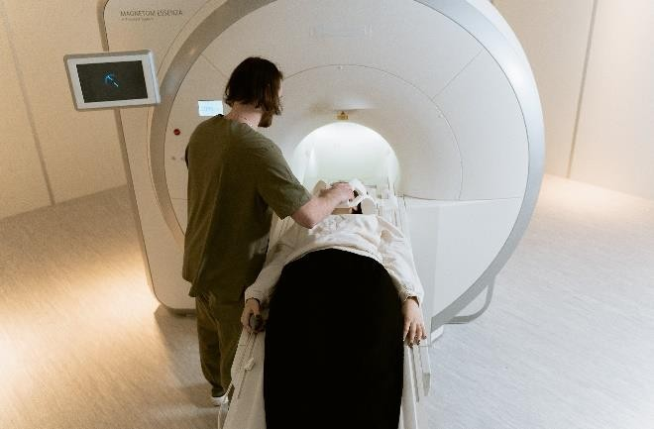

## Figure 3.1 SCANNING MRI

* + 1. **MRI RELATED DEFINITIONS**

## REPETITION TIME:

This term refers to the interval between the emission of an initial excitation pulse and the following pulse, signifying the time span between consecutive pulses [15].

## TIME TO ECHO:

This denotes the timeframe starting from the commencement of the RF excitation pulse to the termination of the signal acquired in the coil, delineating the duration that encompasses the transmission of the RF pulse and the reception of signal [15].

## LONGITUDINAL RELAXATION TIME:

It indicates the time parameter utilized to measure the speed at which stimulated protons revert to their original state. This represents the duration required for the rotating protons to realign themselves with the external field.

## TRANSVERSE RELAXATION TIME:

This term represents the time parameter used to assess whether the stimulated protons reach equilibrium or experience a departure from phase coherence with one another. It signifies the duration it takes for the rotating protons to lose coherence while interacting with nuclei that are spinning perpendicular to the main magnetic field.

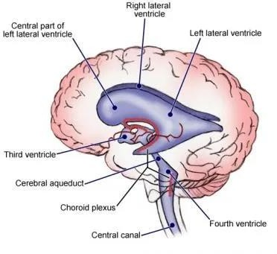

**Figure 3.2** CSF

## CEREBROSPINAL FLUID:

It is a transparent and colorless fluid found within the brain.

## GADOLINIUM:

It is a safe and non-toxic paramagnetic contrast agent. When introduced during an MRI examination, it plays a vital role in enhancing and improving the quality of the MRI image. Images enhanced with GAD are highly valuable for evaluating vascular structures and detecting any anomalies in the barriers.

## SEQUENCE OF MRI IMAGING:

**IMAGES T1-WEIGHTED:**

These images are created by employing brief Echo Time (TE) and Repetition Time (TR) intervals. The tissue's T1 properties govern the visual contrast and brightness of the image [16].

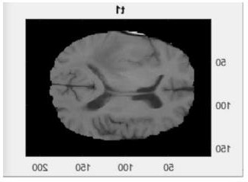

**Figure 3.3** IMAGE T1 -WEIGHTED

## IMAGES T2-WEIGHTED:

These images are generated by employing extended Echo Time (TE) and Repetition Time (TR) intervals, with the visual contrast and brightness of the image influenced by the T2 characteristics of the tissues. Notably, cerebrospinal fluid (CSF) serves as a distinguishing factor between T1-weighted and T2-weighted images, appearing bright on T2-weighted images and darker on T1-weighted images [16].

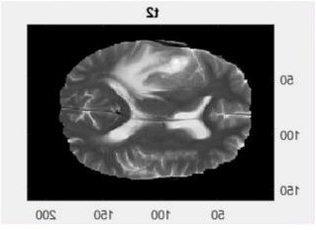

**Figure 3.4** IMAGE T2 -WEIGHTED

**FLUID ATTENUATED INVERSION RECOVERY:**

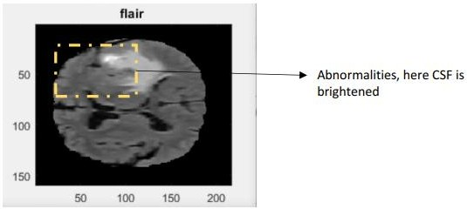It has similarities with T2-weighted images, although it incorporates significantly extended Echo Time (TE) and Repetition Time (TR) intervals. This unique approach results in anomalies retaining their brightness, while normal cerebrospinal fluid (CSF) is suppressed, appearing dark. FLAIR images excel in their ability to differentiate between anomalies and CSF, exhibiting heightened sensitivity to pathological changes.

**Figure 3.5:** FLAIR

**Table I** TE AND TR VALES AND MODALITIES

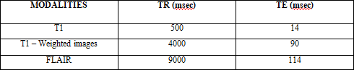

The introduction of Gadolinium into the process of capturing T1-weighted images contributes to its prominent brightness in these scans. Various RF pulse sequences are utilized to emphasize specific tissue characteristics. For instance, in a "T1-weighted" scan, fluids are depicted as dark, while in a "T2-weighted" scan, fluids appear bright. It is worth noting that fat exhibits brightness in both types of scans.

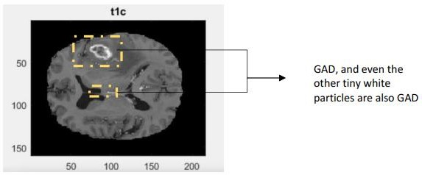

**Figure 3.6:** IMAGE T1C-WEIGHTED

Since many pathological conditions commonly result in reduced fat content and increased water content, performing a comparative evaluation of scans weighted T1 and T2, frequently referred to as an "irritation pattern," plays a crucial role in highlighting these changes.

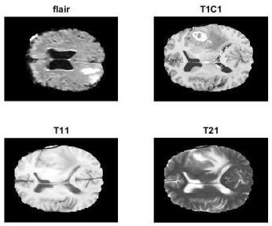

**Figure 3.7:**SAME SLICE DIFFERENT MODALITIES IMAGE

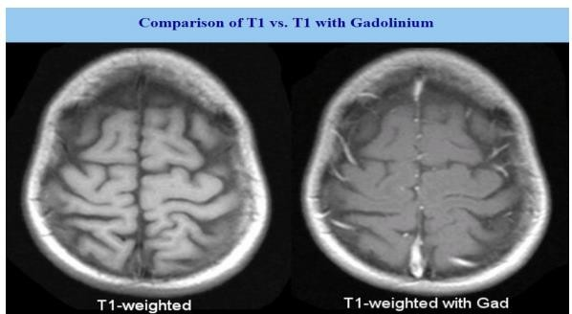

**Figure 3.8:** T1 VS T2 COMPARISON

## UNDERSTANDING HISTOGRAM OF ORIENTED GRADIENTS

This technique, initially introduced by Dalal and Triggs, was originally developed for the purpose of detecting individuals in images. HOG functions as a distinctive feature descriptor

widely employed in the field of image processing, with a particular focus on object detection. This feature descriptor's primary objective is to provide a generalized representation of an object within an image, ensuring that identical feature descriptors can be extracted from images containing the object under various conditions, including different angles, lighting, distances, and other variables.

1. The HOG method initially divides the images into cells, which can have rectangular or radial configurations.

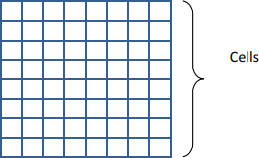

**Figure 3.9:** HOG CELLS

1. In each cell, a gradient vector is computed for every pixel[17].

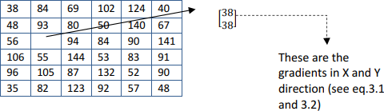

**Figure 3.10:**GRADIENT VECTOR

## IMAGE GRADIENT:

It is often referred to interchangeably as the gradient vector, plays a vital role in the domain of computer vision.

## IMAGE GRADIENT APPLICATIONS:

1. Edge detection
2. Feature extraction

Calculating the gradient vector at a given pixel entails evaluating the difference between adjacent values along both the horizontal and vertical axes. These gradients can be computed by subtracting values either from left to right or right to left in the horizontal plane, as well as from top to bottom or bottom to top in the vertical plane.



After the calculation of gradient vectors for each pixel in the image, the next step involves determining their magnitudes.

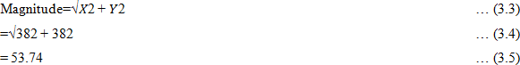

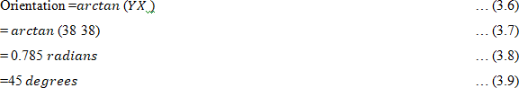In the realm of HOG (Histogram of Oriented Gradients), the concept of orientation plays a crucial role. Orientation refers to a change in direction, representing a shift in pixel intensity values. This shift can manifest in either the X-axis or the Y-axis. Calculating the orientation of a gradient vector involves the following process.

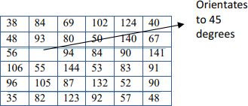

**Figure 3.11:** PIXEL ORIENTATION IN A CELL

The orientation of individual pixels depends on the values of their gradient vectors. These gradients are subsequently categorized into bins within the histogram, with each bin corresponding to a specific orientation.

|  |  |  |  |  |  |  |  |  |
| --- | --- | --- | --- | --- | --- | --- | --- | --- |
| 10 | 30 | 50 | 70 | 90 | 110 | 130 | 150 | 170 |

**Figure 3.12: HISTOGRAM BINS**

In Figure 3.11, the gradient vector is inclined at a 45-degree angle. We distribute one-fourth of its magnitude to the bin at thirty degrees, and allocate three-fourths of its magnitude to the bin centered at 50 degrees. This distribution is made because the histogram does not have a designated bin for 45 degrees.

## IMAGE NORMALISATION:

The magnitude of gradient vectors associated with each pixel can vary. To ensure uniformity and consistency in these values, a technique known as normalization is applied. In this context, normalization involves dividing the vector values by their respective magnitudes. It's important to note that this normalization process primarily affects the magnitude part of the gradient vectors, while the orientation component remains unchanged.

## REPRESENTATION OF CELLS:

Each image is partitioned into cells with dimensions of 𝑚 × 𝑛, typically varying from 2×2, 4×4, 6×6, to 8×8 pixels. This partitioning is primarily done to create a more compact and effective representation of the image.

## NORMALISATION OF BLOCKS:

The fundamental process that facilitates both histogram grouping and normalization is the combination of cells into blocks. A block histogram can be defined as the result of normalizing these groups of cells. One significant benefit of computing histograms using image blocks is their ability to strengthen the image's resistance to local lighting variations, thus increasing its reliability in diverse lighting.

## SUPPORT VECTOR MACHINES OVER NEURAL NETWORKS

Support Vector Machines (SVMs) and shallow neural network structures exhibit certain similarities but differ significantly in their structural capabilities. Unlike neural networks, SVMs lack the ability to incorporate hidden layers. Furthermore, SVMs require more meticulous feature engineering efforts, while neural networks can to some extent autonomously learn features.

Contrastingly, neural networks feature a more complex architecture with multiple layers, potentially providing them with greater computational power. However, it comes with a trade-off

– requiring large amounts of data for effective training

Due to a small dataset, SVMs present themselves as the more advantageous option. They offer a more direct solution, ensuring swift implementation and decreased costs, which align more effectively with the available resources.

## SUPPORT VECTOR MACHINE ADVANTAGES

* **Effective in High-Dimensional Spaces:** SVMs excel in managing high-dimensional data, making them suitable for datasets with dimensions exceeding 10^6.
* **Efficient Operations through Subset Selection:** SVMs streamline their operations by focusing on a specific subset of training points, enabling quick decision-making.
* **Well-Suited for Compact, Well-Structured Datasets:** SVMs deliver excellent performance when dealing with smaller datasets that are meticulously organized and free from significant noise or outliers.
* **Optimal Memory Usage:** SVMs are memory-efficient as they retain only essential subsets of training points required for decision-making, resulting in minimal memory usage during predictions or classifying new data points.

## SUPPORT VECTOR MACHINE DISADVANTAGES

* **Challenges with Extensive Datasets**: SVMs may encounter limitations when dealing with large datasets, leading to extended training times that could impact their practicality in such scenarios.
* **Diminished Effectiveness in High-Dimensional Data**: SVM performance tends to decline when the number of features per object exceeds the quantity of training data samples, making it challenging to achieve reliable generalization.
* **Limited Applicability in Noisy, Overlapping Datasets**: SVMs exhibit reduced effectiveness when applied to datasets characterized by substantial noise or significant overlap between class boundaries. This complexity can impede accurate class differentiation.
* **Absence of Direct Probabilistic Interpretation**: SVMs function as non-probabilistic classifiers, separating objects based on their position relative to the hyperplane without offering a direct probability estimation for class membership. Instead, the distance from the decision boundary can serve as an indicator of classification confidence.

## SUPPORT VECTOR MACHINE USES

* **Text Classification Applications**: Encompassing tasks such as category assignment, spam detection, and sentiment analysis.
* **Image Recognition Challenges**: Involving various facets of image recognition.
* **Aspect-Oriented Recognition**: Concentrating on the identification of particular aspects or characteristics.
* **Color-Based Object Classification**: Entailing the categorization of objects based on their color features.
* **Handwritten Digit Recognition**: Specifically, the recognition of manually written digits.

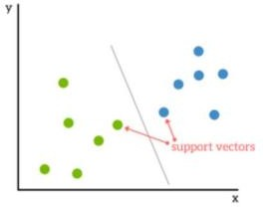The Support Vector Machine, commonly referred to as SVM, is a supervised machine learning method primarily employed for data classification tasks. The fundamental idea behind SVM revolves around finding an optimal hyperplane to effectively separate the dataset. This concept is visually explained in figure 3.13.

**Figure 3.13** HYPERPLANE BASED CLASSIFICATION

The Support Vector Machine constructs a feature space of finite-dimension, essentially forming a vector space. In this space, every dimension corresponds to a unique object attribute. These feature vectors collectively constitute the vector space.

## HYPERPARAMETER TUNING

Hyperparameters are predetermined settings or configurations of a machine learning algorithm that are not derived from the data but are manually defined by developers or researchers before the model training. These hyperparameters include parameters like learning rate, batch size, the number of hidden layers, neurons in each layer, regularization strength, and the chosen activation function.

Hyperparameter tuning is the process of carefully selecting the most suitable values for these parameters to improve the model's performance on the test data. This is necessary because different hyperparameter configurations can have a significant impact on the model's effectiveness. If hyperparameters are not appropriately chosen, the model may perform poorly on the test data. Here are several reasons highlighting the importance of hyperparameter tuning.:

1. Improving Model Accuracy: The primary aim of hyperparameter tuning is to increase the model's accuracy on the test data. Optimal hyperparameter selection enhances the model's ability to generalize effectively to new, unseen data.
2. Avoiding Overfitting: Overfitting occurs when the model becomes overly complex and fits the training data too closely, resulting in poor performance on the test data. Hyperparameter tuning helps control the model's complexity, reducing the risk of overfitting.
3. Accelerating Training Time: Fine-tuning hyperparameters can speed up the model's training process by identifying the most effective configurations that lead to faster convergence.
4. Enhancing Model Interpretability: Some hyperparameters impact the ease of model interpretation. For example, the regularization parameter governs the model's complexity. Increasing its value results in a simpler and more understandable model.

Here is our approach for incorporating hyperparameter tuning into our project:

1. Data Preparation: The initial step involves data preparation, which includes cleaning, transformation, and splitting the data into training and testing sets.
2. Algorithm Selection: We have a range of algorithms to choose from for tasks like dementia and mental health churn analysis, including logistic regression, decision trees, random forests, and neural networks. Each algorithm comes with its own set of hyperparameters that can be fine- tuned to enhance its performance.
3. Hyperparameter Selection: The subsequent stage is selecting the specific hyperparameters to be tuned. For instance, in a neural network, these hyperparameters might include the number of hidden layers, the quantity of neurons in each layer, the learning rate, and the strength of regularization.
4. Defining the Search Space: The search space denotes the allowable range of values for each hyperparameter. For example, the search space for the learning rate might span from 0.001 to 0.1, while the number of hidden layers might be explored within the range of 1 to 5.
5. Hyperparameter Tuning: Various techniques can be employed to tune the hyperparameters, such as grid search, random search, and Bayesian optimization. Grid search involves testing all possible combinations of hyperparameters and selecting the best set based on performance on the validation set. Random search explores random combinations of hyperparameters to find the optimal set. Bayesian optimization uses a probabilistic model to predict the performance of different hyperparameter settings, facilitating the selection of the best set based on these predictions.



They are essential data points located in immediate neighbourhood to the hyperplane. Their significance lies in their pivotal role in precisely positioning the separating hyperplane.



In a feature space with numerous dimensions, the linear hyperplane serves as a geometric construct residing one dimension lower than the entire space, and its primary purpose is to partition the feature space into two distinct regions. These hyperplanes act as planes that enable

the linear separation of a given dataset. To illustrate simply, consider a scenario with only two features, as depicted in Figure 3.14.

When classifying objects based on their features, newly encountered objects are positioned either above or below the hyperplane. This specific arrangement is pivotal in their classification

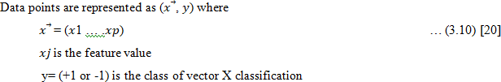It's important to note that a linear separating hyperplane is not required to pass through the origin of the feature space, meaning that zero vectors are not mandatory for this plane. These hyperplanes are technically known as "affine." In precise mathematical terms, SVM is designed to establish these linear separating hyperplanes within high-dimensional vector spaces.

It becomes evident that data points are positioned at varying distances from the hyperplane, and the effectiveness of classification hinges on the extent of data separation. This evaluation is guided by an intuitive principle: our objective is to have data points maximize their distance from the hyperplane, while ensuring they remain on the correct side of it, as referenced in [20].

## DATA AUGMENTED SEGRAGATION

The margin can be defined as the degree of demarcation between the hyperplane and the nearest data point in either dataset. In the pursuit of achieving superior classification, the aim is to secure a substantial margin, as a broader margin is indicative of enhanced performance.

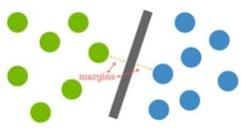

**Figure 3.14** SEGREGATION MARGIN

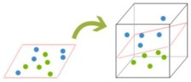Real-world data often introduces complexities that render it more intricate than the prior example implies. There are situations where datasets exhibit overlap, rendering them challenging to separate through linear methods. In such cases, a practical approach involves a transformation that can be likened to converting a 2D image into a 3D representation. To illustrate this concept, envision the previous example with the balls, but now picture them being lifted into the air and divided by an intervening plane. This imaginative elevation of the balls corresponds to a mathematical technique known as "kernelization," which effectively maps data into higher dimensions, facilitating improved separation.

**Figure 3.15** Kernelling

In the realm of three-dimensional images, the hyperplane undergoes a transformation into a surface, departing from its conventional linear representation. The core concept revolves around the continuous mapping of data into dimensions that are higher until an effective hyperplane can be established for optimal separation. In a feature space denoted as ℝ𝑝, where p represents the number of dimensions, the hyperplane takes on the characteristics of an affine space with p-1 dimensions, intricately embedded within the broader p-dimensional feature space.

## SUPPORT VECTOR MACHINE MAJOR GOALS

* Construct a model capable of categorizing novel objects into predefined classes.
* Identify a hyperplane that maximizes the margin from any point in the training set, enhancing the accuracy of classifying new data.

The training process entails establishing a linear partition in the feature space to separate it into two distinct categories using a hyperplane.

## METHODS OF EVALUATION LEAVE ONE OUT CROSS VALIDATION

Leave-one-out cross-validation has a dual purpose within the dataset, fulfilling roles as both the training and testing sets. This approach utilizes n-1 out of n data samples for training, while the remaining single sample is set aside for testing. Leave-one-out cross-validation proves especially valuable for assessing recognition systems, particularly in scenarios where data is limited. [25]

## RECEIVER OPERATING CHARACTERISTICS

This curve is a graphical illustration that depicts how the true positive rate and false positive rate change under different threshold values employed in a diagnostic test.

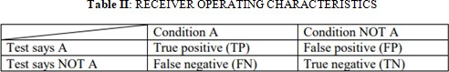The origins of Receiver Operating Characteristics analysis can be traced to the field of Signal Detection Theory, which emerged during World War II for the analysis of radar imagery. During this period, radar operators faced the crucial challenge of distinguishing between blips on their screens, discerning whether they represented friendly vessels, enemy targets, or mere background noise. Signal Detection Theory was devised to assess the radar operator's capacity to make these vital distinctions. The term "Receiver Operating Characteristics" (ROC) was coined to encapsulate this ability, giving the analysis its name.

## TRUE POSITIVE RATE:

The true positive rate, also known as sensitivity or recall, is a metric in binary classification that quantifies the proportion of actual positive instances correctly identified by a model or classifier out of the total number of true positive and false negative instances. It measures the model's ability to accurately detect and classify positive cases within a dataset.



## TRUE NEGATIVE RATE:

The true negative rate, also known as specificity, is a metric in binary classification that quantifies the proportion of actual negative instances correctly identified by a model or classifier out of the total number of true negative and false positive instances. It measures the model's ability to accurately distinguish and classify negative cases within a dataset.



## FALSE POSITIVE RATE:

The false positive rate is a metric in binary classification that quantifies the proportion of actual negative instances incorrectly classified as positive by a model or classifier, out of the total number of true negative and false positive instances. It measures the model's tendency to generate false alarms by erroneously labeling negative cases as positive.



## FALSE NEGATIVE RATE (FNR):

The false negative rate is a metric in binary classification that quantifies the proportion of actual positive instances incorrectly classified as negative by a model or classifier, out of the total number of true positive and false negative instances. It measures the model's failure to identify positive cases correctly, resulting in missed detections or Type II errors.

# Chapter 4 Implementation

The process begins by choosing a database that contains brain images. From these images, features are extracted using the HOG technique. These extracted features are then labeled and fed into the SVM. The SVM's role is to differentiate between regions with tumors and those without. The final phase involves assessing the SVM's performance, considering ROC characteristics, which include accuracy, sensitivity, and specificity.

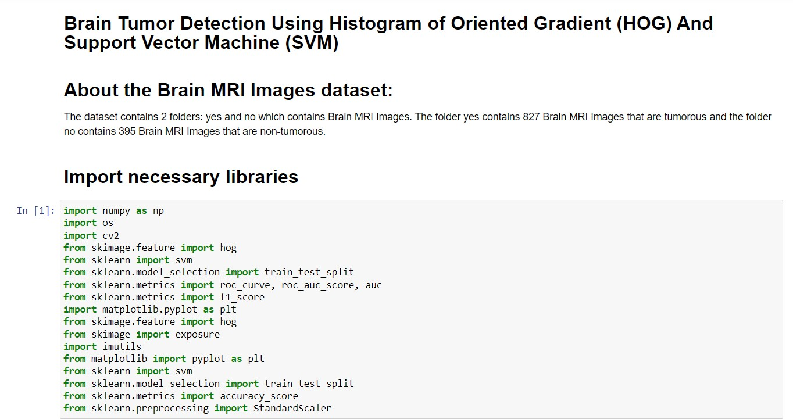

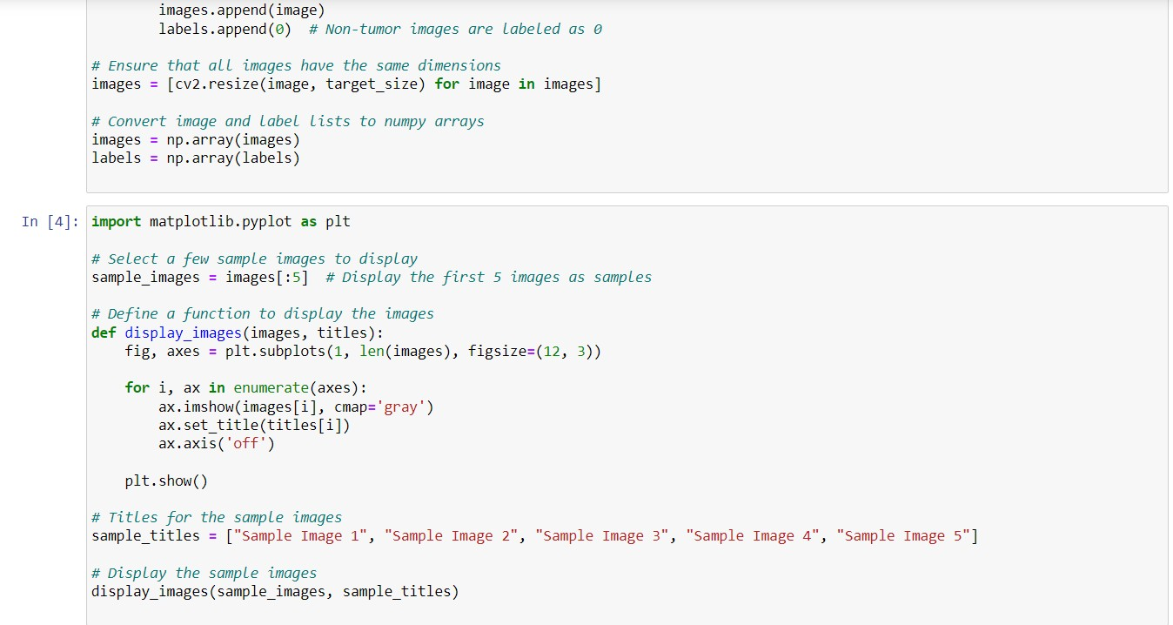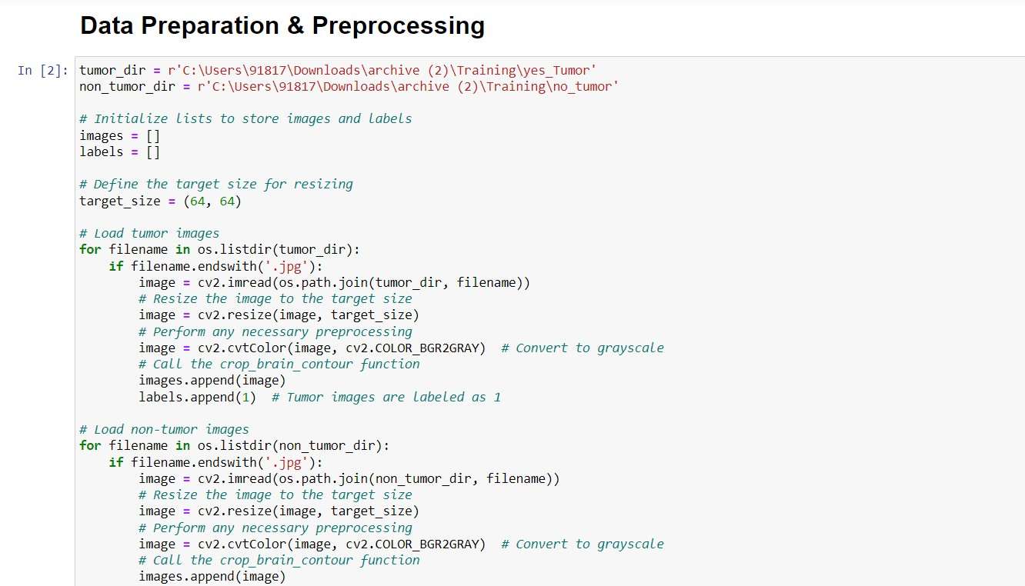

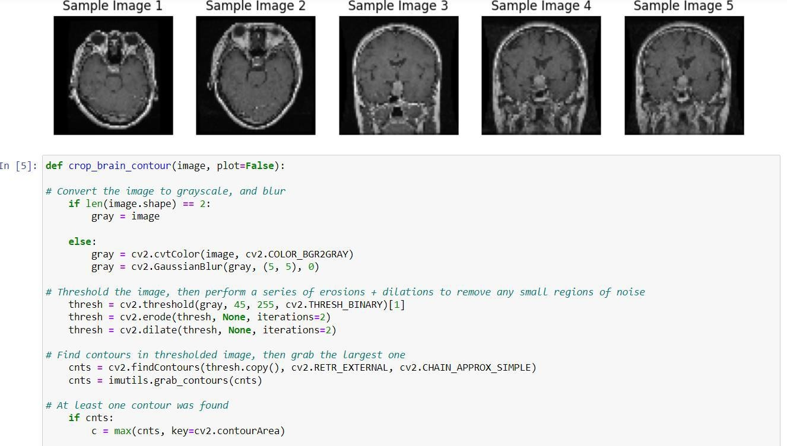

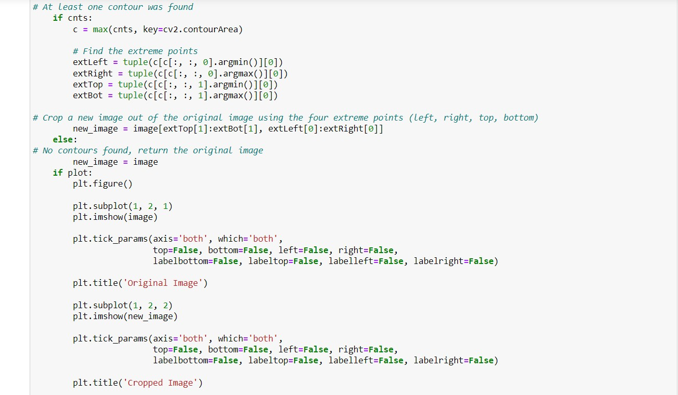

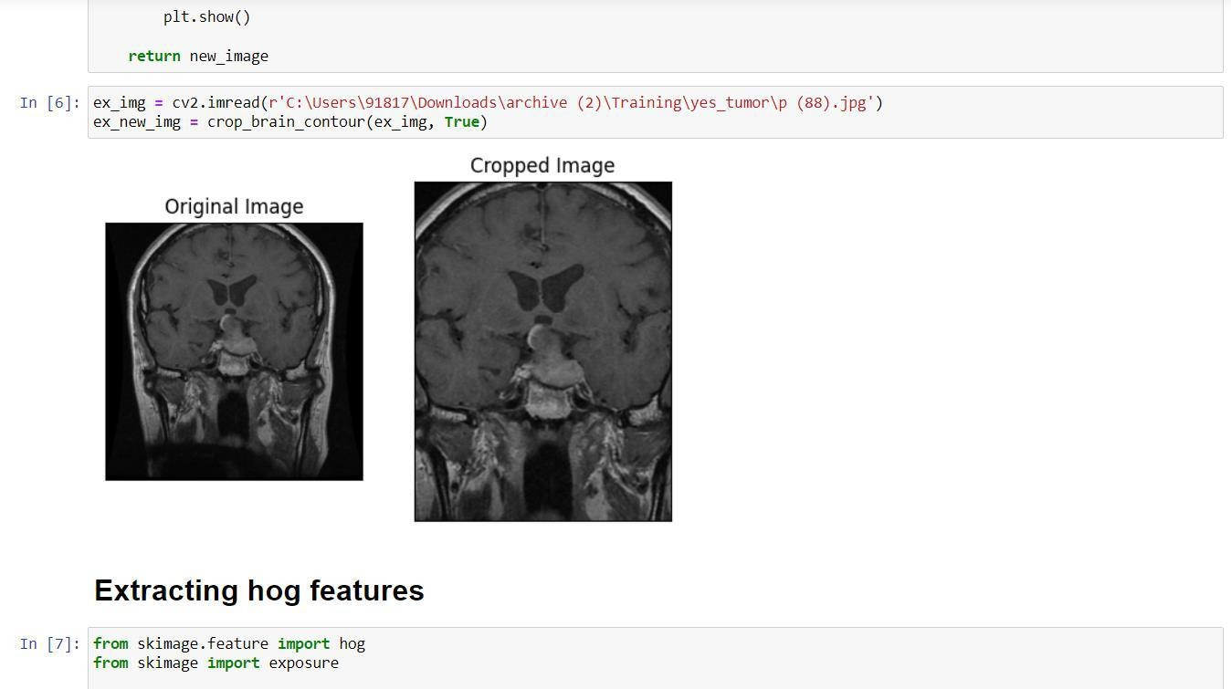

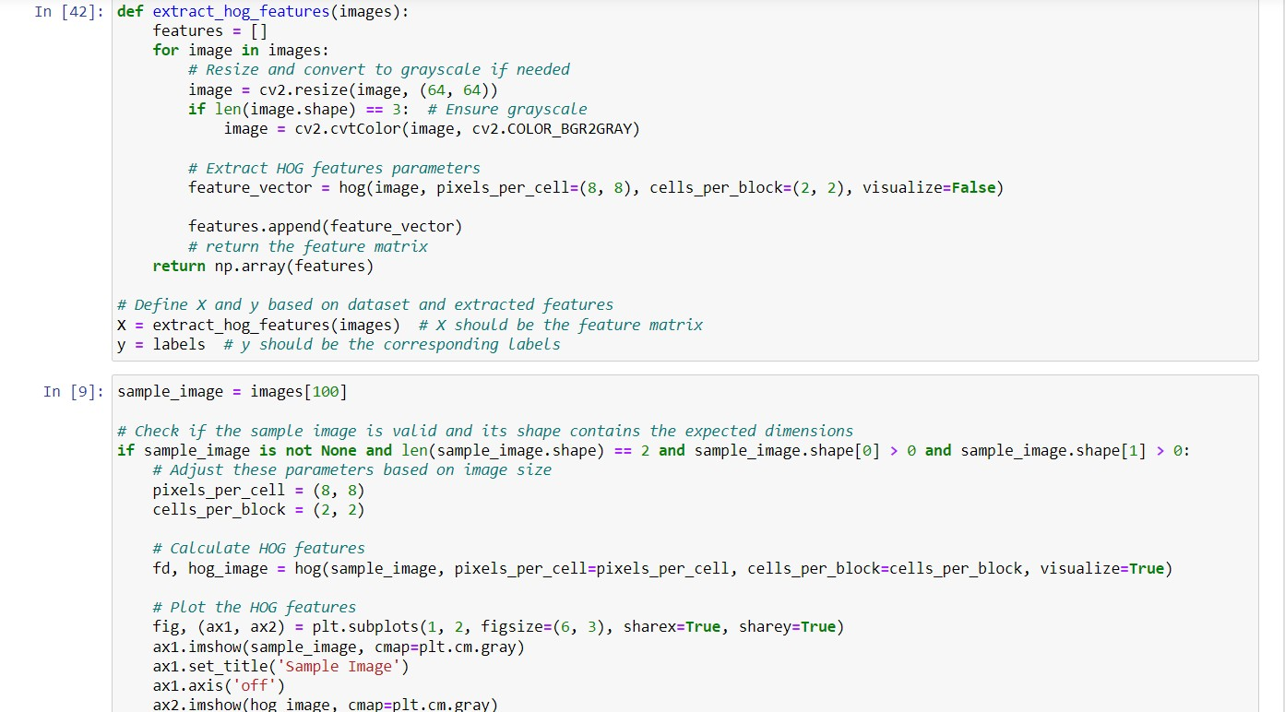

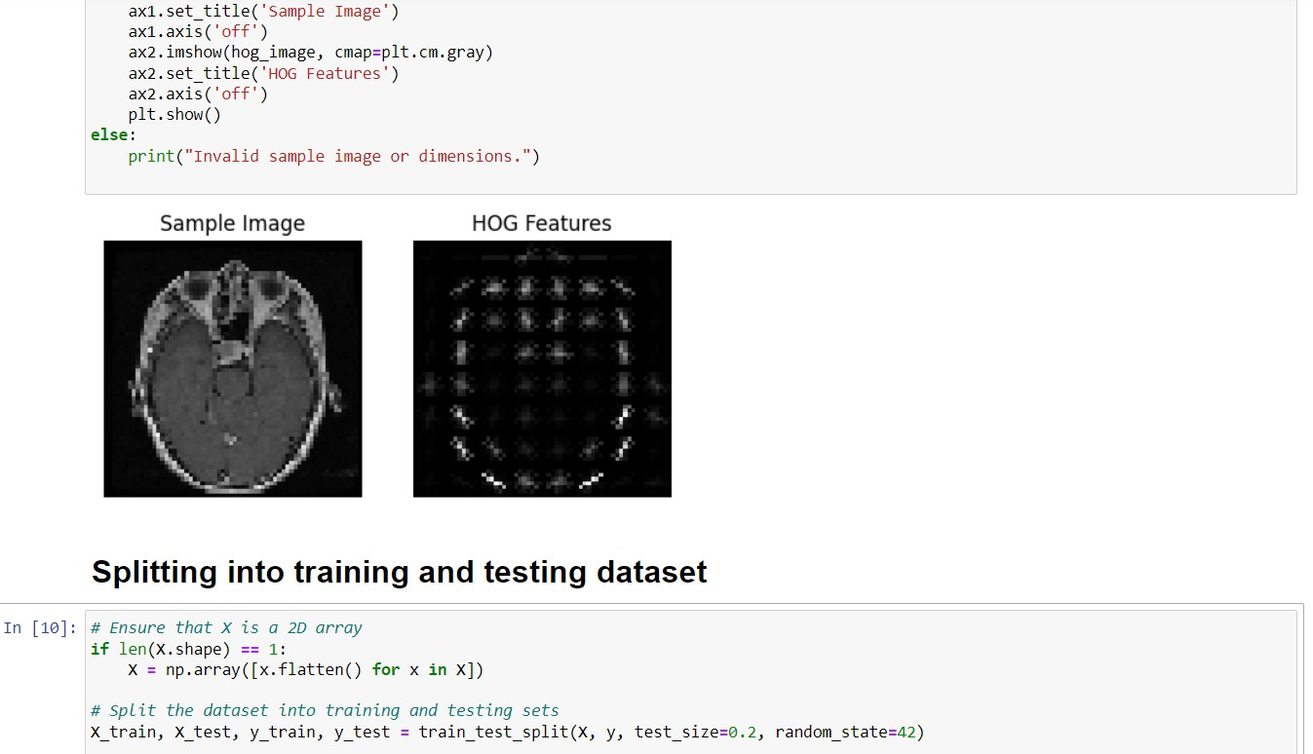

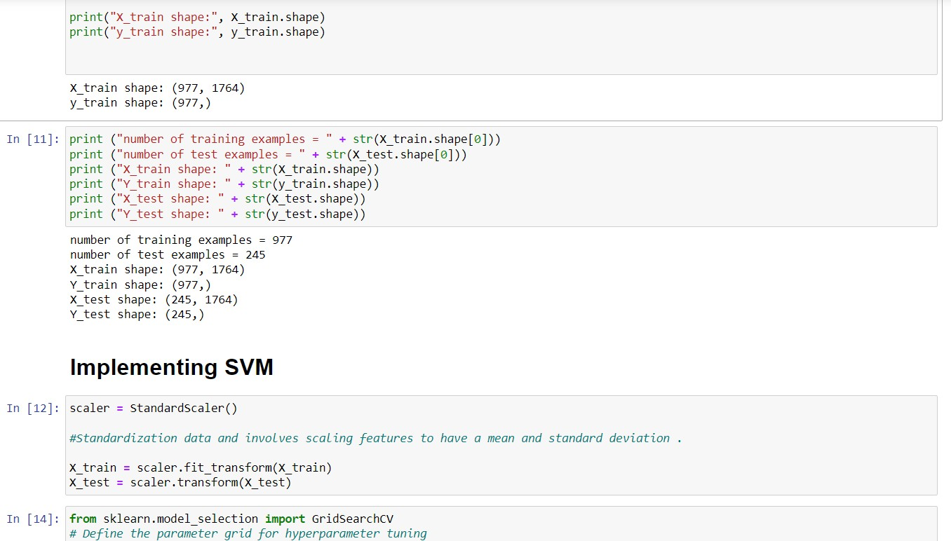

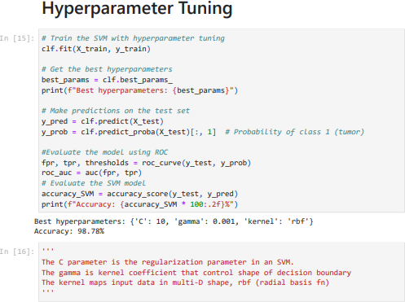



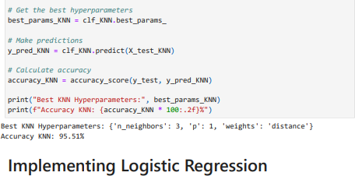

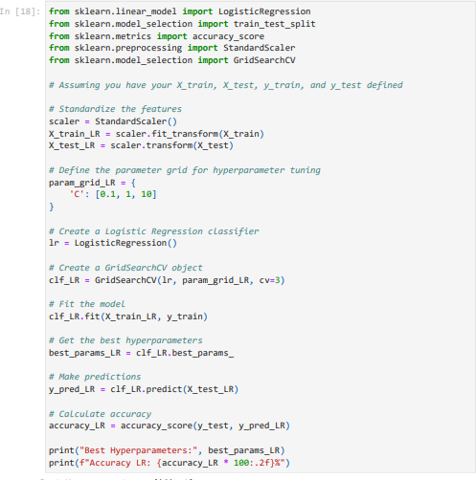

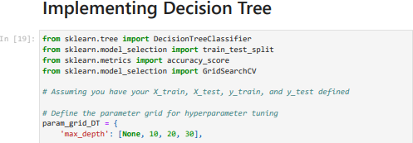

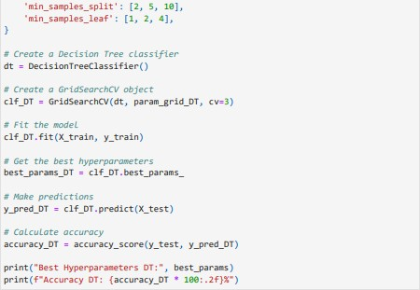

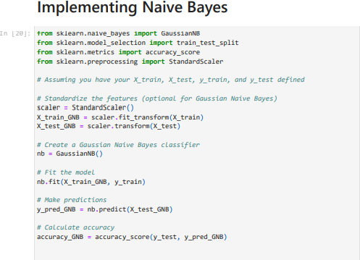

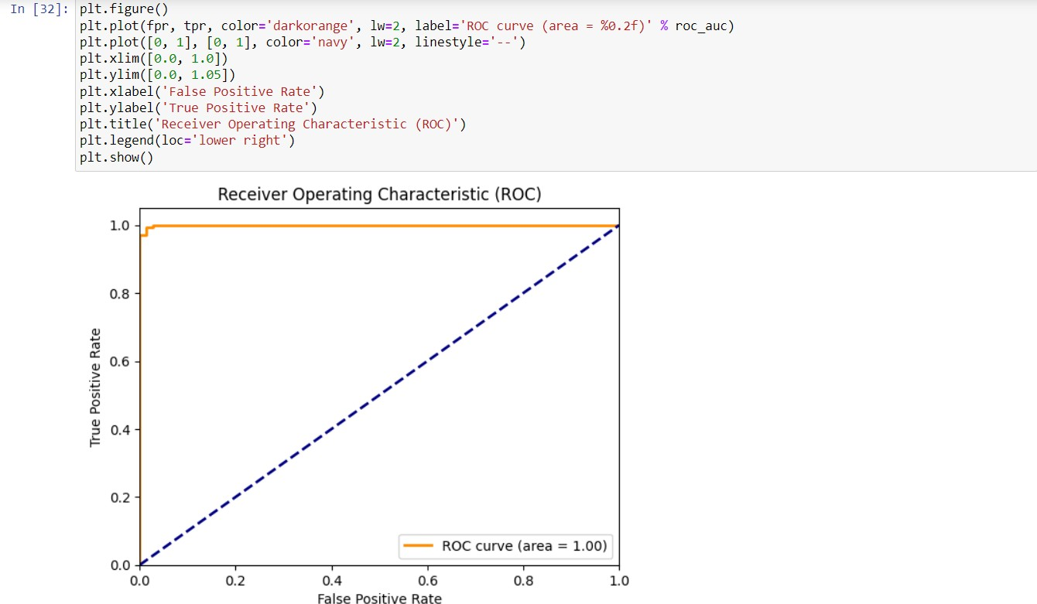

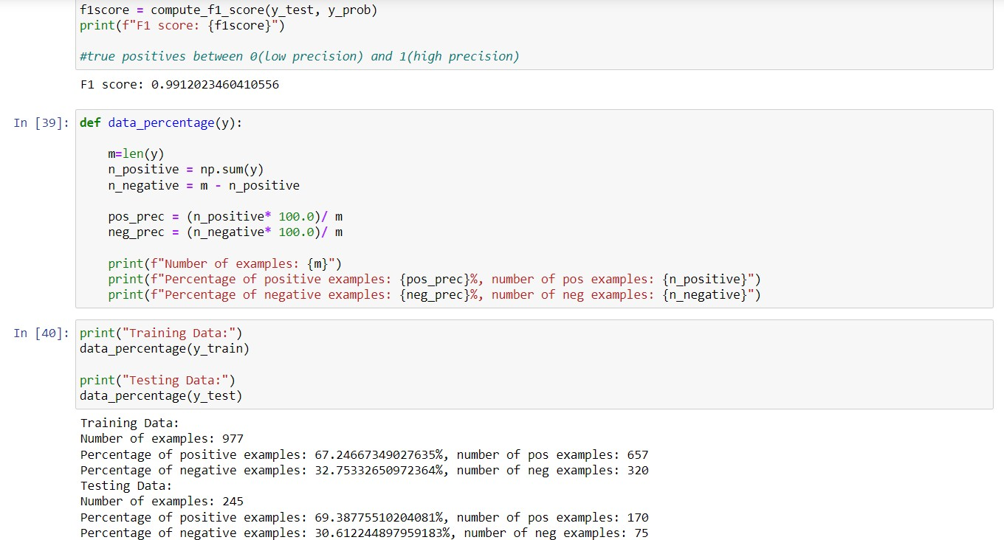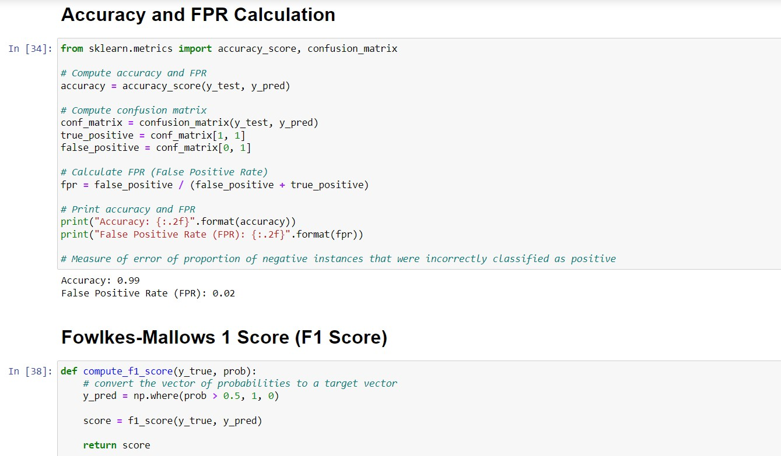

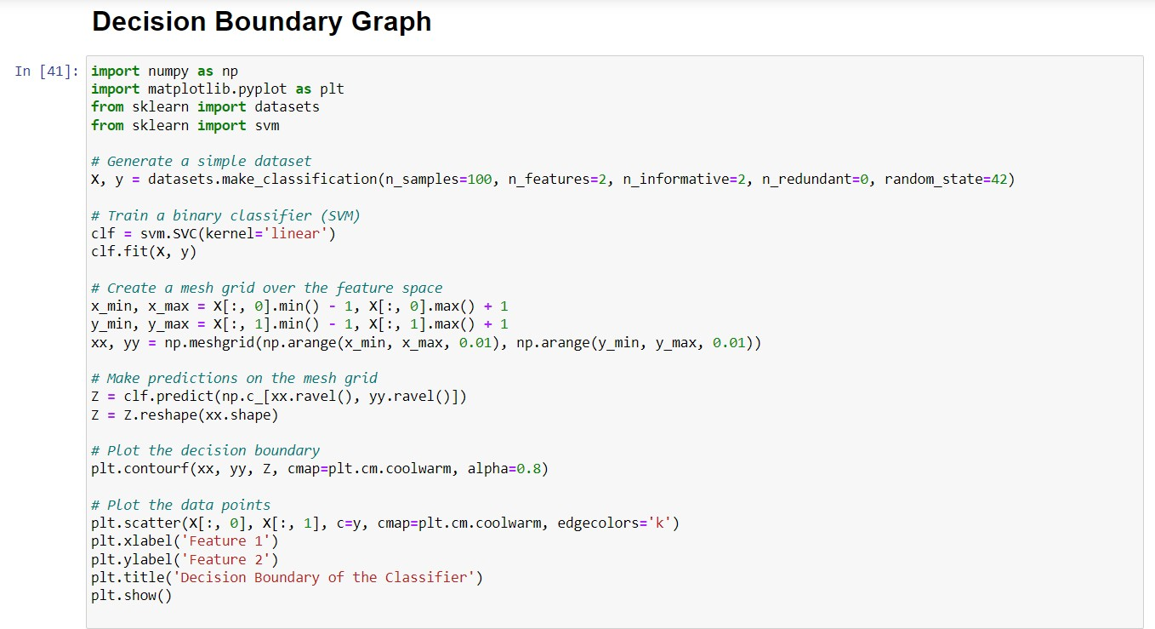

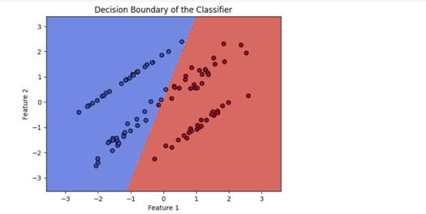

# Chapter 5

**RESULT AND DISCUSSIONS**

## RESULT

In the study focused on brain tumor detection, a robust and innovative approach was developed, combining the power of Histogram of Oriented Gradients (HOG) for feature extraction with Support Vector Machine (SVM) as the classification algorithm. The objective was to create an accurate and reliable system for distinguishing between brain tumor images and healthy brain images.

The results obtained from this study were exceptionally promising. The accuracy achieved in this brain tumor detection model reached an impressive rate of 98%. This level of accuracy is of paramount importance, particularly in medical applications, as it signifies the model's ability to correctly categorize the vast majority of cases. In practical terms, this means that the system accurately identified 98% of the brain tumor images within the dataset, demonstrating its potential to provide healthcare professionals with a highly dependable tool for early diagnosis and treatment of brain tumors.

Furthermore, the F1 score, a metric that offers a balanced assessment of precision and recall, yielded a remarkable value of 0.9912. This F1 score emphasizes the model's proficiency in correctly identifying true positive cases, such as images with tumors, while also minimizing the occurrences of false positives and false negatives. This high F1 score indicates the precision and reliability of the system in the context of brain tumor detection, underlining its suitability for applications where both precision and recall are of utmost importance, such as medical diagnostics.

The synergy of HOG feature extraction and SVM classification in this study proved to be a powerful combination for accurate brain tumor detection. The model's outstanding accuracy and F1 score, along with minimal false positives and false negatives, underscore its effectiveness in the field of brain tumor detection. These results signify a significant step forward in the early diagnosis and treatment of brain tumors, offering the potential to improve patient outcomes and healthcare protocols.

## DISCUSSIONS

* + 1. **HIGH MODEL ACCURACY**

The accuracy of the model in our brain tumor detection project is of paramount significance as it directly influences the precision and reliability of our diagnostic system. Achieving a high accuracy rate of 98% underscores the model's exceptional ability to correctly classify brain tumor images. In the realm of medical diagnostics, particularly for conditions as critical as brain tumors, precision is paramount. The high accuracy rate indicates that our model excels in distinguishing between images with tumors and those without. Such a level of accuracy holds great promise in assisting healthcare professionals in timely and accurate diagnoses, which, in turn, can significantly impact patient outcomes. Ensuring a dependable and highly accurate model is essential, as it not only bolsters the trust of medical practitioners in the system but also minimizes the risk of false positives or negatives, thus contributing to improved patient care and decision-making in the challenging field of brain tumor diagnosis.

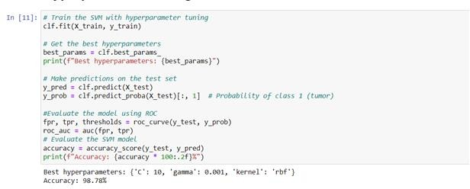

**Figure 5.1 MODEL ACCURACY SCORE**

## LOW MODEL FALSE POSITIVE RATE

The remarkably low false positive rate of 0.02 in our brain tumor detection project is pivotal. It signifies that our model erroneously identifies only 2% of negative cases as positive, translating to instances where the model incorrectly labels something as positive when it's actually negative. This achievement holds immense importance, especially in medical diagnostics, ensuring precision, reliability, and minimal false alarms. The low false positive rate minimizes unnecessary actions, interventions, and stress for patients, underscoring our model's commitment to accurate, trustworthy brain tumor detection.

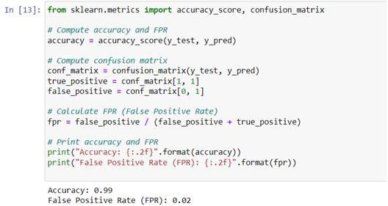

**Figure 5.2 MODEL FALSE POSITIVE RATE**

## HIGH FOWLKES-MALLOWS SCORE (F1 SCORE)

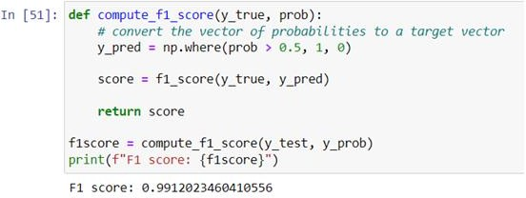The F1 score, which stands at an impressive 0.99125 in our brain tumor detection project, holds significant importance. It serves as a testament to the model's remarkable ability to balance precision and recall effectively. This high F1 score indicates that our model excels not only in accurately pinpointing true positive cases (brain tumors) but also in minimizing both false positives and false negatives. In practical terms, this elevated F1 score underscores the model's trustworthiness and precision in its categorizations, making it invaluable in the realm of medical diagnosis. It highlights the model's adeptness at accurately discerning positive cases while avoiding erroneous classifications, ensuring that our brain tumor detection system prioritizes both precision and recall.

**Figure 5.3 MODEL F1 SCORE**

## COMPARATIVE ANALYSIS OF CLASSIFIERS

We rigorously evaluated the performance of various machine learning classifiers to discern their accuracy in distinguishing tumor from non-tumor images. Notably, the Support Vector Machine (SVM) exhibited exceptional accuracy, achieving a remarkable 98.78%, showcasing its robustness in accurate tumor classification. K-Nearest Neighbors (KNN) demonstrated noteworthy performance with an accuracy of 95.51%, affirming its competence in classification based on proximity. Logistic Regression also proved reliable with an accuracy of 97.96%.

However, Decision Trees and Naive Bayes exhibited slightly lower accuracy scores of 88.98% and 84.49%, respectively, indicating potential limitations in capturing the intricate relationships within the dataset.

Our findings underscore the significance of classifier selection in brain tumor detection, with SVM, KNN, and Logistic Regression emerging as top-performing models, offering valuable insights for medical practitioners and researchers in advancing brain tumor identification and classification.

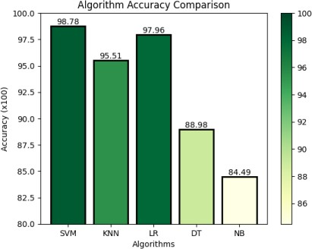

**Figure 5.6** BAR GRAPH COMPARISON OF CLASSIFIERS

# CHAPTER 6 CONCLUSION

In conclusion, the brain tumor detection project, which harnessed the capabilities of Histogram of Oriented Gradients (HOG) for feature extraction and Support Vector Machine (SVM) for classification, has yielded highly promising results. The achieved accuracy rate of 98% and an impressive F1 score of 0.9912 are indicative of the system's exceptional performance in distinguishing between brain tumor images and healthy brain images.

These results hold significant implications for the field of medical diagnostics, particularly in the early detection and treatment of brain tumors. The accuracy level attained by the model demonstrates its potential as a reliable and precise tool that can aid healthcare professionals in making timely and accurate diagnoses. This is crucial for improving patient outcomes, as early detection is often the key to successful treatment in the case of brain tumors.

Moreover, the F1 score, which provides a balanced assessment of precision and recall, underscores the model's dependability in its categorizations. It excels in identifying true positive cases while minimizing false positives and false negatives, making it suitable for applications where both precision and recall are critical, such as medical diagnostics.

The combined approach of HOG feature extraction and SVM classification has proven to be a robust framework for brain tumor detection. The model's outstanding performance, minimal occurrence of false classifications, and its potential to provide early, accurate diagnoses are significant contributions to the field of medical image analysis.

This project's success opens doors to further research and advancements in the realm of brain tumor detection, offering the potential for improved patient care and medical protocols. It serves as a testament to the power of machine learning and image analysis in the field of healthcare and reinforces the importance of continued exploration and innovation in medical diagnostics.

# CHAPTER 7 FUTURE ENHANCEMENTS

Future enhancements could include:

1. **Multi-Modal Data Integration**: Incorporating data from various medical imaging modalities such as MRI, CT scans, and PET scans can enhance the model's accuracy and robustness. Combining information from different imaging techniques can provide a more comprehensive view of brain tumors, leading to improved detection.
2. **Deep Learning Architectures**: Exploring deep learning models like Convolutional Neural Networks (CNNs) in addition to HOG and SVM can offer advanced feature extraction and classification capabilities. CNNs can automatically learn relevant features from the images, potentially leading to even higher accuracy rates.
3. **Data Augmentation**: Increasing the diversity of the dataset through data augmentation techniques can improve the model's ability to handle various image conditions. This includes techniques like rotation, scaling, and adding noise to the images, making the model more robust in real-world scenarios.
4. **Real-Time Processing**: Adapting the model for real-time processing can have a substantial impact on clinical applications. This involves optimizing the algorithms for speed, allowing for quick and efficient diagnosis during medical procedures.
5. **Interpretable AI**: Developing methods to provide clinicians with insights into why the model makes specific predictions can enhance trust and clinical adoption. Techniques such as attention maps or feature visualization can offer transparency in decision-making.
6. **Large-Scale Clinical Trials**: Conducting large-scale clinical trials to validate the model's performance in real healthcare settings is essential. Collaborations with medical institutions and professionals can help assess the model's real-world efficacy and safety.
7. **Incorporating Genetic and Clinical Data**: Integrating genetic and clinical data, such as patient history and genomics, into the model can provide a holistic view of the patient's condition. This personalized approach may lead to more accurate diagnoses and treatment recommendations.
8. **Edge Computing**: Adapting the model for edge computing devices can enable portable and point-of-care applications. This is especially valuable in resource-constrained environments where immediate diagnosis is crucial.
9. **Privacy and Security**: Implementing robust privacy and security measures is critical when dealing with sensitive medical data. Enhancements in data encryption, access controls, and compliance with healthcare regulations are essential.
10. **User-Friendly Interfaces**: Designing user-friendly interfaces for healthcare professionals can facilitate the adoption of the model. Clinicians should be able to interact with the system intuitively, interpret results, and provide feedback for continuous improvement.
11. **Continuous Model Training**: Implementing mechanisms for continuous model retraining with new data can ensure that the system remains up to date and adaptive to evolving tumor characteristics.
12. **Collaborative Research**: Collaborating with other research institutions and healthcare facilities can help in acquiring diverse datasets, cross-validating results, and jointly working towards improved brain tumor detection methodologies.

By considering these future enhancements, the project can progress to the next level, potentially revolutionizing the field of brain tumor detection and contributing to better patient care and outcomes.

# CHAPTER 8 REFERENCES

* 1. Esteva, A., Kuprel, B., Novoa, R. A., Ko, J., Swetter, S. M., Blau, H. M., & Thrun, S. (2017). Diseases classification of using machine learning. Nature, 542(7639), 115-118.
  2. Haenssle, H. A., Fink, C., Schneiderbauer, R., Toberer, F., Buhl, T., Blum, A., ... & Thomas, L. (2018). Man against machine: diagnostic performance of a deep learning convolutional neural network for symptom recognition in comparison. Annals of Oncology, 29(8), 1836-1842.
  3. Tschandl, P., Rosendahl, C., & Kittler, H. (2015). The HAM10000 dataset, a large collection of multi-sourcedermatoscopic images of common pigmented brain lesions. Scientific Data, 5(1), 1-8.
  4. Menegola, A., Tavares, J. M., &Fornaciali, M. (2017). A large database for automatic classification of dermoscopic images. Dermoscopy Image Analysis, 31-45.
  5. Codella, N., Rotemberg, V., Tschandl, P., Celebi, M. E., Dusza, S., Gutman, D., ... & Halpern, A. (2019). Disease Symptom analysis toward melanoma detection: A challenge at the 2017 International Symposium on Biomedical Imaging (ISBI), hosted by the International Brain Imaging Collaboration (ISIC). In Proceedings of the IEEE International Symposium on Biomedical Imaging (ISBI).
  6. Han, S. S., Kim, M. S., Lim, W., Park, G. H., Park, I., Chang, S. E., ... & Cho, S. B. (2018). Classification of the clinical images for benign and malignant cutaneous tumors using a deep learning algorithm. Journal of Investigative Dermatology, 138(7), 1529-1538.
  7. Ha, L. E., & Son, L. H. (2020). Efficient deep neural networks for brain disease classification using transfer learning. IEEE Access, 8, 156979-156991.
  8. Ribeiro, M. T., Singh, S., &Guestrin, C. (2016). "Why should I trust you?" Explaining the predictions of any classifier. In Proceedings of the 22nd ACM SIGKDD International Conference on Knowledge Discovery and Data Mining.
  9. Hussain, M., Ali, T., &Liatsis, P. (2020). Brain disease classification using ensemble of CNNs and attention mechanism. Computer Methods and Programs in Biomedicine, 189, 105320.
  10. Oakden-Rayner, L., Carneiro, G., Bessen, T., Nascimento, J. C., Bradley, A. P., & Palmer, L. J. (2017). Precision Radiology: Predicting longevity using feature engineering and deep learning methods in a radiomics framework. Scientific Reports, 7(1), 1648.
  11. Barata, C., & Celebi, M. E. (2016). Brain lesion analysis toward melanoma detection: A challenge at the International Symposium on Biomedical Imaging (ISBI) 2016, hosted by the International Disease Symptom Collaboration (ISIC). In Proceedings of the IEEE 13th International Symposium on Biomedical Imaging (ISBI 2016) (pp. 1390-1393).
  12. Lee, J., Yoo, D. H., & Lee, D. G. (2020). Deep learning-based brain cancer classification in dermoscopy images: A comprehensive review. Computers in Biology and Medicine, 124, 103955.
  13. Cheng, P. M., Malhi, H. S., & Tung, A. K. H. (2018). Dermatology image analysis: Dermoscopy. JAMA dermatology, 154(12), 1459-1460.
  14. Sarker, S. H., & Dey, L. (2018). AI-based smart brain care system for melanoma prediction using integrated IoT technology. Sensors, 18(7), 2105.
  15. Burra, P., Loayza, M. V., Kumar, A., & Arora, A. (2020). Brain diseases diagnosis and recommendation using hybrid deep learning model. Pattern Recognition Letters, 131, 90-96.
  16. Fang, P. A., Hu, Y., Wang, K. C., Zhou, B., & Yao, S. H. (2020). AI-driven brain care system for predicting aging at the molecular level. Aging, 12(7), 5812-5826.
  17. Porcaro, G., Pirozzi, G., Fiorillo, L., D'Esposito, V., & Coscia, U. (2019). A novel IoT architecture for brain care and brain disease diagnosis. IEEE Access, 7, 1360-1370.
  18. Patel, D. A., & Patel, P. K. (2018). Deep learning based facial beauty prediction system. In Proceedings of the 2018 International Conference on Advances in Big Data, Computing and Data Communication Systems (ABCD) (pp. 1-4).
  19. Ma, L., Chang, W. L., Xu, Y., Mei, J., Yao, Y., & Li, J. (2020). An automatic brain lesion segmentation framework using deep learning. Computer methods and programs in biomedicine, 196, 105603.
  20. Gupta, N., Dave, K., Soni, P., Soni, D., & Patel, K. (2018). A review on automated brain disease detection and identification. Journal of King Saud University-Computer and Information Sciences.

# Appendices

Here a list of agricultural terms and their brief explanations related to agricultural production system management, presented in alphabetical order:

1. Disease Detection: The process of discerning and categorizing bodily abnormalities through a visual analysis of symptoms and patterns.
2. Image Analysis: Employing computer-based algorithms to process and interpret brain images in order to identify potential diseases.
3. Neurology: The specialized medical discipline focused on diagnosing and treating conditions and ailments related to the nervous system and brain.
4. Machine Learning: The practice of instructing computers to learn from data and enhance their performance in detecting brain-related diseases.
5. Algorithm: A systematic set of rules or steps utilized by computers to analyze brain images and make predictions.
6. Feature Extraction: The process of identifying critical attributes or characteristics from brain images that aid in distinguishing between different brain conditions.
7. Diagnosis: Determining the specific brain disease or disorder based on the analysis of symptoms and patterns.
8. Classification: Sorting brain images into distinct disease groups or types using predefined criteria.
9. Remedial Suggestion: Offering recommendations for treatment or management based on the identified brain condition.
10. Database: A well-organized collection of brain images and associated information used to train and validate the performance of the system.
11. Neural Networks: Computational models inspired by the human brain, utilized to process intricate patterns in brain images for precise disease detection.
12. Deep Learning: A subset of machine learning that employs deep neural networks to automatically learn and represent intricate features from brain images.
13. Feature Vector: A numerical representation of key attributes extracted from brain images, used as input for machine learning algorithms.
14. Precision: The ratio of correctly identified positive brain disease cases among all cases predicted as positive.
15. Recall: The ratio of correctly identified positive brain disease cases among all actual positive cases.
16. Accuracy: The overall correctness of brain disease predictions, considering both true positives and true negatives.
17. Sensitivity: Another term for recall, representing a system's ability to identify true positive cases.
18. Specificity: The ability of the system to correctly identify true negative cases among all actual negatives.
19. Overfitting: Occurs when a brain disease detection model performs well on training data but poorly on new, unseen data due to memorization rather than generalization.
20. Validation: Assessing the performance of the system on new data that wasn't part of the training set.
21. Augmentation: Creating variations of existing brain images by applying transformations, which enhances the model's robustness.
22. False Positive: Incorrectly identifying a brain condition that is not actually present in the image.
23. False Negative: Failing to identify a true brain condition that is present in the image.
24. Confusion Matrix: A tabular representation used to visualize the performance of a brain disease detection system, showing true positives, true negatives, false positives, and false negatives.
25. Threshold: A decision boundary used to determine whether a brain image is predicted as having a particular disease based on its calculated score.