

**MS5108- Applied Customer Analytics**

**Individual Assignment 2**

**Submitted By:**

Jogil Jose

18230054

Q1.

Dataset – Local Property Tax Statistics 2018

<https://data.gov.ie/dataset/local-property-tax-lpt-statistics-2018>

1 a) The R base graphics

***Script***

tax <- read.csv("local-property-tax-2018.csv")

hist(tax$lpt_collected_â..m,main="Local Property Tax Ireland(2017-2018)",breaks = seq(0,70,5),

xlab="Tax Collected(€m)",

border="darkblue",

col="lightblue")

***Plot***

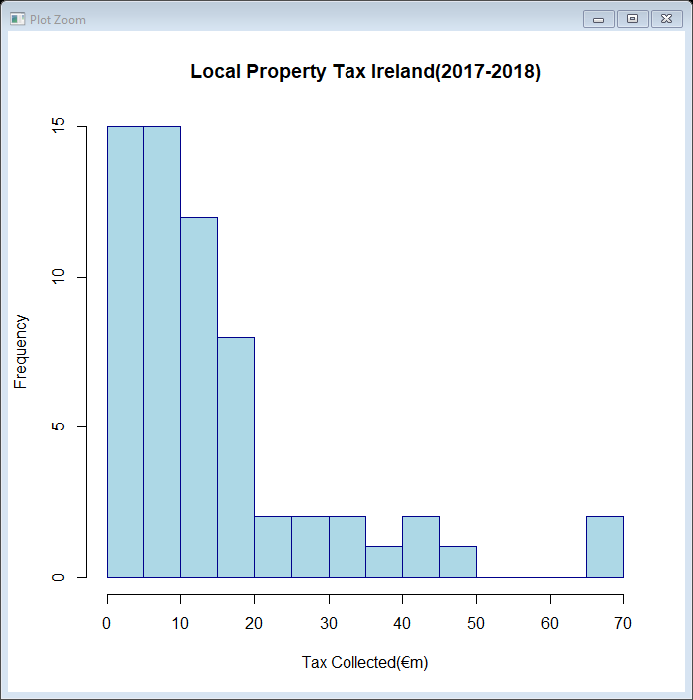

b) GGPLOT2

***Script***

library(ggplot2)

ggplot(tax, aes(x=tax$lpt_collected_â..m,color= tax$local_authority))+

geom_histogram(breaks = seq(0,70,5),color="darkblue", fill="lightblue")+labs(x="Tax Collected(€m)")

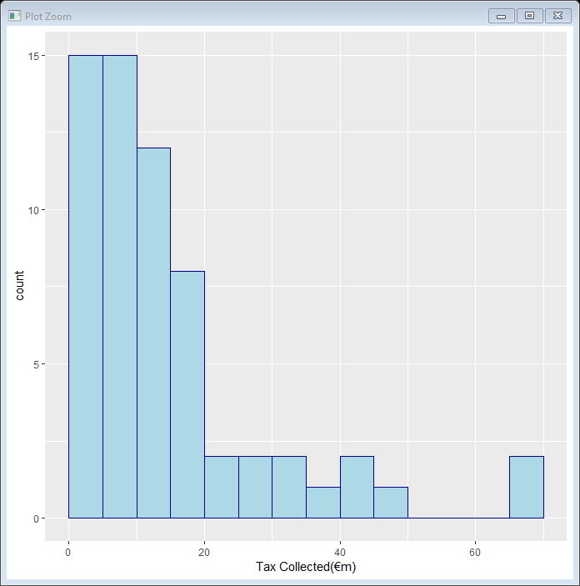

Using the same dataset, represent another aspect of the data as a scatter plot using;

1. The R base graphics

***Script***

plot(tax$lpt_collected_â..m,tax$properties_returned_k, main="Local Property Tax Ireland(2017-2018)", xlab="Tax Collected(€m)", ylab="Properties Retruned (000s)")

***Plot***

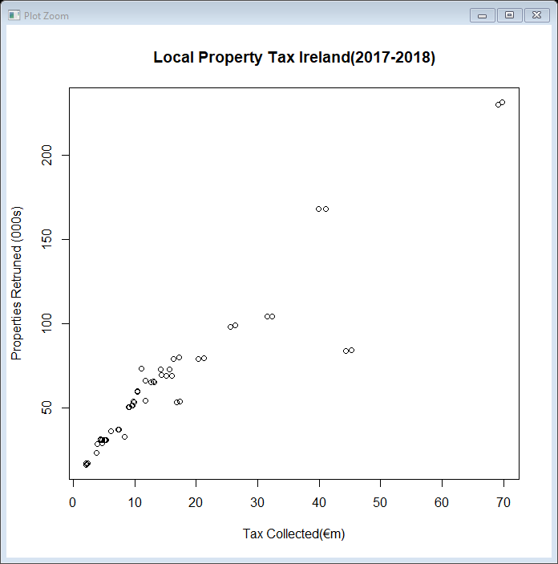

1. GGPLOT2

***Script***

ggplot(tax,aes(x=tax$lpt_collected_â..m,y=tax$properties_returned_k))+geom_point(color="darkblue", fill="lightblue")+labs(x="Tax Collected(€m)",y="Properties Retruned (000s)")

***Plot***

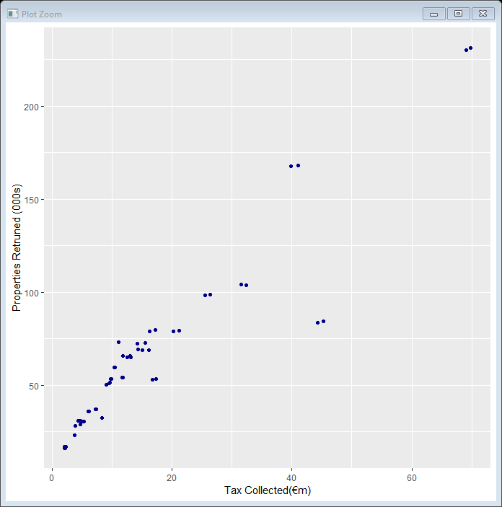

**Q2.**

1. The R base graphics

***Script***

price <- read.csv("Second hand Appartment Prices.csv")

str(price)

pricecounty <- price[,2:7]

TimeSeries <- ts(pricecounty,start=c(1997,1),frequency = 1)

print(TimeSeries)

plot(TimeSeries,main="Price Variations for Second Hand Apartments from 1997 - 2015",xlab="Year",ylab="Apartment Price")

***Plot***

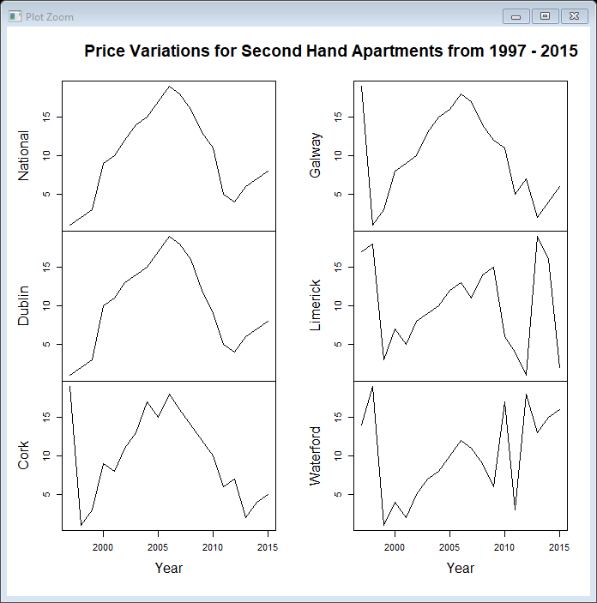

b) Any other R functions which will enable you to produce a more professional and higher

quality graphic.

***Script***

library(reshape2)

library(ggplot2)

price1 <- read.csv("Second hand Appartment Prices.csv",na.strings = "",stringsAsFactors = FALSE)

colnames(price1)

for (x in colnames(price1)){

price1[[x]] <- as.numeric(gsub(",","",price1[[x]],fixed=TRUE))

}

price1_long <- melt(data = price1, id.vars = "YEAR")

ggplot(price1_long, aes(x = YEAR, y= value, colour = variable)) +

geom_line()+

geom_point() +

xlab("Year")+

scale_y_continuous(name = "Second Hand Apartment Prices", labels = scales::comma)

***Plot***

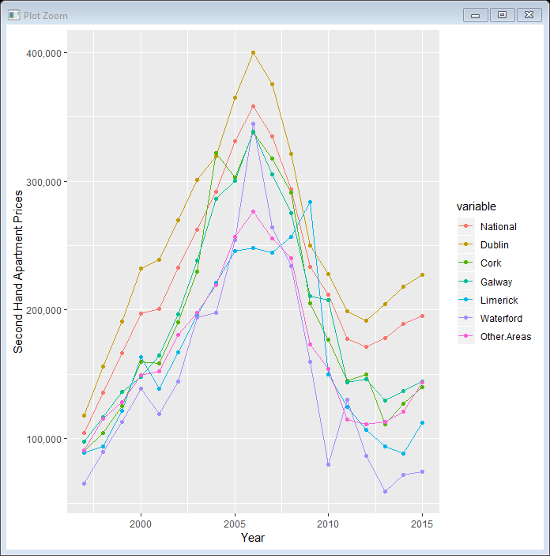

**Q3.**

***Script***

library(leaflet)

mapdata <- read.csv("Cork_Coordinates.csv")

geo_cordinates <- cbind(mapdata$longitude,mapdata$latitude)

leaflet() %>%

addProviderTiles('OpenStreetMap.Mapnik',

options = providerTileOptions(noWrap = TRUE)) %>%

addMarkers(data = geo_cordinates,

popup = paste0("<strong> Place: </strong>",mapdata$postal_town))

str(mapdata)

**Plot**

