

# Audit Report

## Company:- h| Audit:- IA-Apri | Data Set:- Sales

# Summary Observations

|  |  |  |
| --- | --- | --- |
| **Total Transactions:** | **Transactions Audited:** | **Total Queries:** |
| 213 | 19 | 66 |

|  |  |  |
| --- | --- | --- |
| **Total Risk Score:** | **Transactions Audited:** | **Total Queries:** |
| 684 | 90 | 13.16% |

## Query Summary for: Sales

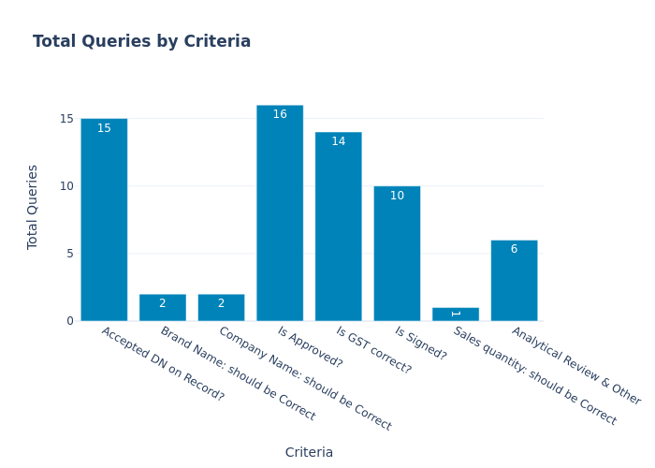

|  |  |  |
| --- | --- | --- |
|  | **Criteria** | **Total Queries** |
| **0** | Accepted DN on Record? | 15 |
| **1** | Brand Name: should be Correct | 2 |
| **2** | Company Name: should be Correct | 2 |
| **3** | Is Approved? | 16 |
| **4** | Is GST correct? | 14 |
| **5** | Is Signed? | 10 |
| **6** | Sales quantity: should be Correct | 1 |
| **7** | Analytical Review & Other | 6 |

## Risk Based Audit Summary for: Sales

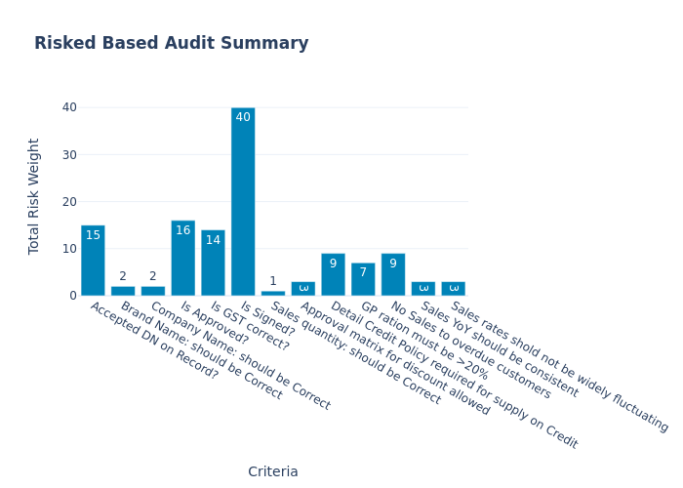

|  |  |  |
| --- | --- | --- |
|  | **Criteria** | **Total Risk Weight** |
| **0** | Accepted DN on Record? | 15 |
| **1** | Brand Name: should be Correct | 2 |
| **2** | Company Name: should be Correct | 2 |
| **3** | Is Approved? | 16 |
| **4** | Is GST correct? | 14 |
| **5** | Is Signed? | 40 |
| **6** | Sales quantity: should be Correct | 1 |
| **7** | Approval matrix for discount allowed | 3 |
| **8** | Detail Credit Policy required for supply on Credit | 9 |
| **9** | GP ration must be >20% | 7 |
| **10** | No Sales to overdue customers | 9 |
| **11** | Sales YoY should be consistent | 3 |
| **12** | Sales rates shold not be widely fluctuating | 3 |