

# Audit Report

## Company:- h| Audit:- IA-May | Data Set:- Sales

# Summary Observations

|  |  |  |
| --- | --- | --- |
| **Total Transactions:** | **Transactions Audited:** | **Total Queries:** |
| 213 | 6 | 40 |

|  |  |  |
| --- | --- | --- |
| **Total Risk Score:** | **Audited Risk Score:** | **Risk Percentage:** |
| 480 | 219 | 45.62% |

## Query Summary for: Sales

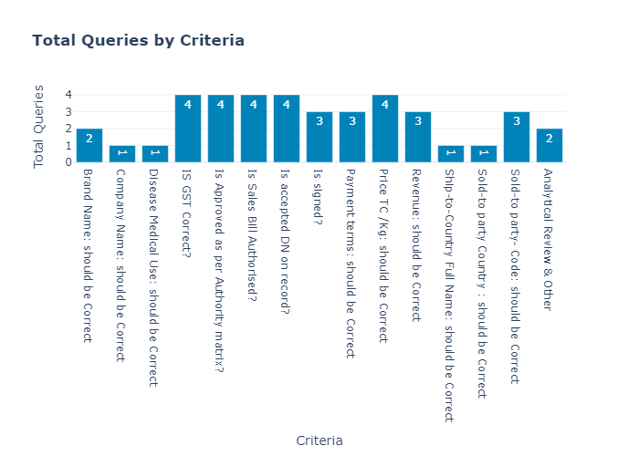

|  |  |  |
| --- | --- | --- |
|  | **Criteria** | **Total Queries** |
| **0** | Brand Name: should be Correct | 2 |
| **1** | Company Name: should be Correct | 1 |
| **2** | Disease Medical Use: should be Correct | 1 |
| **3** | IS GST Correct? | 4 |
| **4** | Is Approved as per Authority matrix? | 4 |
| **5** | Is Sales Bill Authorised? | 4 |
| **6** | Is accepted DN on record? | 4 |
| **7** | Is signed? | 3 |
| **8** | Payment terms: should be Correct | 3 |
| **9** | Price TC /Kg: should be Correct | 4 |
| **10** | Revenue: should be Correct | 3 |
| **11** | Ship-to-Country Full Name: should be Correct | 1 |
| **12** | Sold-to party Country : should be Correct | 1 |
| **13** | Sold-to party- Code: should be Correct | 3 |
| **14** | Analytical Review & Other | 2 |

## Risk Based Audit Summary for: Sales

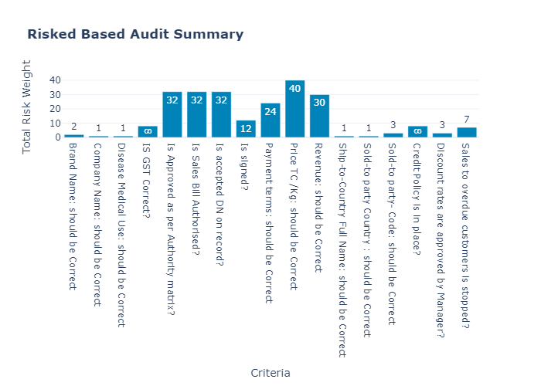

|  |  |  |
| --- | --- | --- |
|  | **Criteria** | **Total Risk Weight** |
| **0** | Brand Name: should be Correct | 2 |
| **1** | Company Name: should be Correct | 1 |
| **2** | Disease Medical Use: should be Correct | 1 |
| **3** | IS GST Correct? | 8 |
| **4** | Is Approved as per Authority matrix? | 32 |
| **5** | Is Sales Bill Authorised? | 32 |
| **6** | Is accepted DN on record? | 32 |
| **7** | Is signed? | 12 |
| **8** | Payment terms: should be Correct | 24 |
| **9** | Price TC /Kg: should be Correct | 40 |
| **10** | Revenue: should be Correct | 30 |
| **11** | Ship-to-Country Full Name: should be Correct | 1 |
| **12** | Sold-to party Country : should be Correct | 1 |
| **13** | Sold-to party- Code: should be Correct | 3 |
| **14** | Credit Policy is in place? | 8 |
| **15** | Discount rates are approved by Manager? | 3 |
| **16** | Sales to overdue customers is stopped? | 7 |