

# Audit Report

## Company:- h| Audit:- IA-May | Data Set:- PO

# Summary Observations

|  |  |  |
| --- | --- | --- |
| **Total Transactions:** | **Transactions Audited:** | **Total Queries:** |
| 4223 | 7 | 56 |

|  |  |  |
| --- | --- | --- |
| **Total Risk Score:** | **Audited Risk Score:** | **Risk Percentage:** |
| 609 | 290 | 47.62% |

## Query Summary for: PO

<image: POh8c1.png>

|  |  |  |
| --- | --- | --- |
|  | **Criteria** | **Total Queries** |
| **0** | Is Accepted Po on record? | 5 |
| **1** | Is Authorised? | 5 |
| **2** | Is Signed? | 5 |
| **3** | Lowest Price is Selected? | 5 |
| **4** | More than 3 Quotation taken? | 6 |
| **5** | PO are not modified after issue? | 7 |
| **6** | PO are serially numbered? | 7 |
| **7** | bcamnt: should be Correct | 2 |
| **8** | ccode: should be Correct | 3 |
| **9** | clsup: should be Correct | 1 |
| **10** | itamnt: should be Correct | 1 |
| **11** | itqty: should be Correct | 2 |
| **12** | tramnt: should be Correct | 2 |
| **13** | Analytical Review & Other | 5 |

## Risk Based Audit Summary for: PO

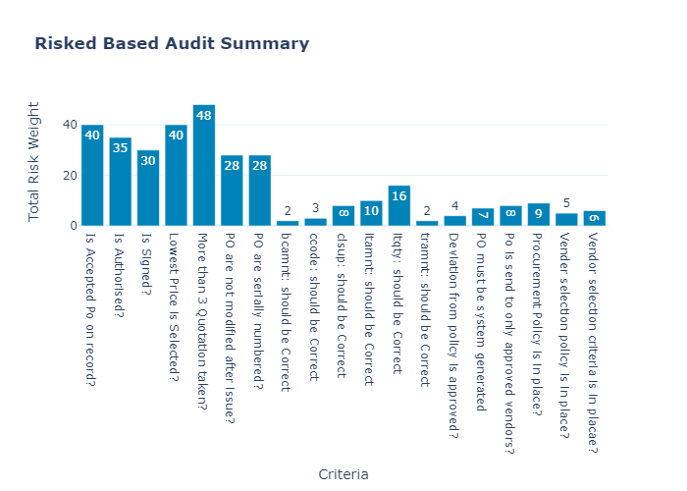

|  |  |  |
| --- | --- | --- |
|  | **Criteria** | **Total Risk Weight** |
| **0** | Is Accepted Po on record? | 40 |
| **1** | Is Authorised? | 35 |
| **2** | Is Signed? | 30 |
| **3** | Lowest Price is Selected? | 40 |
| **4** | More than 3 Quotation taken? | 48 |
| **5** | PO are not modified after issue? | 28 |
| **6** | PO are serially numbered? | 28 |
| **7** | bcamnt: should be Correct | 2 |
| **8** | ccode: should be Correct | 3 |
| **9** | clsup: should be Correct | 8 |
| **10** | itamnt: should be Correct | 10 |
| **11** | itqty: should be Correct | 16 |
| **12** | tramnt: should be Correct | 2 |
| **13** | Deviation from policy is approved? | 4 |
| **14** | PO must be system generated | 7 |
| **15** | Po is send to only approved vendors? | 8 |
| **16** | Procurement Policy is in place? | 9 |
| **17** | Vender selection policy is in place? | 5 |
| **18** | Vendor selection criteria is in placae? | 6 |