Plausible values and creation of new variables

## Zika Project

Under this document we describe the plausible values consider for each of the variables used in the imputation model. In addition we provide the rules that we applied on the creation of additonal variables requiered for the imputation model.

summary(cars)

## speed dist   
## Min. : 4.0 Min. : 2.00   
## 1st Qu.:12.0 1st Qu.: 26.00   
## Median :15.0 Median : 36.00   
## Mean :15.4 Mean : 42.98   
## 3rd Qu.:19.0 3rd Qu.: 56.00   
## Max. :25.0 Max. :120.00

## Including Plots

You can also embed plots, for example:

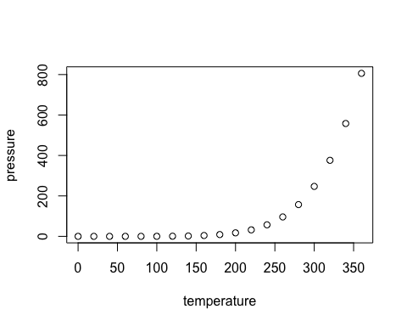

Note that the echo = FALSE parameter was added to the code chunk to prevent printing of the R code that generated the plot.