**NLP Group 9**

**Review Reviewer**

**Automated Review Scoring Model**



**Professor**: Angel Castellanos Gonzalez

**Group members:**

Abigail Carpenter

Alberto Donà

Carlos Lopez

Johan Barreiro

Jorge Gonzalez

Marguerita Alting von Geusau

**Introduction 3**

Problem statement 3

**Business case 3**

Value Proposition 4

Key Components 4

Strategic Impact 5

**Literature review 5**

**Methodology 6**

Data 6

Model - Zero Shot Classification 6

Streamlit 7

**Conclusion 7**

**Appendix 8**

# Introduction

In the digital age, online reviews have become a significant factor influencing consumer decisions, especially in the restaurant industry. With platforms like Yelp, Google Reviews, and TripAdvisor, customers can easily share their dining experiences, providing valuable feedback for both other consumers and restaurant owners. However, the sheer volume of reviews can make it challenging to quickly discern the overall quality of a restaurant. Moreover, individual biases and subjective opinions can lead to inconsistencies in review scores, complicating the task of obtaining an accurate assessment of customer satisfaction. Many customers decide to visit only restaurants that have a certain review level, prompting owners to proactively try to raise their ratings.

To address these challenges, we present "Review Reviewer," an automated review scoring model. This system leverages advanced natural language processing (NLP) techniques to analyze restaurant reviews and assign consistent and objective scores from 1 to 5 to identify what the written reviews actually mean. By automating the review scoring process on the written reviews, "Review Reviewer" aims to provide reliable evaluations, assisting potential customers in making informed dining choices and helping restaurant owners gain actionable insights into their performance with the Review Dashboard.

## Problem statement

The primary problem addressed by this project is the inconsistency and subjectivity in manually assigned review scores, which can lead to misleading perceptions of a restaurant's quality. Specifically, the issues include:

* **Subjectivity:** Different reviewers have varied standards and biases, resulting in inconsistent scoring.
* **Volume:** The high volume of reviews makes it difficult for users to quickly and accurately assess a restaurant's overall quality.
* **Time-Consuming:** Manually reading and evaluating reviews is time-consuming for both consumers and business owners.

"Review Reviewer" aims to mitigate these issues by providing a consistent, automated scoring system, enhancing the reliability of review scores and making it easier for users to evaluate restaurants efficiently.

# Business case

In the competitive restaurant industry, maintaining a positive online presence is crucial for attracting and retaining customers. Accurate and reliable review scores can significantly impact a restaurant's reputation and business success. "Review Reviewer" addresses the challenges of subjective and inconsistent review scoring, providing valuable benefits to both consumers and restaurant owners.

## Value Proposition

**For Consumers:**

* **Reliable Evaluations:** Provides consistent and objective scores, helping consumers make informed dining choices.
* **Sentiment Analysis:** Assigns emotional sentiment to written reviews for deeper insights into dining experiences.

**For Restaurant Owners:**

* **Actionable Insights:** Offers scores and sentiment analysis to understand customer satisfaction and identify areas for improvement.
* **Efficiency:** Saves time by automating review analysis, allowing focus on core business activities.
* **Decision Support:** A dashboard for reviewing and visualising the emotions of the written reviews, aiding in strategic decision-making.

## Key Components

* **Automated Scoring Model:** The Automated Scoring Model leverages advanced Natural Language Processing techniques to analyze and classify user reviews. This model assigns a score from 1 to 5 to each review based on its content. The scoring system helps quantify qualitative feedback, providing a consistent metric for review quality and sentiment.
* **Sentiment Analysis:** The Sentiment Analysis component evaluates the emotional tone of each review. It categorizes the reviews into three main sentiment classes: positive, neutral, or negative. This classification allows businesses to understand the general sentiment trends among their customers, identify areas of concern, and recognize strengths.
* **Dashboard for Owners:** The Dashboard for Owners serves as a comprehensive tool for restaurant managers and owners to monitor customer feedback. It aggregates data from all reviews, presenting a detailed overview that includes:
  + Key KPIs: Displays the overall average score assigned by the Automated Scoring Model and the average star ratings of the total reviews.
  + Sentiment Review: Summarizes the distribution of review sentiments (positive, neutral, negative) overall and per review.
  + Individual Review Insights: Provides detailed information on each review, including the automated score, sentiment classification, and original review text. This feature enables owners to dive into specific reviews, identify recurring themes, and respond appropriately to individual reviews.

The dashboard is created to gain quick, data-driven insights into all the restaurant's reviews and improve customer engagement *(Appendix 1).*

* **Streamlit**: Model for users to receive assistance in writing reviews. Predicts a rating based on user input and elaborates the input based on the prediction through openAI API (prompt engineered) *(Appendix 2*).

## Strategic Impact

"Review Reviewer" aims to enhance the accuracy and objectivity of review scores, helping to:

* **Boost Customer Trust:** Reliable reviews build consumer confidence, potentially increasing foot traffic and sales.
* **Improve Service Quality:** Insights enable data-driven improvements, enhancing customer satisfaction.
* **Streamline Operations:** Automation reduces time and resources spent on manual review analysis.

In conclusion, "Review Reviewer" offers a reliable and efficient solution to improve the utility of restaurant reviews, benefiting both consumers and business owners by enhancing review accuracy and providing actionable insights through the Review Dashboard. As an extra support for the user we provided a model (through streamlit) that assists through generative AI the user in creating “unbiased” reviews *(Appendix 3)* based on a predicted rating (*Appendix 2*). Ultimately this would lead to a higher population of standardised reviews for better eligibility of the restaurants.

# Literature review

Current trends

* **Reliance on Reviews**: According to 2023 data from LinkedIn over 98% of consumers consult restaurant reviews before dining there, and it's reported that a one-star increase correlates with a 5-9% sales increase. These stats indicate the influence that reviews have in the restaurant industry for both consumers and owners.
* **Social Media**: platforms like Instagram and Facebook invite users to interactively share their dining experiences with followers; with the rise of user generated content there is an increasing trend to support multimedia reviews.

Key challenges

* **Subjectivity and Bias**: individual preferences may sway the overarching restaurant experience. Likewise, some customers exhibit the tendency to leave non-representative reviews that distort the overall assessment.
* **Volume of Reviews:** Restaurants receive an abundance of reviews from multiple sources, wherein it is difficult to maintain a consistent image. Additionally this lends itself to the presence of fake reviews, which skews the authenticity customers look for.

Existing solutions

* **Manual evaluation**: many users and businesses will sift through the reviews manually to gather insights
* **Aggregate rating system:** platforms provide an average rating from submitted reviews
* **Sentiment Analysis**: NLP tools analyze text to determine overall sentiment that help consumers understand the general consensus of the restaurant

# Methodology

## Data

**Data collection**:

The dataset contains reviews posted on TripAdvisor for 5855 restaurants around Madrid; the dataset was extracted from Kaggle with 176848 rows, 13 columns.

**EDA**: Initial EDA uncovered the following relationships

* Rating distribution:
  + 5 Star: 55.7%
  + 4 Star: 26.2%
  + 3 Star: 8.8%
  + 2 Star 4.2%
  + 1 Star 5.1%
* Average rating over time follows an upward trend from 2007 - 2019
* The distribution of review word count is heavily skewed to the left with most reviews containing 40-50 words.

**Feature Engineering**: The following features were created to enhance the model analysis

* Sentiment of review: positive, negative, neutral
* Emotion of review: measuring for anticipation, joy, positive, negative, surprise, trust, anger, disgust, sadness
* Sentiment shift in review: measured in absolute changes between sentences
* Number of stopwords
* Length of review
* Stop word use to length of review
* Presence of URL
* Exclamation mark usage
* Punctuation usage
* Hashtag count
* Mentions (@)
* Blob Polarity
* Blob Subjectivity

## Model - Zero Shot Classification

Two Models were used for zero shot classification: RoBERTa and DeBERTa. Other models considered were: Bart, Llama 2, Distilbert, and Flan T-5.

RoBERTa and DeBERTa were chosen due to their performances on small subsets of the data compared to other models. Additionally, while these models were slower than DistilBERT, they were faster than Bart and Flan T-5. Llama 2 was unable to be used due to its size (7 Billion Parameters), when loaded it would kill kernels on both local machines and Google Colab. All models considered are large pretrained language models.

Zero Shot Classification is a text classification task conducted by providing a body of text and a set of labels to be classified into. Since there is no target column to be trained on, zero shot classification is an unsupervised learning task. Since the purpose of this task is to obtain a restaurant rating number free from user bias using only their text, we cannot use their restaurant ratings as ‘ground truth values as that would introduce bias into the classification task.

The labels provided act as context for the model and its classification task. The model provides a probability for each of the labels and we select the one with the highest probability. Initially the labels (very bad, bad, average, good, very good) were used. However this led to some highly inaccurate classifications. When the word review was added to the labels, ex. ‘very bad review’, the amount of misclassified reviews dropped. However, this is not the most accurate model and was chosen due to its efficiency and the large amount of data we had.

## Streamlit

Additionally, as mentioned in the potential impact, we decided to strengthen the use case by providing a review tool through the integration of openAI to develop reviews through the technique of prompt engineering, and Streamlit for the UX.

From a coding perspective, 3 python files involved:   
 1. A file that through the deBERTa model predicts a suitable rating for the user input

2. A file that defines the function for the openAI API

3. A main.py file to call the functions, set up and run the streamlit

The business use case for this model is to improve the quality of, and standardise the reviews that are present online for a more clear understanding of the positives and negatives of each restaurant.

# Conclusion

“Review Reviewer” leverages advanced NLP techniques to achieve scalable review analyses that mitigate bias and dispute inconsistencies present among vast amounts of data. Online reviews significantly influence consumer choices and business success in the restaurant industry, and as the digital age progresses this reliance will increase. The "Review Reviewer" application unifies the interests of both customers and owners by delivering consistent and objective evaluations that simplify decision making processes.

# Appendix

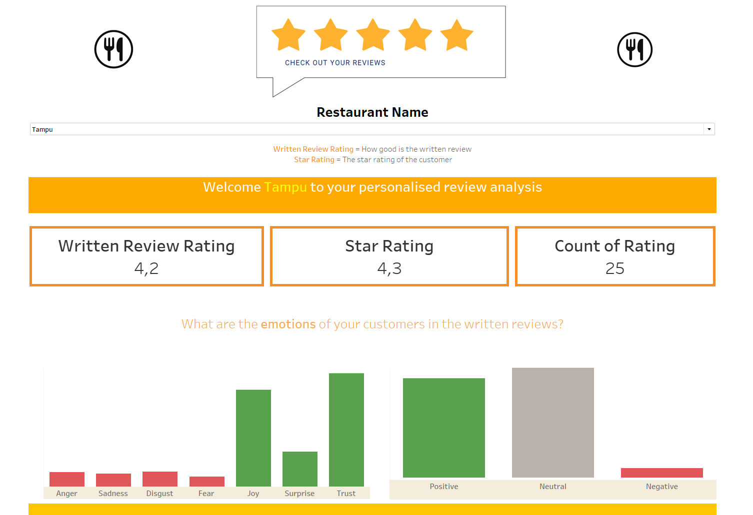

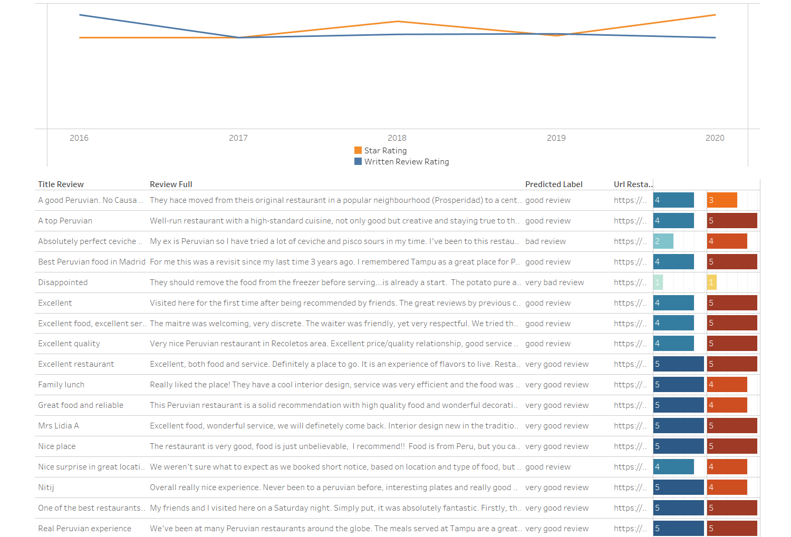

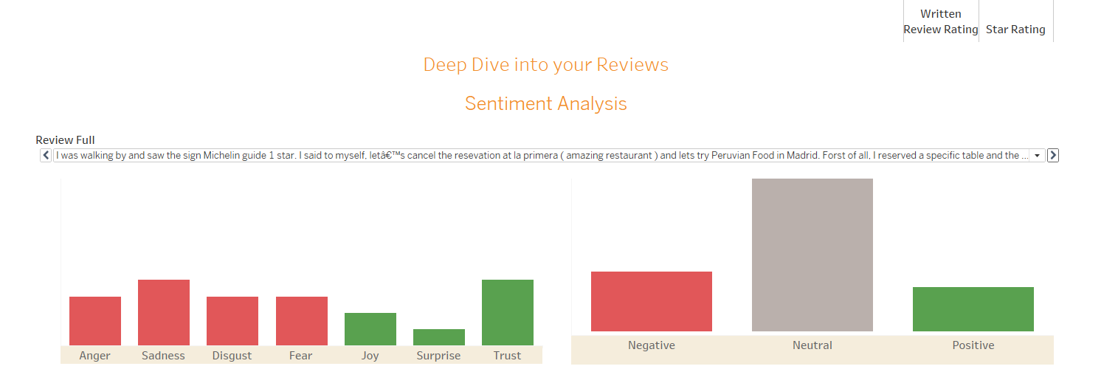

*Appendix 1.* [*Review Reviewers Dashboard*](https://public.tableau.com/views/NLPdashboard/NLPDashboard?:language=en-US&publish=yes&:sid=&:display_count=n&:origin=viz_share_link)

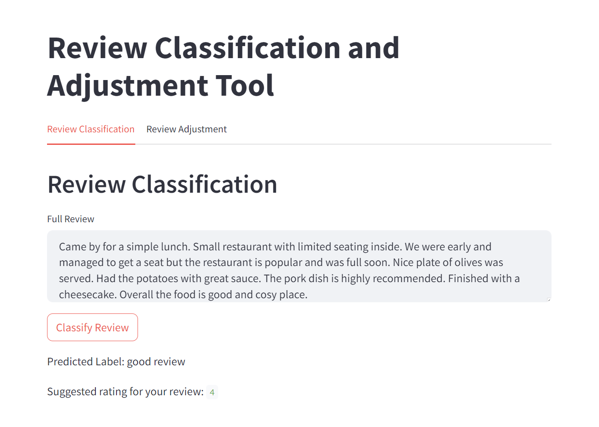

*Appendix 2. Streamlit tool rating predictor*

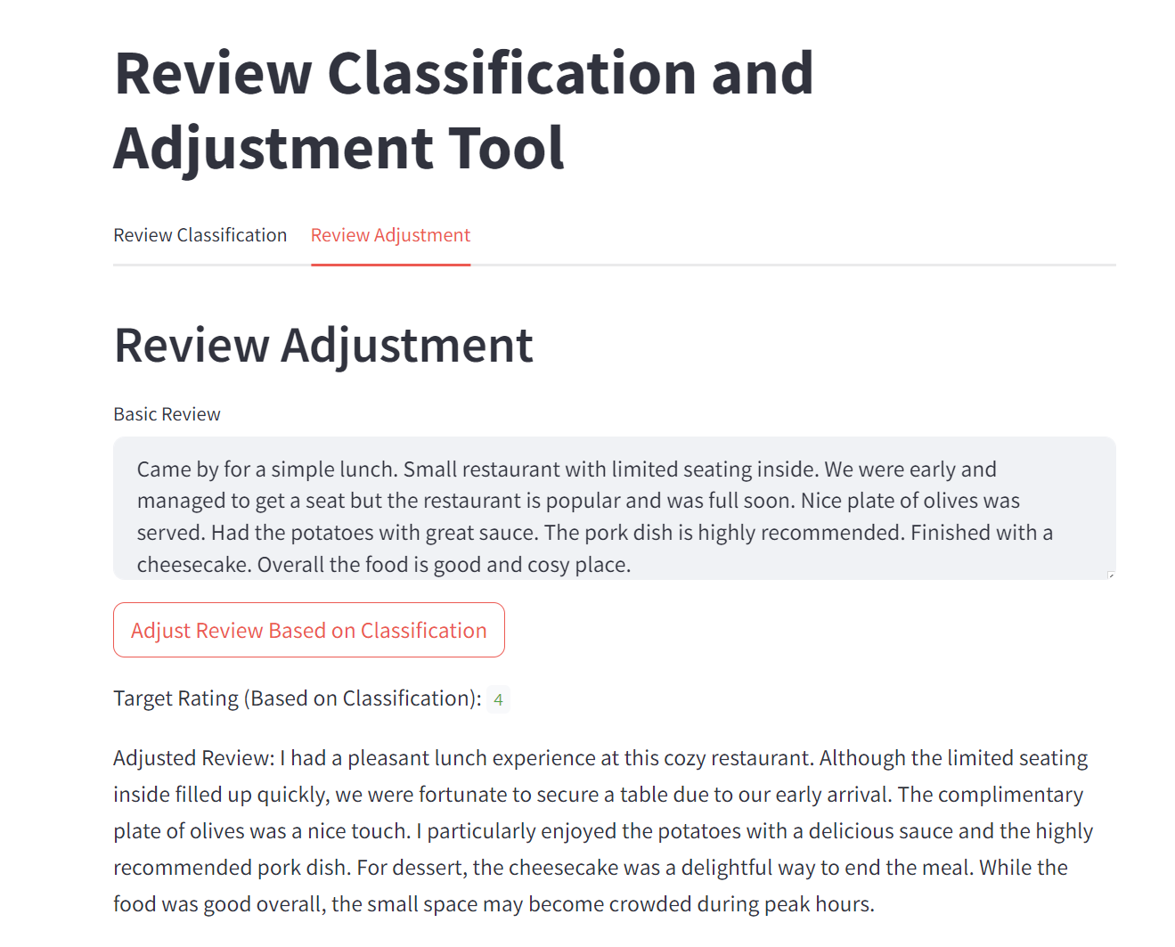

*Appendix 3. Streamlit tool review assistant*