Sygnia
Design Manual
Cash-Movement Backend — gRPC · EF Core · SQL Server · Angular

Audience: junior developers and non-technical stakeholders.
No prior familiarity with the codebase is assumed.

1. Executive Summary
Sygnia is a small but production-shaped banking backend built to demonstrate how a financial system should handle money movements safely. It lets a client record a cash movement (a deposit or withdrawal) against an account, transfer money between two accounts in one atomic step, check an account's balance, and download a full statement of an account's history.
In plain terms: this is the kind of system a bank's core ledger relies on. Two properties make or break a system like this, and both are treated as first-class design goals rather than afterthoughts:
- No duplicate money movements. If the same instruction is submitted twice — for example because a network retry fired after a slow response — the system recognises the repeat and does not double-process it.
- Statements never run the server out of memory. An account with tens of thousands of movements can be downloaded as a statement without the server loading the whole thing into RAM first.
The rest of this document explains, in increasing technical depth, how the system is built, why it is built that way, and what was deliberately left out.

2. Tech Stack
What each layer is built with, and why that choice was made.
Layer | Technology | Why
API surface | gRPC (.NET 8) | Strongly-typed contracts, efficient binary wire format, and native support for server streaming — needed for the statement feature below.
Backend language/runtime | .NET 8 / C# | Modern, high-performance, first-class async support required by every I/O path in this system.
Database | SQL Server | Mature relational engine with strong transactional guarantees — required for the idempotency mechanism described in Section 4.
Data access | Entity Framework Core 8 | Productive, well-understood ORM with native async streaming query support (AsAsyncEnumerable), used deliberately rather than a lighter micro-ORM so the statement invariant could be enforced at the query layer.
Integration testing | Testcontainers | Spins up a real, disposable SQL Server in Docker for tests — so the idempotency race condition is proven against a real database engine, not a mock.
Front end | Angular 18 | Component-based SPA framework; consumes the backend via gRPC-Web (the browser-safe variant of gRPC).
Logging | Serilog -> Seq | Structured logging shipped to a searchable log viewer (Seq), rather than plain text log files.
Tracing | OpenTelemetry -> Jaeger | Distributed tracing so a single request can be followed across service boundaries during troubleshooting.
Local orchestration | docker-compose | Brings up SQL Server, Seq, Jaeger, the backend host, and the SPA together with one command.
Legacy interop (optional, last) | .NET Framework 4.8 WCF gateway | A single GetBalance operation exposed the old-fashioned way (NetTcp/WCF), acting as a gRPC client under the hood — demonstrates bridging a legacy consumer to the modern core without duplicating logic.

3. Architecture
The backend follows Clean Architecture: code is organised into layers, and dependencies only ever point inward, toward the centre. The centre (Domain) knows nothing about the outside world — not the database, not gRPC, not even that a database exists. This keeps the core business rules testable and free of framework noise.

3.1 Layers
Layer | Responsibility
Sygnia.Domain | The core business models (Movement, Account, User) and small helpers (Guard clauses, a Result<T> type, Error). Has no dependencies on anything else in the solution.
Sygnia.Application | The use cases: "submit a movement", "transfer between accounts", "read a balance", "stream a statement". Defines the ports (interfaces) the outer layers must implement, e.g. IMovementRepository.
Sygnia.Infrastructure | The real implementations: the EF Core DbContext, the composite-key configuration, and the repository that contains the idempotency logic (the SQL error 2627 catch, explained in Section 4.1).
Sygnia.Presentation | The gRPC host. Exposes the use cases over the network, translates results into gRPC status codes, and is the composition root — the one place all the layers are wired together at startup.
Sygnia.Wcf.Gateway | An optional, last-built legacy bridge: a .NET Framework 4.8 WCF service exposing one balance-lookup operation, itself acting as a client of the gRPC core.

3.2 Dependency direction
The single rule that keeps the architecture honest: dependencies only point toward the Domain at the centre. Nothing in Domain ever references Application, Infrastructure, or Presentation.
Presentation ---> Application ---> Domain
Infrastructure ---> Application ---> Domain
Presentation ---> Infrastructure (composition root only — to wire up services at startup)
Domain ---> nothing

Every project exposes only public interfaces plus exactly one registration method (e.g. AddInfrastructure(...)); everything else is marked private so it cannot be referenced — let alone accidentally wired up — from outside the layer that owns it.

4. The Two Invariants
Most of the code in this system is plumbing — wiring, mapping, configuration. Two rules, however, are what the system is actually graded and judged on. Both fail silently if broken: the code still compiles, most tests still pass, and the bug only shows up under real-world load or a race condition.

4.1 Idempotency lives in the database, not in C#
Plain-language version: if the exact same movement instruction arrives twice (say, a retried network call), the system must not record it twice — but it also must not simply reject the retry as an error, because the caller may not know whether the first attempt succeeded.
The temptation is to check "does this record already exist?" in application code before inserting it. That approach loses under concurrency: two requests can both check at almost the same instant, both see "not found", and both insert — producing a duplicate. This is exactly the race condition the assignment tests for.
The fix: let the database itself be the single source of truth for "has this happened before?" The table's primary key is the composite (AccountId, ExternalRef) — the external reference the caller supplies, scoped to the account. The flow is:
- Attempt the INSERT unconditionally — no check-first.
- If SQL Server rejects it with error 2627 or 2601 (a primary-key/unique-index violation), read the row that is already stored under that key.
- Compare amount, currency, and date/time against what was just submitted.
- Identical -> this is a safe retry: return the stored row as a normal success (OK).
- Different -> this is a genuine conflict: return ALREADY_EXISTS, naming exactly which fields differ.
The database's own uniqueness guarantee is atomic — it cannot be raced — so this is the only place the check can safely live. The SQL exception is caught at the boundary between Infrastructure and Application and is never allowed to escape as a raw exception; it becomes a typed Result value instead.

4.2 Statements stream end to end, or they are wrong
Plain-language version: an account statement can have tens of thousands of rows. Loading all of them into server memory before sending any of them to the client works fine in a demo and fails in production — either slowly (a long wait before the first row appears) or catastrophically (out of memory).
The rule this system enforces end to end: a movement record is read from the database, sent to the client, and only then is the next one read. At no point does the full result set exist in memory at once. Concretely:
- EF Core query uses AsAsyncEnumerable() with AsNoTracking() — reads rows lazily, one at a time, without EF's change-tracking overhead (which is pointless for a read-only stream).
- The repository's return type is IAsyncEnumerable<Movement>, not a List<Movement> — the type system itself forbids collecting the whole thing into memory.
- The handler yields each row onward while keeping a single running total (a plain decimal) as it goes, rather than summing after the fact.
- The gRPC layer uses server streaming — WriteAsync per row — so the client starts receiving rows immediately.
- The client (grpcurl or the Angular app) reads and renders one row at a time; the Angular side is bound by the identical rule — it never collects the stream into an array before displaying it.
A single .ToListAsync() anywhere on this path would defeat the whole requirement while every ordinary functional test kept passing — the bug would only appear under real load. This is why the project's guard against regression here is a dedicated 50,000-row memory test, not a correctness assertion alone.

5. Activity Diagram — Submit Movement
This diagram traces one "submit movement" request through every layer, shown as a swimlane per architectural layer (matching Section 3). Colour key: blue = entry point, yellow = decision point, green = success outcome, red = conflict/error outcome. An editable source file for this diagram (docs/diagrams/activity-submit-movement.drawio) is included alongside this manual for anyone who wants to open it in draw.io.
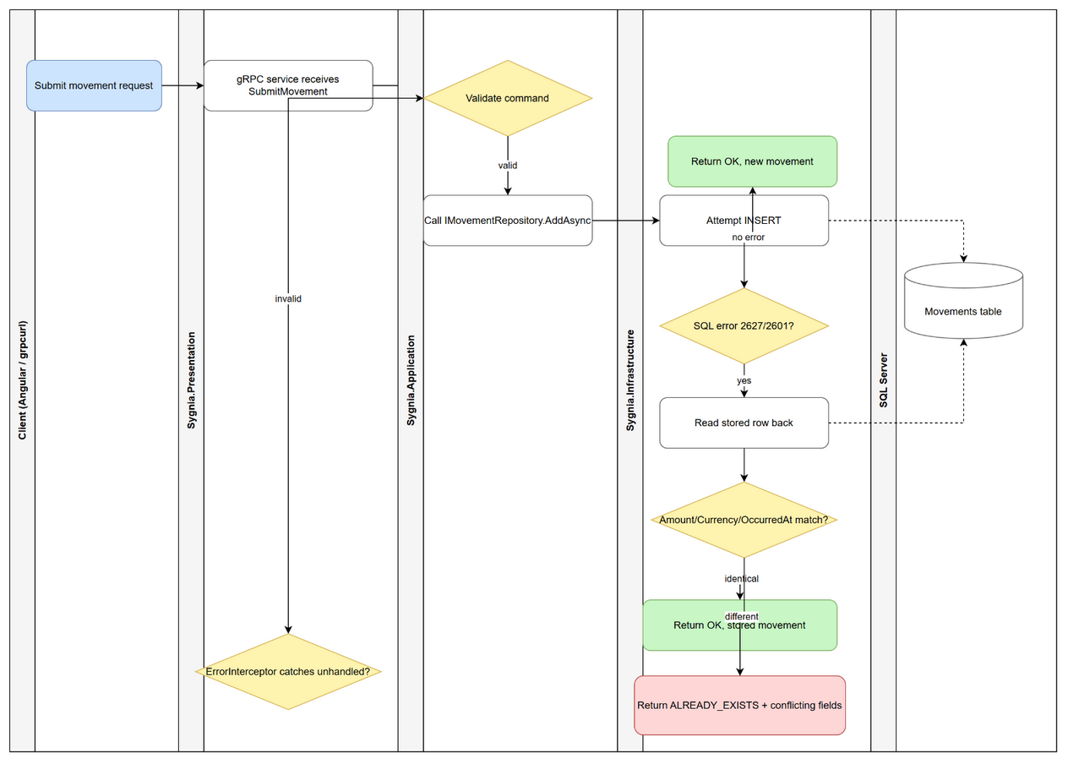

Reading order: rows correspond to swimlanes top to bottom (Client -> Presentation -> Application -> Infrastructure -> Database); within a lane, steps run top to bottom and an arrow (->) marks the next action taken.

6. Sequence Diagram — Submit Movement
This diagram shows the same SubmitMovement flow as a message sequence between the five participants, including the idempotency conflict branch on SQL error 2627/2601. An editable source file (docs/diagrams/sequence-submit-movement.drawio) is included alongside this manual.
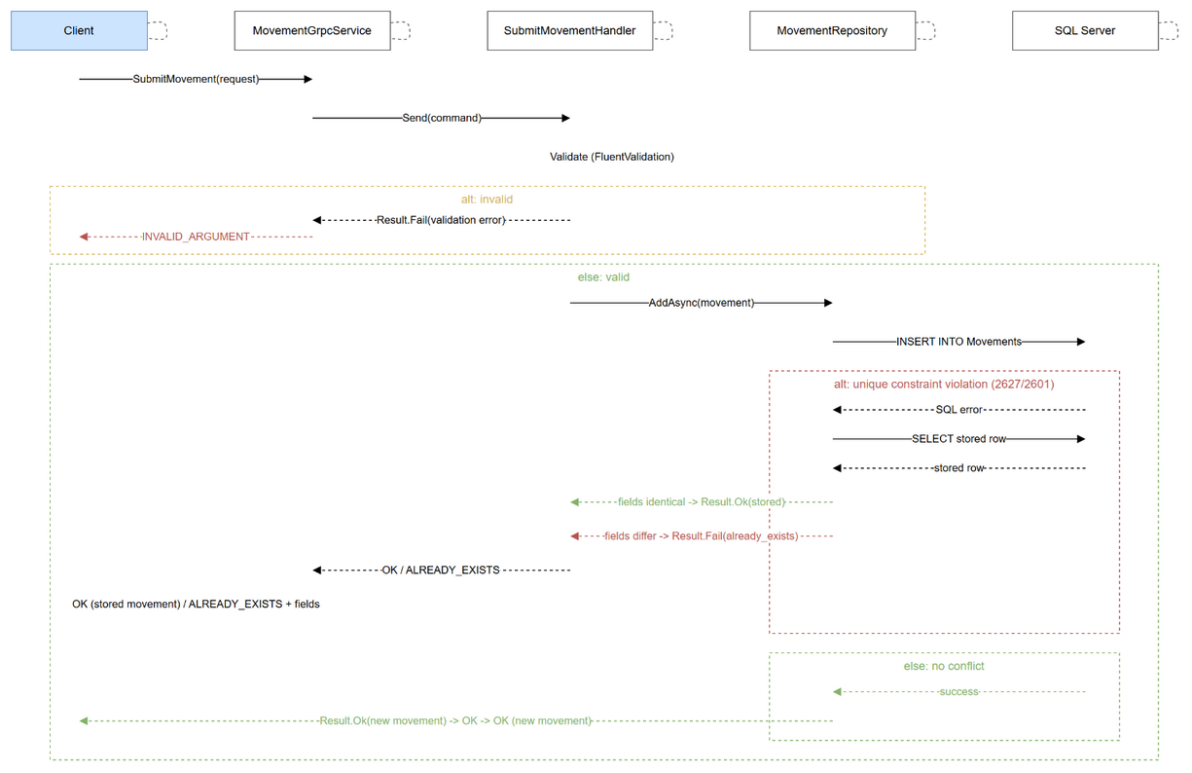

Participants, left to right: Client -> MovementGrpcService (Presentation) -> SubmitMovementHandler (Application) -> MovementRepository (Infrastructure) -> SQL Server (Database).

7. Deliberate Scope Omissions
The developer's original notes (planning.md) listed more than the assignment brief actually asks for. The following were deliberately left out of the delivered solution, each for a specific reason — not overlooked, but consciously not built:
- GitHub Pages: Originally scoped out as unnecessary for grading the assignment brief. Subsequently added back in at the developer's explicit request as a simple project landing page (see docs/index.html) — recorded as an intentional exception in docs/SOLUTION.md.
- MediatR / pipeline behaviours (root scope): Off by default across the solution to keep the dependency out of Sygnia.Domain and Sygnia.Presentation; opted back in specifically for Sygnia.Application via that project's own nested CLAUDE.md, for loose coupling between the gRPC layer and the use-case handlers.
- Materialised/running balance: Balance is computed on read via SUM(Amount), backed by an index; a pre-computed running balance was considered and documented as an alternative rather than built, since it is unnecessary at this data volume.

8. Known Limitations / Next Steps
Honest list of what a production rollout of this system would still need, in rough priority order:
- Maker/checker approval: Add a second-approver workflow before a submitted movement becomes final, so the person who initiates a transaction is never also the person who approves it.
- Secret management: Database credentials currently sit in appsettings.json for local-dev simplicity. A real deployment should use user secrets locally and a secrets manager (Azure Key Vault / AWS Secrets Manager) in the pipeline, with periodic rotation.
- Currency normalisation: Currency codes are validated as three letters but not case-normalised — "zar" and "ZAR" are currently accepted as distinct values. Flagged as a known gap rather than silently patched.
- Materialised balance: If read volume ever makes the SUM(Amount) aggregate itself the bottleneck, the documented next step is a materialised, incrementally-updated balance column.
- Batch submission / file export: Both were explicitly optional in the brief and were not built.
- WCF gateway hardening: The legacy .NET Framework 4.8 gateway currently runs with SecurityMode.None (no transport encryption, no authentication) to match the rest of the take-home's unauthenticated surface. A real deployment would use SecurityMode.Transport with Windows authentication.
- No retry/resilience policies: Neither the WCF-to-gRPC hop nor the WPF-to-WCF hop retries on failure; a single attempt is made and failure is surfaced directly to the caller.

For the full technical rationale behind every design decision summarised in this manual, see docs/SOLUTION.md in the repository.

