Abstract
A summary of planned screens and menus for scrap salvager game to be built for DAT602 assessment.
Scrap salvage game
DAT 602 Assessment project
Johan Hobbs

Brief Description
The player clicks tiles to move around – when the player moves onto a square with an item on it, they can pick the item up. Most items are “Scrap” that can be converted to materials.
The player can use the materials to craft machines or parts, and may sell machines or parts or scrap to an NPC market place, and use the funds to buy different materials or other supplies.

Main screens

1: Login Screens
User Story: the Player needs to Login:
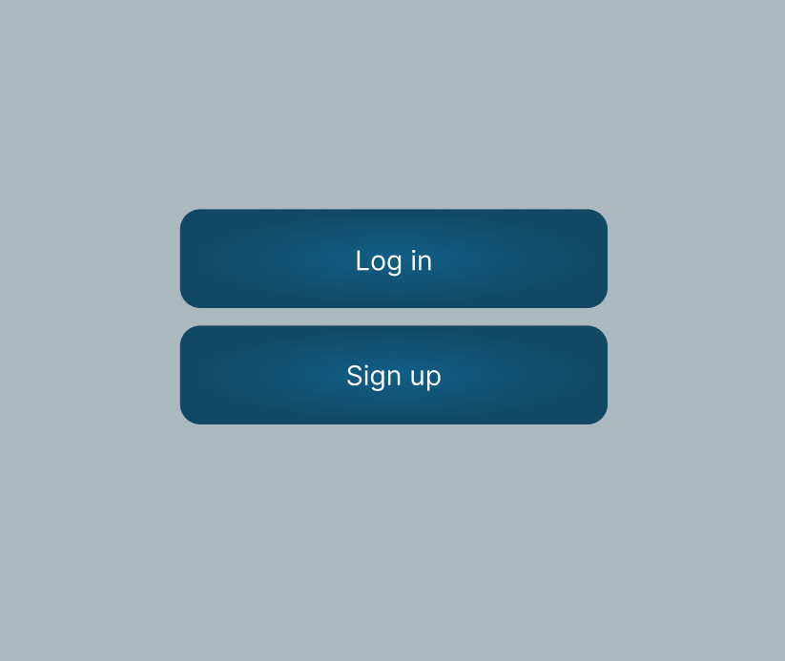Figure 1.1: Pre-login screen
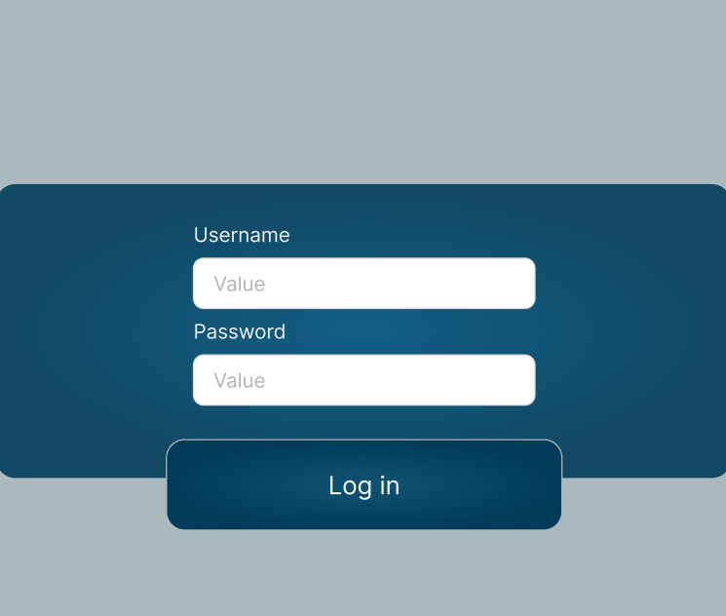Figure 1.2: Login Screen
- The Player starts on the Pre-login screen [Figure 1.1] and clicks the button labelled “log in”, which takes the player to the login screen [Figure 1.2]
- Now they are on the login screen, the Player enters their account username, enters a password, and clicks the Log in button again.
- The application sends the values entered in the username and password field to the database.
- The database runs a procedure to check for a matching username.
- If a matching username is not found, the database returns an error to the client. This is also displayed to the user, stating that the username or password is incorrect.
- If a matching username is found, the database runs a select statement, retrieving the status of the account associated with the username, the number of failed login attempts, and the user’s password.
- If the number of failed login attempts for the account is greater than or equal to the maximum, OR if the player’s account is currently suspended, the player receives an error, and is unable to log in.
- If the username exists, but the password is not the password associated with that account, the incorrect login attempts are increased by one. An error message is displayed to the user saying that the username or password is incorrect.
- If both are correct, the user is taken to the Character Select screen [Figure 1.3]. If the account’s incorrect attempts are greater than zero, they are set to zero.
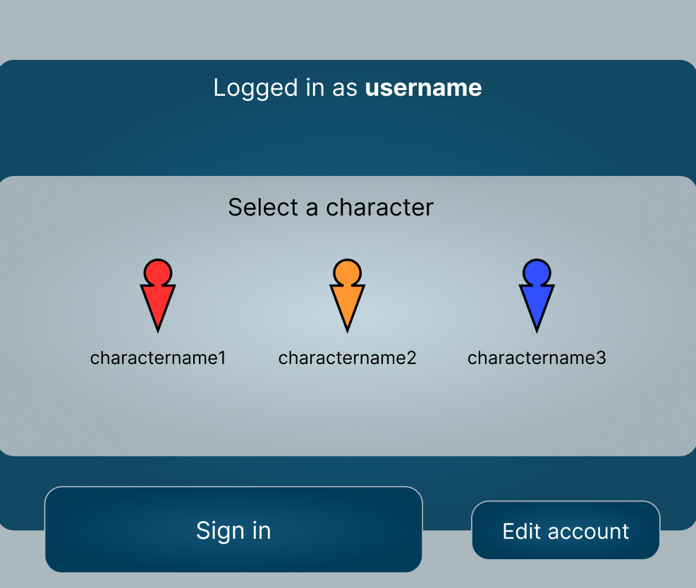Figure 1.3: Character Select Screen

User Story: Player registration:
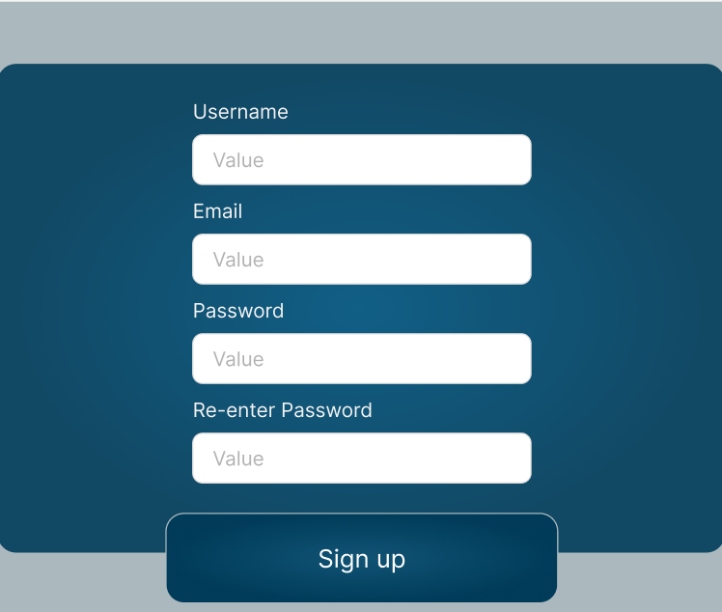Figure 1.4: Player Registration Screen
- The Player starts on the Pre-login screen [Figure 1.1]. The Player clicks the “Sign Up” button, and is taken to the Player Registration screen [Figure 1.4].
- Player enters their details in all four fields: username, email address, and desired password twice, then hits the sign up button.
- The four values are validated client side, to confirm that all inputs contain only valid characters, that the password matches the retyped password, and that the email address is formatted like an email address. If any field does not meet the requirements, an error is returned, along with a descriptive message showing what the error is.
- If there is no error in the previous step, the username and email are verified against the database. If the username or email address are already in use, an error is displayed.
- If the username and email address both passed the validation step and are not in use, and the passwords match, an account is created using the username, email address, and password specified, and the player is logged into the new account. This takes them to the character select screen, as user registration would
- In a later iteration of the game, the game may require the player to verify their account via email before taking part in some activities.
User story: Player Deletes Own account
- Player must be logged in and viewing the character Select Screen (Figure 1.4).
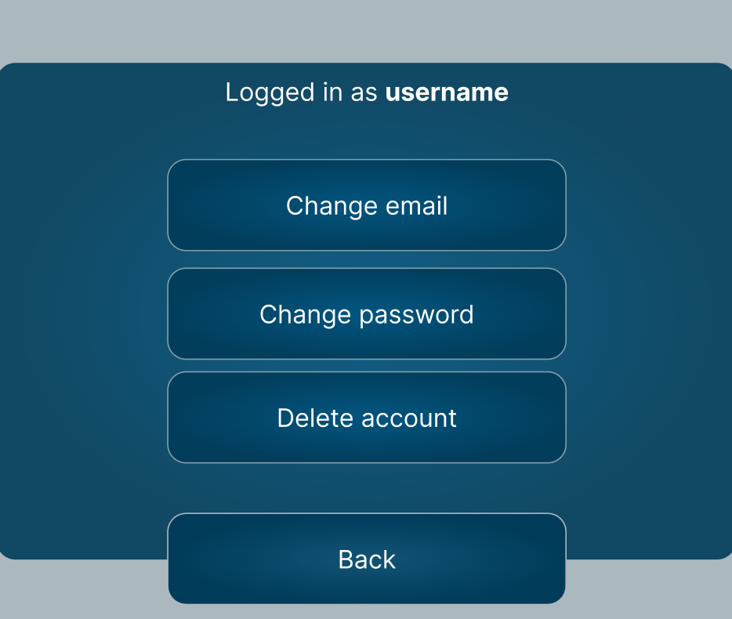Figure 1.5: Account settings menu
- Player selects the “Edit account” Button, which takes the player to the account settings menu. (Figure 1.5)
- Player selects the “Delete account” Button, causing the account deletion confirmation pop-up (Figure 1.6) to appear.
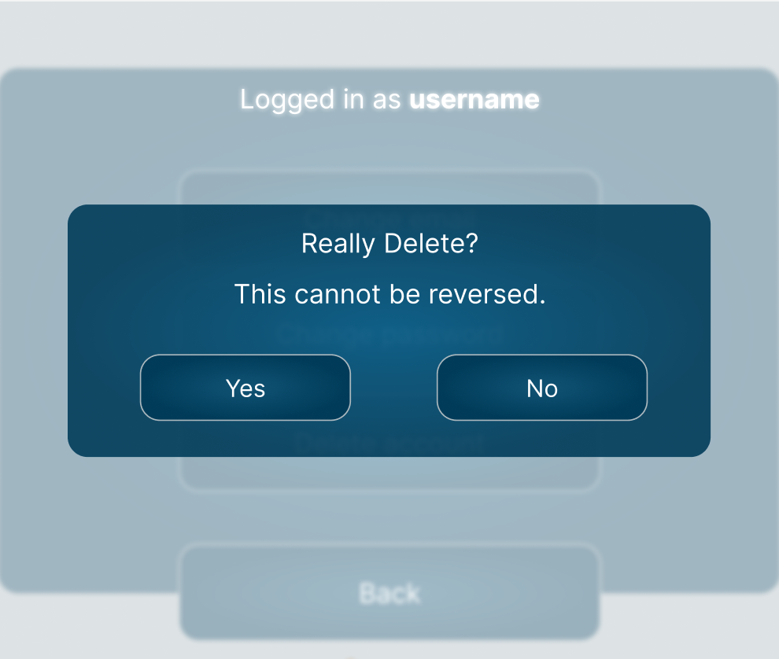Figure 1.6: Account deletion confirmation pop-up
- If the player clicks “no”, the pop-up closes, returning the player to the account settings menu.
- If the player clicks “Yes”, a message is sent to the database containing an instruction to start the deletion procedure, as well as the information required to uniquely identify the player’s account.
- The database deletes Player Characters belonging to the primary key associated with that account, running the same routine that would be run if the player was deleting those characters manually, making sure all records outside of the character table that depend on that character are deleted.
- Messages sent by this player in chat logs are modified – the contents of the message are set to whitespace, and the account name is given a primary key corresponding to a fake/system account called “deleted”.
- The account ID is removed from all group chats it was a part of.
- The account is deleted.
- The client then logs the player out of the game – the player will need to log in using a different account, or register a brand new account in order to play the game again.
 |  | Table: Account
 |  | accountID | username | password | emailaddress | failedLoginAttempts | accountstatus | suspensionStartTime
Process | Log in | - | R | R | - | C, R, U, D | R | R
Process | Register | C | R, C | C | R C | - | - | -
Process | Delete own account | R, D | D | D | D | D | D | D

 |  | Table: Player_Character
 |  | characterID | accountID
Process | Delete own account | R, D | R, D

 |  | Table: Character
 |  | characterID | name | mapID | status | currency | xPosition | yPosition | sprite
Process | Delete own account | R, D | D | D | D | D | D | D | D

 |  | Table: Player_NPC
 |  | npcID | playerID | amicability
Process | Delete own account | D | R, D | D

 |  | Table: Character_Item
 |  | characterID | itemID | quantity
Process | Delete own account | R, D | D | D

 |  | Table: Account_Chat
 |  | accountID | chatID
Process | Delete own account | R, D | R, D

 |  | Table: Message
 |  | messageID | accountID | chatID | timestamp | contents
Process | Delete own account | - | U | - | - | U

2: Map Screens

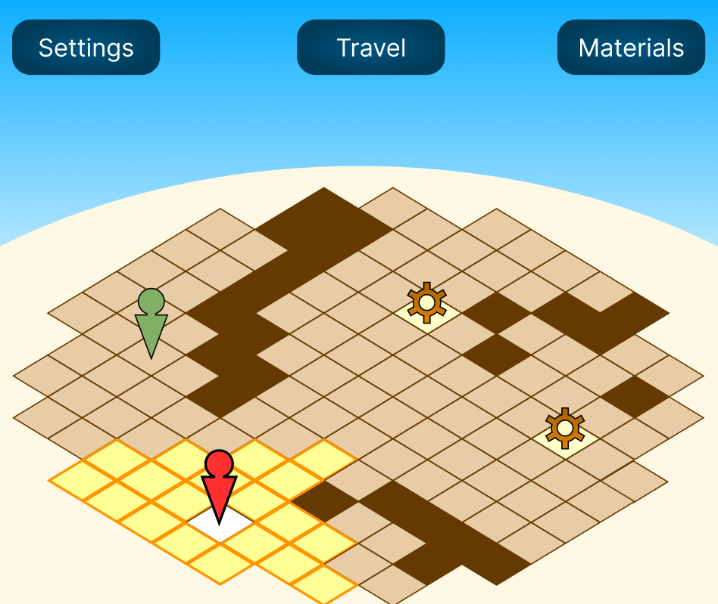
An interactive screen that allows the player to navigate around a “zone”.
The grid, and all visual assets are placeholders now, and are subject to change.
The “sky” part of the map is intended to be an aesthetically pleasing way of reserving a certain amount of screen space for UI elements.
Impassable dark tiles may be either built into the map. The player can not move onto these, but may move around them, and with the required powerups, might be able to “hop” over them.
An icon representing the player is displayed on the map, and tiles that the player is able to move to are highlighted visually. (A red arrow with a circular head is here being used to represent the player.)
When the player has moved, it ends the player’s turn, and any entities controlled by the system can move.
The player can move to a “legal” square by clicking on it.
In the example, a system entity (NPC) is represented by a green arrow with a round head. The player may interact with an NPC by moving to an adjacent tile, and the NPC may interact with a player by moving to them.
Items that can be picked up are displayed on the map as well (represented in the example by “cogwheel” images) – the player or an NPC can pick an item up by moving to an item square.

NPC interaction
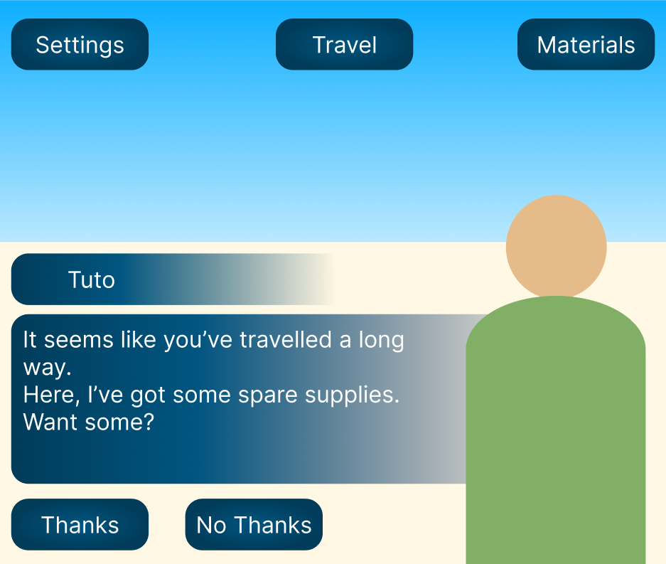
While interacting with an NPC, the NPC portrait should appear, and the NPC’s name should appear above their dialogue box.
Buttons below the dialogue box give the players options to respond.
A player’s dialogue options may have different effects depending on the interaction – for example, in this interaction, the NPC “Tuto” might give the player some resources if the player says “Thanks”.
Each NPC might have a table of potential interactions, including NPC dialogue, available player replies, and the different things that might happen if a player selects a particular option. (For example, the player may gain or lose resources, currency, or NPC friendship value, or gain an item)

Workshop Zone
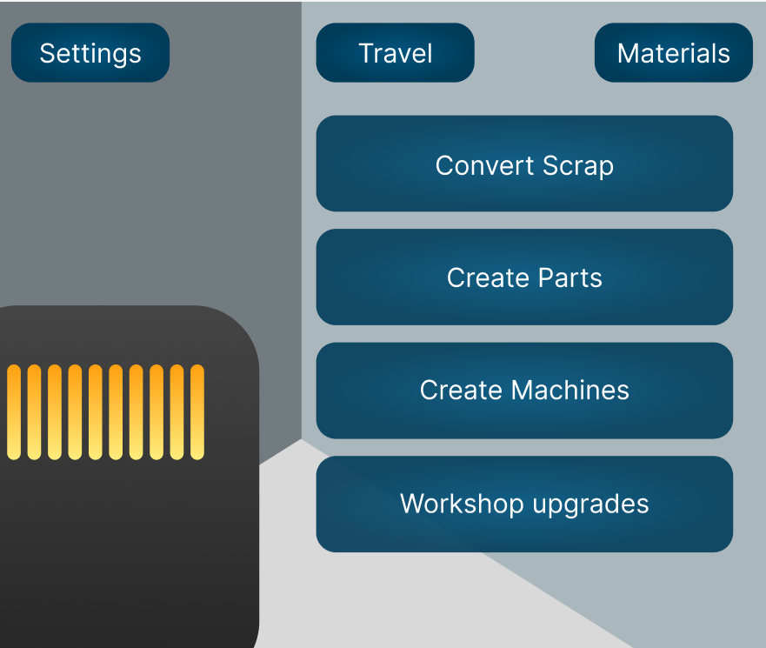
The workshop allows the player to create things from materials that they can obtain by gathering, by trading with NPCs or by

Travel Menu
A Menu that will allow the player to travel from their current location to another location – for example, from the workshop to the outdoor zone.

Settings Menu
Adjust things like window colour (Dark mode vs light mode?) difficulty

Materials menu
A list of all the materials the player currently possesses, including scrap, machine parts, complete machines, and tools. (Menu name should possibly be changed to reflect this)

Relational Database Tables

Full Entity relationship Diagram

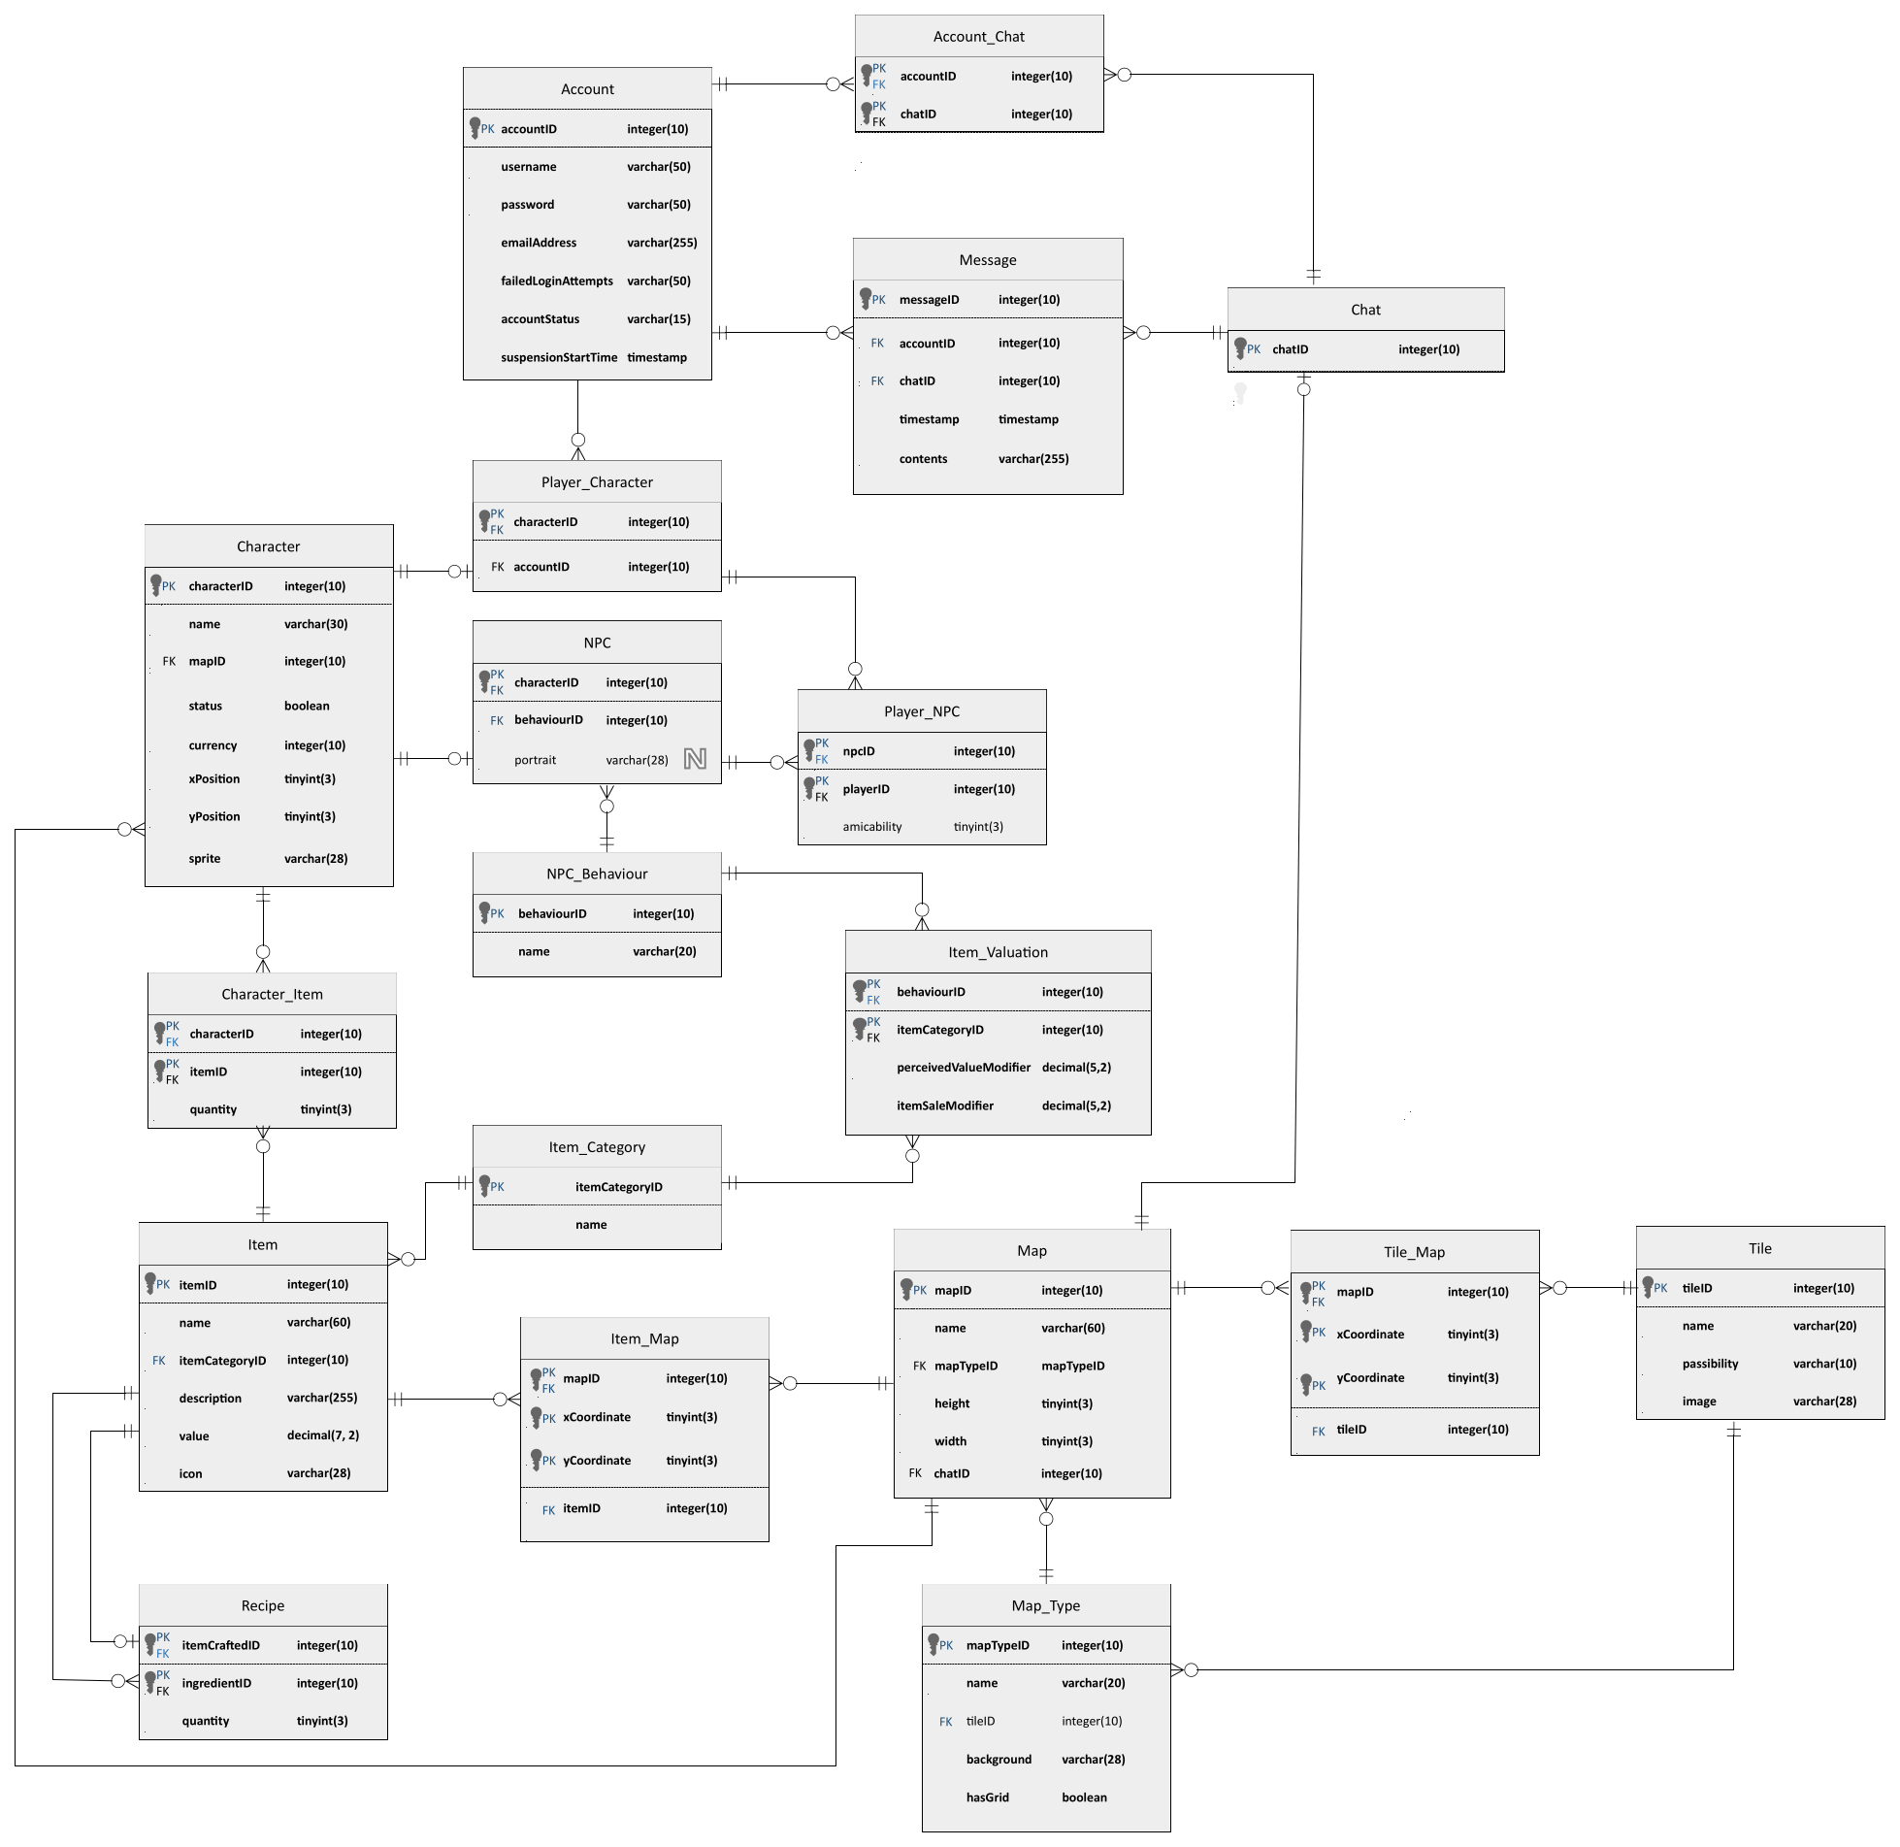

Account
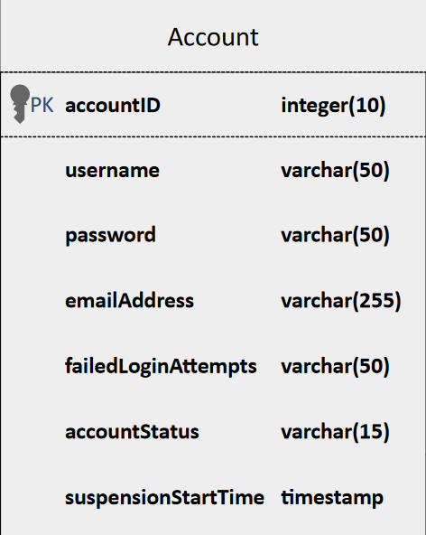
This table represents the account a user uses to play the game.
- accountID – The primary key for the Account table. As with all primary keys, mandatory and must be unique and not null.
- username – the user’s username, must be unique and cannot be null or empty.
- password – the user’s password, cannot be null or empty.
- emailAddress – the user’s email address, must be unique and cannot be null or empty.
- failedLoginAttempts – tracks the number of consecutive failed login attempts for a given user. Cannot be null, but can be zero. Will be reset to zero on a successful login.
- accountStatus – Stores a value indicating whether the account is an active account and able to play, or whether the account has been banned or suspended. Cannot be null or empty.
- suspensionStartTime – if an account has been suspended, the timestamp for the beginning of the most recent suspension is saved
Further notes: Another way to structure this database might be: account status, login attempts, and suspensions could all be moved to a seperate table, which would allow for better record keeping and a tidier data structure overall

Character
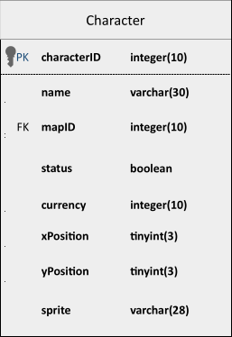
The character table is used to track and render player and non-player character entities.
- characterID – The primary key for the Character table. As with all primary keys, mandatory and must be unique and not null.
- name – the name of the character, as displayed on the User Interface. Must be unique, and cannot be null or empty.
- mapID – foreign key, indicates which map the character is on. Cannot be null or empty.
- status – indicates whether a character is currently “active” in the game – a character is either present or not present.
- currency – indicates how much of the game’s currency the character has. Can’t be null or negative, but can be zero.
- xPosition – a coordinate that is used in calculations to show the position of a player, as well as to calculate their legal movement range
- yPosition – a coordinate that is used in calculations to show the position of a player, as well as to calculate their legal movement range
- sprite – the filename of an image from the game’s files, used to represent the character on the game’s maps.

Player_Character
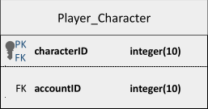
This is similar to a join table, although it only joins to one table. Connects the details specific to a player character to the “Character” table via the characterID. Most of a character’s important info is stored in the Character table.
- characterID – The primary key for the Player_Character table. As with all primary keys, mandatory and must be unique and not null. This is ALSO a foreign key – this was done to reduce duplicate structures in the database while still distinguishing Player Characters from NPCs on a table level, because while they share most of the same data there are important differences.
- accountID – Foreign key linking to the account that owns the character

NPC
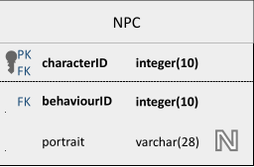
This is similar to a join table, although it only joins to one table. Connects the details specific to an NPC to the “Character” table via the characterID. Most of a character’s important info is stored in the Character table.
- characterID - The primary key for the NPC table. As with all primary keys, mandatory and must be unique and not null. This is also a foreign key.
- behaviourID – A foreign key used to identify the behaviour of an NPC. This is a foreign key that will link to the NPC_Behaviour table.

Item
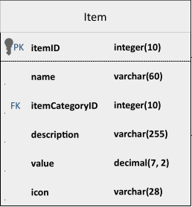
The item table records the details of every item in the game
- itemID – The primary key for the Item table. As with all primary keys, mandatory and must be unique and not null.
- name – the name of the item – this is displayed on the UI and is useful for human players to identify what item they are handline. As such, the item name should be unique, and cannot be null or empty.
- itemCategoryID – this is a foreign key linking to the item Category table. The item category will modify some of the game’s logic.
- description – a description of the item for players to read.
- value – this is the first value that the calculations determining the purchase and sale price of an item are based on when trading with an NPC.
- icon – this is a varchar indicating the name of the item’s icon in the game’s files, as it will be displayed on the user interface. For example: “item_wrench.png”

Recipe
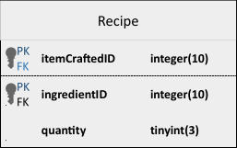
This is a form of join table, connecting the Item table back onto itself.
Each entry in the recipe table represents one ingredient used in one recipe, and the list of all entries with a single itemcraftedID represents all the ingredients used to create the specified item.
- itemCraftedID – The first of two joint primary keys for the Recipe table, representing the item created by a recipe. As with all primary keys, mandatory and cannot be null or empty. The combination of the two primary keys must be unique, but a single itemCraftedID can be repeated so long as the combination of itemCraftedID and ingredientID is unique. This is also a foreign key, representing the itemID of one entry in the Item table.
- ingredientID – The second of two joint primary keys of the Recipe table, representing the item created by a recipe. As with all primary keys, mandatory and cannot be null or empty. The combination of the two primary keys must be unique, but a single ingredientID can be repeated so long as the combination of itemCraftedID and ingredientID is unique. This is also a foreign key, representing the itemID of one entry in the Item table.
- quantity – This integer value represents how many of a specific item is required to make the item being crafted. This should default to 1 if no value is specified, and should never be null or zero.

Item_Category
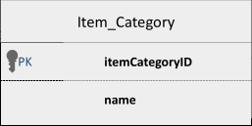
This represents the broader category an item falls into
- itemCategoryID – The primary key for the Item_Category table. As with all primary keys, mandatory and must be unique and not null.
- name – the name of the item category – displayed in the UI
This table is mostly used for internal logic and connecting other tables to each other – it doesn’t store a lot of data on it’s own, but its presence will keep things tidier overall.

Item_Map
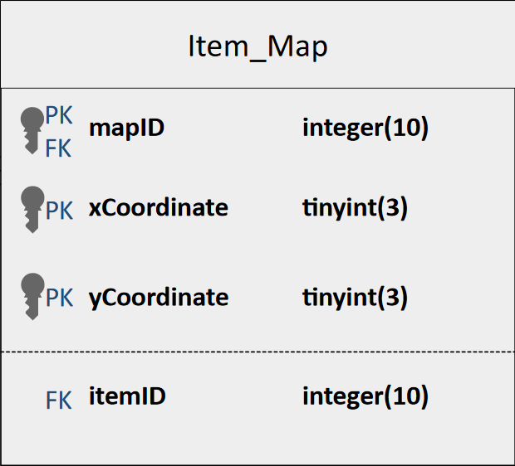
This table represents the position of a single instance of any item on any map. While this table does reference both the Map table and the Item table, I switched from my original plan of making it a normal join table with the mapID and itemID as foreign keys that are joint primary keys, to making it use the mapID and the two coordinate values as a three-way joint key. I did this because a map can have many instances of an item, but it should only have one item at any given pair of coordinates.
- mapID – the first of three joint primary keys, this represents the map the item is on. As with all primary keys, this is a required field and cannot be null. This is also a foreign key. This must be unique in combination with the other two keys.
- xCoordinate – the second of three joint primary keys, this represents the position of the item on the map in a single dimension. This cannot be empty or null, and the three primary keys must be unique in combination with each other
- yCoordinate – the third of three joint primary keys, this represents the position of the item on the map in a single dimension. This cannot be empty or null, and the three primary keys must be unique in combination with each other
- itemID – foreign key representing the item found at this position, referencing the Item table.

Character_Item
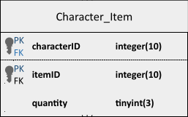
This table is a join table that represents the items in the game being carried by any character.
When viewed together, all entries with the same characterID represent the inventory of that character, and a list of all entries with the same itemID represents a list of all characters that have that item.
- characterID – joint primary key, and also a foreign key referencing the Character table. Represents the character holding a given item.
- itemID – joint primary key and also a foreign key referencing the Item table. Represents an item being held by a given character.
- quantity – a stored value representing how many items of a given type the player is holding

Player_NPC
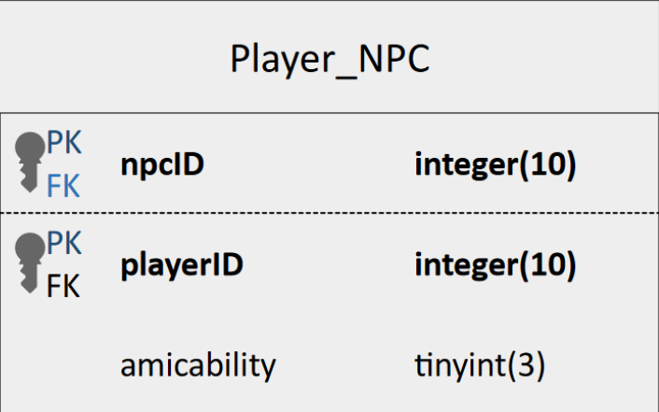
This table represents the relationship between an NPC and a player character – it’s used to track how much an NPC likes the player in question.
Since both primary keys, ultimately reference the characterID on the character table, I’ve renamed them to npcID and playerID to save confusion.
- npcID – the first of two joint primary keys/foreign keys. Cannot be null or empty, and must be unique in combination with the playerID. Actually references the characterID on the NPC table.
- playerID – the second of two joint primary keys/foreign keys. Cannot be null or empty, and must be unique in combination with the npcID. Actually references the characterID on the player table.
- amicability – how much the NPC and player get along. This is just a value that goes up if you have a positive interaction with an NPC.

Message
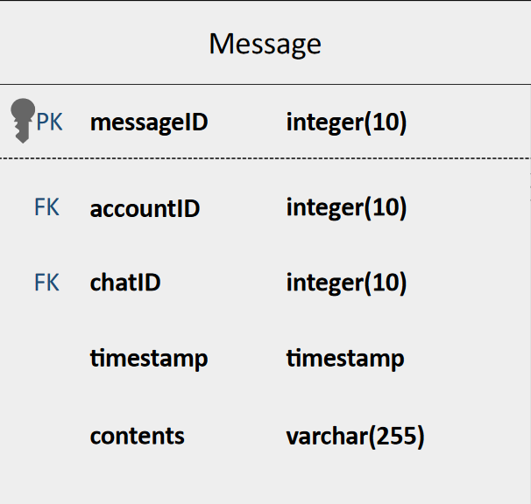
The Message table contains data on messages sent in any channel. Each entry in the message table represents a singular message
- messageID – The primary key for the Message table. As with all primary keys, mandatory and must be unique and not null.
- accountID – a foreign key that represents the account that sent the message. Mandatory, cannot be null or empty.
- chatID – a foreign key representing which chat the message is being sent to – this is a mandatory field and cannot be null or empty.
- timestamp – a timestamp indicating when the chat message was sent – this is a mandatory field and cannot be null.
- contents – a string of characters up to 255 characters, representing the contents of a message. This is, of course, a mandatory field.

Chat
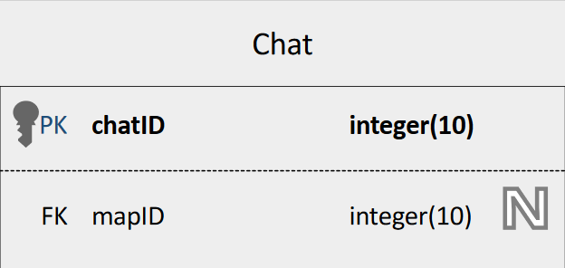
The chat table contains the chat ID, a boolean indicating whether it is a private chat or not, and links the chat to a map if appropriate.
- chatID – The primary key for the Chat table. As with all primary keys, mandatory and must be unique and not null

Account_Chat
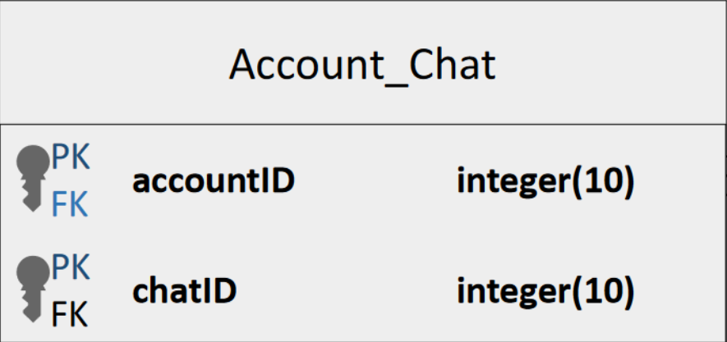
The Account_Chat table links two or more accounts to a single private chat.
- accountID – the first of two joint primary keys/foreign keys. Cannot be null or empty, and must be unique in combination with the chatID.
- chatID – the second of two joint primary keys/foreign keys. Cannot be null or empty, and must be unique in combination with the accountID.

Item_Valuation
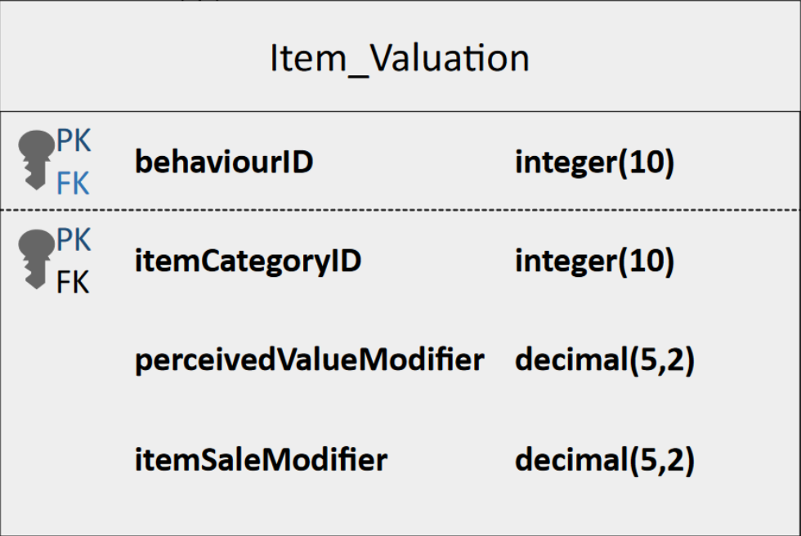
This table is a join table that models the relationships between the NPC_Behaviour table and the Item_Category table.
- behaviourID – the first of two joint primary keys/foreign keys. Cannot be null or empty, and must be unique in combination with the chatID.
- itemCategoryID – the second of two joint primary keys/foreign keys. Cannot be null or empty, and must be unique in combination with the behaviourID.
- perceivedValueModifier – this value is used in calculations which determine how NPCs with the same behaviourID will perceive the value of items with the same itemCategoryID when those NPCs are offered those items in a trade, or when they see them on the map.
- itemSaleModifier – this value is used in calculations which determine how NPCs with the same behaviourID will perceive the value of items with the same itemCategoryID when those NPCs are offering those items in a trade.

NPC_Behaviour
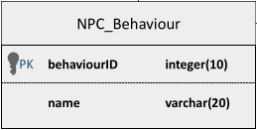
This is a table used to identify NPC behaviours. It is used as a middle point to logically join the NPC table to the item table – item valuations are connected to Behaviour rather than each individual NPC to allow the creation of multiple NPCs with the same behaviour with less work.

Map
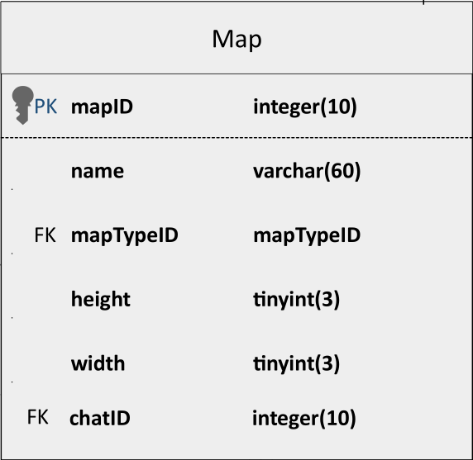
Map gives details on each individual map, including the following
- mapID – The primary key for the Map table. As with all primary keys, mandatory and must be unique and not null
- name – the name of the map, used to identify it in the user interface of the game
- mapTypeID – a foreign key referencing the Map_Type table. This indicates which map type the map should use as a template, reducing duplicate data in the table.
- height – this represents the height of the map – the map’s height is used to constrain the vertical placement of characters and items.
- width – this represents the width of the map – the map’s width is used to constrain the horizontal placement of characters and items.
- chatID – a foreign key referencing the Chat table. This links the map to the specific chat associated with it.

Tile_Map
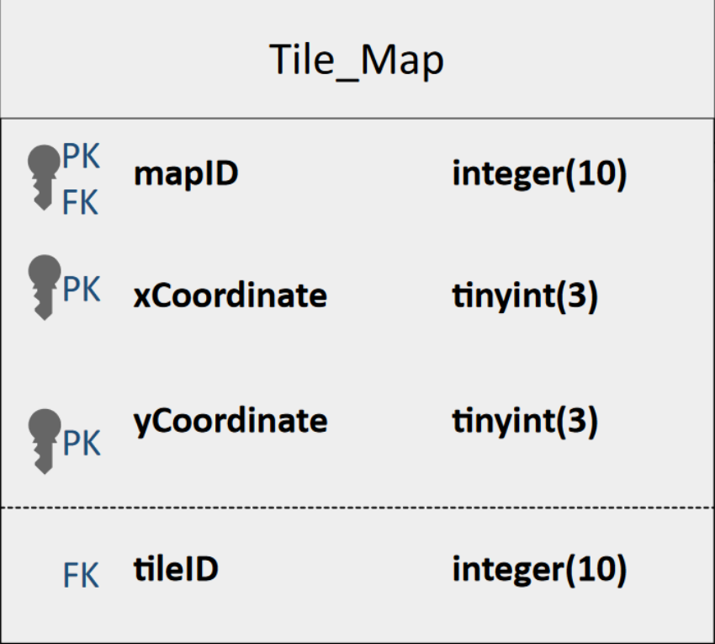
This indicates the locations and type of individual tiles as they appear on a map.
- mapID – first of three joint primary keys, foreign key connecting to the Map table. This represents the map the tile is being placed on.
- xCoordinate – second of three joint primary keys, this represents the position of the item in the horizontal axis of the map.
- yCoordinate – third of three joint primary keys, this represents the position of the item in the vertical axis of the map
- tileID – foreign key, this links to a tile table, indicating which tile to place at the designated location.
The three primary keys (mapID, xCoordinate, yCoordinate) must form a unique combination – it’s okay for many tiles to be on the same map, but if so then they must have a different x or y coordinate to do so.

Tile
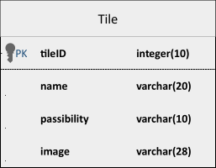
This contains the basic information on a specific kind of tile that may be reused many times across many maps.
- tileID – The primary key for the Tile table. As with all primary keys, mandatory and must be unique and not null.
- name – the name of the tile, used to make this section of the table more human readable.
- passibility – a string (varchar) indicating how the tile affects player movement. For example, a tile might be passable, might represent a wall that can’t be moved through, or might represent a hole in the ground that can be hopped over but not “stopped on”.
- image – the filepath to the image that the game should load when displaying this tile within the games files.
This table could be slightly more normalised by moving “Passibility” into an external table and using a foreign key here instead of a varchar – I’ve chosen not to do this in order to reduce the total number of tables because I’m trying to avoid massive scope creep, but if I was making this project on a larger scale, I probably would do it that way instead of using the simplified approach I have chosen for this project.

Map_Type
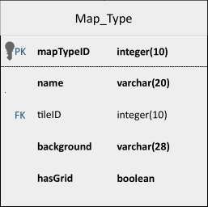
The Map_Type table forms a template for data that may be reused to create many maps with similar properties. This allows new maps to be created more quickly, and means the map table no longer needs to store a lot of repeated data.
- mapTypeID – The primary key for the Map_Type table. As with all primary keys, mandatory and must be unique and not null.
- name – The name of the map type, for the purpose of making the table more human readable
- tileID – Foreign key, links to the Tile table. This indicates which tile should be used as the “default” tile for maps of this type where no other tile is specified.
- background – the filepath to the image within the games files that the game should load when displaying this background for maps of this type.
- hasGrid – a boolean value indicating whether this is a normal map that has a grid, or a “special” map, which won’t display the grid at all.

