HeadsetPresenter for Beginners

Introduction
The HeadsetPresenter is a true value adder for anyone wanting to use their Bluetooth headset for more then talking. However since the combinations of Headsets and Bluetooth USB adaptors are endless the functionality offered by the HeadsetPresenter might depend on what Headset and what dongle the end user owns.
This document will give a brief overview on how to use the HeadsetPresenter, more information can always be found on www.headsetpresenter.com.
Table of Contents
Introduction 2
1 Installing the application 4
2 Connecting your Headset to the computer 7
2.1 Microsoft Bluetooth stack 7
2.1.1 Pairing a Headset to the computer 7
2.2 Widcomm/ Broadcomm Bluetooth stack 10
2.2.1 Normal mode 10
2.2.2 Advance mode 12
2.2.3 AVRCP support 14
2.3 Toshiba Bluetooth stack 14
2.3.1 AVRCP support 15
2.4 BlueSoleil 15
3 Adding or changing an application 16
3.1 Change application behavior 16
3.2 Adding a new application 17
3.3 Command syntax 18
3.3.1 Advanced key configurations 18
4 HeadsetPresenter Speech 21
4.1 Changing the commands 22
5 FAQ 24
5.1 HeadsetPresenter does not find my PowerPoint window. 24
5.2 COM port failure with BlueSoleil software 25
5.3 Connection lost 26
5.4 BlueSoleil Service Search fails 27
5.5 Double movement problem 28
6 Licensing 29

- Installing the application
Installation of the HeadsetPresenter is very simple. If you have received the application on a CD just insert the CD and the installation program will start. If you have downloaded the program from the Internet just double click on the Setup.exe icon and the installation program will start.
Note: You must have necessary user permissions to install applications on your computer. If installation fails contact the IT support responsible for your Windows installation.
If PowerPoint is running close it down before continuing with the installation.
1. First of all the welcome screen is displayed, simply press Next to continue.
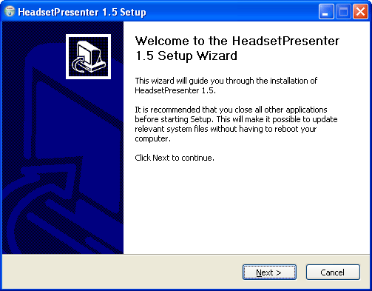
The first windows of the installation program.
2. Secondly the license agreement window is displayed. If you accept the licensing terms click on the “I accept the terms in the License agreement” and then Next to continue.
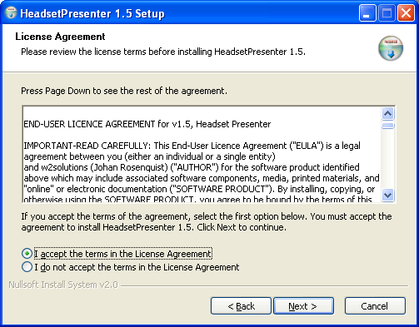
The license agreement window.
3. Third you are prompted for an installation directory. The default path is the Program Files folder with the subfolder HeadsetPresenter. Click Install to continue with the installation.
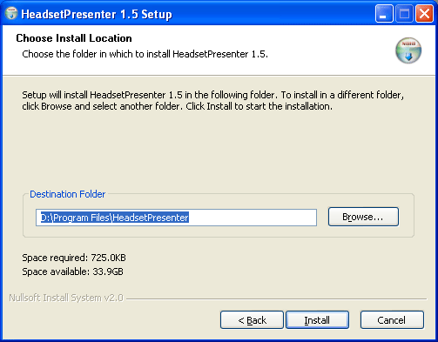
The path selection window.

4. Finally the installation complete window is displayed and the HeadsetPresenter is installed.
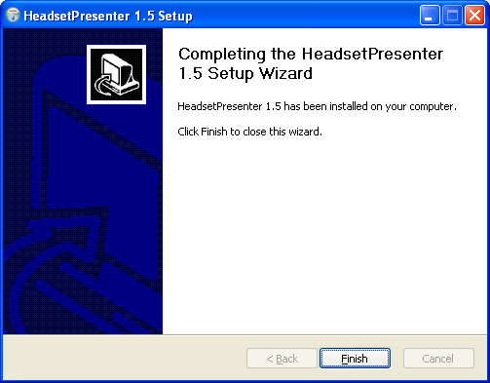
The installation completed window.
5. Now you have a new application on your Start Menu as usual.
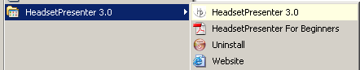

- Connecting your Headset to the computer
Depending on which Bluetooth stack your PC has installed some parts of the HeadsetPresenter looks slightly different. This mostly affect the pairing procedure (when connection your headset to the computer). This chapter is divided into several parts depending on the stack you have installed on your computer.
  - Microsoft Bluetooth stack
The Microsoft Bluetooth stack was introduced in Windows XP SP2. It is also available in Windows Vista but at the time of writing it has quite limited functionality. Speech recognition and AVRCP are not supported when using the Microsoft stack.
    - Pairing a Headset to the computer
- The first time you start the HeadsetPresenter you will need to go through the wizard.
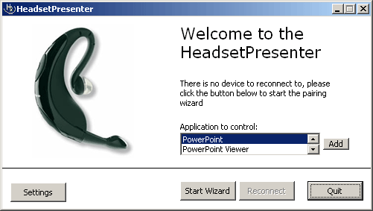
When the “Start Wizard” button is clicked you will first be asked to select which mode to use. The Microsoft drivers only support Normal mode so the selection is easy. Click the Next button and the Microsoft pairing guide will start.
- Put you Headset in pairable mode. Usually this is done by pressing and holding the Connect button of the Headset until a lamp either starts blinking or shows a constant light.
- Check the “My device is set up and ready to be found” box and click Next.
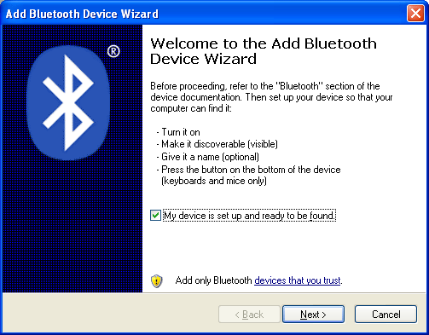
Microsoft Version pairing wizard page 1
- The wizard will search for devices and if your Headset is in pairable mode it will appear under Audio devices as on the screen below. Select the device you want to use and press Next.
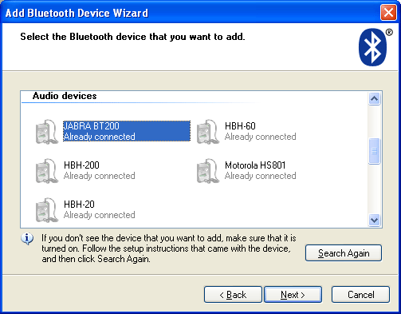
Microsoft Version pairing wizard page 2
- Enter the PIN code for your Headset. Most models use 0000 but for instance Nokia has a unique pin code for each Headset. Press Next to continue.
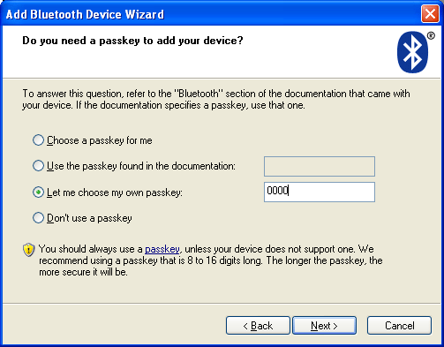
Microsoft Version pairing wizard page 2
- If the Headset is configured correctly and the correct PIN code is entered the wizard will be completed and the following screen will be displayed.
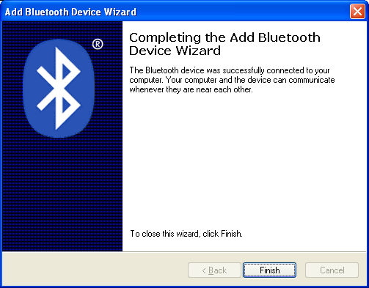
Microsoft Version pairing wizard complete page
- The Wizard will now continue to the next step where the capabilities of your headset are tested.
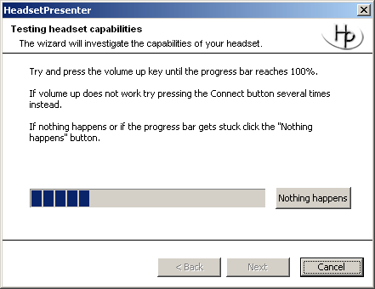
First try pressing the volume up button a few times and see if the progress bar moves at all. If the volume button did not work you headset do not support this feature and the connect button must be used instead. If that is the case, try pressing the connect button until the progress bar reaches 100%.
- When the test is completed the wizard is finished and the main screen of HeadsetPresenter will be displayed informing that the HeadsetPresenter is active and which application it is controlling. Just start this application and the commands that are configured will be sent to the active application.
- When you are done using the HeadsetPresenter preferably use the Quit button to disconnect the headset and exit the application.
- See chapter 3 for instructions on how to use the HeadsetPresenter once the wizard is completed.
  - Widcomm/ Broadcomm Bluetooth stack
If you have a Widcomm Bluetooth stack installed the HeadsetPresenter can operate in two modes. Normal mode and Advanced mode. The functionality in the two modes differs slightly and this is explained below.
    - Normal mode
In normal mode HeadsetPresenter has full control of the connection to your headset. A custom user friendly guide is offered to assist with paring the headset and the HeadsetPresenter will take care of the disconnection once the application is shut down. In normal mode an audio connection to the headset is not used which means that battery consumption is insignificant. The drawback is that normal mode might offer less functionality then advanced mode.
- Click the “Start Wizard” button and you will be presented with the Choose Mode dialog. If Widcomm drivers are installed you will have two selections, choose Normal mode.
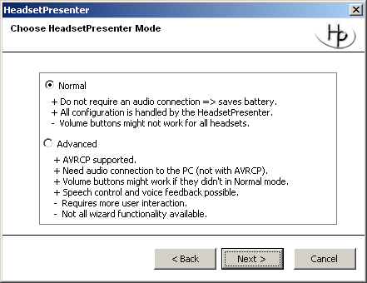
- The pairing dialog is displayed. Make sure your headset is in pairable mode and click the “Start Search” button.
- Select your headset from the list.
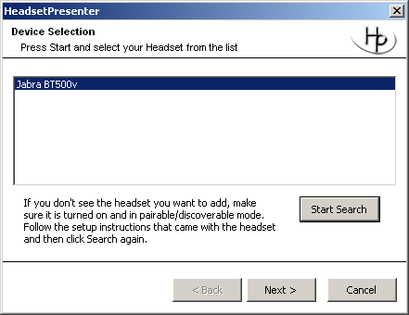
- The wizard continues with the headset capabilities dialog. Start by clicking the volume up button a few times to see if your headset supports control with the volume buttons. If that does not work click the connect button until the progress bar reaches a 100%. Click next to continue. If there is no reaction on the volume buttons your headset do not support this feature. Volume buttons might however work in Advanced mode.
- When the test is completed the wizard is finished and the main screen of HeadsetPresenter will be displayed informing that the HeadsetPresenter is active and which application it is controlling.
- When you are done using the HeadsetPresenter preferably use the Quit button to disconnect the headset and exit the application.
- See chapter 3 for instructions on how to use the HeadsetPresenter once the wizard is completed.

    - Advance mode
In advanced mode the HeadsetPresenter do not offer a paring dialog, when the “Start Wizard” or “Reconnect” button is pressed you will be asked to connect the headset by using the applications offered by Widcomm.
- Put you Headset in pairable mode. Usually this is done by pressing and holding the Connect button of the Headset until a lamp either starts blinking or shows a constant light. If your Headset already is paired to your computer you can skip these steps.
- Right click on the icon in the lower right corner of the desktop. Select Quick Connect and Headset.
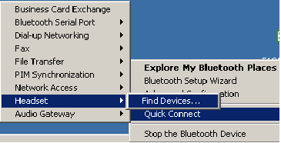
Quick connect to a Headset
- If the device is not already available click “Find Devices”.
- When the Headset is discovered, select it and press Connect.
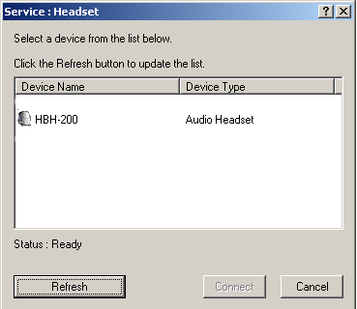
Finding a Headset
- If you are prompted for a PIN code, enter the PIN of the Headset to continue. Most often it is 0000 but for instance Nokia uses a unique PIN for each Headset.
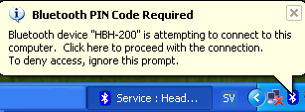
PIN code prompt
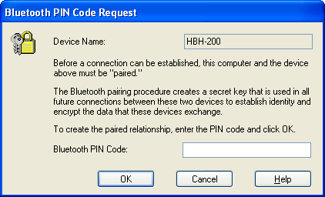
PIN code dialog
- You will now hear a ring tone in your Headset, answer by pressing the Connect button.
- When the Headset is connected the Bluetooth icon will turn green.
- The headset capabilities dialog will start. Try pressing the volume up button and see if the progress bar reaches all the way up. There is a possibility that the progress bar will stop just before the end. That means your headset cannot move in both directions. You have to use the volume up button until it stops working then switch to volume down and when that stops working switch to volume up again. This is a limitation in the headset and it is explained in detail in chapter n.
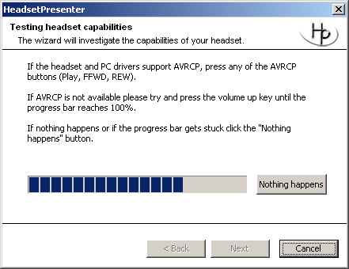
In advance mode be careful when pressing the connect button, it will disconnect you headset and usually the volume buttons have no effect when disconnected, you have to press connect again to establish an audio connection and reactivate the volume buttons.
- Depending on your Headset you might not have to pair the Headset to the computer the next time you want to use HeadsetPresenter. If the Headset stores the information you only have to set up the audio connection, either from the “Quick Connect” menu or from the Headset by clicking the Connect button.
    - AVRCP support
In advanced mode AVRCP is supported. AVRCP is short for Audio Video Remote Control Profile. Note that both your headset and your PC stack must support AVRCP for this feature to work. If you can control your Media Player with your AVRCP headset then you can control any application with AVRCP and HeadsetPresenter as well. You need to go through the pairing steps as for a normal headset but then it should be enough just to click the AVRCP buttons without having an active audio connection to the headset.
  - Toshiba Bluetooth stack
HeadsetPresenter is primary designed for use with Microsoft or Widcomm Bluetooth stacks. However has been tested on other stack as well but performance and stability cannot be guaranteed.
- The first time you run HeadsetPresenter click the “Start wizard” button to start the wizard dialog.
- The Toshiba stack only support advanced mode so just click next in the mode selection dialog.
- The first time starting HeadsetPresenter you must restart the computer. This is mandatory in order for HeadsetPresenter to finish the installation. It will not work at all before this is done. The restart is only needed the first time HeadsetPresenter is started in Advanced mode.
    - AVRCP support
In advanced mode AVRCP is supported. AVRCP is short for Audio Video Remote Control Profile. Note that both your headset and your PC stack must support AVRCP for this feature to work. If you can control your Media Player with your AVRCP headset then you can control any application with HeadsetPresenter as well. You need to go through the pairing steps as for a normal headset but then it should be enough just to click the AVRCP buttons without having an active audio connection to the headset.
The Toshiba stack might require that you manually activate support for AVRCP this is done in the Settings menu as shown below.
It is also recommended that the information window is never shown.
  - BlueSoleil
To be written.
- Adding or changing an application
Start by clicking the Add button in the main dialog.
  - Change application behavior
Each application is configured with a simple text block like this one:
ApplicationName : PowerPoint
WindowMatch : StartMatch
GrammarFile : HPGrammar.xml
VolumeUpButton : n
VolumeDownButton : p
ConnectButton : n
PlayButton : b
StopButton : {ESC}
PauseButton : b
FFWDButton : n
REWButton : p
The exact meaning of each element is explained in the next subchapter “Adding a new application”.
The three lines VolumeUpButton, VolumeDownButton and ConnectButton are the standard buttons available on a normal headset.
If the headset supports AVRCP (Audio Video Remote Control Profile) it will also have buttons for Play, Pause, Stop, FFWD and REW. These are the last five elements in the list and obviously they only apply for headsets supporting AVRCP.
If you headset supports the volume buttons in normal mode then you can reconfigure the connect button to do something else in PowerPoint since in the default configuration it will also move to the next slide “n”. Just replace the ConnectButton : n with ConnectButton : b and when the connect button is pressed PowerPoint will show a black screen instead. Click OK and restart HeadsetPresenter to activate the change.
  - Adding a new application
HeadsetPresenter sends virtual key presses to the defined application window. In PowerPoint for instance pressing “n”, “space” or “right arrow” while giving a presentation will move to the next slide. HeadsetPresenter only needs to know the name of the window you want to send commands to and what command that should be sent.
- Identify the window name simply by looking at the top of the window.
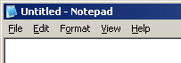
If we take Notepad as an example all notepad windows are named filename – Notepad. HeadsetPresenter must identify this window. This is done with the parameters ApplicationName and WindowMatch. Application name is obvious, we set that to Notepad. WindowMatch however tells HeadsetPresenter how to use the application name to find the correct window. Three values are possible for WindowMatch:
StartMatch - The target window text need only start with the same text as the WindowTitle, and is not case sensitive.
ExactMatch - Target application text must match WindowTitle in both content and case.
PartialMatch - The target window text need only contain the WindowTitle text somewhere within it, and is not case sensitive.
In the Notepad example this would correspond to:
  - StartMatch : Notepad must be the first word in the window name. This will not work here since filename is the first word(s) in the window name for Notepad.
  - ExactMatch : ApplicationName must exactly match the name of the window. Since we most likely do not know the exact name of the Notepad window including the name of the currently opened text file this is useless here. It would work with for instance Windows Media Player.
  - PartialMatch : ApplicationName must be found somewhere in the name of the window. This works for us since Notepad can be found somewhere in the window name.
  - Command syntax
Commands are not limited to only simple letters like n or b. As a matter a fact long sequences of commands including delays and more can be sent to the application. The most useful modifiers are:
Shift Key +
Ctrl Key ^
Left Alt Key %
Right Alt Key (Alt Gr) !
So using the line ConnectButton : ^o would start the File Open dialog in our Notepad example.
    - Advanced key configurations
Support is not offered for the advanced features since not all of them has been fully tested.
Function Keys
Function key definitions are enclosed within braces, keys from F1 to F24 are represented by:
{F1}...{F24}
State Modifiers
Shift Key +
Ctrl Key ^
Left Alt Key %
Right Alt Key (Alt Gr) !
Prefix any key definition with the appropriate modifier to affect the key press immediately following it e.g. +ab will result in the key strokes Ab being directed to the application.
To extend the modifier to affect a group of characters enclose them in parentheses e.g !(ab) will result in AB being simulated. Parentheses may be nested so that !(+(ao)) will give ÁÓ.
To simulate the press and release of a modifier key then the key symbol must be the only character in the Keys string.
Numeric Keypad
Numeric keypad keys are enclosed within braces.
0 to 9 {NUMPAD0}...{NUMPAD9}
- {NUMPAD-} or {NUMPADSUBTRACT}
+ {NUMPAD+} or {NUMPADADD}
/ {NUMPAD/} or {NUMPADDIVIDE}
* {NUMPAD*} or {NUMPADMULTIPLY}
. {NUMPAD.} or {NUMPADDECIMAL}
Navigation Keys
Navigation keys are enclosed within braces.
Enter {ENTER} or {RETURN} or ~
Newline {NL} or {NEWLINE}
Cursor Down {DOWN}
Cursor Up {UP}
Cursor Left {LEFT}
Cursor Right {RIGHT}
Page Up {PGUP} or {PAGEUP} or {PRIOR}
Page Down {PGDN} or {PAGEDOWN} or {NEXT}
Delete {DEL} or {DELETE}
Backspace {BS} or {BKSP} or {BACKSPACE}
Home {HOME}
End {END}
Tab {TAB}
Formfeed {FF}
Delay
A delay may be introduced into the key stream by using:
{SLEEP n}
where n is a numeric value representing a number of milli-seconds to wait. Note: the PushInfo.KeyDelay pause is ignored following a {SLEEP} key.
Direct Entry
A key code may be entered directly in the form:
{\nnnn}
where nnnn represents the Alt-Numeric keypad keys used to generate the character.
Note: Normally this option is not needed as characters may be entered directly into the Keys string. See example
Other Keys
This section includes the method to send reserved keys: !,%,^,+,~. See example
Bell {BELL}
Break {BREAK}
Caps lock {CAPS} or {CAPSLOCK}
Escape {ESC} or {ESCAPE}
Help {HELP}
Insert {INS} or {INSERT}
Number lock {NUMLOCK}
Printscreen {PRINTSCREEN} or {PRTSC}
Scroll lock {SCROLLLOCK} or {SCRLK}
Pause {PAUSE}
Cancel {CANCEL}
Left Windows key {LEFTWIN} or {START}
Right Windows key {RIGHTWIN}
Applications key {APPS} or {CONTEXT}
Left brace {{}
~ {~}
+ {+}
% {%}
^ {^}
! {!}
Multiple Keys

To output a series of key presses multiple times they should be enclosed in braces and terminated with a numeric value following a space.

- HeadsetPresenter Speech
In advanced mode it us possible to control any application with voice commands. This is activated in the Settings menu.
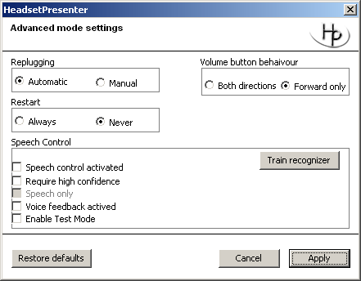
Speech control activated : Activates Speech control.
Require high confidence : When the speech recognizer has been trained this should be enabled to limit the risk of false recognitions.
Voice feedback activated : When this is active a voice will speak in the headset when a command is executed.
Enable Test Mode : When test mode is enabled a dialog box will pop up whenever a command is recognized.
It is possible to define a unique grammar for each application. The default grammar is called HPGrammar.xml and supports the commands below to control PowerPoint.
Presentation move forward | Moves forward one slide.
Presentation move backward | Moves back one slide.
Presentation move to last slide | Moves to the last slide in the running presentation.
Presentation move to first slide | Moves to the first slide in the running presentation.
Presentation command black | Makes the screen black.
  - Changing the commands
The available commands are described in HPGrammar.xml available in the HeadsetPresenter folder. The text to be recognized may be changed but make sure to make a copy of the HPGrammar.xml file first since the grammar parser is very sensitive to errors.
The grammar file looks like this:
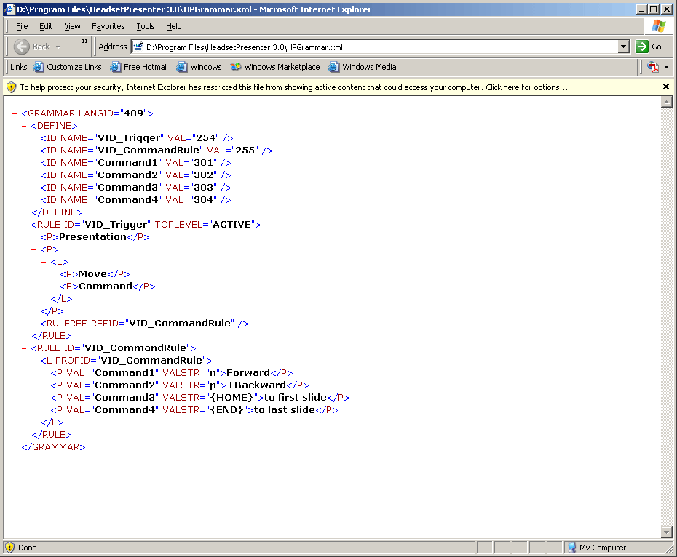
There is two rules, one called VID_Trigger and one called VID_CommandRule. The Trigger rule starts with the word “Presentation”. The idea with this keyword is to select something that is not commonly used in your presentation. If this would be skipped and we only used “Move forward” instead of “Presentation move forward”, the sentence “It is now time for this company to move forward” would advance the presentation one step since it is a valid command.
You can change the keyword to something even more unique of you wish as long as it is not so strange that the recognizer does not recognize it.
The next xml element is a middle word here set to, “Move” or “Command” also these words can be altered. You can even remove one of them or add a new one if you please.
Finally we get to the actual command, here forward backward, to first slide and to last slide. Also these words can be changed and the command to execute is contained in the VALSTR= field.
A more detailed guide will be written in time.
- FAQ
  - HeadsetPresenter does not find my PowerPoint window.
This is valid for any application not only PowerPoint.
HeadsetPresenter sends commands directly to the application window for instance the PowerPoint presentation window. In order to do that HeadsetPresenter must know the name of the window. HeadsetPresenter comes preconfigured with settings working with the English version of the programs. However in some countries window names have been changed to the local language.
This is very simple to fix:
- Find out the name of the window. This is explained in detail in a previous chapter but here an example is given for PowerPoint in particular. Normally it is enough to just read the header of the window, like with Notepad below.
However we want the presentation window of PowerPoint it does not have a header since it has no frame. To find out the PowerPoint presentation window name hold the keys Alt+Tab and a list of small icons will appear showing all windows currently opened. Hold the Alt key and press Tab until the PowerPoint presentation window is selected. Note the name of this window, in Italian it would be something like “Prezentatione di PowerPoint – [name of the presentation].
- Click the Add button in the main screen of HeadsetPresenter and this window will appear:
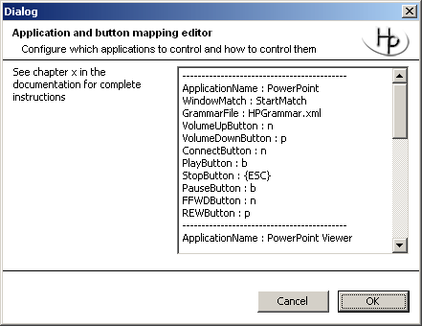
- Change the application name from PowerPoint to the name of your PowerPoint presentation window, in our example it would be “Prezentatione di PowerPoint”. Do not include the name of the current presentation since that will change between each time you give a presentation.
- That’s it, just restart HeadsetPresenter and you should be good to go, otherwise contact support.
- If you encounter this problem with a local PowerPoint name. Please email info@headsetpresenter.com with the information about the local name so it can be introduced in HeadsetPresenter. Then next time this happens HeadsetPresenter can handle the local name automatically.

  - COM port failure with BlueSoleil software
After successful pairing there is an error message stating that COMn could not be opened:
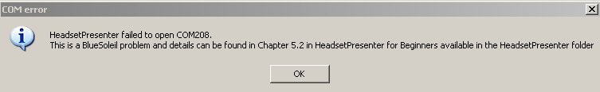
At the time of writing this the cause of this problem is not resolved. BlueSoleil has been contacted. It only happens on some computers and when looking in the DeviceManager the following can be seen for the COM ports:
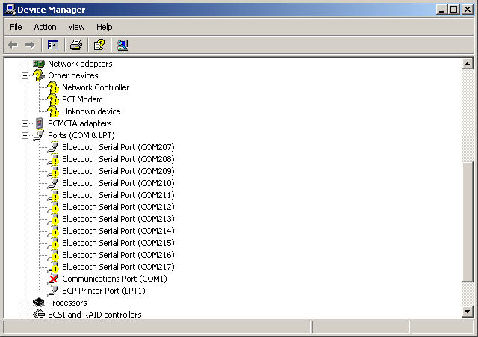
The driver failed to load for almost all COM ports including the one BlueSoleil tried to connect to. This is an issue within Windows and the BlueSoleil drivers and out of control for the HeadsetPresenter. Feel free to contact support to share your comments if you have this problem.
  - Connection lost
Sometimes the connection between the headset and the computer is lost. This can be for any number of reasons from low battery power to the headset being out of range.
Some headsets however will disconnect automatically if there is no data transmitted to or from the computer. HeadsetPresenter has a feature called KeepAliveTimer that when enabled will send some nonsense data to the headset at regular intervals to keep the connection alive.
If the connection is always lost try adjusting the KeepAliveTimer it is available in the Settings menu. A reasonable value should be around 1 second = 1000ms.
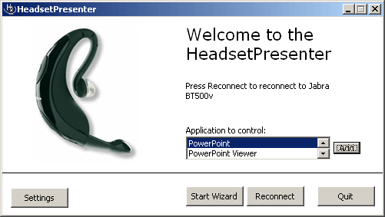
- Click on the Settings button.
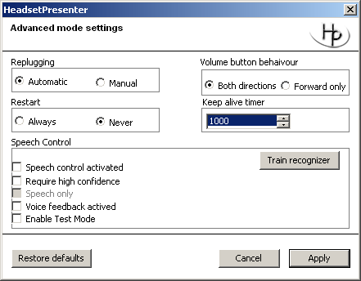
- Change the KeepAliveTimer value.

  - BlueSoleil Service Search fails
The programming interface provided by BlueSoleil is very limited and has not been updated in several years so there are some issues.
One issue is that for some devices it is not possible to perform a service search on the remote device and this is necessary to establish a connection.
Solution:
It appears that this problem disappears if you perform a service search through the BlueSoleil user interface prior to using HeadsetPresenter. Perform these steps once and then retry running the HeadsetPresenter wizard.
- Open the BlueSoleil user interface.
- If your Headset is not already shown in the window, double click the “sun” in the middle to perform a device search.
- Right click on your headset and select “Refresh Services”.
- BlueSoleil is now hopefully aware of the services provided by your headset and hopefully the service search from HeadsetPresenter will return with the information already known by BlueSoleil.
- It appears as this procedure might need to be executed from time to time if BlueSoleil does not remember the services of the headset.
- If this does not work Advanced mode is an option that is also available for BlueSoleil. Advanced mode will not suffer from these limitations.

  - Double movement problem
At least one headset model the Plantronics 220 sends double commands when clicking the volume buttons. This is a strange behavior in the headset but HeadsetPresenter offers a workaround for this. Since it is a rare problem the workaround must be manually activated. Follow these simple steps:
- Locate your HeadsetPresenter installation folder. Typically it is found under C:\Program Files\HeadsetPresenter 3.5\
- In that folder there is a text file called HPSettings.txt. Double click on this text file to open it in Notepad.
- Towards the end of the file there is a line that looks like this:
BlockDoubleClicks=0
Change this line to:
BlockDoubleClicks=1
- Restart HeadsetPresenter and hopefully the problem is gone.

This workaround will have the effect that you will not be able to browse between slides with less then 1 second between the clicks on your headset. During normal usage this is not a problem obviously but if you are quickly browsing through a presentation you might encounter that some of your clicks are ignored. Again this only occurs if the time between two clicks are around 1 second.
- Licensing
The HeadsetPresenter uses a licensing tool from w2solutions. When the application is purchased you receive a license key. This license key grants you to install the HeadsetPresenter on one specific computer. A license file that will lock the application to the computer it was first installed on is created and put in the HeadsetPresenter directory.
However if you move your Bluetooth adaptor to the new computer the HeadsetPresenter license will still be valid.

