Results from Usability Testing
Student Data Analyser - ENGR489 Engineering Project
Johann Moses – 27th September 2026

1. Purpose
This report presents the results of usability testing carried out on the Student Data Analyser, a visual query tool that lets a non-programmer answer questions about student enrolment and grade data by wiring nodes together on a canvas. Testing had two aims: to measure perceived usability against an established benchmark, and to identify concrete changes that would make the tool easier to pick up without training. Section 5 reports each theme alongside what was done about it, so the report doubles as a record of which feedback has been actioned and which remains open.

2. Method

2.1 Participants
Seven participants took part in individual sessions of approximately twenty-five minutes. Participants were recruited from student advisors, VUW staff, or other university staff who work with course enrolment or grade data but who do not write code as part of that work, which matches the intended audience for the tool. All participants gave informed consent before the session and no identifying information is recorded in this report. The method was either an offline session for the user, or an inperson one.

2.2 Tasks
Each participant attempted three query tasks, drawn from the use cases the tool was built to serve. Tasks were given as questions about the data rather than as instructions about which nodes to use, so that discoverability was tested along with the mechanics:
- Use case 1 - the number of students enrolled in a particular course in a certain year, as a single numerical result.
- Use case 2 - the average enrolment for a course across several years.
- Use case 3 - a histogram of course grades for a particular course in a certain year.
After each task participants rated how easy it was to complete on a five-point scale, where 1 is very difficult and 5 is very easy, and were asked what feedback or help would have made the task easier. Participants then identified which task they found hardest.

2.3 Instrument
Perceived usability was measured with the System Usability Scale (SUS), a ten-item questionnaire with alternating positive and negative wording, each answered on a five-point agreement scale. Item scores are converted to a 0 to 100 score: for the five positively worded items the contribution is the response minus one, for the five negatively worded items it is five minus the response, and the sum of the ten contributions is multiplied by 2.5. The scale is not a percentage. A score of 68 is the commonly cited average across a large body of published studies, and is used here as the benchmark. Free-text questions on aesthetics, colour, consistency, interface feedback, missing features and the help material were asked alongside the scale.

3. Overall perceived usability
The mean SUS score across the seven participants was 77.1, which sits above the 68 benchmark. On the curved grading scale commonly applied to SUS this falls in the B band, and on the adjective scale it sits in the Good range, below Excellent. Five of the seven participants scored the system above the benchmark. The two scores below it, 65 and 67.5, both came from sessions run before the contrast and help changes described in section 5, which is the most plausible explanation for the spread rather than any difference between the participants themselves.
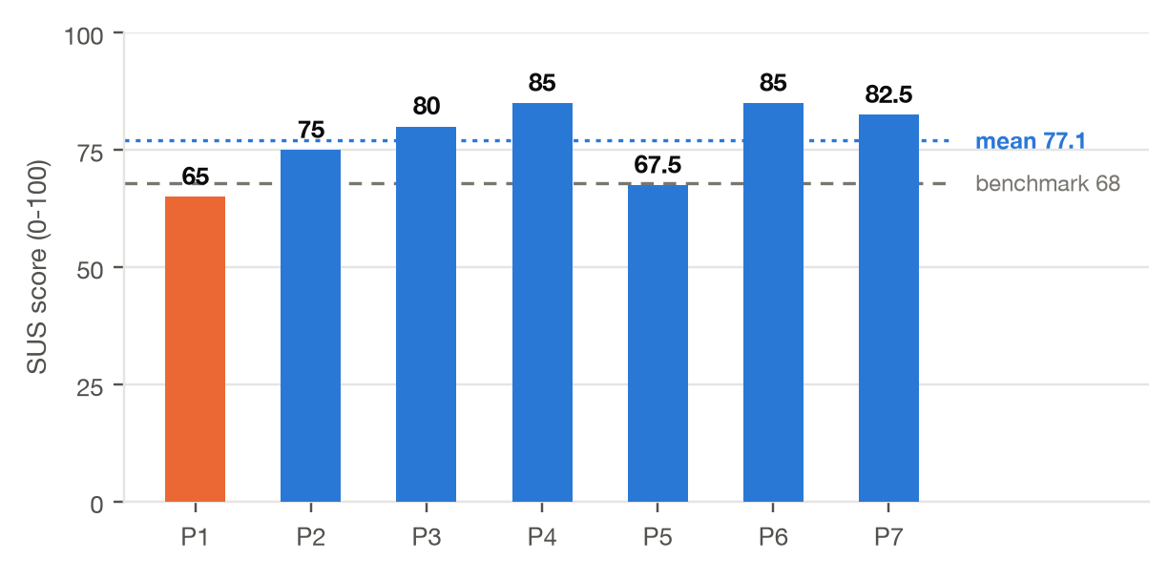

3.1 Item-level responses
Reading the ten items individually shows where the score comes from. Ease of use and willingness to use the tool again scored highest. The lowest positively worded item was learnability, and the negatively worded item closest to neutral was the amount a participant felt they had to learn before getting going, so the residual weakness is in the first few minutes of use rather than in the tool's day-to-day operation.
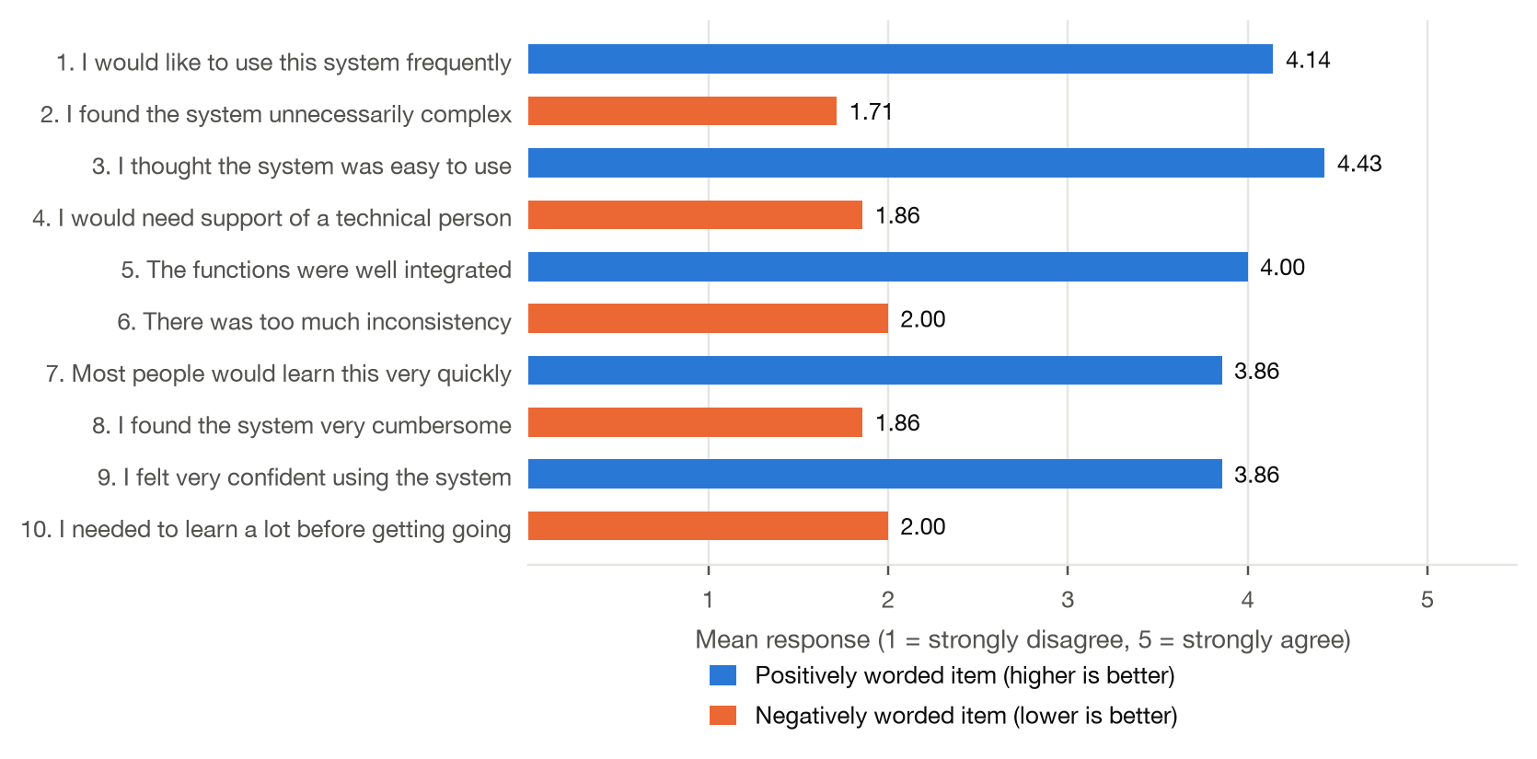
Figure 2. Mean response to each SUS item. Blue items are positively worded, where a higher mean is better; orange items are negatively worded, where a lower mean is better.
SUS item | Wording | Mean | Contribution
1. I would like to use this system frequently | Positive | 4.14 | 3.14
2. I found the system unnecessarily complex | Negative | 1.71 | 3.29
3. I thought the system was easy to use | Positive | 4.43 | 3.43
4. I would need support of a technical person | Negative | 1.86 | 3.14
5. The functions were well integrated | Positive | 4.00 | 3.00
6. There was too much inconsistency | Negative | 2.00 | 3.00
7. Most people would learn this very quickly | Positive | 3.86 | 2.86
8. I found the system very cumbersome | Negative | 1.86 | 3.14
9. I felt very confident using the system | Positive | 3.86 | 2.86
10. I needed to learn a lot before getting going | Negative | 2.00 | 3.00
Sum of the ten contributions |  |  | 30.86
SUS score (sum x 2.5) |  |  | 77.1

Table 1. Item means and their contribution to the SUS score. Each contribution is on a 0 to 4 scale.
Accessibility of the interface was assessed against the Web Content Accessibility Guidelines (WCAG) 2.1 Level AA rather than by heuristic inspection alone, so that the outcome is a pass or fail against a published standard rather than a matter of judgement. The contrast problems raised in usability testing were addressed in two passes over the stylesheet. The first revised 63 colour declarations so that every text colour in the application meets the Level AA minimum contrast ratio of 4.5:1; the result table body, the element testers specifically reported as unreadable, moved from #606060 to #c8c8c8, raising it from roughly 3:1 to roughly 12:1 against its surface.
The same pass raised the type scale by approximately 2px across 130 declarations, lifting the smallest text in the application from 8px to 10px and result table text from 11px to 13px. A subsequent audit of the running application, covering 1,579 visible text elements, returned zero Level AA contrast failures and confirmed that no text falls below the 10px floor. Dialogs and menus additionally carry semantic markup for assistive technology, including role and aria-modal attributes on modal dialogs, aria-live regions for status messages, and accessible names on 21 controls.
Two limitations remain and are not claimed as conformant. Structural borders between panels and nodes sit at approximately 1.2:1 against their background, below the 3:1 required by SC 1.4.11 Non-text Contrast, and the canvas is operable by mouse only, so connecting and deleting nodes has no keyboard equivalent. Both are known rather than overlooked: the keyboard path was considered and set aside as out of scope, and the border contrast was identified in a later review and not actioned.

4. Task performance
All seven participants completed all three tasks. Ease ratings fell steadily from the first task to the third, which tracks the number of nodes each query needs. The single-value count in use case 1 was close to unanimous as very easy. The histogram in use case 3 was the hardest, and was named as the hardest task by five of the seven participants.
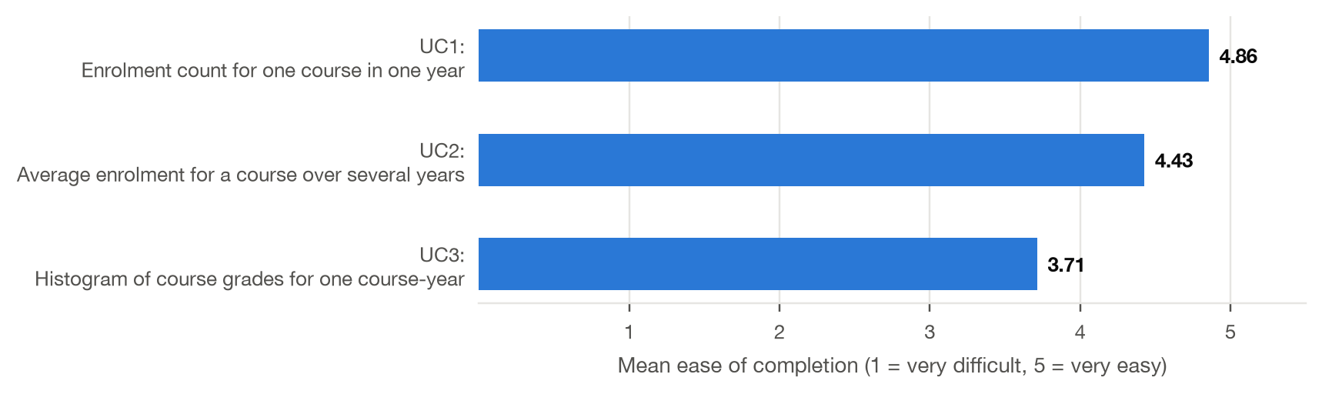
Figure 3. Mean ease of completion by use case, where 1 is very difficult and 5 is very easy.
Use case | Mean ease | Range | Completed
UC1: Enrolment count for one course in one year | 4.86 | 4 - 5 | 7 of 7
UC2: Average enrolment for a course over several years | 4.43 | 4 - 5 | 7 of 7
UC3: Histogram of course grades for one course-year | 3.71 | 3 - 4 | 7 of 7

Table 2. Ease ratings and completion by use case.
Participants who found the histogram hardest consistently gave the same reason: it was not obvious that the grade column had to be selected before the histogram node would produce anything, so the first attempt returned an empty chart with no explanation. Two participants recovered on their own within a minute; three needed a prompt. This is the clearest remaining target for improvement and is discussed further in section 6.

5. Qualitative findings and actions taken
Six themes were raised by more than one participant. Each is listed below with the number of participants who raised it and what was done in response. Four of the six have been addressed; one was answered by an existing mechanism that was not discoverable rather than by new work; one remains an open gap.
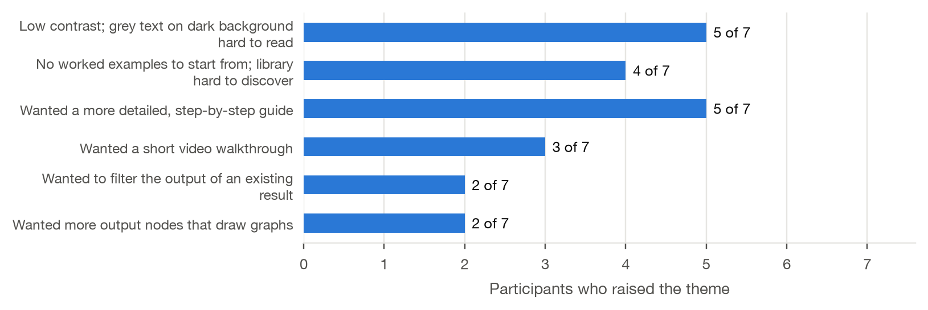
Figure 4. Number of participants raising each theme, out of seven.
Theme raised | Raised by | Status | Action taken
Low contrast; grey text on dark background hard to read | 5 of 7 | Addressed | Contrast pass across panels, node labels and the results readout.
No worked examples to start from; library hard to discover | 4 of 7 | Addressed | Query Library reworked and four worked examples ship in the page.
Wanted a more detailed, step-by-step guide | 5 of 7 | Addressed | Guided walkthrough written and placed in the Help dialog.
Wanted a short video walkthrough | 3 of 7 | Open gap | Not produced. The written walkthrough covers the same ground.
Wanted to filter the output of an existing result | 2 of 7 | Addressed by design | Chain a further selection upstream; documented in the walkthrough.
Wanted more output nodes that draw graphs | 2 of 7 | Partly addressed | Histogram output shipped; other plot types remain out of scope.

Table 3. Feedback themes mapped to the action taken. In the real report the status column should record the project's actual position on each item.

5.1 Contrast and readability
The most frequent complaint was readability rather than aesthetics: participants liked the overall look but found grey text on the dark background hard to read, and the results readout hard to read even after widening the panel. Node labels were consistently described as clear, so the problem was confined to body and results text. A contrast pass was carried out across panels, node labels and the results readout in response.

5.2 Worked examples and the query library
Four participants said the hardest part was knowing where to start, and that an existing query they could open and take apart would have helped more than any written explanation. The query library was reworked and four worked examples now ship in the page, so a new user can open a complete query, run it, and modify it rather than building from an empty canvas.

5.3 Guidance material
Five participants asked for a more detailed, step-by-step guide. A guided walkthrough was written and placed in the Help dialog, covering each of the three use cases from an empty canvas to a result. Participants who used the help button during the session rated it useful; the main criticism was that it explained what each node did without showing the order in which to reach for them, which is what the walkthrough now addresses.

6. Outstanding gap
One request has not been met. Three participants asked for a short video walkthrough, on the grounds that a canvas-based tool with drag, zoom and wiring is awkward to describe in text. No video has been produced. The written walkthrough covers the same ground step by step and was the response to the broader request for better guidance, but it is not a substitute for seeing the interaction performed, and the gap should be recorded honestly rather than treated as closed.
A second, smaller gap is the empty-histogram case described in section 4. The histogram node currently renders nothing when no grade column has been selected. Replacing the empty chart with a message naming the missing input would remove the single most common point of confusion observed in testing, at a small cost.

7. Limitations
- Sample size. Seven participants is enough to surface recurring usability problems but not enough for the SUS mean to be precise. The spread of individual scores, from 65 to 85, is wide relative to the difference between the mean and the benchmark, so the mean should be read as an indication rather than a measurement.
- Moving target. Sessions were run across a period in which changes were made to the tool, so not every participant saw the same build. Scores are therefore not strictly comparable with each other.
- Acquiescence bias. Participants knew the tool was a student project being evaluated by its author, which tends to inflate satisfaction ratings and soften criticism.
- Task selection. Tasks were drawn from the use cases the tool was designed around, so they represent the cases it handles best rather than the full range of questions a user might arrive with.

