Results on KTH dataset using only scenario 1
Riemannian Manifolds
L=20

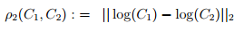
Log-Euclidean Metric:

Accuracy: 80.67%
Stein Divergence:
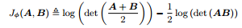

Accuracy: 69.33%

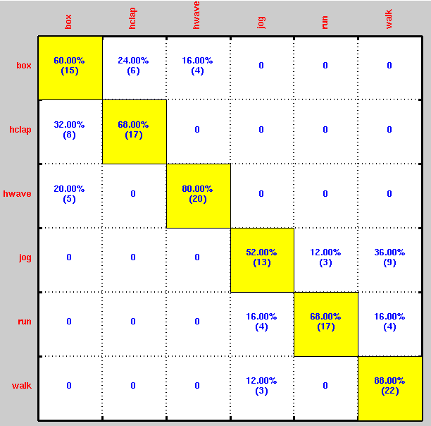
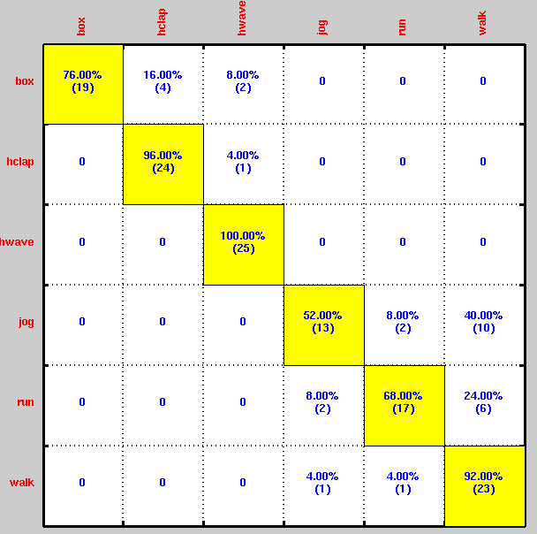
Results on KTH dataset using only scenario 1
Grassman Manifolds
L=20. P=12 (order of the optimised subspace)
Projection Metric:
