Assessment of seabird species prevalence and influencing environmental factors during an offshore seabird survey

**Author:** [Johanna-Lisa Bosch](https://orcid.org/0009-0002-1046-8179)

**Affiliation:**

Wildlife Research Division, Environment and Climate Change Canada, 6 Bruce St., Mount Pearl, NL, A1N 4T3, Canada

# Abstract

This report assesses seabird species prevalence and the environmental factors influencing their distribution during an offshore seabird survey conducted by Environment and Climate Change Canada. The study identifies the most common seabird species and examines how weather, sea state, and glare conditions affect their presence.

# Introduction

Seabird populations and their distribution patterns are critical indicators of ocean health and ecosystem dynamics. Historically, systematic monitoring of seabirds in Atlantic Canada ceased in the mid-1980s, creating a gap in data needed to understand the impacts of human activities on these species (Gjerdrum et al. 2012). In response, Environment and Climate Change Canada (ECCC) established a pelagic seabird monitoring program, with protocols formalized by Gjerdrum et al. (2012). The analysis of this survey, conducted approximately 500 km off the coast of Newfoundland on a vessel, aims to identify the most common seabird species and analyze how various environmental conditions influence their presence. By visualizing this data, I aimed to inform future studies on the prevalence of seabird species off of Newfoundland’s Atlantic coast.

# Background

ECSAS surveys offshore are conducted by observing birds along a line transect on one side of the boat that is ≤300 m (Tasker et al. 1984) depending on the visibility from the platform. All observers conducting the surveys are trained and have experience working with and identifying seabirds. As the observer performs the surveys, data is entered into a Microsoft Access Database (SQL based) that has been customized for ECSAS protocols. The observer will collect data on the watch period, including the start time and end time of the survey, the coordinates, the weather, sea state, glare conditions, visibility, etc. Then, they will begin a sighting period where they collect data on the species they observe, the count of birds, their behaviour and associations with the vessel or other debris, their flight direction, etc. Species are recorded using standard 4-letter bird species codes ([birdpop.org/pages/birdSpeciesCodes.php](https://www.birdpop.org/pages/birdSpeciesCodes.php)). Much of this data is entered using unique identifiers and codes – for example, weather is entered based on a scale from 1-7, where each number is associated with a kind of weather, and descriptions for the weather codes are found in a separate ‘lookup’ table stored in the Access database file (‘.mdb’ format). Any data collected during a watch period is stored in a separate file (‘tblWatch’) from the actual seabird sightings data (‘tblSighting’) or cruise data (‘tblCruise’), and is also stored with any additional lookup tables containing metadata related to the main tables (‘lkpSpeciesInfo’, ‘lkpPlatform’, ‘lkpWeather’, etc).

The survey data used in this analysis was collected by an ECCC employee during a 3-week offshore survey conducted ~500 km off of the coast of Newfoundland (ECCC 2024), and provided in the Microsoft Access database format (.mdb file, a total size of 12708 KB). Certain data have been altered or removed to maintain the confidentiality of the study and the name of the collaborators – however, the seabird sightings and watch period metadata belonging to ECCC have not been altered. The data was collected during a 17-day period in May, and observations took place every day for no more than 12 hours. The vessel was apparently stationary for a majority of the cruise, with a total of 169 stationary platform surveys and only 5 moving platform surveys. As a result of the differing survey methods, I decided to disregard any of the moving platform survey data collected by the observer. To read more about the variation in survey methods, see the Supplementary materials section.

The map of the survey points below shows that a total of 19 watch periods were conducted approximately 250 km offshore, and an additional 150 watch periods were conducted approximately 500 km offshore. An interactive map is available for download, made using the Folium (Journois et al. 2015) library. Distances were roughly determined using the GeoPy library (Tygart et al. 2008).

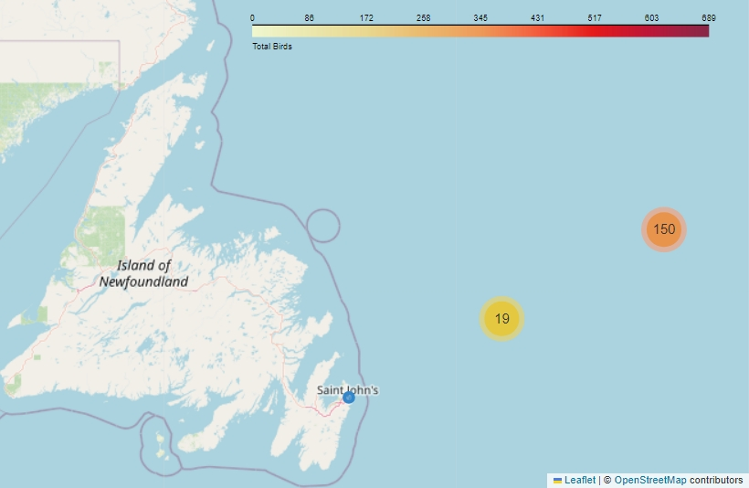

**Figure 1.** A map showing general locations where watches were conducted during the cruise period. The blue dot represents the arrival and departure port, and the clusters markers represent the number of watches conducted in the area. Download in interactive version of this map.

# Analysis

The primary objectives of this analysis were to assess and visualize the prevalence of seabird species off of the coast of Newfoundland during a single survey period, and to determine the species’ prevalence across different environmental conditions, including weather, sea state, and glare conditions. All analyses were conducted on a laptop using the latest version of Python (Van Rossum and Drake 2009), and some HTML code used to format the text in the figures. The Plotly library (Plotly Technologies Inc. 2015) was also used in this analysis to create an interactive scatter plot of seabird counts, and a pie chart of the environment factors observed during the watch periods.

## 1. Data preprocessing and basic metrics

Several libraries and tools were employed during this stage to perform various tasks, ranging from data loading and cleaning to calculating essential metrics. First, I extracted all of the tables and query metadata from the Access database using the Pyodbc (Kleehammer 2008) library, which allows users to connect to Access databases and query information. I created a list of each table and their column headers for easy reference (File S1) and then retrieved all of the tables from the Access database and saved them as individual Excel files.

I inspected each of the files to find a unique identifier used among the tables ('WatchID') that could be used to merge the files together and make a single data frame for each watch period and seabird species sighted throughout the cruise. Using the Pandas library (McKinney 2010), the relevant Excel files were first read into data frames and merged to combine watch data with sightings data, species and platform information into one data frame (514 rows total). Next, any missing values for seabird counts were filled with 0 to account for watch periods with no seabird sightings. Unnecessary columns were dropped, and the data for stationary and moving platform surveys were filtered into two Excel files so that I could focus the analysis on the stationary survey data. For the final data clean-up, I dropped columns irrelevant to stationary surveys and standardized the date and time formats to sort the watches chronologically for downstream analysis.

Several Pandas functions (McKinney 2010) were used to further inspect the data from the cruise period and derive basic metrics such as the total number of surveys, the total number of species observed, and to identify the most and least seen species. To calculate the distance from the port to each watch point, the Haversine formula was implemented (Korn 2000), which calculates the great circle distance between two points on the Earth using their latitude and longitude. The NumPy library (Harris et al. 2020) was used for mathematical operations and converting coordinates to radians.

## 2. Prevalence of seabird species during the cruise

To assess the prevalence of seabird species during the survey period, I aggregated the counts of each species during the cruise period, and sorted them in descending order based on their total counts and average counts, providing a list of the most common species (Table 1). Next, a scatter plot was created to display the counts of each species during the observer’s watch periods (Figure 2). Z-scores were calculated using the transform function from Pandas (McKinney 2010), which normalized the species counts and made them comparable across different watches. A Generalized Additive Model (GAM) was fitted to the data to visualize trends and patterns in species prevalence over time using the PyGAM library (Servén and Brummitt 2018). Download the [interactive version of Figure 2](https://github.com/johannabosch/ECSAS_analysis/blob/main/figures/interactive_scatter_plot.html) to hover over the data points and visualize the species code, date and count of the birds during the watch period.

## 3. Environmental conditions influencing species prevalence

To analyze the environmental conditions observed during the watch periods, I created pie charts displaying the most common sea state, weather, and glare conditions used by the observer. The sea state, glare and weather codes displayed on the chart in Figure 3 can be found in Table S1, and downloading the [interactive version of Figure 3](https://github.com/johannabosch/ECSAS_analysis/blob/main/figures/pie_charts.html) allows you to hover over the pie chart areas to view descriptions of the codes. I used Pandas functions to aggregate the count data based on the environmental conditions, and queried the respective lookup tables for descriptive labels. Next, I created two heatmaps using the Seaborn library (Waskom 2021) to explore how the count of each species during every watch varied under different weather and sea state conditions.

A high-resolution geospatial analysis was conducted using the Folium library (Journois et al. 2015), which allowed for interactive mapping of the observer’s survey points from the time the vessel left and returned to port (Figure 1). Using the Branca Colormap plug-in, a color scale was applied to each watch period, represented as a point on the map, based on the count of total birds during the watch. To manage the large number of survey points, folium’s `MarkerCluster` plug-in was utilized, enhancing the map's usability by clustering nearby markers. Custom JavaScript was used for the HTML output to dynamically control the clustering behavior based on zoom levels, because detailed spatial patterns could not be examined when zoomed in with the clusters. This section of the analysis was conducted on via the Digital Research Alliance of Canada’s Graham cluster, which offers high-performance computing resources and extensive storage capabilities. I conducted this section of the analysis on the cluster for reproducibility of this method, because the computational intensity of the geospatial analysis generally requires more processing power and memory and would be required given a larger dataset from a longer cruise period.

# Results

The analysis revealed a distinct pattern in species presence throughout the cruise period, and also showed that certain weather conditions and sea states may have influenced the prevalence of select species found offshore. Overall, Northern fulmars were the most common species observed offshore, followed by Thick-billed murres, Great black-backed gulls, Herring gulls, and Common murres (Table 1). The number of Northern fulmars exceeded all of the other seabird species seen during the cruise period combined. Figure 2 highlights the deviations in seabird counts, providing a deeper understanding of species distribution dynamics over the survey period, and showed various outliers, including one mentionable watch period where a total of 689 fulmars were observed.

**Table 1.** Total and average count of observed seabird species during cruise period, and the number of watch periods the seabird(s) were observed (watch count)

|  |  |  |  |
| --- | --- | --- | --- |
| Species | Total count | Average count | Watch count |
| Northern Fulmar | 7641 | 14.3 | 108 |
| Thick-billed murre | 87 | 12 | 1 |
| Great black-backed gull | 31 | 6 | 1 |
| Herring gull | 22 | 4 | 2 |
| Common murre | 12 | 3.7 | 10 |
| Unknown gull | 8 | 3.7 | 6 |
| Unknown murre | 8 | 2.7 | 3 |
| Common redpoll | 6 | 1.4 | 20 |
| Unknown bird | 4 | 1 | 1 |
| Leach’s storm petrel | 3 | 1 | 2 |
| Ring-billed gull | 2 | 1 | 2 |
| Black-legged kittiwake | 1 | 1 | 4 |
| White-throated sparrow | 1 | 1 | 1 |

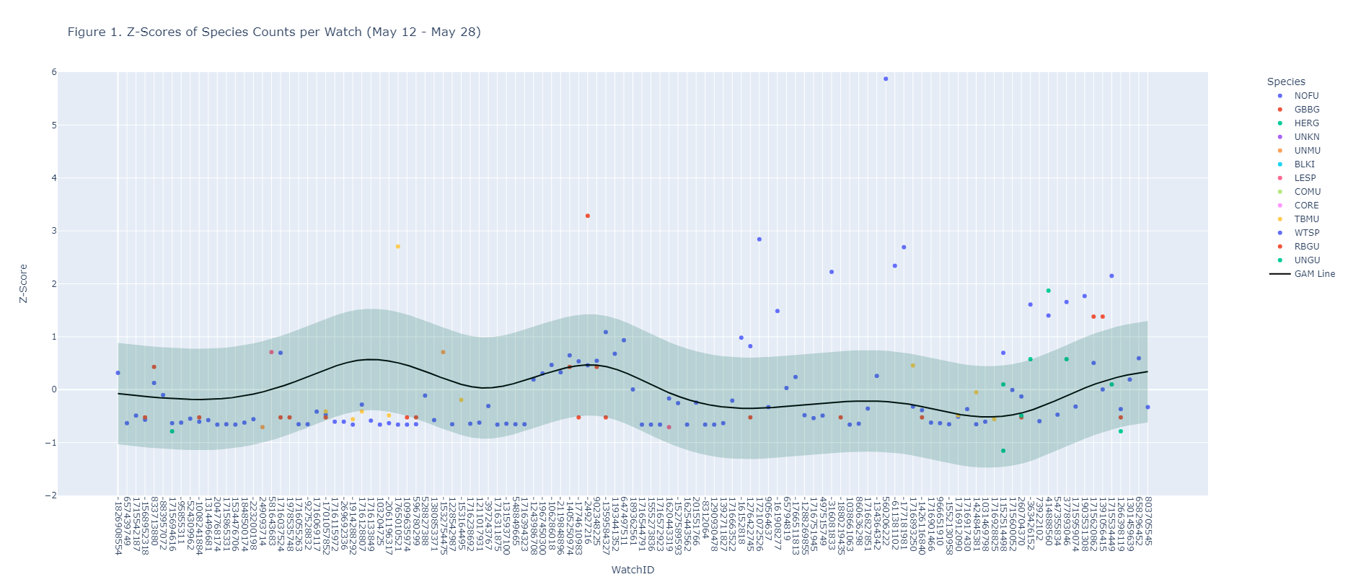

**Figure 3.** Sum of observer’s counts per species for each watch period of the cruise (May 12 – May 29) The line represents the GAM’s predicted line of best fit and the grey area represents the 95% confidence interval for the predicted mean (potential outliers)  
Download an [interactive version](https://github.com/johannabosch/ECSAS_analysis/blob/main/figures/interactive_scatter_plot.html) of this map

Based on the observations, the most common weather observed throughout all watches (total of 169) was weather with less than 50% cloud cover, with no fog or rain (code 1), which was observed during 48.1% of the watches, followed by solid fog which was observed during 21.8% of the watches (code 3). Large wavelets, where crests begin to break and there are scattered whitecaps (code 1), were observed during 46.3% of the watches, however there was a period during the cruise where an intense sea state occurred and the air filled with foam and spray (code 3). Inspecting the effects visibility had on the observers limitations showed that the overall count of seabirds declined as visibility, hindered by weather and sea state, decreased (Figure S2). Glare on the water from the observation platform was overall low, with no glary conditions observed during 65.6% of the watches.

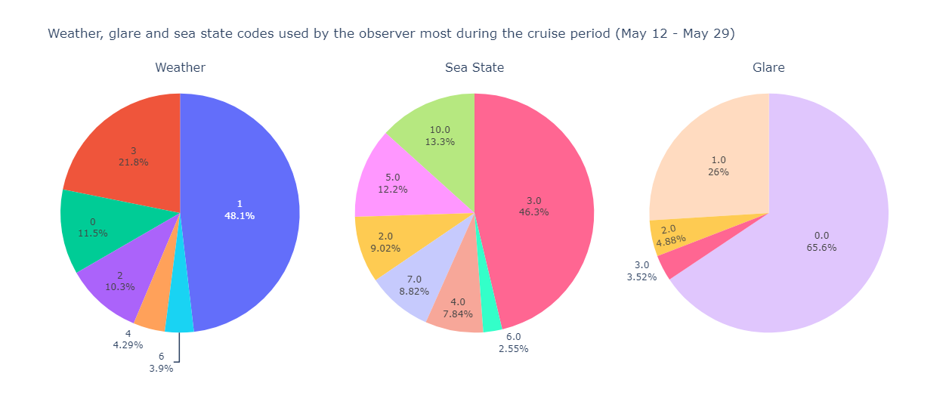

**Figure 3.** Most common weather, sea state and glare codes used by the observer during the cruise period (May 12 – May 29). See Table S1 for code descriptions, or download an [interactive version](https://github.com/johannabosch/ECSAS_analysis/blob/main/figures/pie_charts.html) of this map.

Further investigation into the prevalence of seabird species during various weather and sea state conditions found that most seabirds were present during periods of less than 50% cloud cover, with no rain or fog. Certain species were only observed during periods with solid fog, including the Black-legged kittiwake (BLKI), Leach’s storm petrel (LESP), and White-throated sparrow (WTSP). While species like the Common murre (COMU) were typically found during clear weather conditions (code 1), 12 individuals occurred during periods of high sea state with high waves and dense sea foam. Interestingly, a total of 15 Great black-backed gulls were observed during the intense sea state period.

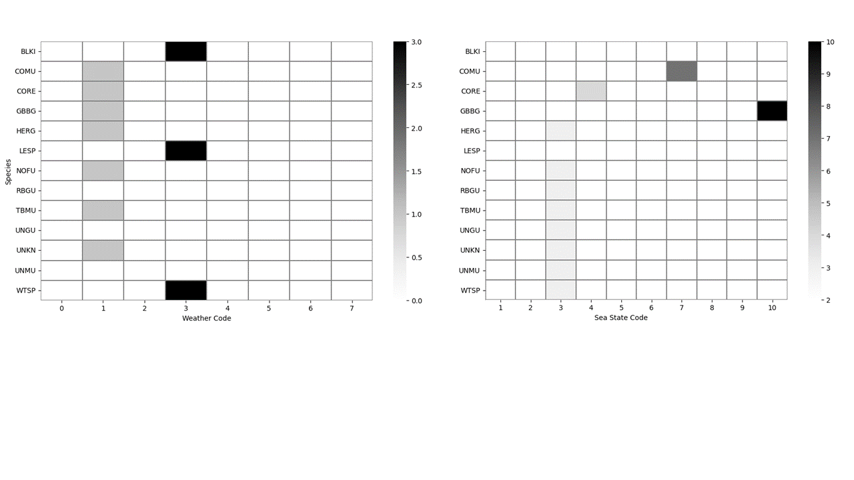

**Figure 4.** Heatmap displaying the counts of seabird species in relation to the weather code (left) and sea state code (right) used by the observer during the watch periods on the cruise (May 12 – May 29). Darker shades represent the higher occurrences of species during various conditions.

Finally, the geospatial analysis revealed that the one specific watch period where a total of 689 fulmars were observed occurred 506.5 km from the departure port. During this watch period, a note was made by the observer that a drilling ship was conducting operations nearby and potentially attracting fulmars to the area. During this watch period, there were moderate waves observed, and weather was less than 50% cloud cover, with no fog or rain.

# Discussion

Northern fulmars are a common occurrence offshore for numerous reasons. For one, they have a tubenose which functions as an inbuilt desalination mechanism allowing them to drink sea water and presumably spend longer periods out at sea. Like the other seabirds observed during the cruise period, fulmars were typically observed close to the survey platform during periods of moderate sea swell with some white caps and periods with less than 50% cloud cover. The fulmars seemed to be attracted to a drilling vessel during the cruise period as well, suggesting there may be certain anthropogenic factors such as vessel operations that were influencing the presence of fulmars during the survey. The majority of Canada's Northern Fulmars breed in 11 colonies distributed across the eastern Canadian Arctic, however a few pairs have been known to nest in three main area of Newfoundland, including Baccalieu Island (Bay de Verde), Funk Island, and Great Island (Witless Bay) (Gaston et al. 2006), making these large sightings far off the shores of Newfoundland valuable sightings data for future studies in the area.

Seabirds such as Leach’s storm petrels, black-legged kittiwakes and white-throated sparrows were seen during period of intense fog, which aligns with the behaviors of these species far offshore. Sparrows are not commonly found as far as 500 km offshore, and will often seek refuge on vessels as they cross paths in the open ocean. Leach’s storm petrels and kittiwakes are also well-known for getting disoriented in foggy conditions, often ending up stranded on vessels as the effect of the artificial lights attract them to the vessel (Miles et al. 2010).

A small amount of Great black-backed gulls and Common murres, species well adapted to life out at sea, were also observed during periods of intense sea state. Common murres are pursuit divers that commonly feed off of capelin off the coast of Newfoundland and are able to dive more than 100 m below the surface (Burke and Montevecchi 2018). It is likely that murres would be nearby the vessel while foraging because bait fish, like capelin, are typically attracted to vessels offshore (Røstad et al. 2006). Great black-backed gulls are resilient seabirds that are also often found following ships in the Atlantic, especially in harsh waters (Garthe and Hüppop 1994). Additionally, Common murres, Leach’s storm petrels and Great black-backed gulls are all commonly found breeding along the coast of Newfoundland.

At the beginning of the analysis, I found which species were most common overall by calculating the total and average species observed, however this method presents flaws due to the nature of the survey methods. When conducting stationary surveys once every hour, it is possible that the observer is recounting the same bird(s) each time. This presents a biased in the data, meaning the observer did not likely observe over 7000 individual Northern fulmars during the whole cruise period. Being able to visualize species counts on the scatterplot and an interactive map was advantageous because it took away this biased by displaying species counts for each individual watch period.

# Conclusion

In conclusion, certain seabird species were seen during periods of intense sea state and foggy weather conditions. Assessing the influence weather and sea state had on seabird prevalence aligned well with the known behaviors and distributions of the seabirds observed. While environmental factors did appear to influence seabird presence, a more thorough analysis of seabird distributions offshore during varying environmental conditions would be needed to make any outstanding conclusions regarding the prevalence of specific seabird species during specific weather or sea state periods. The occurrence of seabirds such as the Common murre during high sea states shows the resiliency of murres to prevail out at sea. The study also highlights the prevalence of Northern fulmars during offshore surveys, and found that fulmars may be attracted to vessels during anthropogenic activities. Further research should incorporate data sets with multiple cruises and consider other factors influencing presence, particularly any anthropogenic activities. Future work on this project will involve designing an application/module for surveyors to view the interactive map (.html) and figures considered in this report for their own survey periods.

# Data Accessibility

Data, code and reports for this project can be accessed via Github: <https://github.com/johannabosch/ECSAS_analysis>

# References

Garthe S, Hüppop O. Distribution of ship-following seabirds and their utilization of discards in the North Sea in summer. Marine Ecology Progress Series. 1994 Mar 17:1-9. URL: <https://www.jstor.org/stable/24844808>

Gaston AJ, Mallory ML, Gilchrist HG, O’Donovan K (2006). Status, trends and attendance patterns of the Northern Fulmar *Fulmarus glacialis* in Nunavut, Canada. Arctic 59:165–178.

Harris CR, Millman KJ, van der Walt SJ, et al. (2020). Array programming with NumPy. Nature 585, 357–362 (2020). URL: <https://www.nature.com/articles/s41586-020-2649-2>

Journois MF, Story R, Bird A, Lima A, Tyslacki P, Duke J, et al (2015). Python visualization; Folium. URL: <https://zenodo.org/records/33534#.VkIUpK6rSL4>

Kleehammer 2008. PyPl: pyodbc 5.1.0. URL: <https://pypi.org/project/pyodbc/>

Korn GA, Korn TM (2000) [1922]. Plane and Spherical Trigonometry: Formulas Expressed in Terms of the Haversine Function. Mathematical handbook for scientists and engineers: Definitions, theorems, and formulas for reference and review. Mineola, New York: Dover Publications. pp. 892–893. ISBN: 978-0-486-41147-7.

McKinney W (2010). Data Structures for Statistical Computing in Python. Zenodo. URL: <https://doi.org/10.5281/zenodo.3509134>

Miles, W., Money, S., Luxmoore, R., & Furness, R. W. (2010). Effects of artificial lights and moonlight on petrels at St Kilda. *Bird Study*, *57*(2), 244–251. URL: <https://doi.org/10.1080/00063651003605064>

Plotly Technologies Inc. (2015). Collaborative data science Publisher: Plotly Technologies Inc. Montréal, QC. URL: <https://plot.ly>

Røstad A, Kaartvedt S, Klevjer TA, Melle W. Fish are attracted to vessels. ICES Journal of Marine Science. 2006 Jan 1;63(8):1431-7. URL: <https://academic.oup.com/icesjms/article/63/8/1431/712848>

Servén D, Brummitt C (2018). pyGAM: Generalized Additive Models in Python. Zenodo. DOI: 10.5281/zenodo.1208723

Tygart A, Lopez A, Queiros A et al. (2008). GeoPy. Github. URL: <https://github.com/geopy/geopy>

Van Rossum G, Drake Jr FL. Python 3 Reference Manual. Create Space. Scotts Valley, CA. URL: <https://www.python.org/>

Waskom ML (2021). Seaborn: statistical data visualization. Journal of Open Source Software. URL: <https://doi.org/10.21105/joss.03021>

# Supplementary Materials

## 1. Types of ECSAS surveys

Typically, an observer needs to be familiar with the two types of surveys that can occur during a cruise period, including moving platform surveys for when the vessel is moving greater than 4 kts, and stationary surveys for when the vessel is at a stand still or moving less than 4 kts (Gjerdrum et al. 2012). For stationary surveys, an observer stands at the edge of a platform and records observations once every hour within a 180 degree transect, and a survey will only last approximately 30 seconds (Figure S1). For a moving platform survey, an observer stands at the edge of a platform and records observations every five minutes within a transect that spans 90 degrees from the observer to the front of the vessel (Figure S1).

**Figure S1.** The two types of ECSAS surveys conducted offshore by trained observers, including stationary platform surveys (right) and moving platform surveys (left).

## 2. Assessing observer counts based on visibility

To show the limitations of an observer’s ability to accurately count seabirds, I explored the relationship between the observer's visibility (km) from the platform and the total number of birds counted per watch. The Pandas library () was used to aggregate the count data, and a scatter plot with a linear regression line was created to visualize and quantify the relationship. As the observer’s visibility decreased due to foggy weather, less birds were observed. This analysis helped in understanding how low visibility conditions negatively influenced bird count observations, and displays the observer’s limitations while conducting surveys offshore.

**Figure S2.** Linear regression of the total count of seabirds per watch period and approximate visibility (km) recorded by the observer on the survey platform.

## 3. Weather code descriptions

**Table S1.** Descriptions for weather, glare and sea state codes

|  |  |
| --- | --- |
| **Code** | **Description** |
| **WEATHER** |  |
| 0 | < 50 % cloud cover (no fog, rain or snow) |
| 1 | > 50 % cloud cover (no fog, rain or snow) |
| 2 | Patchy fog |
| 3 | Solid fog |
| 4 | Mist/light rain |
| 5 | Medium to heavy rain |
| 6 | Fog and rain |
| 7 | Snow |
| **SEA STATE** |  |
| 1 | Calm, mirror-like OR Ripples with appearance of scales but crests do not form |
| 2 | Small wavelets, short but pronounced; crests do not break |
| 3 | Large wavelets, crests begin to break; foam of glassy appearance; perhaps scattered whitecaps |
| 4 | Small waves, becoming longer; fairly frequent whitecaps |
| 5 | Moderate waves with more pronounced form;many whitecaps; chance of some spray |
| 6 | Large waves formed; white foam crests more extensive; probably some spray |
| 7 | Sea heaps up; white foam from breaking waves blows in streaks in direction of wind OR Moderately high long waves;  edge crests break into spindrift; foam blown in well-marked streaks in direction of wind OR High waves; dense streaks of foam in direction of wind;crests of waves topple and roll over; spray may affect visibility |
| 8 | Very high waves with long overhanging crests; dense foam streaks blown in direction of wind;  surface of sea has a white appearance; tumbling of sea is heavy;visibility affected |
| 9 | Exceptionally high waves; sea is completely covered with white patches of foam blown in direction of wind; edges blown into froth;visibility affected |
| 10 | Air filled with foam and spray; see completely white with driving spray; visibility seriously affected |
| **GLARE** |  |
| 0 | No glare |
| 1 | Slight/grey |
| 2 | Bright on observer's side of vessel |
| 3 | Bright forward of vessel |