Dissection

To dissect means “to cut open”. The children need to know how to handle the instruments. There is also an emotional aspect, because cutting a dead animal might be something new for the children. Some children might not be ready to see a dissection, and we should not force them. The younger you start, the more comfortable the children would be. You can start dissection with six- and seven-year-olds.

MATERIALS:
- protective cloth
- apron
- latex gloves
- tray
- scalpel
- scissors
- tweezers
- spatula
- Labels
- A whole fish (two if you think your child will want to dissect their own, or three if you would like to practice before you present) - perch is a good choice because it doesn’t have a lot of meat and has easy-to-see organs
  - Note: you can buy whole fish at Asian markets. Specify that you don’t want it cleaned AT ALL.

Watch a dissection video here: https://www.youtube.com/watch?v=pNZQEmGp11k

Here’s an excellent tutorial with up-close pictures so you can practice before you present: https://www.instructables.com/Fish-Dissection/

PRESENTATION: Dissecting a fish

- Show the children the fish.
- Review the external parts of the fish that the children are already aware of from their previous work.
- When we hold the fish, it is slightly slippery because there is a secretion covering the body of the fish. This secretion serves two purposes:
  - It helps the fish move fast in the water
  - It protects the fish against bacteria and parasites
- The scales overlap like shingles on a roof, and they are there for protection against bacteria and parasites as well. They cover the entire fish except for the head and fins. The scales are made of the same material as our fingernails.
- The shape of the fish is streamlined so it can move quickly underwater.
- The fish is darker on top of its body and lighter on its belly, for the purpose of camouflage.
- The fish has three main parts:
  - head
  - body (trunk)
  - tail: it is pure muscle and propels the fish in the water

Head:
- Dissect the head:
  - The head is covered with plates. It is very hard.
  - The fish has two eyes and no eyelids, which means that they can’t close their eyes. The pupils are large.
  - Take out the eye and then take out the lens (tiny glass-like sphere buried within the eye).
  - There is no neck, so the fish has to turn its trunk if it wants to look to the side.
  - Only the lower jaw opens and closes. The teeth are slanted inwards, so that when the fish’s food goes into its mouth it won’t flow back out. The tongue is very hard. Fish cannot move their tongue.
  - Cut out the tongue.
  - The fish has two nostrils, but they are dead ends, meaning that they don’t go anywhere. They are for smelling, not for breathing.

Gills:
  - On both sides of the head fish have gills, which are used for breathing. The fish opens its mouth and takes water in, and then expels it through the gills.
    - The external part of the gill is called the gill cover.
    - Internally, there are four gill arches per gill, each consisting of a gill rake and a gill filament.
      - gill rake: filters large particles and keeps gill arches apart (white part)
      - gill filament: where the fish exchanges O₂ and CO₂ (red part)
  - Cut out one of the gill arches, and show the gill rake and gill filament.

Trunk:
- Find the anal opening and cut from the back towards the front along the fish’s belly.
- Then cut vertically from the anal opening and vertically behind the gill, making a flap that folds over and exposes the interior of the fish.
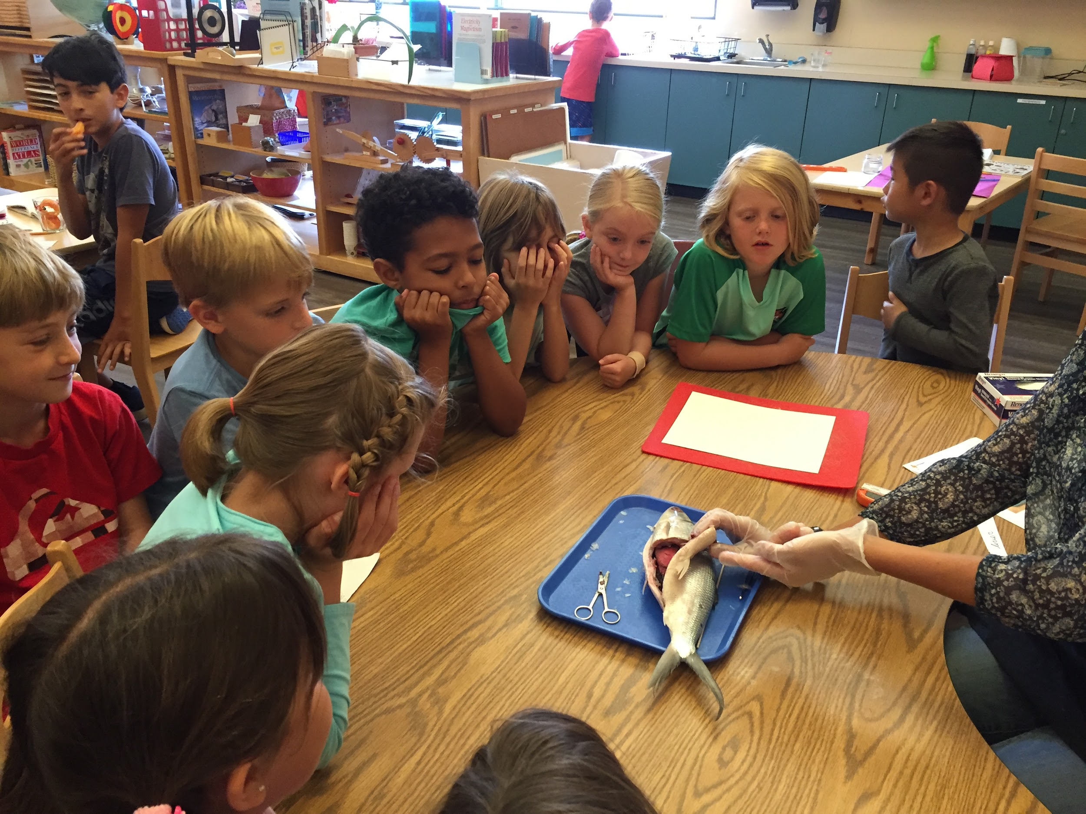
- Find the swim bladder, which is what keeps the fish afloat and adjusts the fish’s buoyancy. It is filled with three different kinds of gases: O₂, N₂, and CO₂.
- Next, find the stomach and intestines (they might be covered with some fatty tissue). To identify the stomach, put a pencil or chopstick down the fish’s mouth until the pencil reaches the stomach.
- Intestines are covered with fat; if you cut them open you can see what the fish has ingested.
- The liver is large and dark red. Next to it (dark brown color) is the gall bladder.
- The liver produces the bile, and then the gall bladder passes the bile to the intestines, to help digest the food.
- Towards the back of the fish are the gonads (reproductive organs). You will either find a pair of testes or a pair of ovaries, depending on the sex of the fish.
- The heart has two chambers: one for receiving blood and one for pumping out blood. All the blood that is pumped by the heart lacks oxygen. The heart pumps the blood to the gills, which is where the blood gets the oxygen.
- The kidneys are long and red, and are hidden behind the swim bladder. Blood passes through the kidneys, where it is cleaned. Carefully remove the swim bladder to expose the kidneys.
- Make a vertical incision to divide the tail from the trunk. Then, cut a cross-section of the fish.
- Remove one of the backbones. Find a tiny hole in the middle; within it is a cross-section of the spinal cord. If you press down on the piece of backbone, the spine will come out.
- Scalp the fish (cutting away from yourself) to expose the brain. Pull out the brain.
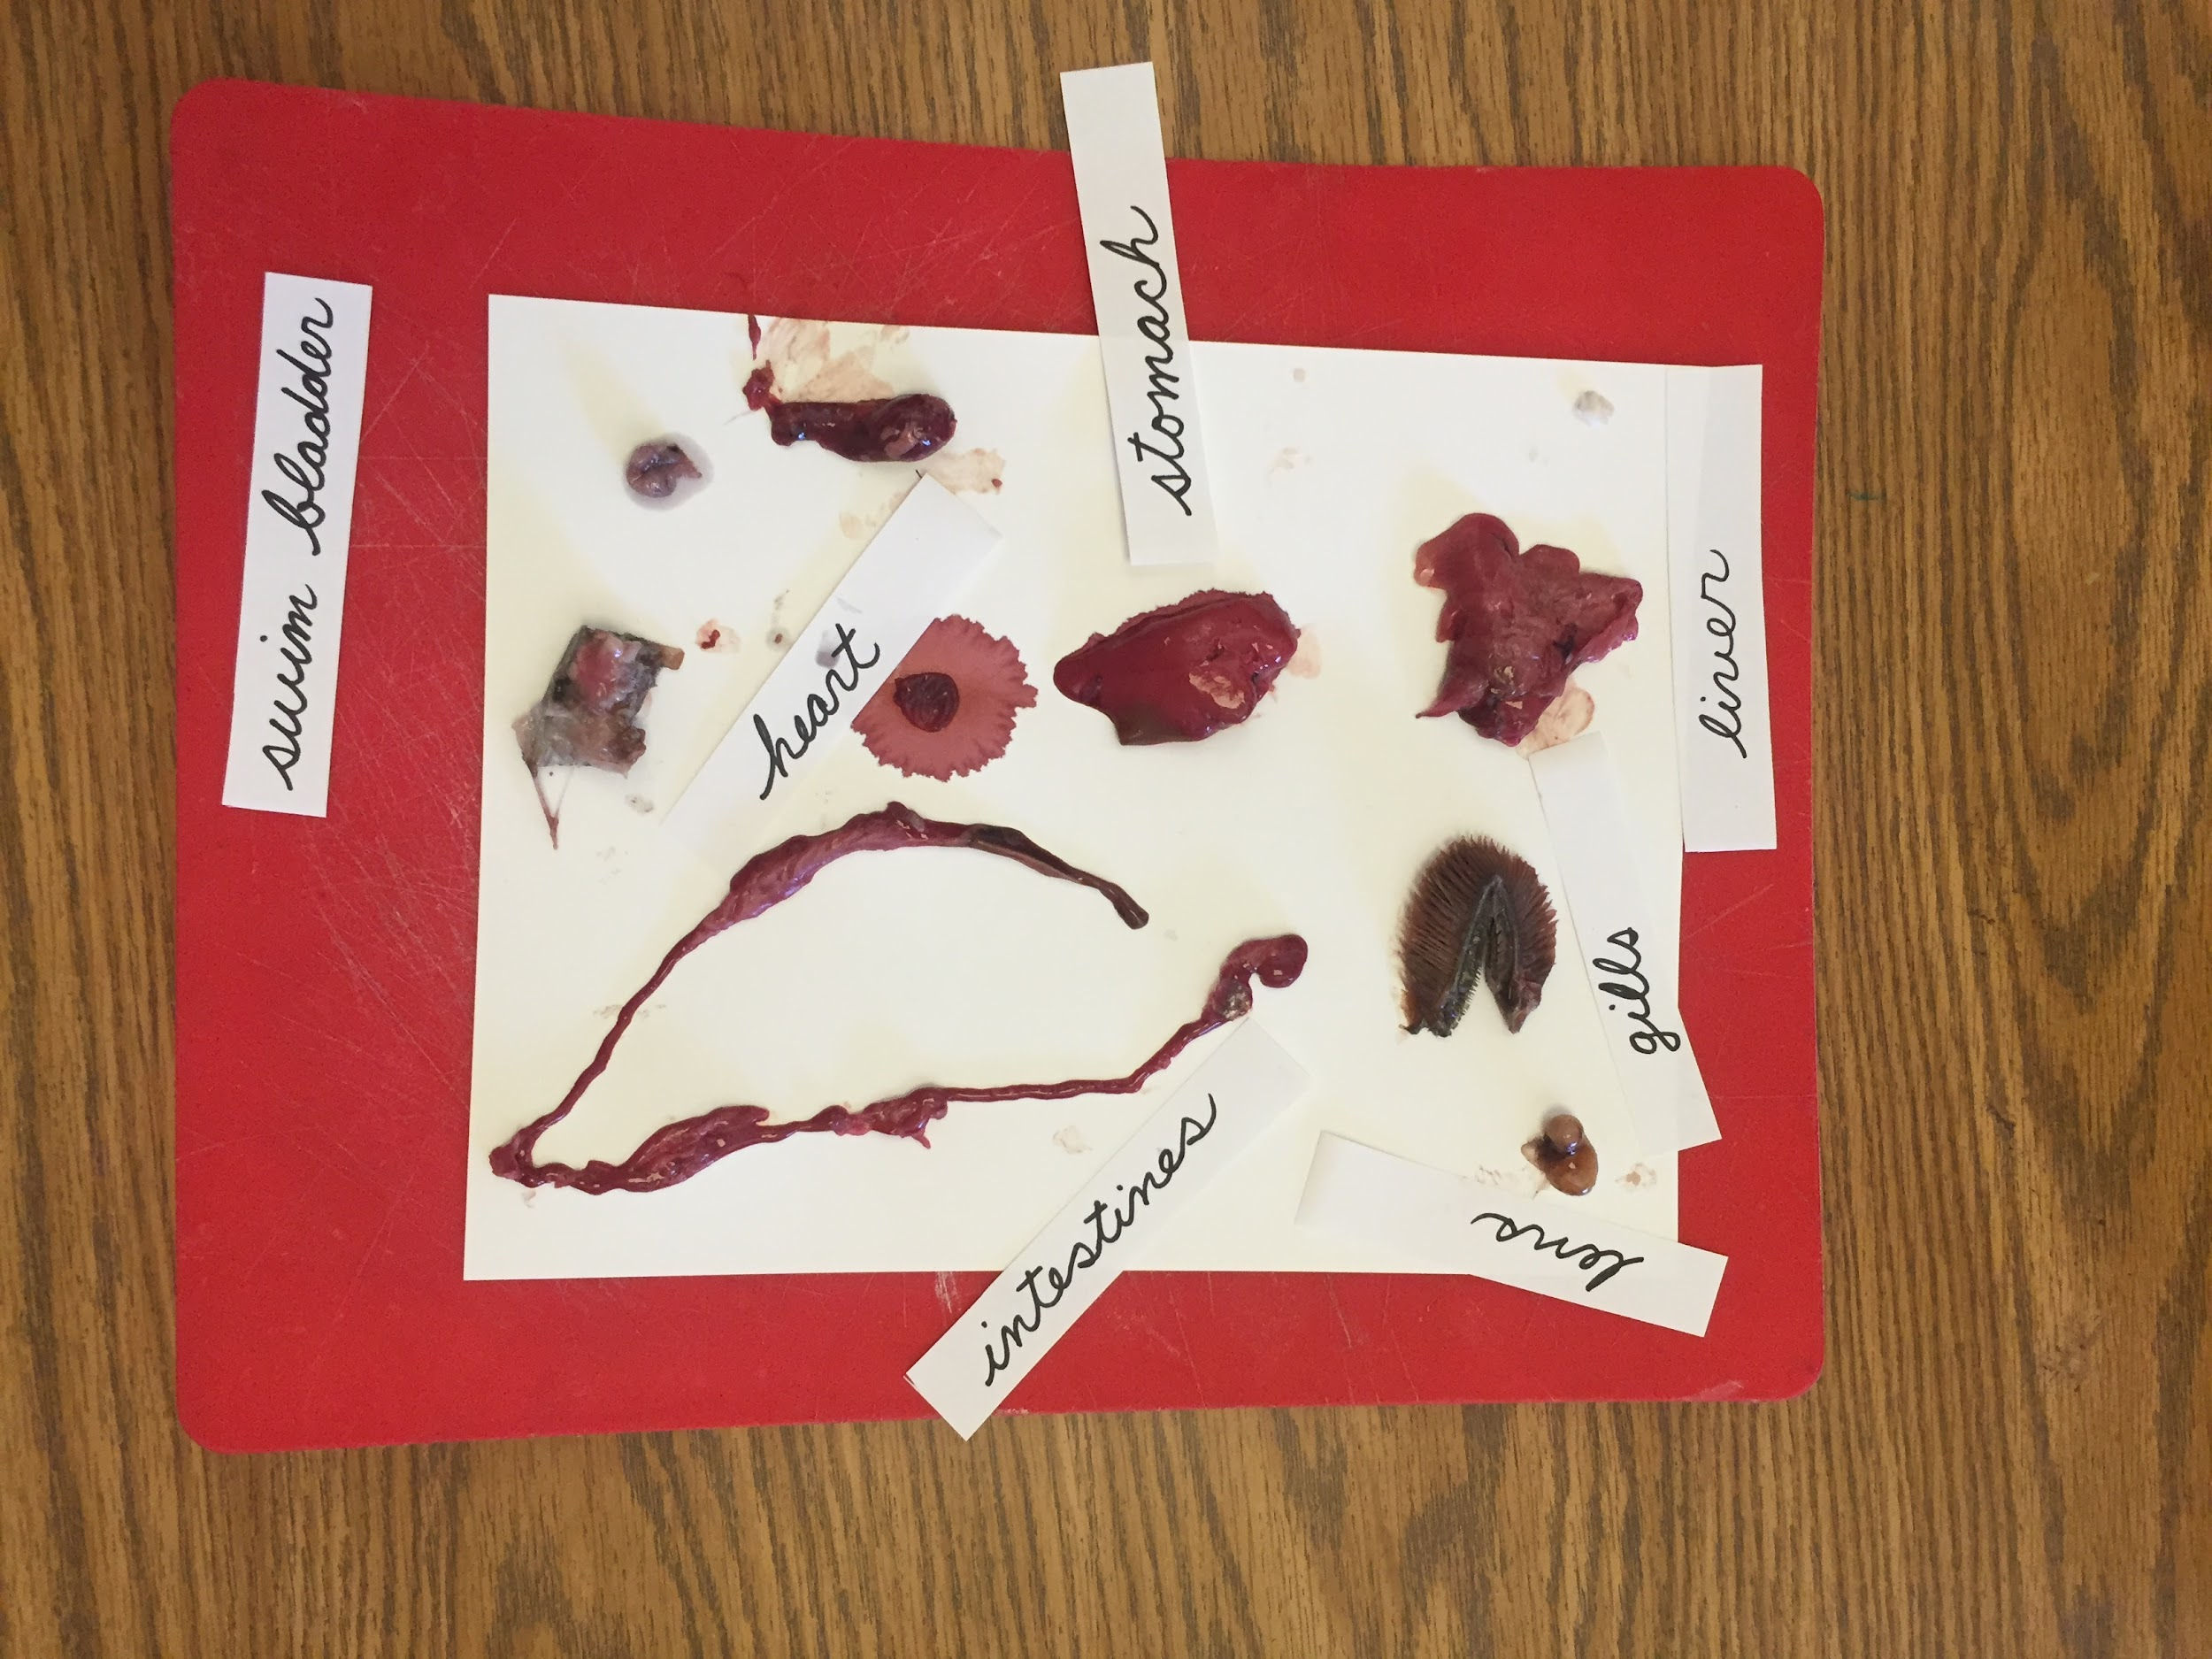
- You can cut vertically (cross-section) at the back of the head to see the connection of the brain to the spine. The brain is situated in the same region as other vertebrates; the spinal cord is encased in the vertebrae.
- The muscles are red, which means that they work for longer periods of time and need to be strong (white muscles don’t have to perform the same amount of work that red muscles do).
- The interior skeleton is there for stability, to protect some of the internal parts, and to provide attachment for muscles. You can boil the fish after the dissection, in order to remove the muscle and expose the skeleton.

Optional Follow-up Activities:
- The children can dissect their own fish.
- The children can write labels for all the parts on the tray.
- The children can write down their observations.
- They can make drawings and descriptions of the internal parts.
- The children can go back to the timeline and the classification charts and try to recall the characteristics of vertebrates.

