Flags

Notes:
- You only need the physical flags of the child’s own continent (for us in North America, you can also include the flags of South America to make it more interesting).
- A flag is a visual symbol that represents a people, group, or country.
- The concept of flags started in the Middle Ages during battles, as a form of identification.
- We should know the story of our country’s flag.
LINKS TO MATERIALS:
- Free flag three-part cards and coloring template: print here (scroll down to Social Studies section in link)
  - The image below is what you’ll see
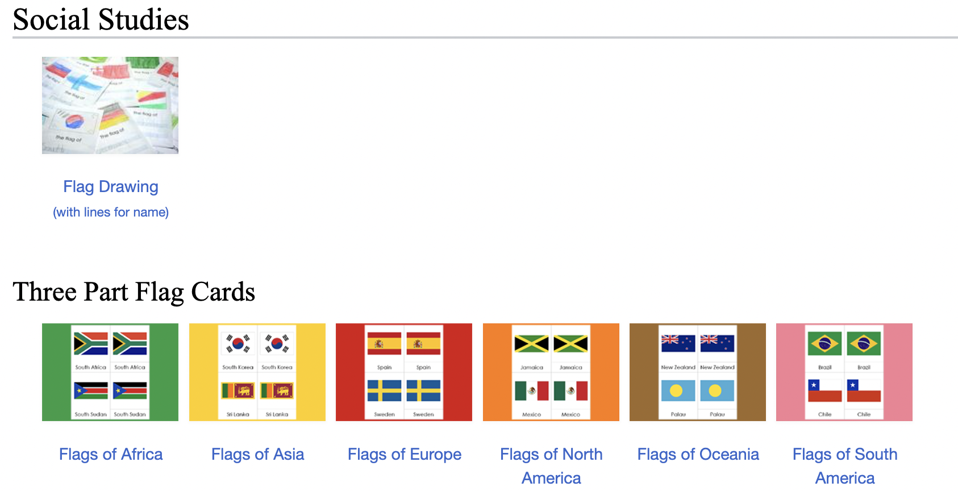
Flag three-part cards plus pin map flags (printable): see “Deluxe Continent Bundles” here
Example:
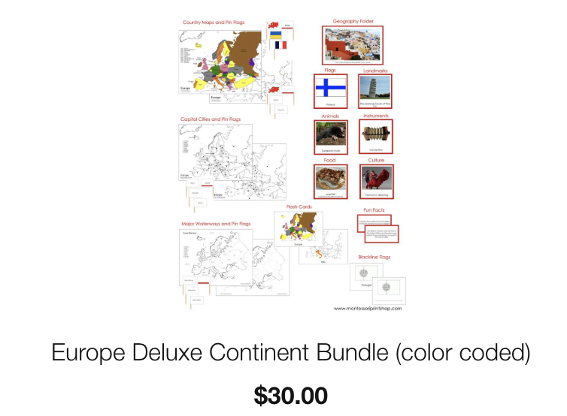
Note: The flag material was introduced into the Children’s House in the late 1930’s in Laren, The Netherlands. The princess was marrying a prince from another country. Amsterdam was full of flags from other European countries, in honor of the royal families who were attending the wedding from abroad. The young children in the Montessori school were fascinated by the flags and wanted to know about the royal families and their countries. After observing the children’s interest, Dr. Montessori brought the flag material into the classroom.

INTRODUCTION TO FLAGS (Primary and Elementary versions)

PRIMARY

Children’s House Presentation: A simple 3-period lesson with three contrasting flags. The child must have worked with the continent map so he knows the country the flag is associated with.

ELEMENTARY

Presentation A: Elementary Flag Presentation
- Choose three or more flags that share one or more similarities.
- For example: the flags of Norway, Iceland, Sweden, Finland, and Denmark all have a Norse cross on them.
- Tell the Story of Flags.
- Discuss the country each flag belongs to and discuss visual similarities.
- Then, give information/origin of each flag with its symbolism. You should structure the explanation so the child can see how one flag relates to another; start with the one that came first and talk about how it influenced the others.
Note: You must have source books with information on flags for children and adults. An interesting book for adults is: Identity Designs, by Karen Cerulo.

Related Activities:

Activity A: Flag Cards
- Provide large images of flags on cards (large enough to show the details of each flag).
- Provide labels and a control chart.
- The child will match the labels to the corresponding flag card.
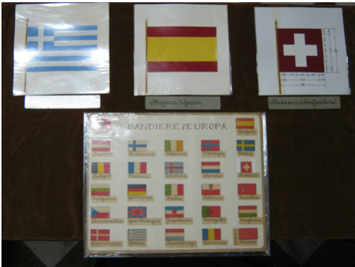

Activity B: Flags on the Map
- Provide a blank map and small flags, along with a control map.
- The child can synthesize the knowledge he already has regarding the name and location of the country and its flag.

Activity C: Flags and Music (Great for an Olympic year)
- Each child carries a different flag.
- The teacher plays a national anthem and when the child recognizes the anthem of his flag, he raises it.

Activity D: National Costume
- Provide dolls with traditional costumes.
- Discuss the reasons for each culture’s particular dress (note: Clothing is a fundamental human need)

Presentation B: Parts of a Flag

MATERIAL: Printables can be purchased here. (You’ll need the three-part cards AND one of the booklet options)

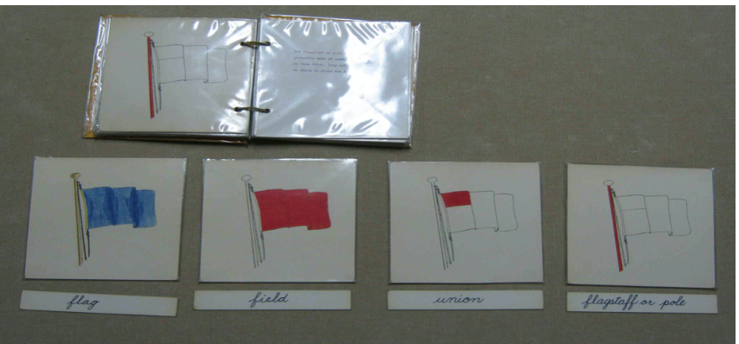
- Provide the classified nomenclature material for the parts of a flag: picture cards, labels, wall chart, definitions.
- Give the child the following terminology and definitions:
  - Flag: a symbol made of cloth representing a country
  - Field: the background of the flag
  - Union/Canton: The upper left area near the pole
  - Flagstaff: The Pole on which the flag hangs
  - Halyard; The ropes used to raise up the flag
  - Hoist: Where the rope runs through the flag
  - Fly: The part that flies free

