ECO 602 – Data Exploration and Deterministic Functions

Johanna Ravenhurst  
Submitted: September 30, 2022  
I worked on my own to complete this assignment, but Wen Xiu did answer a few of my questions.

**Q1 – Terrain Histograms**

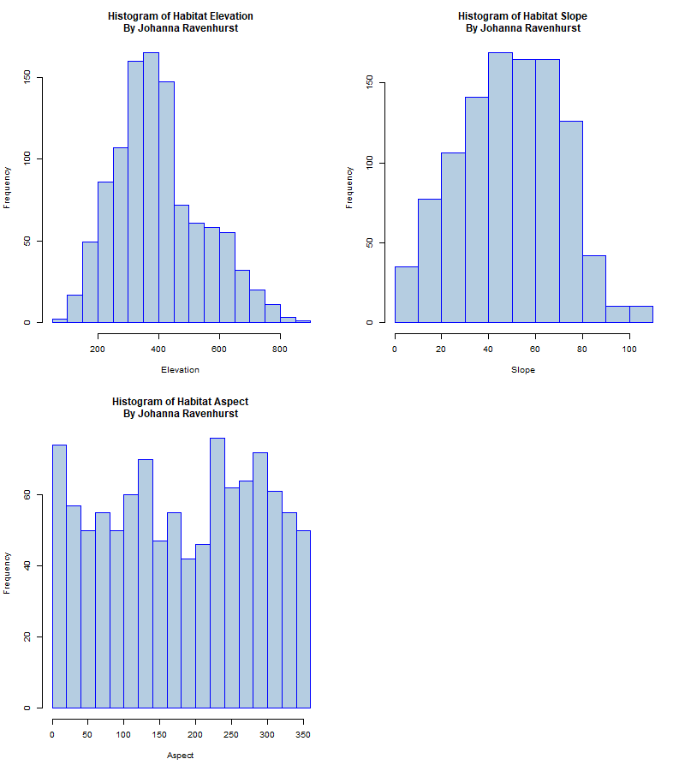

**Q2 – Elevation Histogram Interpretation**

The histogram above shows the distribution of elevations from bird sample sites. Each bar shows the number of sample sites with an elevation that fell within each 50 meter range. This is a way to visualize if there were any patterns in the elevations of the sample sites. For example, we see that there were around 150 or more sample sites in each of the groups of elevations from 300-450 meters. This high peak in the histogram indicates that there were a large number of sample sites in the lower elevations from the total range of 85-872 meters. The higher elevations had comparatively fewer sample sites. This means that overall the distribution of sample sites was slightly skewed to include more lower elevations. However, it looks like there were still a decent number of sample sites at the higher elevations. The slightly skewed distribution could be due to a larger bird habitat area at lower elevations for this particular census.

**Q3 – Slope Units**

*What are the units of slope in this data set?* – the units are percent slope (%) and it ranges from 0-110. This information is from the metadata associated with this dataset.

**Q4 – Slope Histogram Interpretation**

The second histogram shows the slopes of the bird census sample sites. A sample site would be considered flat if it has a 0% slope. There are fewer than 50 sample sites with 0-10% slope. You can see from the histogram that this is a small proportion of the total sample sites, so the majority of the sample sites are not flat. You can see from the peak in the center of the histogram that there are a large number of sites with a 30-80% slope. This indicates that the majority of the sample sites have a slope that falls in the middle of the range, with fewer sites that have a shallow or very steep slope.

**Q5 – Aspect**

Aspect is the direction that the site is facing and is measured in degrees. It ranges from 0-360 degrees because the degrees correspond to the 360 degrees on a compass for the full range of geographical directions in a circle.

**Q6 – Aspect Histogram Interpretation**

The aspects of the sampling sites are shown in the third histogram. There is a fairly even distribution in the directions that the sample sites were facing, but we can see a few trends in the data. There are high frequencies of aspects around 0 degrees and close to 360 degrees, which indicates that a large number of the sample sites were north-facing. In comparison, there seem to be fewer sample sites with an aspect around 180 degrees, or southern-facing. There seem to be similar numbers of sites that face east (90 degrees) and west (180 degrees).

**Q7 – Terrain/Basal Area Linear Models**

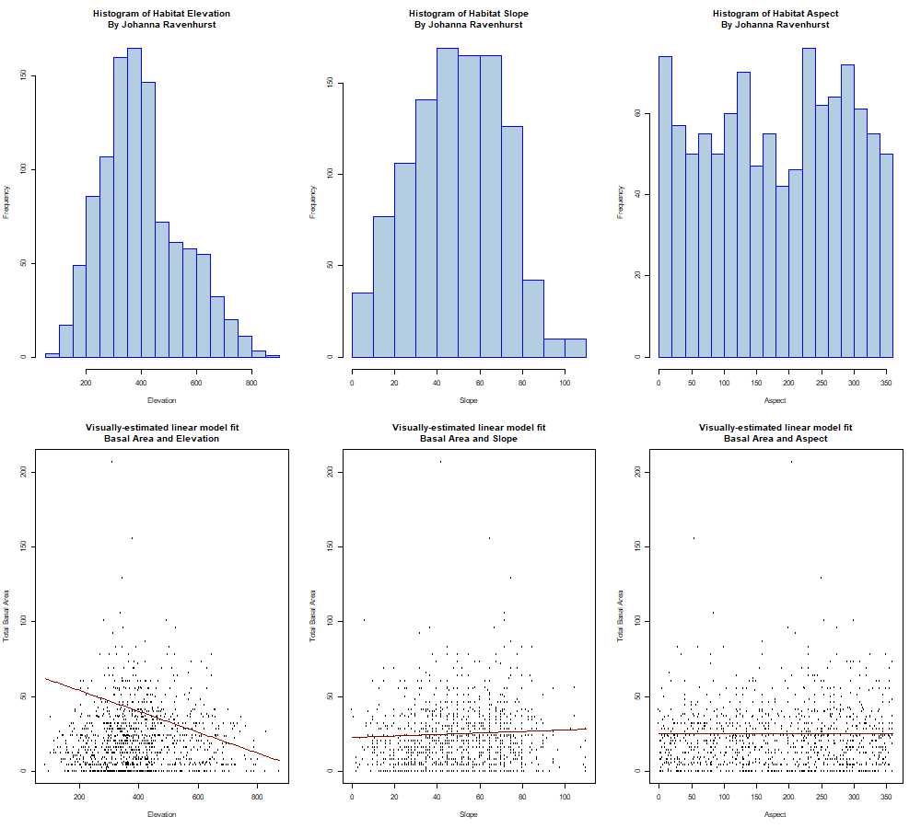

**Q8 – Terrain/Basal Model Interpretation**

There appears to be a negative association between the elevation and total basal area variables. As the elevation increases, the total basal area appears to decrease. This makes sense because I would expect there to be fewer trees at higher elevations, leading to a lower total basal area. However, the line that I fit to the data does not adequately adjust for the increase in the number of sites around 400 meters of elevation, which also seems to be where there was relatively high total basal area for many of the sample sites. This means that my linear model might not be a good fit for the data.

There doesn’t appear to be much of an association between slope and total basal area. However, it looks like there is a bit of an increase in total basal area in the middle of the range of slopes. Since we see in the histogram that there is a large number of sample sites around the middle of the distribution of site slopes, it’s possible that the model should be a curve instead of a simple line. I’m not sure that the linear model I drew is a good fit for the data.

There appears to be no association between aspect and total basal area. The data appears to be evenly distributed in the scatterplot, showing that the density of trees likely isn’t associated with the direction the sample site is facing. I think this linear model is a good fit for the data based on my visual inspection because the data points are evenly distributed around the line.