ECO 602 Software Setup Assignment  
Johanna Ravenhurst

Exercise 1: OneDrive

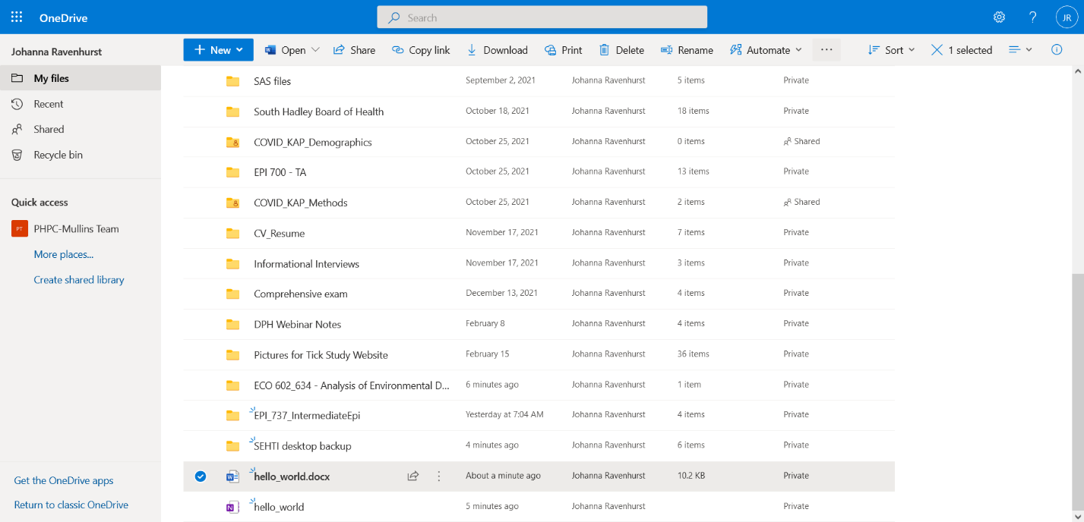

Exercise 2: Azure Virtual Desktop (AVD)

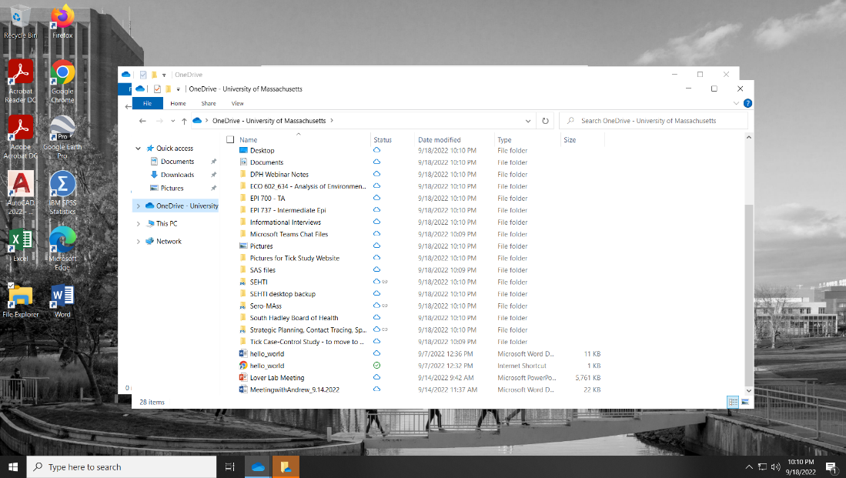

Note: I have access to the virtual desktop, but I often run into errors when I try to log in. I reached out to IT and they advised me to keep closing the error window and trying to log in many times. It seems to be working right now and I have access to OneDrive.

Exercise 3: R Studio – Hello World

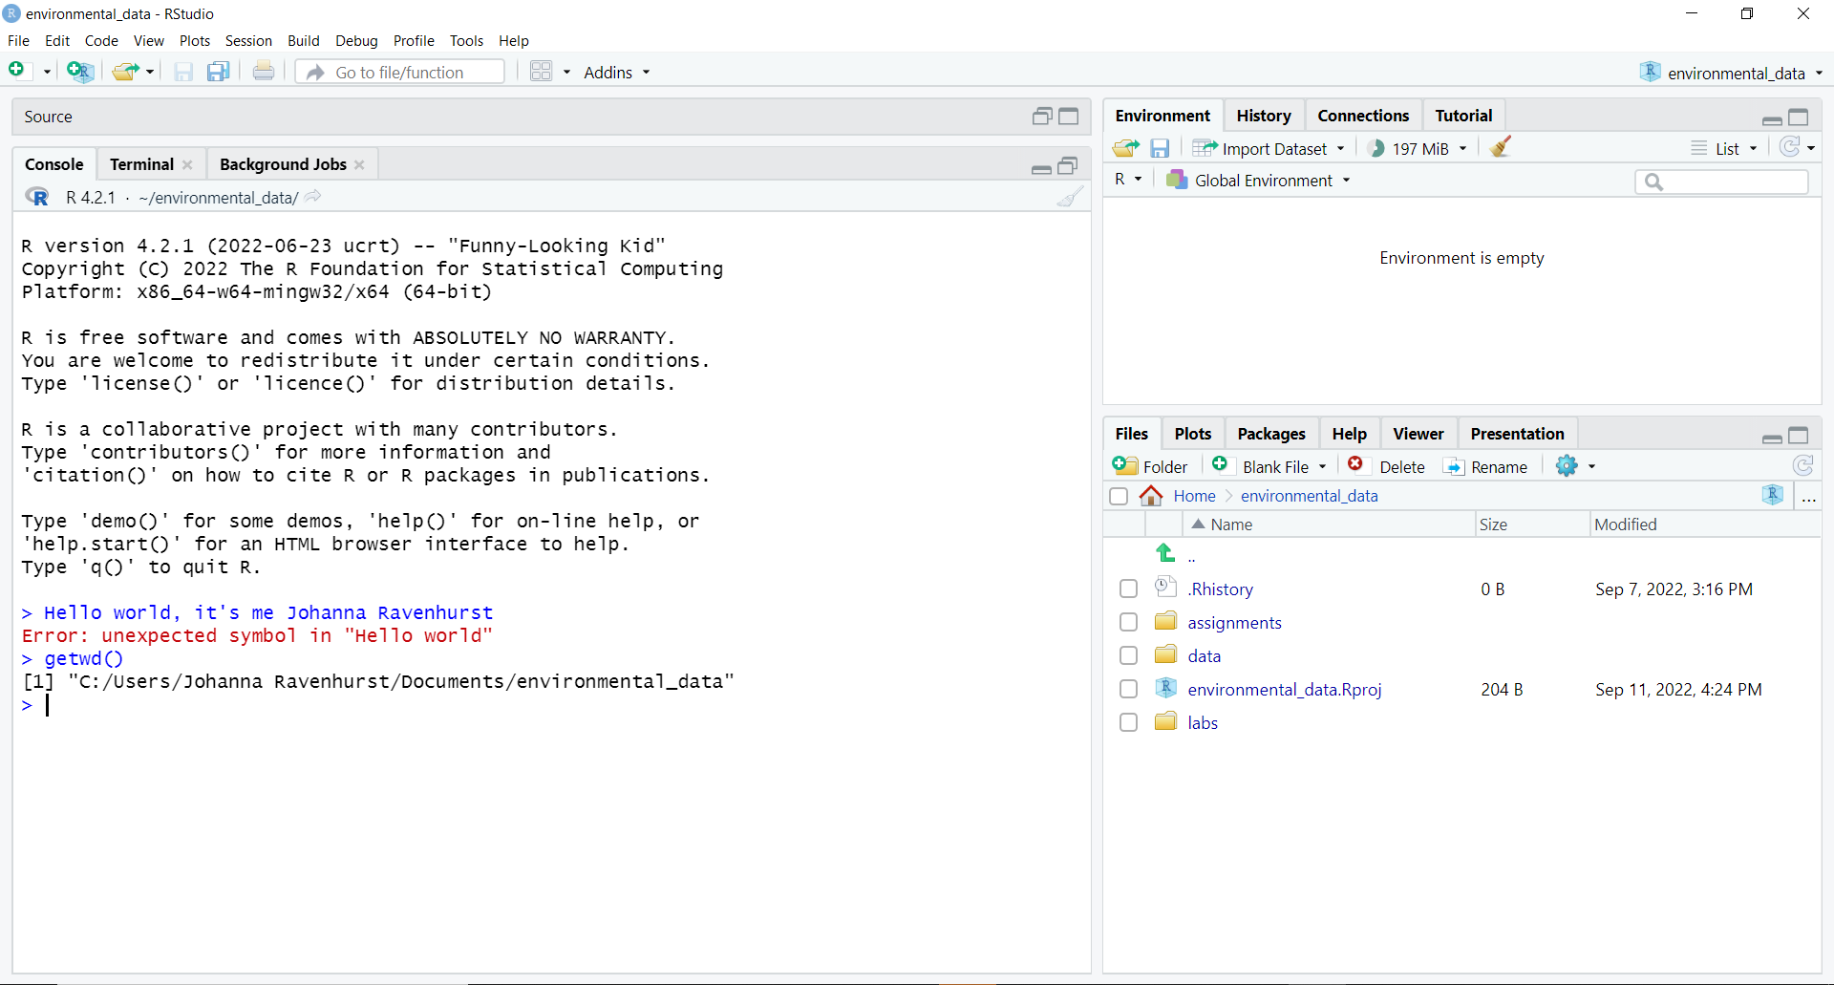

Exercise 4: Course Folder

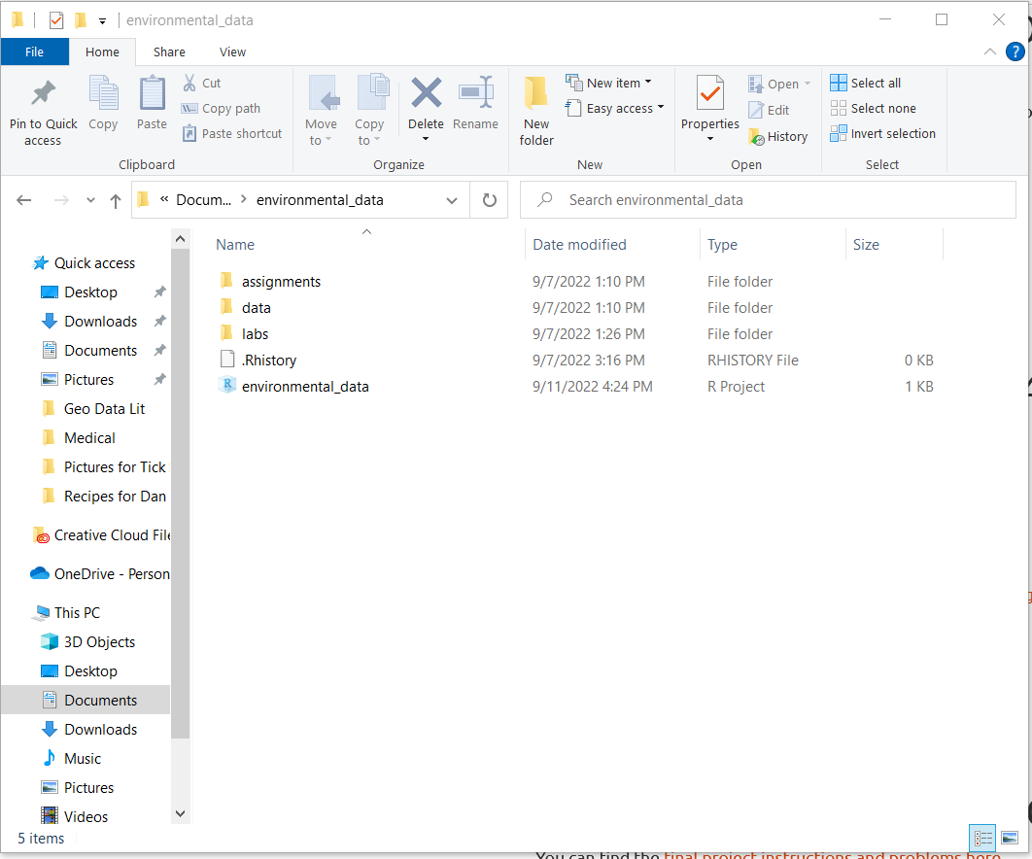

Exercise 5: R Project and R Project Options

