**Game Concept Document:**

R.O.B.E.R

**Rapid Operation Bomb Emergency Robot**

“It’s a working title…”

All work Copyright ©2013 By Working Title Inc.

Written by Daniel Manganaro, Johanna Wald, Raymond Forster and Jon Mace

Version # 1.10

Friday, August 16, 2013

Contents

Introduction 3

Background 3

Description 3

Key Features 4

Genre 4

Platforms 4

Concept Art 5

Feature Set 6

General Features 6

Gameplay 6

The Game World 6

Rendering System 6

# Introduction

R.O.B.E.R is a puzzle solving game where the player takes control of an experimental bomb disposal robot called Rapid Operational Bomb Emergency Robot or R.O.B.E.R. The goal of the game is to manoeuvre boxes into their correct positions in order to gain access to an explosive device and disarm it before time runs out. The game is set in a secret research facility deep beneath Murdoch University.

The player will face a series of levels with varying difficulty, each one harder than the last, with additional challenges to overcome. Boxes can be moved by either pushing or pulling them, however, pulling a box will incur a slight time penalty.

# Background

The game will build upon “Shay’s World” - a basic openGL environment based upon the campus of Murdoch University, located on South Street.

This option section provides information about any tools, engines or licenses that the game uses from previous work that may need some explanation.

# Description

Deep underneath Murdoch University is a top secret facility where R.O.B.E.R, a highly advanced and specially equipped robot built for disposing of a bomb, is being developed. You’ll be taking control of R.O.B.E.R to traverse your way through complex mazes in time to find and defuse a bomb. You will have to manipulate the environment, by pushing and pulling boxes, and activating switches to find the best way through.

As you advance through the levels of increasing difficulties, you will need to be aware of additional challenges. You will encounter traps which you will need to avoid or you may detonate the bomb prematurely.

# Key Features

The sorts of things that might appear on the back of the game's packaging in a store. Lists the features of this game. What sets this game apart from other games in it's genre.

* Navigate a full 3D maze to find your way through.
* Solve puzzles by manipulating the environment to your advantage

# Genre

R.O.B.E.R is a Puzzle Solver game with a sci-fi theme.

# Platforms

R.O.B.E.R will be developed for the Windows platform.

# Concept Art

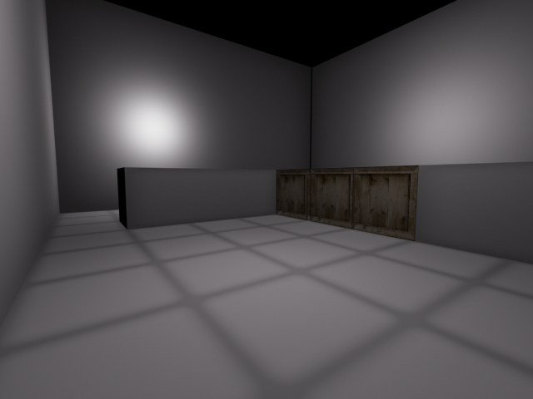

# Feature Set

## General Features

* 3D graphics
* 32-bit color
* Particle effects
* 3rd Person Camera View

## Gameplay

* Navigate puzzle by moving obstacles
* Beat the timer before the bomb goes off

# The Game World

The game takes place in an underground laboratory where the top secret project R.O.B.E.R. is being development and you (as the player) will be testing it.

# Rendering System

This game will be created using the OpenGL with a 3D environment.