ICT207 Group Declaration Sheet

Assignment/Project Name: Project

Group Name: Working Title Inc.

Member’s Names | Brief Description of Tasks  (This part is only a summary from the individual accounting sheet.  If more space is needed, attach extra sheets.) | Member’s contribution to the total work (%) | Date | Signature
Johanna Wald | Collision Detection, Transitions, Game Object Handling, Debugging and Testing | 28 | 16/1/2014 | 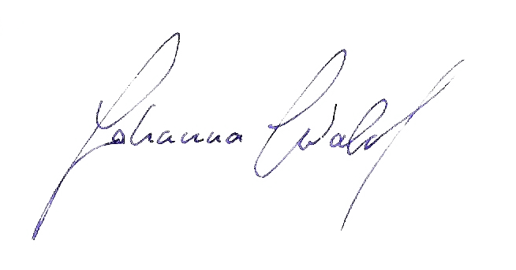
Raymond Forster | Camera Movement, Debugging and Testing | 22 | 16/1/2014 | 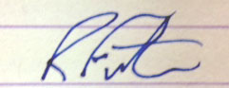
John Mace | Level Creation and Modelling, Win and Lose Screens | 28 | 16/1/2014 | 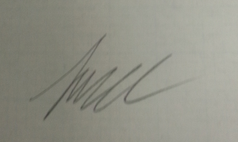
Daniel Manganaro | Particle Effects Explosion and Documentation, | 22 | 16/1/2014 | 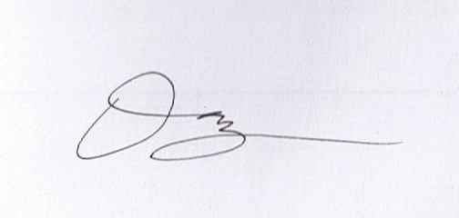
Total percentage (should total to 100% if all work is completed)

Instructions:
The purpose of this declaration is to provide documentary evidence of each group member’s contribution to the submitted work. This was demonstrated during the lecture at the start of the semester. Please present this sheet after the printed and completed unit cover sheet.

Please complete the information as specified above. It should list each group member’s percentage contribution to the submitted work and it is a summary of the individual accounting sheet. For example if there are 4 members and they all make equal contributions to the total work, then each gets 25%. This statement needs to be signed by all group members to indicate their agreement to percentage breakdown. Detailed evidence must be provided in the individual accounting sheet.

Individual accounting spreadsheet should also be completed and submitted with the project.

The self and peer assessment form should be completed by each team member and submitted separately into LMS.

