School of Engineering and Information Technology

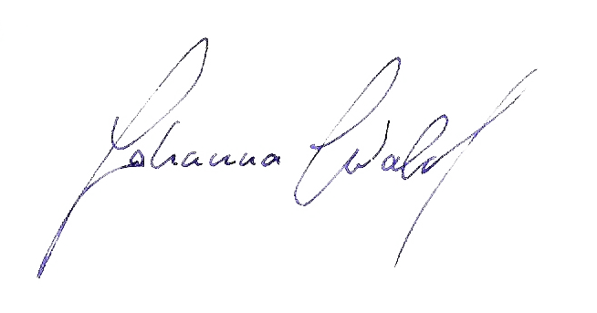
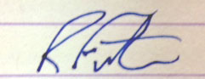
ICT207 COVER SHEET
Given Names | Surname/Family Names | Student Numbers | Mode (D/X)
Johanna | Wald | 32272216 | D
Raymond | Forster | 30901315 | D
John | Mace | 30617187 | D
Daniel | Manganaro | 31110337 | D
Name of tutor: _____Craig Lonsdale_______________________ Day & Time of tutorial: ____Friday 3:30____________

Assignment Number: __2___ Due Date: ____1/11/2014__________ Date Submitted: __1/11/2014____________
If the given name by which your tutor knows you differs from your name on university records, you should indicate both names above. Tutor’s name must be entered. Penalty is 10% of the total marks for the submission for not providing information and content asked for or not satisfying any applicable requirement listed below.

Your assignment should meet the following requirements. Please confirm this (by ticking boxes) before submitting your assignment that you have checked the declarations you need to make. Some items do not apply for online/electronic submission.

o Except where I have indicated, the work I am submitting is my own work for the purpose of this assessment and has not been submitted for assessment in another unit.
o This submission complies with Murdoch University's academic integrity commitments. I am aware that information about plagiarism and associated penalties can be found at http://www.murdoch.edu.au/teach/plagiarism/. If I have any doubts or queries about this, I am further aware that I can contact my Unit Coordinator prior to submitting the assignment.
o I acknowledge and agree that the assessor of this assignment may, for the purpose of assessing this assignment:
- Reproduce this assignment and provide a copy to another academic staff member; and/or
- Submit a copy of this assignment to a plagiarism-checking service. This web-based service will retain a copy of this work for the sole purpose of subsequent plagiarism checking, but has a legal agreement with the University that it will not share or reproduce it in any form.
o I have retained a copy of all submitted work. Zip file submitted in LMS is retained by all whose names appear on this sheet.
o I will retain a copy of the notification of receipt of this assignment. If you have not received a receipt within three days, please check with your Unit Coordinator.
o Assignment is presented on A4 size paper and is neatly collated. (When hardcopy is required)
o Assignment includes virus-free disk with machine-readable programs & files relevant only to this submission. CD or DVD only may be accepted. (When disk is required)
o Instructions relating to answering of questions, formats used for electronic submission and LMS submission have been followed.
- Writing is clearly legible or has been printed (When hardcopy is required)
- Group work declaration sheet and individual accounting sheet for group work projects has been completed and signed by all team members.
o Pages have been firmly stapled. (When hardcopy is required)

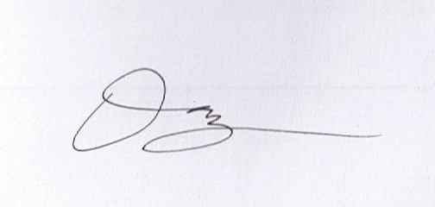
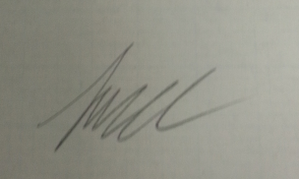
_____________________________________________________________________________ (all group members must sign)
Signature(s) – sign in order of the names given above for submission via the assignment box.

For Submission in LMS:
Only one team member needs to submit the entire assignment into LMS. All students need to submit this cover sheet in LMS.
o I am aware that I am making this declaration by submitting this document electronically and by using my Murdoch ID and password it is deemed equivalent to executing this declaration with my written signature.

