SDD: Project Platypus

Hidstrand, Fredrik
Keinestam, Johannes
Sjöqvist, Magnus
Thander, Fredrik

TDA367
Chalmers University of Technology
10 April 2011

Table of Contents

System design document for Project Platypus

1 Introduction
1.1 Design goals
1.2 Definitions, acronyms and abbreviations
1.3 References
2 Proposed system architecture
2.1 Overview
2.2 Software decomposition
2.2.1 General
2.2.2 Tiers
2.2.3 Communication
2.2.4 Decomposition into subsystems
2.2.5 Layering
2.2.6 Dependency analysis
2.3 Concurrency issues
2.4 Persistent data management
2.5 Access control and security
2.6 Boundary conditions
2.7 References
APPENDIX

Version: 1.5

Date 2011-04-10

1 Introduction
This section provides a brief overview of the project.

1.1 Design goals
The design must have loose couplings between the different parts of the application so that mainly the GUI is easily replaceable. The application must also feature testable parts (modules, classes). It should be easy to write new filters and incorporate them into the application.

1.2 Definitions, acronyms and abbreviations
- GUI, graphical user interface.
- MVC, a way to partition an application with a GUI into distinct parts avoiding a mixture of GUI code, application code and data spread all over.
- Plugin, an optional extension to the program that adds additional functionality.
- Filter, a plugin with a set of adjustments to the chosen images, for instance increase contrast.
- Preset, a collection of predefined filters.

1.3 References
MVC, see http://en.wikipedia.org/wiki/Model-view-controller

2 Proposed system architecture
In this section we propose a high level architechture.

2.1 Overview
The application will use a standard MVC model with an anemic model. This will make the controller handle nearly all the logic, with the model acting just as data. Testing of our application will therefore be centralized to the controller.

2.1.1 Filters
The application will be very extendable, in that it is possible to add custom-made filters. The filter will contain its own panel for the filter settings. The filters will be stored in the users home folder.

2.1.2 Event handling
The application will have a central location for the communication between the modules. This communication will be located in a class named ComBus.

2.2 Software decomposition

2.2.1 General
The application is composed of the following modules, see figure 2:
- Main, application entry and build class.
- view, top level package for all the GUI-classes.
- view.components, GUI-classes that dosn’t take over the entire interface.
- ctrl, controller-classes that contain all logic.
- model, the objectoriented model.
- util, general utilities.
- util.IO, classes handling the input/output subsystem.

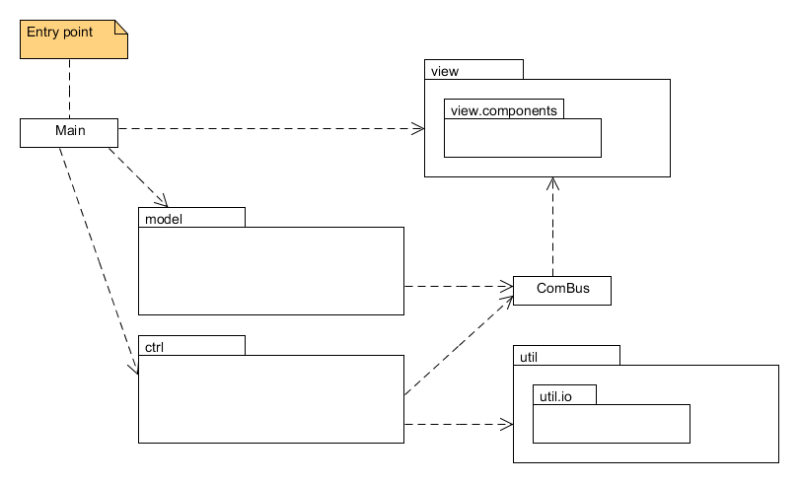
Figure 2: Modules

2.2.2 Tiers
N/A. The application will always function as a standalone client on the users computer.

2.2.3 Communication
N/A

2.2.4 Decomposition into subsystems
There will be a subsystem to handle input/output operations, such as loading filters and presets.

2.2.5 Layering
The layering is shown in figure x. The higher layers are at the top of the image.

2.2.6 Dependency analysis
No circular dependencies, hopefully.

2.3 Concurrency issues
The process och applying the filters to the batch of images will be threaded to decrease waiting time. Some filters may be prone to bugs, which we will handle with an option for the user to abort the operation exporting of images. If aborted, the current saving and applying of filters will stop, and the images already processed are saved.

2.4 Persistent data management
The persistent data will be the presets that the user may choose to save. These presets will be saved in separate data files at a specific location in the users home folder.

2.5 Access control and security
By giving a lot of freedom to the contents of a filter we’re running the risk of them containing malicious code. It has been discussed and the outcome is that the application will not enforce a securitysystem, instead it is the responsibility of the user.

2.6 Boundary conditions
N/A

2.7 References

APPENDIX

